VIEW JOB RESULT FROM SDSF (System Display and Search Facility)

1. In ISPF menu, select option 3 (Utility functions). Press Enter.

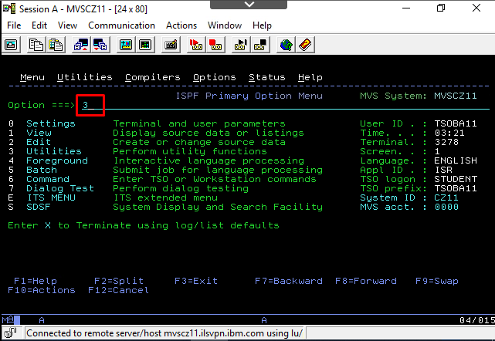

1. Select option 4 for display datasets. Press Enter.

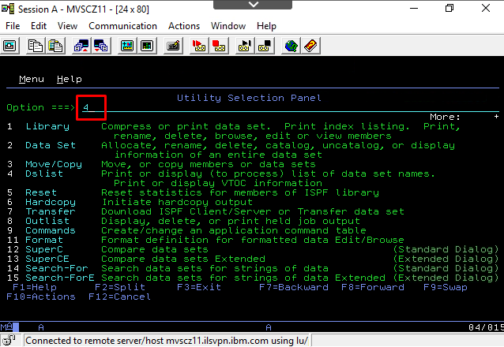

1. Press again Enter.

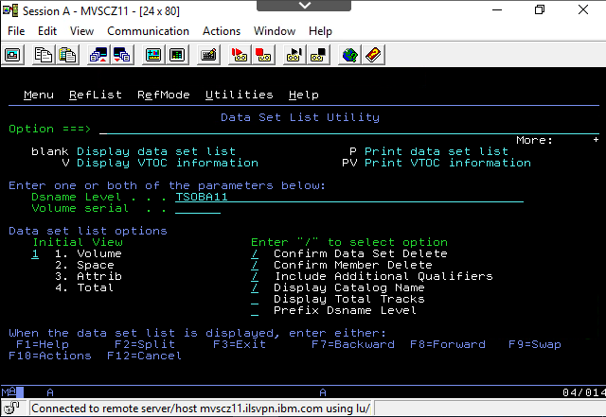

1. Select dataset and press “E” key and press Enter.

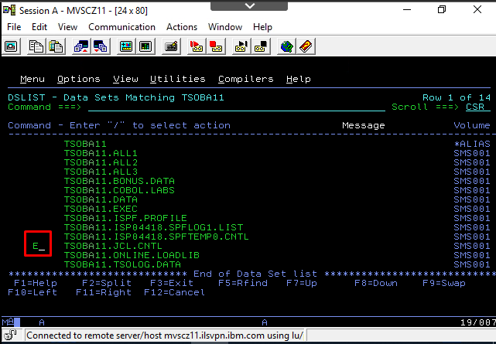

1. Select dataset and press “E”. Press Enter.

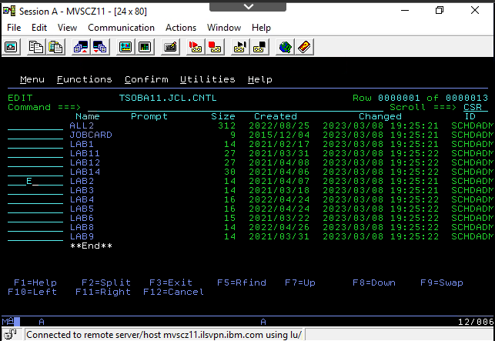

1. In JCL member file, input “SUB” command or “SUBMIT” and press Enter.

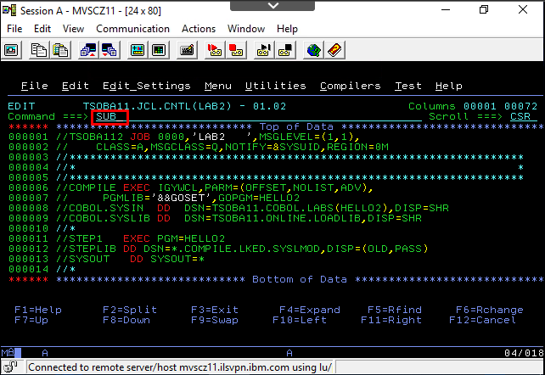

1. A Message to the job submited is displayed. Press Enter.

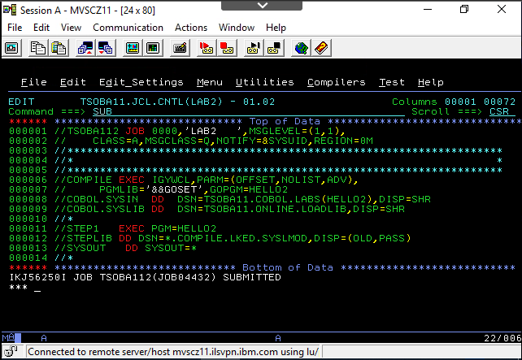

1. Press again enter to get the Maximum Condition Code (MAXCCC=0000 no errors).

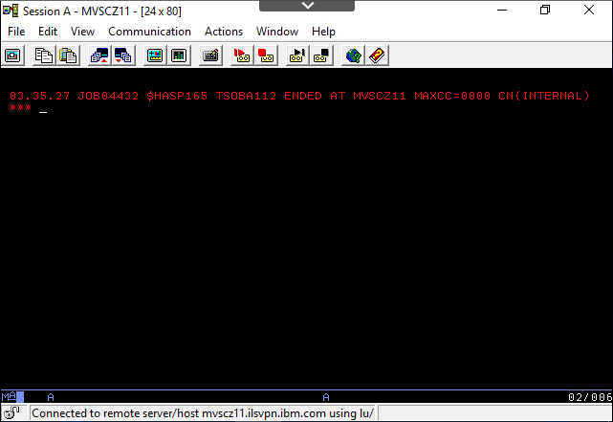

1. Press “=S" to enter SDSF and get the results.

