DISPLAY A SOURCE FILE FROM LIBRARY

1. Input the command “STRPDM”, and then press Enter.

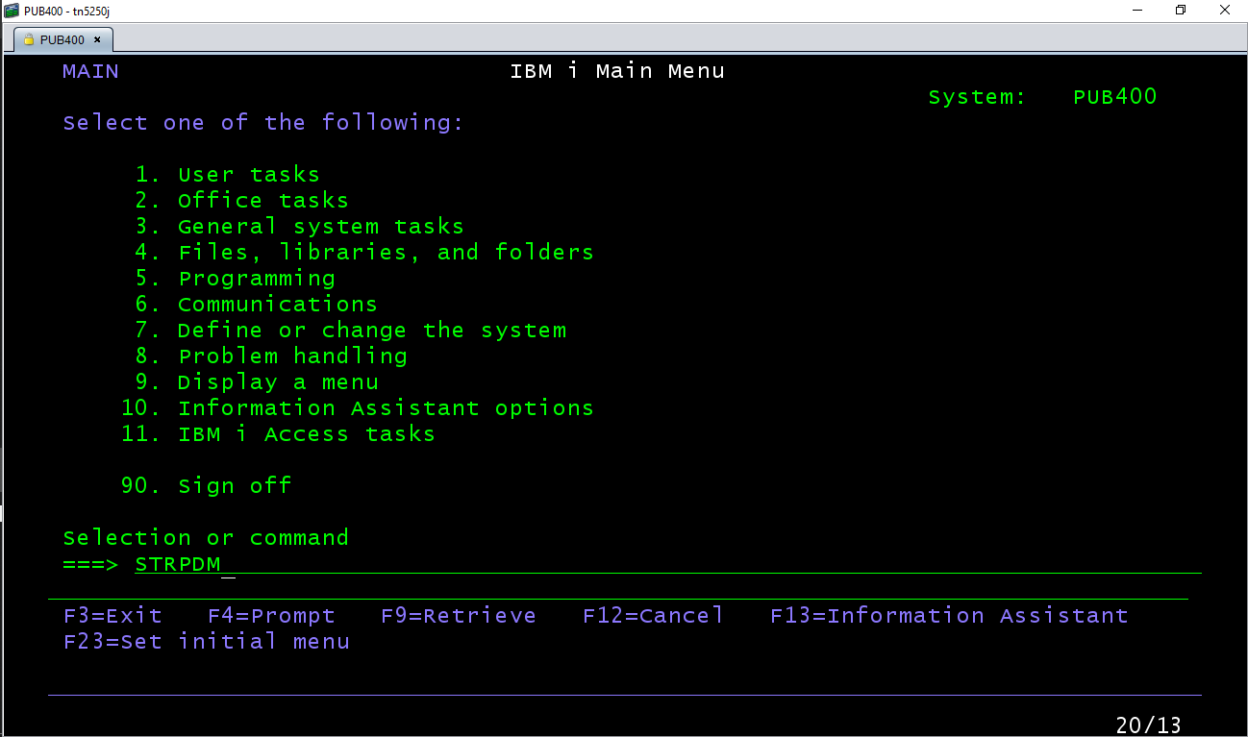

1. Select option “1” (Work with libraries).

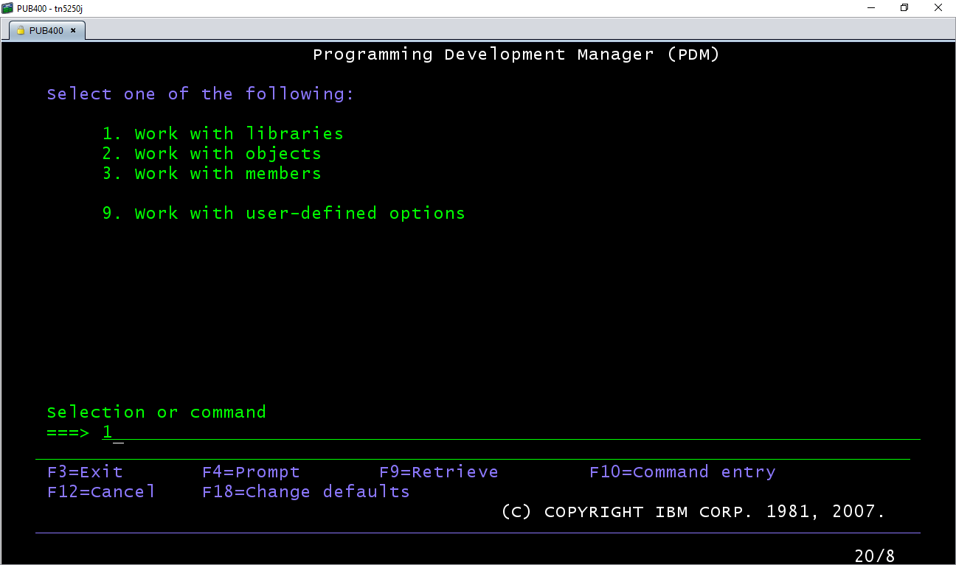

1. Input the library name (REINALDO1) and then press enter.

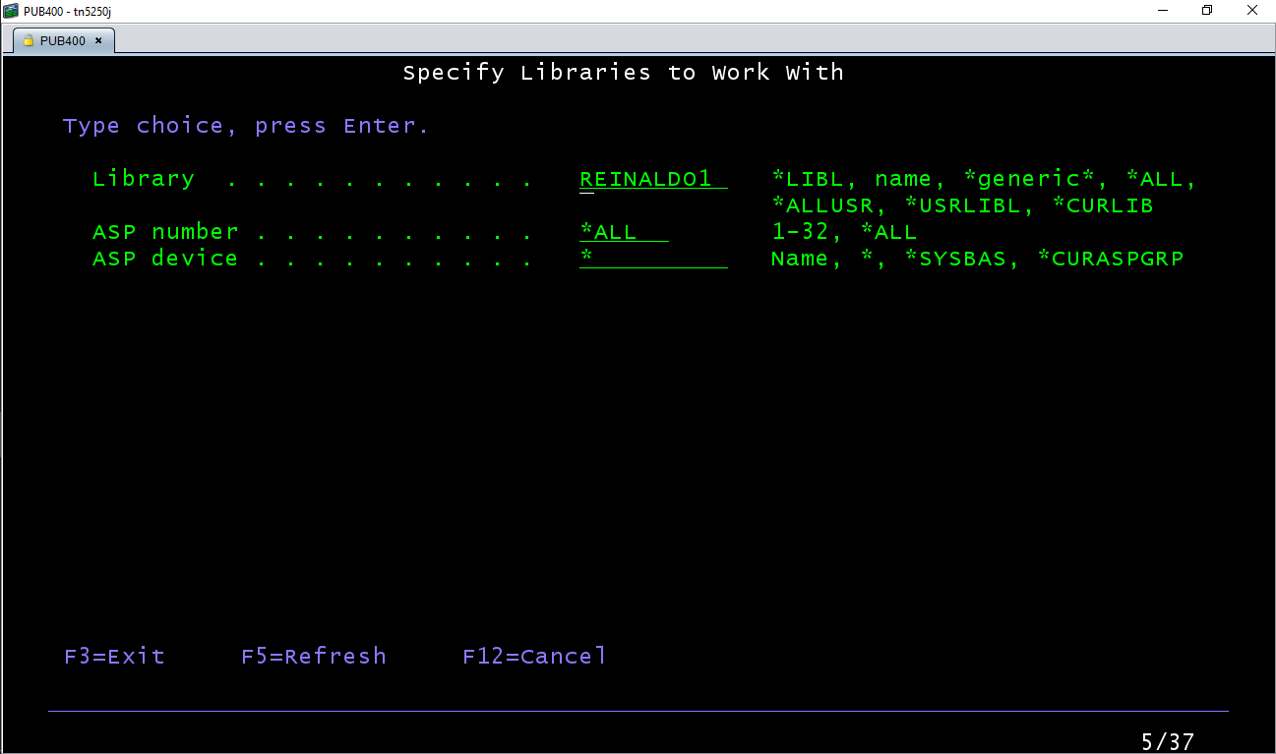

1. Input the option 12 to work with the library.

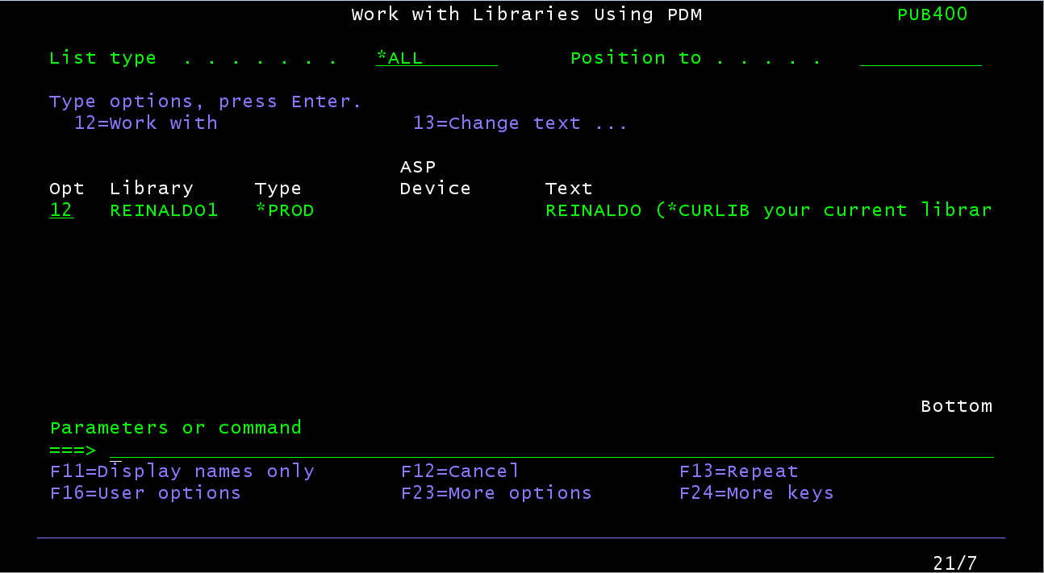

1. Select the Phisical File with contains the source with “12” option.

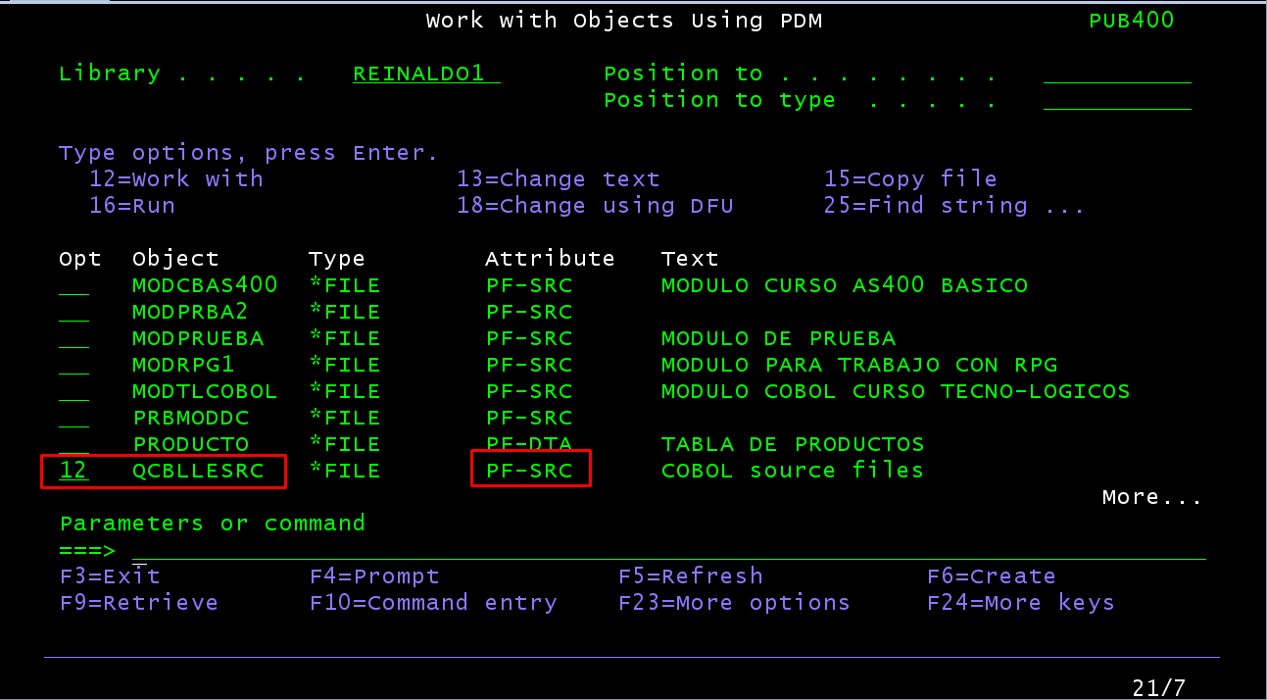

1. Select file source and any option from superior menu. To view content only press 5 and Enter.

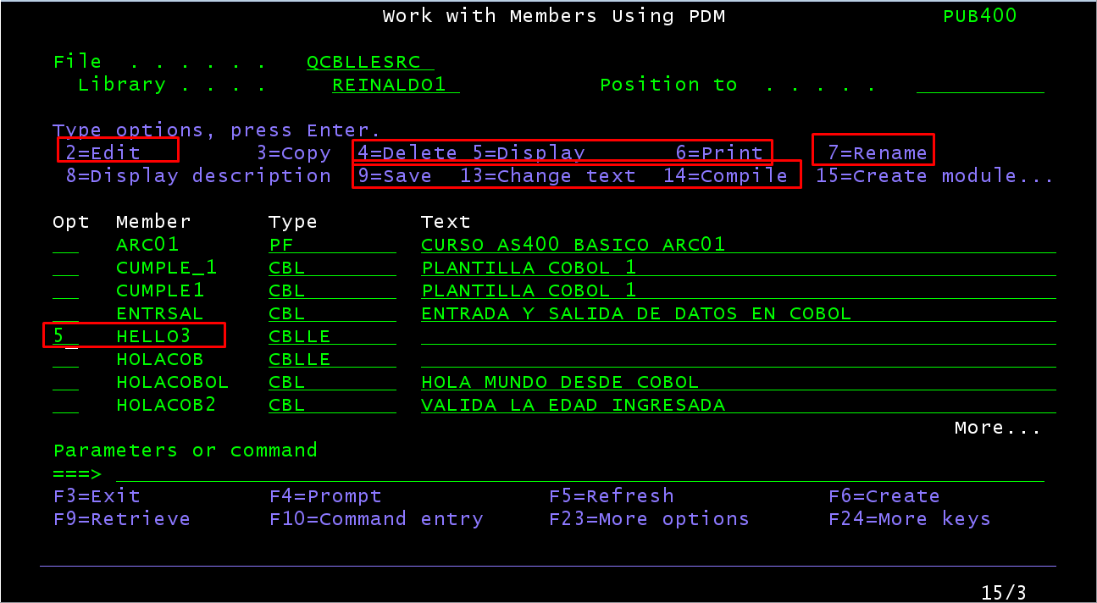

1. The content of the source file are displayed in screen.

