CREATE A MEMBER (SOURCE)

1. Use the “STRPDM” option and press enter.

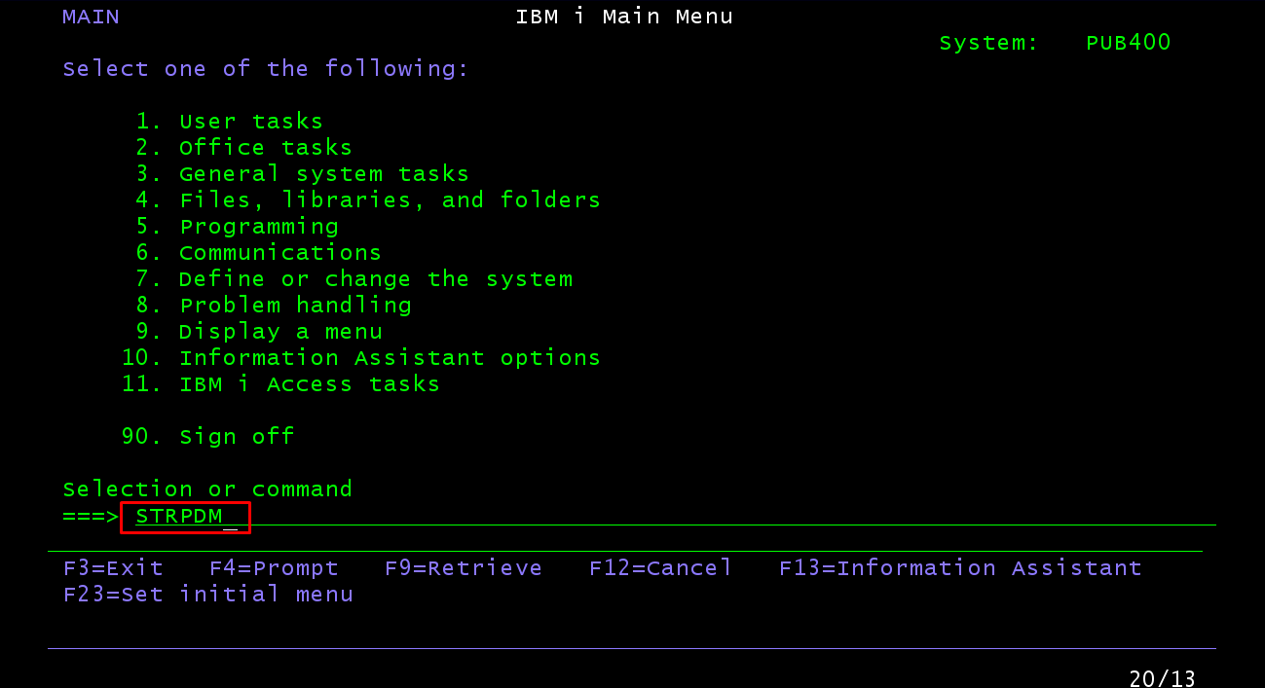

1. Select option 3 (work with members) and press “Enter”.

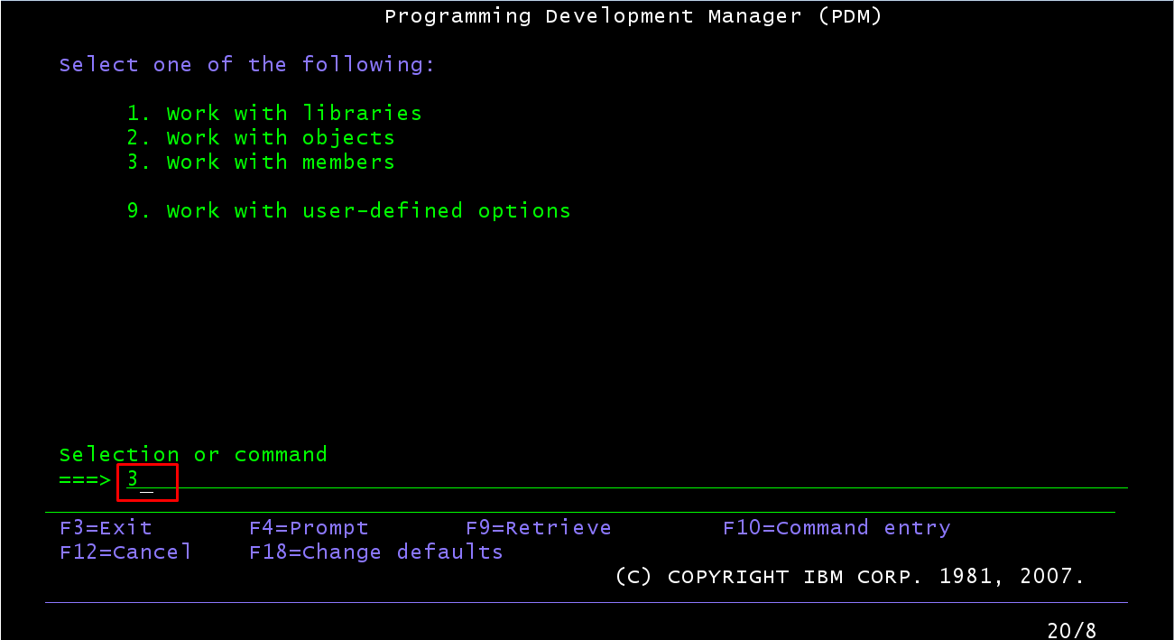

1. Select type file “QCBLLESRC” and press Enter.

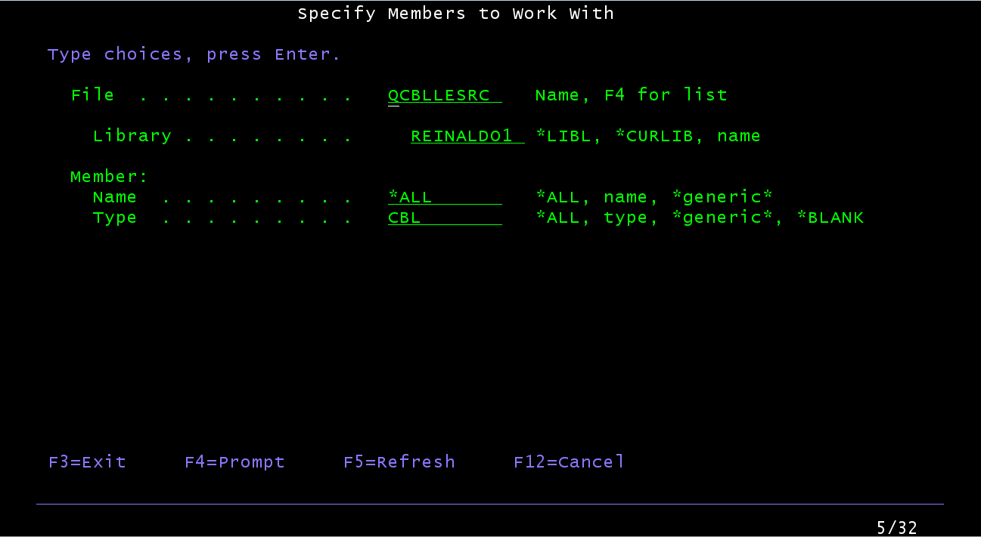

1. Select a member to edit or pres key “F6” to create a new member.

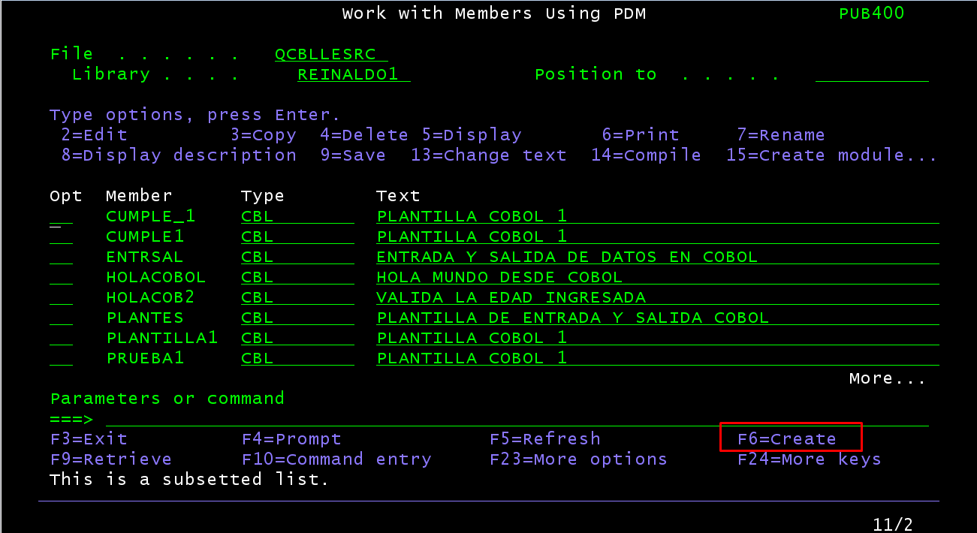

1. Digit name of new member file and press Enter.

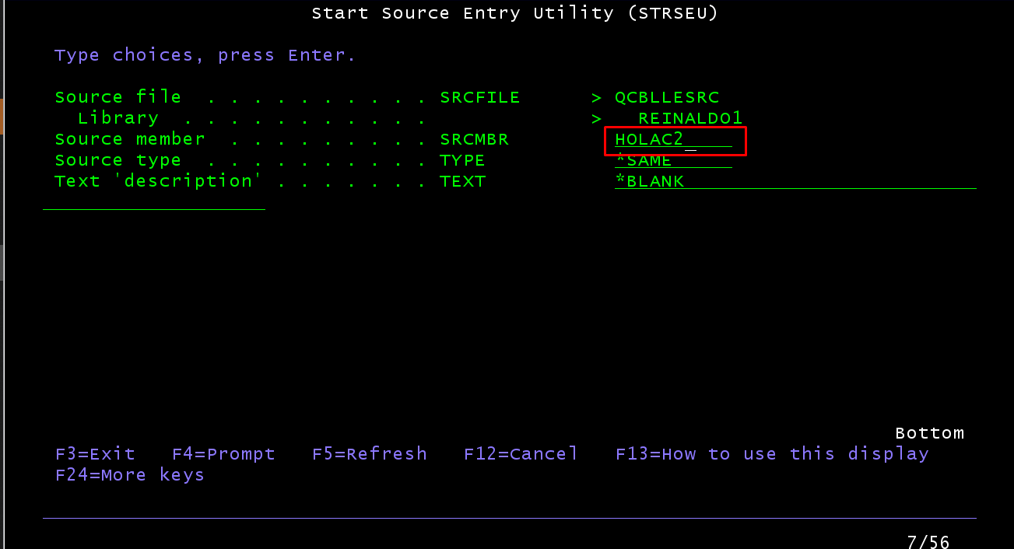

1. You access to write the program. Insert new line placing in number line and press “I” key.:

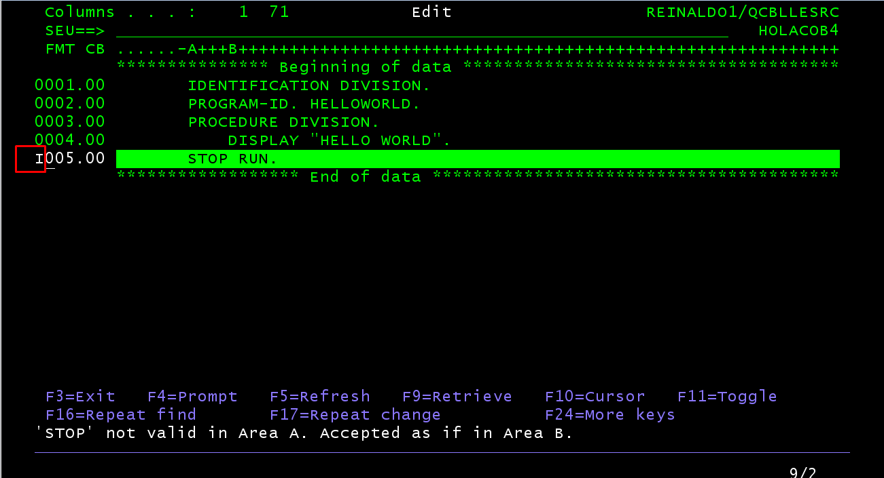

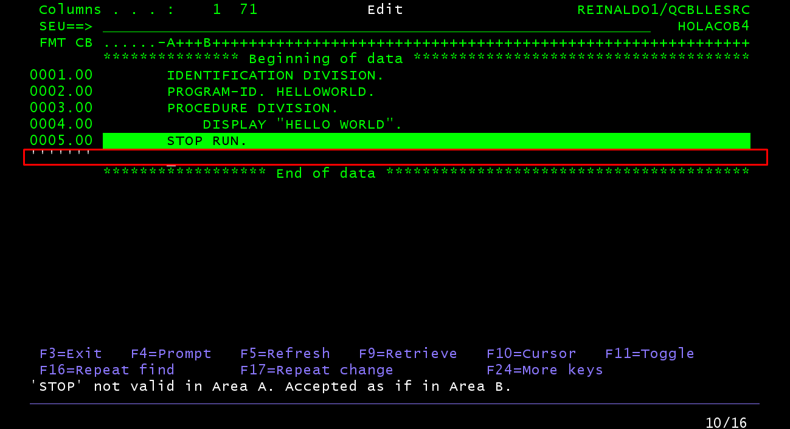

1. Press “F3” and comfirm changes pressing Y in “Change/create member”.

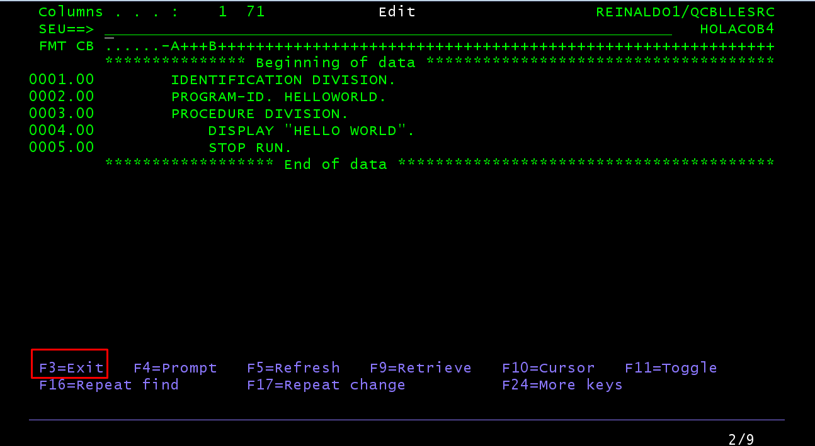

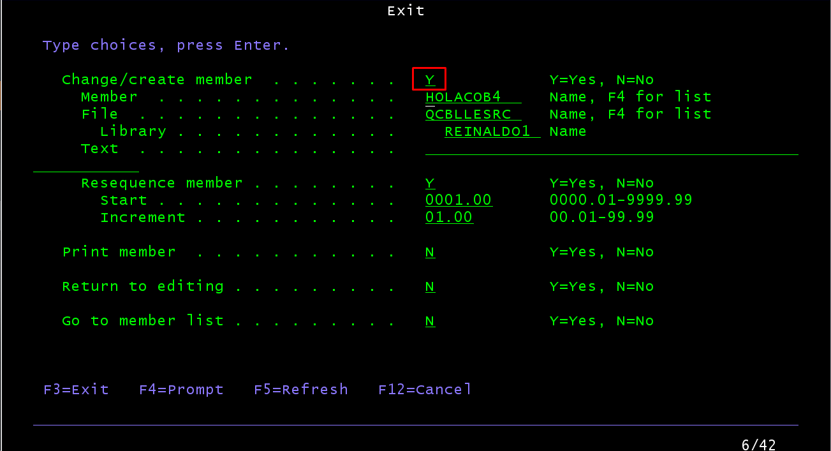

1. To compile the cobol member file, use the option “CRTCBLPGM” and press “F4” key.

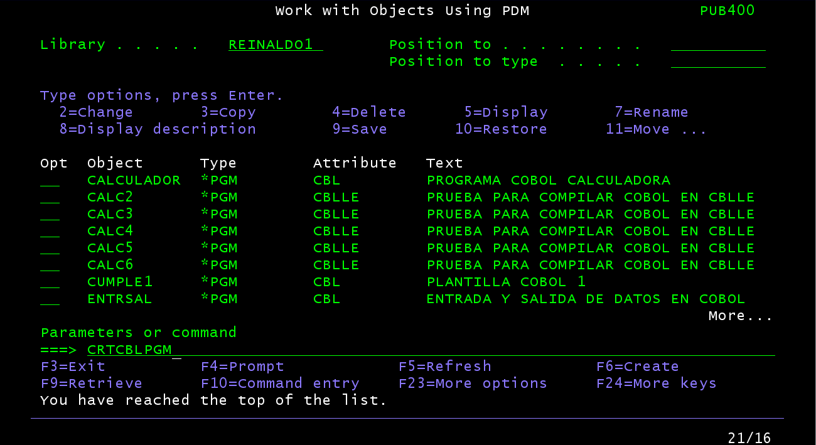

1. Insert program output name, library, source file and source member and press Enter.

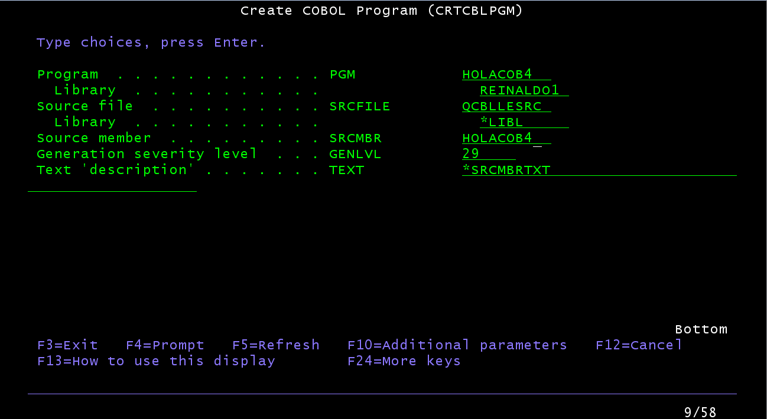

1. In Screen appears a message with program created or any message of error.

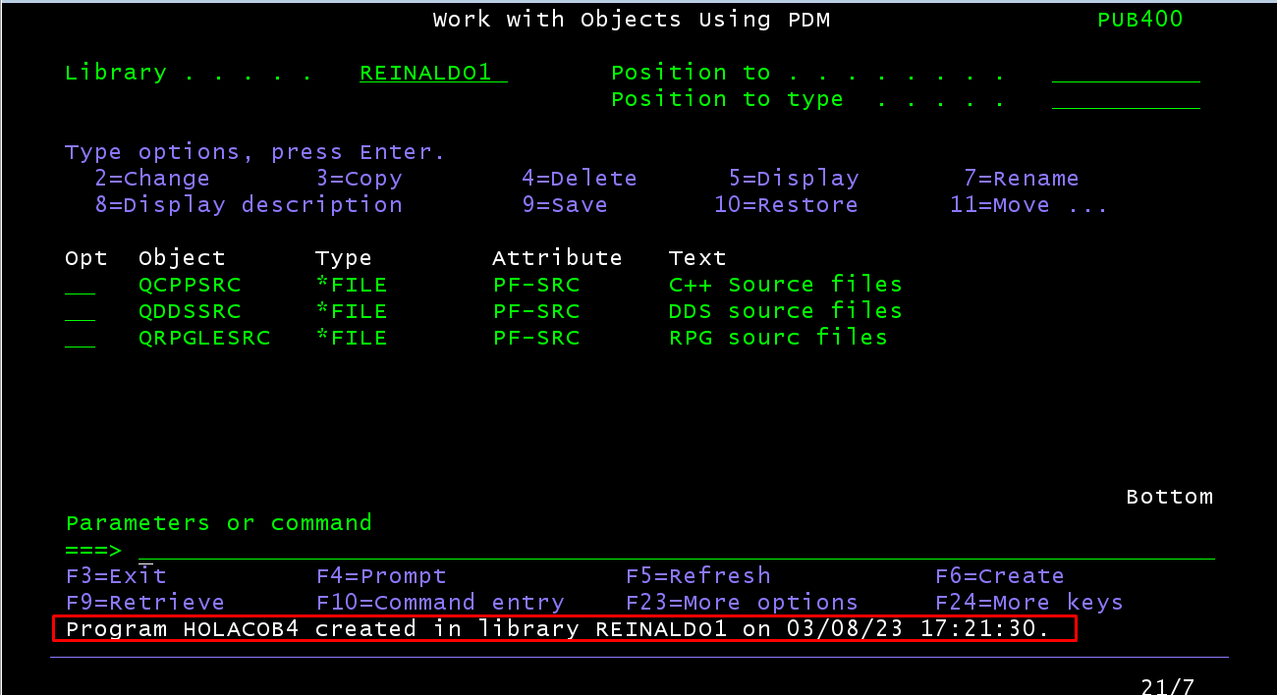

1. To call the program compiled, use the “STRPDM” command and press Enter.

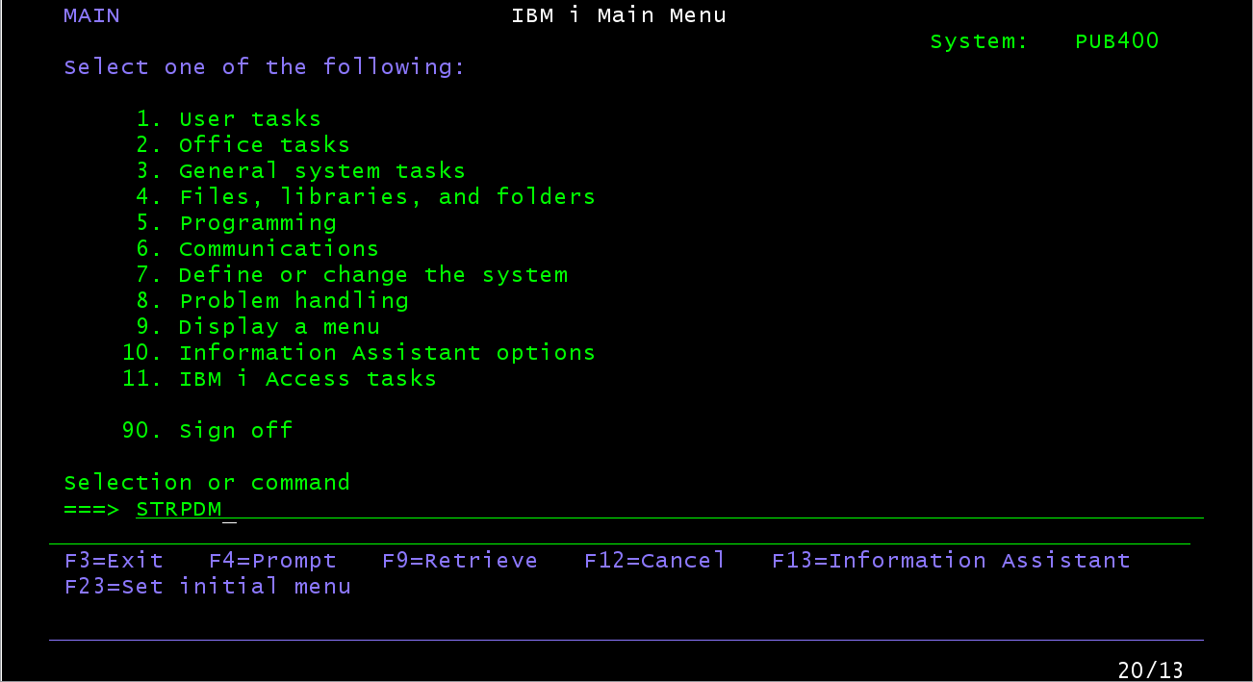

1. Select option “Work with objects”.

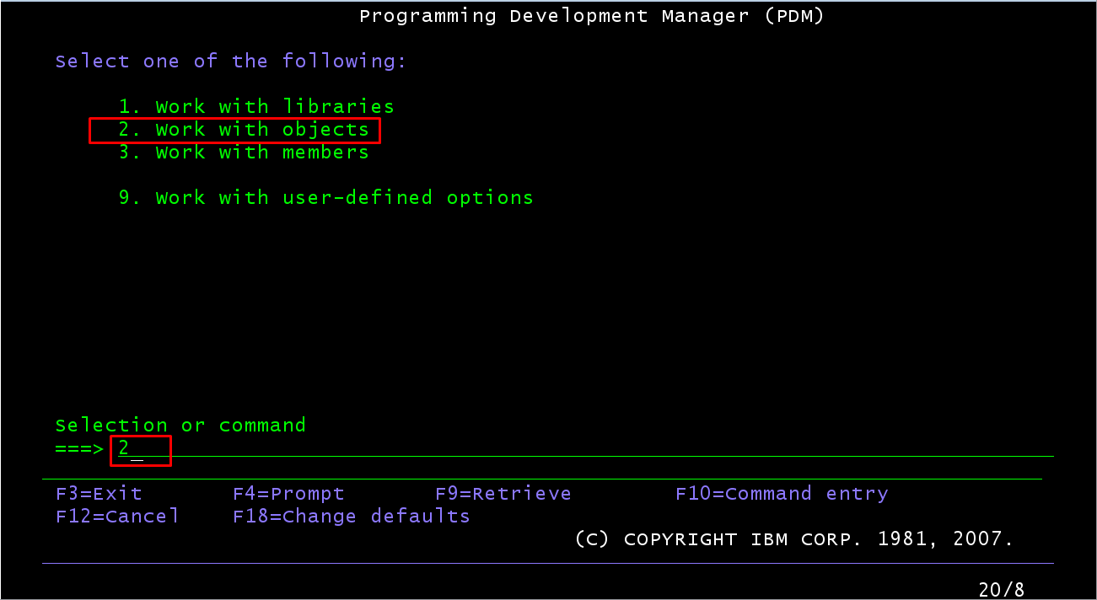

1. Select library that is allocated the object and press Enter.

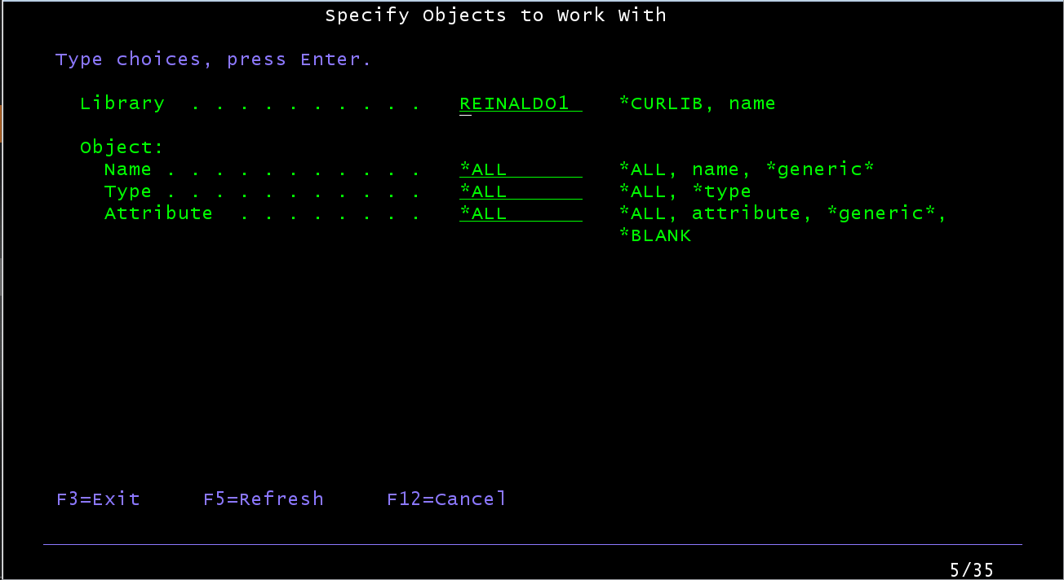

1. To call program simply press “C”. In Screen appears result messages.

