START WITH AS400 WITH PUB400.COM

1. You need to sign in pub400.com page and get the message with your user and password.

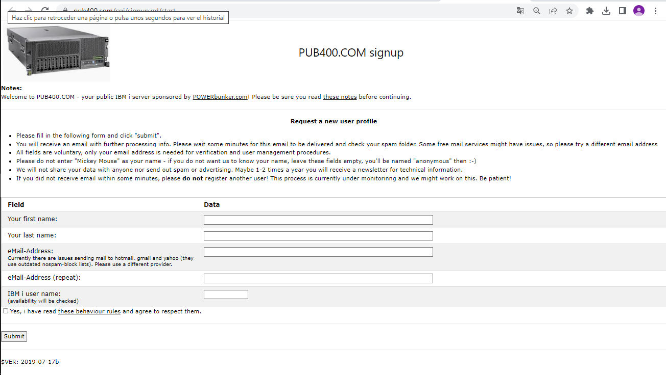

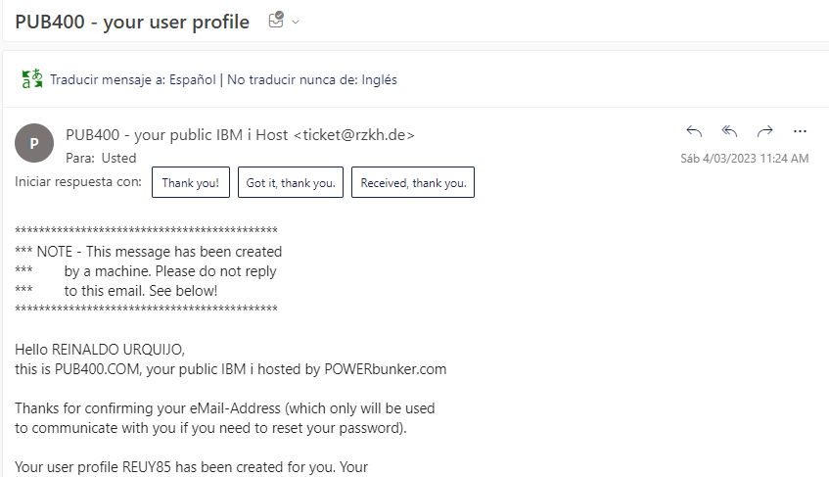

1. Once you get user and password to pub400.com, download an as400 emulator (ibm iseries, tn5250, mochasoft, etc). Configure to access remotely.

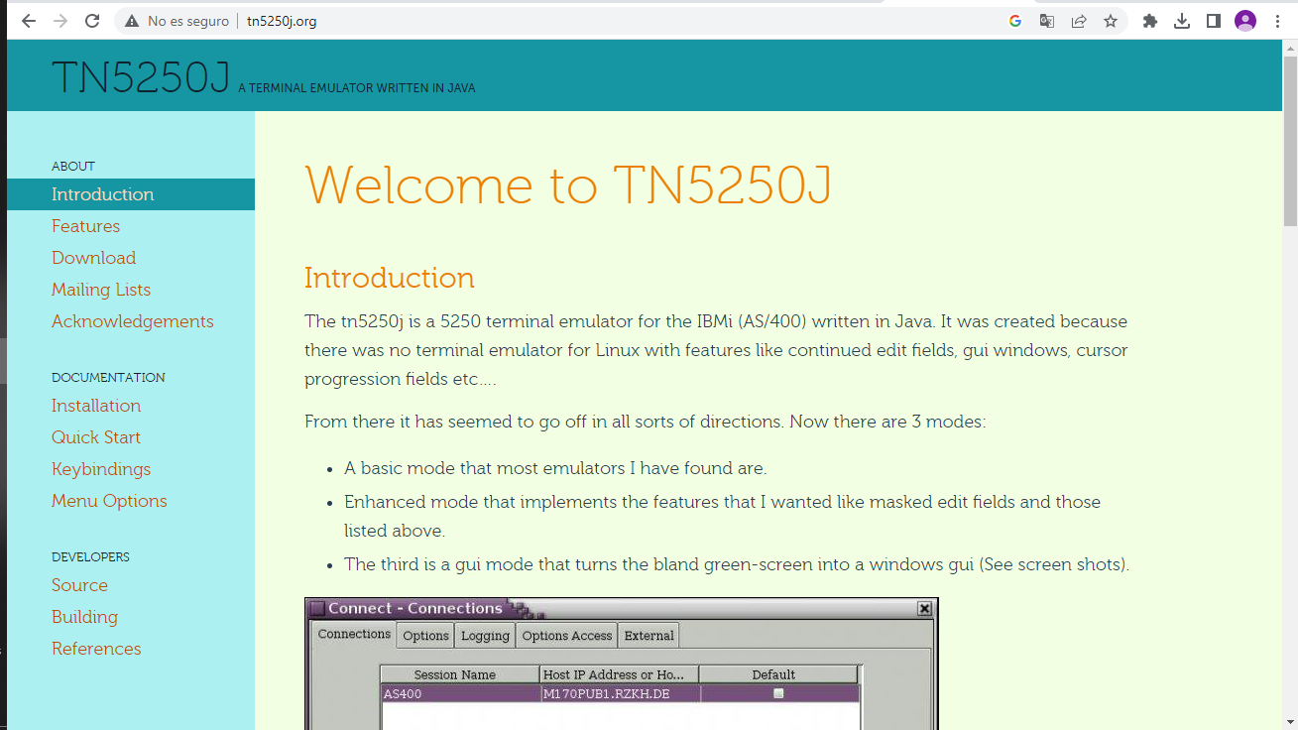

1. Access to program and configure a new connection.

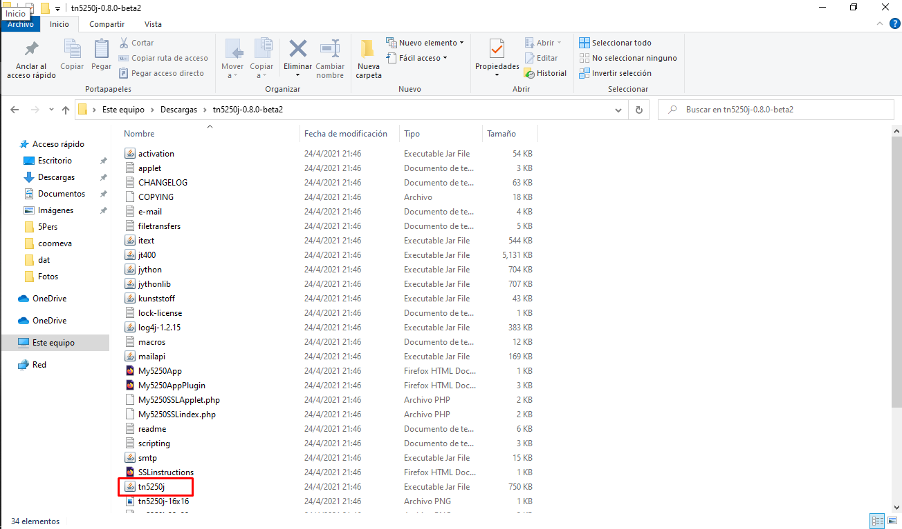

1. Create a new connection with DNS, port, and name. Use TLS SSL type.

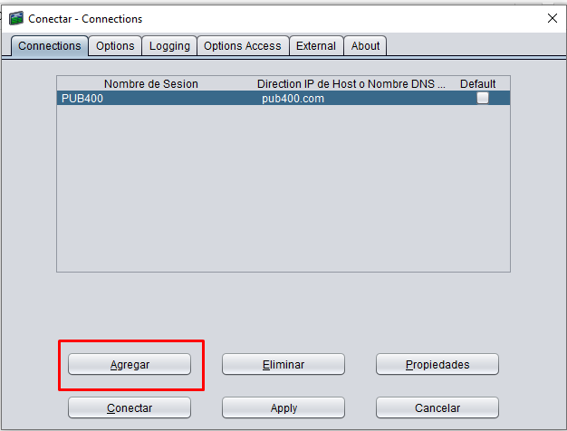

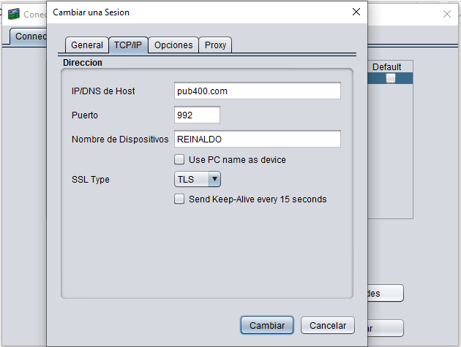

1. Clic on connect and wait to access to pub400.com

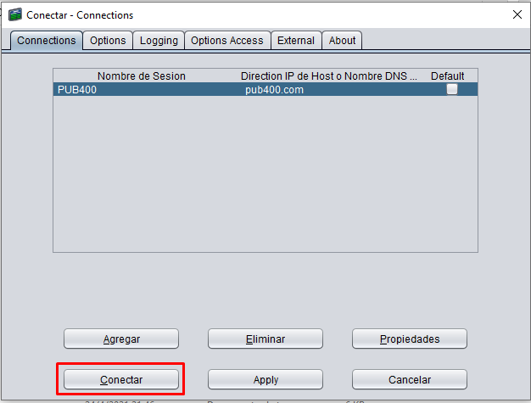

1. Once you can connect, the new window appears for log in the pub400.com server with your user and password account.

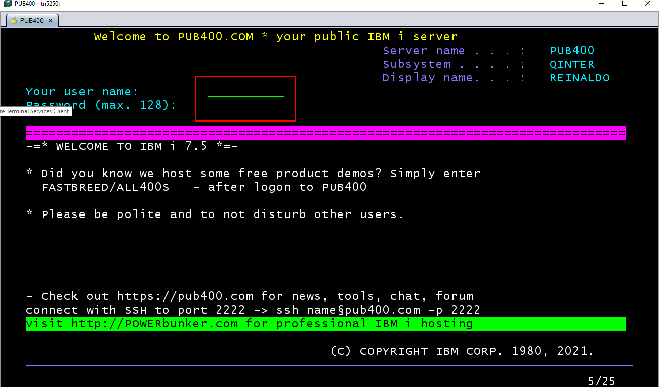

1. That’s all, you can access to pub400.com server.

