ISPF EDITING AND EXECUTIN COBOL AND JCL MEMBERS

1. Log on the VM and mainframe session in MVSCZ11.

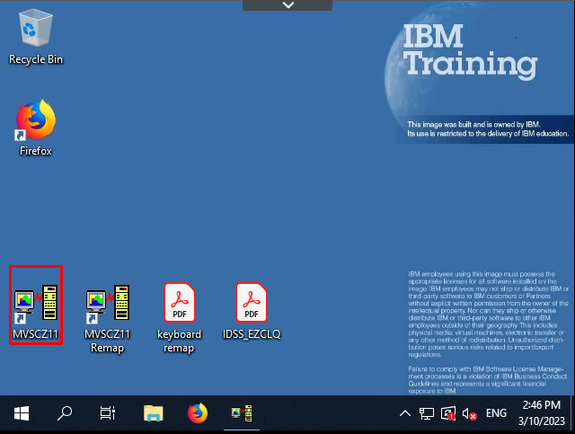

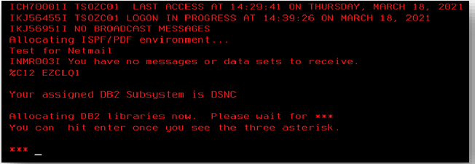

1. Press option 3 and enter (Perform utility functions) or 3.4 to edit members of datasets.

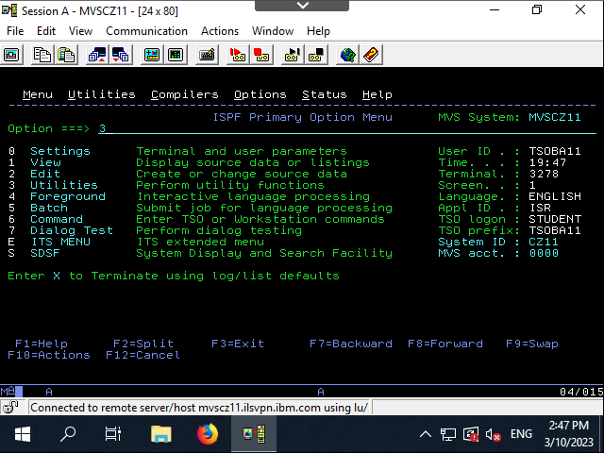

1. Press option 4 and Enter (Print or display (to process) list of data set names).

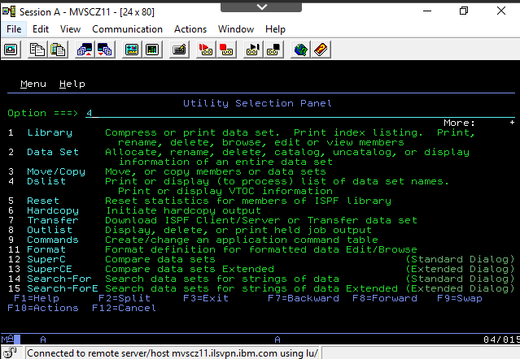

1. Press Enter again. You see a list of datasets.

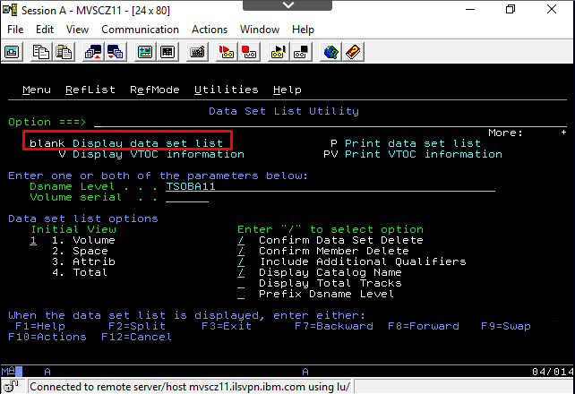

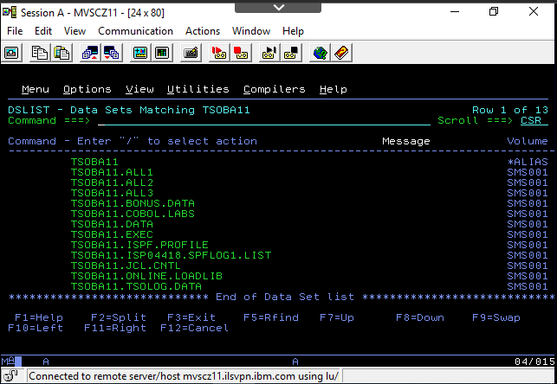

1. To edit dataset, press E in Command column left to the selected dataset. Press Enter.

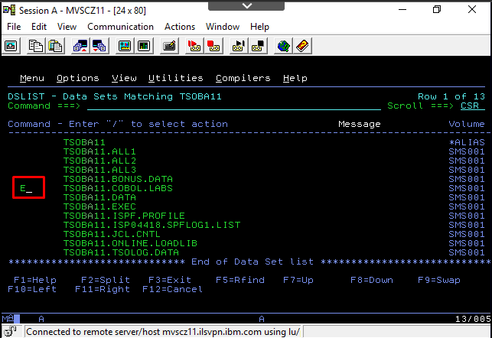

1. In file member list, select the file member to edit and press “E” and Enter.

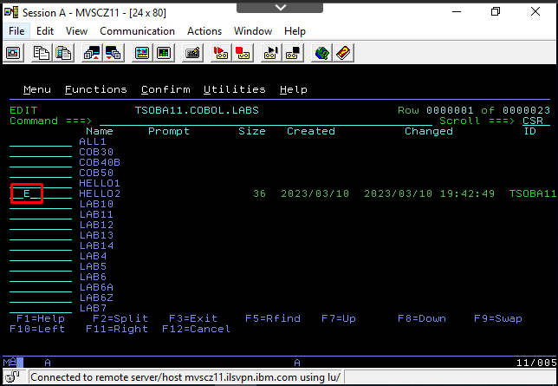

1. Enter in edit mode of member file. To save and exit press F3 key.

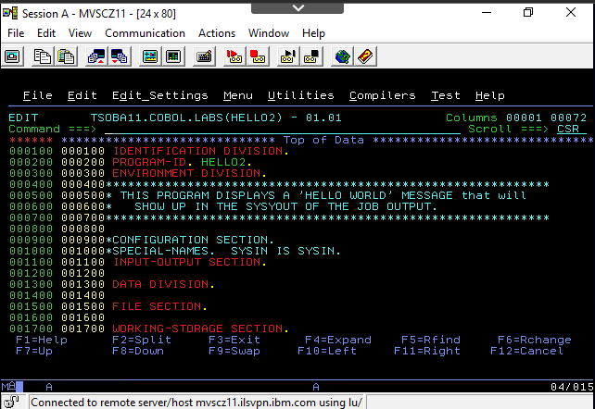

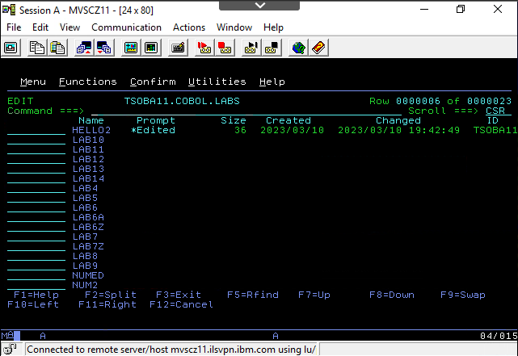

1. Press again “F3” and return to datasets lists.

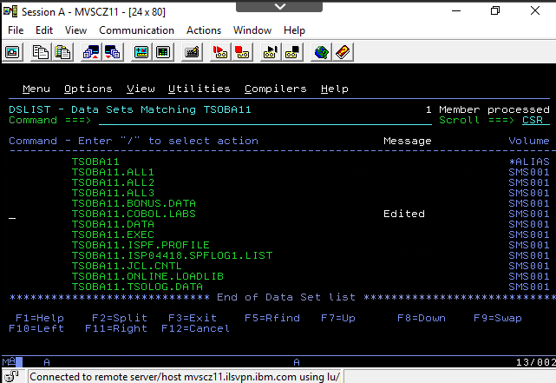

1. Select the JCL dataset and press E to edit.

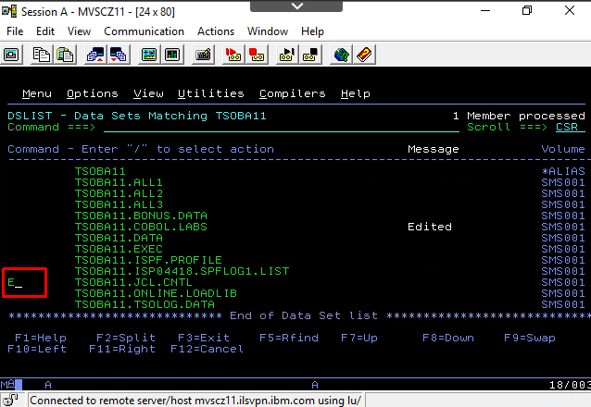

1. Select the member file and press E and Enter.

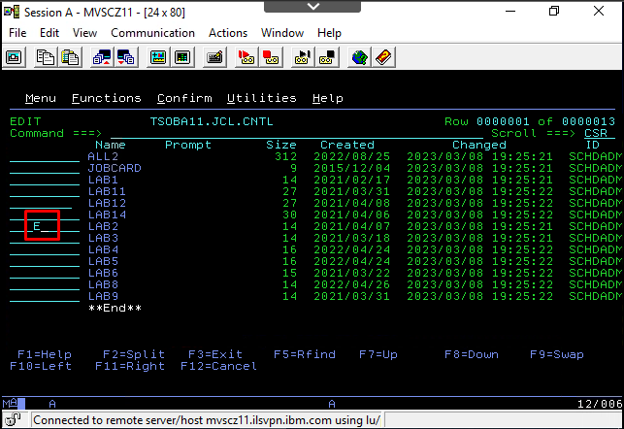

1. Edit the JCL member file. Press “SUB” in command to submit the job. Appears a screen with the message of the job is submitted.

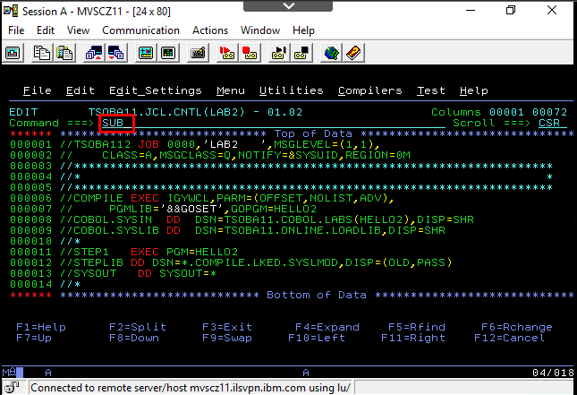

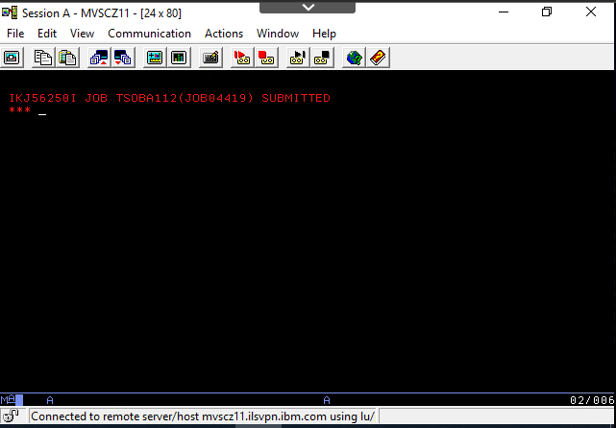

1. Press Enter again. The job returned successful (MAXCC=0000) without errors. Press “Enter” to return to JCL member edit.

