**Steps to run the application using Tomcat server :**

* Launch STS and import **abcInsuranceProject** as Maven Project.
* Right click the project and Run As -> Run on Server.
* While doing this the below Project Facet Cloud Foundry issue might occur. This can be resolved by right clicking on project -> Properties -> Project Facet -> Uncheck Cloud Foundry Standalone Application (refer screenshot)
* 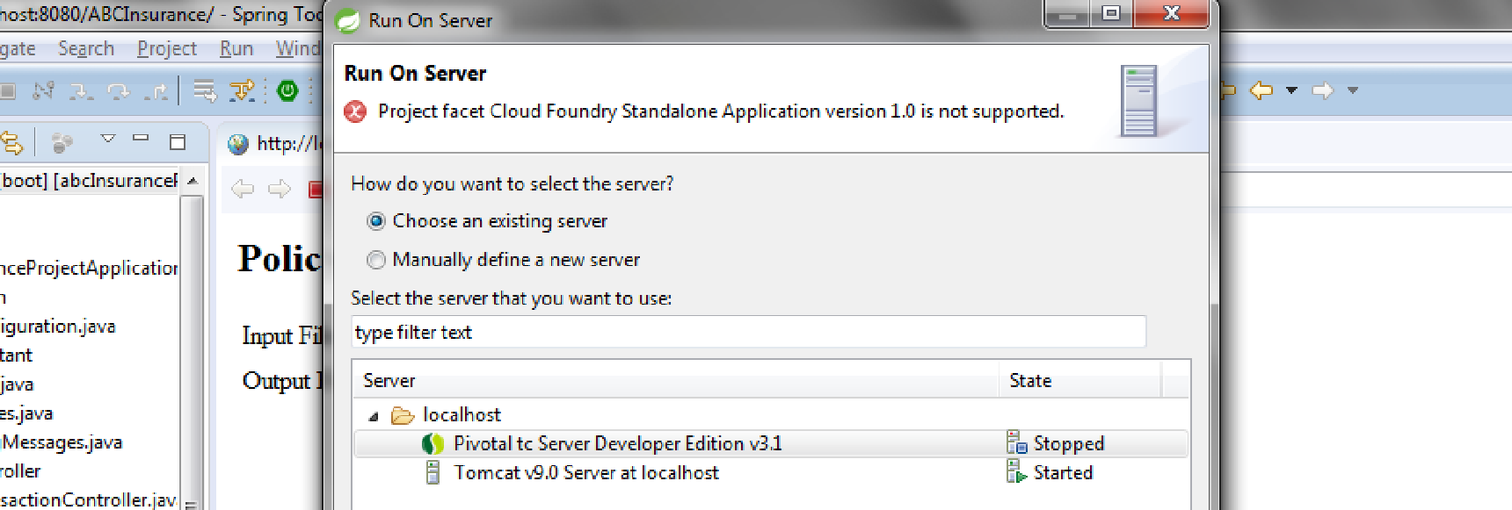
* 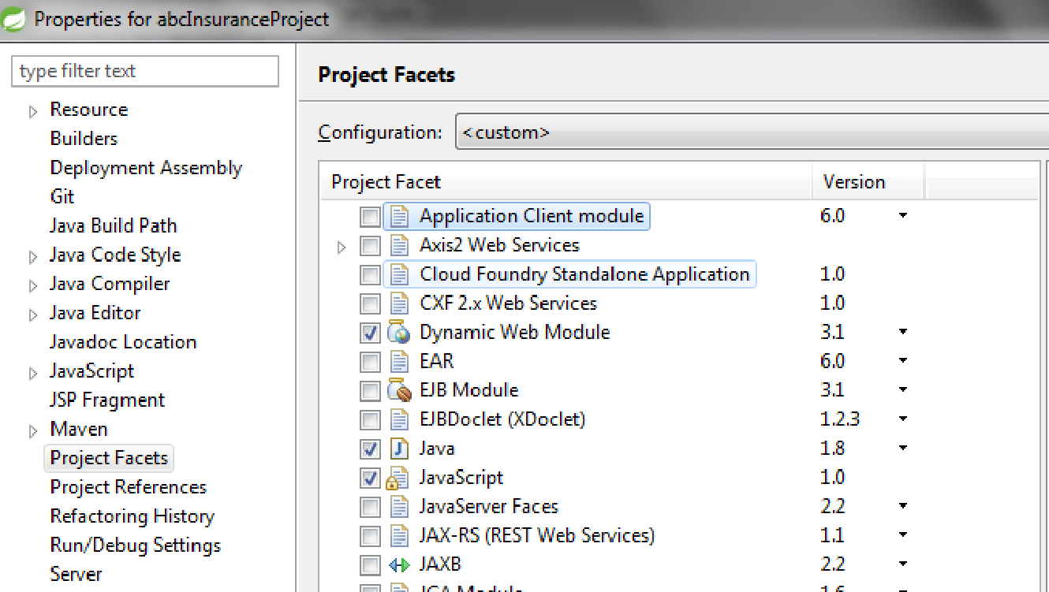
* The server starts successfully and the UI page will be displayed.
* 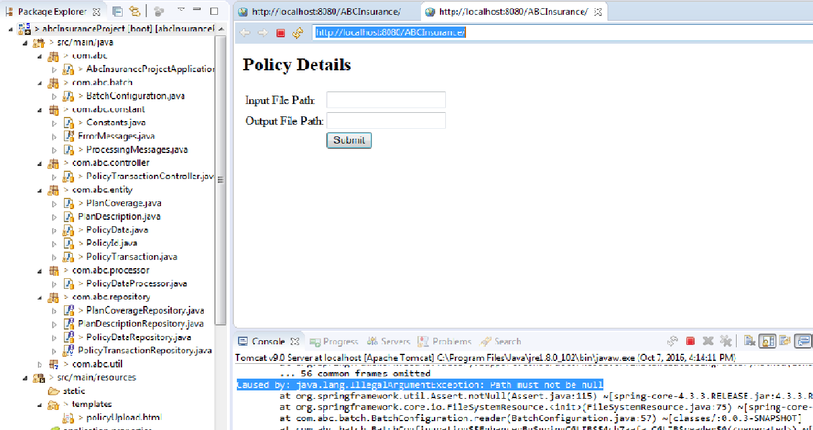
* Go to the browser and type [http://localhost:8080/](http://localhost:8080/ABCInsurance/)
* If this gives Page not found exception, the go to the STS and click on **Project->Properties->Web Project Settings** and change the context root to / as shown below. If no such error then proceed to next step
* 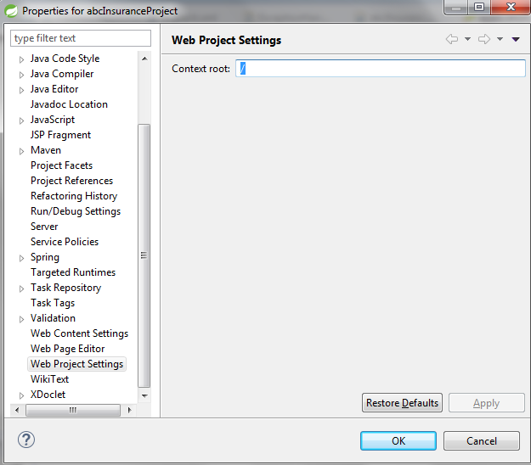
* Enter the input and output file location paths in the text box and click on submit**.** Place the input file in the local system and provide its path. Ex : For testing the input file is placed in C:\Users\Loaner\Documents\Documents folder and input and output path is provided as **C:\Users\Loaner\Documents\Documents\SampleInputTransactionFile.csv and C:\Users\Loaner\Documents\Documents\SampleOutputTransactionFile.csv** respectively.Specify the **absolute path and name of the output file** that needs to be created.
* 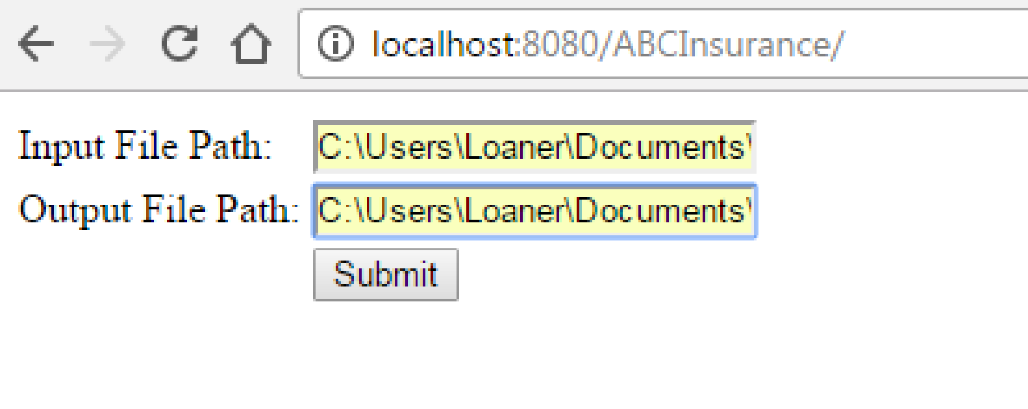
* 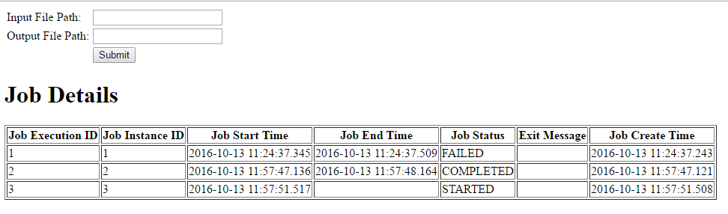
* Go to the output folder path and verify the output file created.

**Steps to run application using command prompt :**

* Open command prompt. Change to the current directory to the project (abcInsuranceProject) directory using **cd** command. Ex : cd C:\Users\Loaner\Documents\CTS_OCT_06\abcInsuranceProject
* Enter command **mvn clean package -Dmaven.test.skip=true**
* 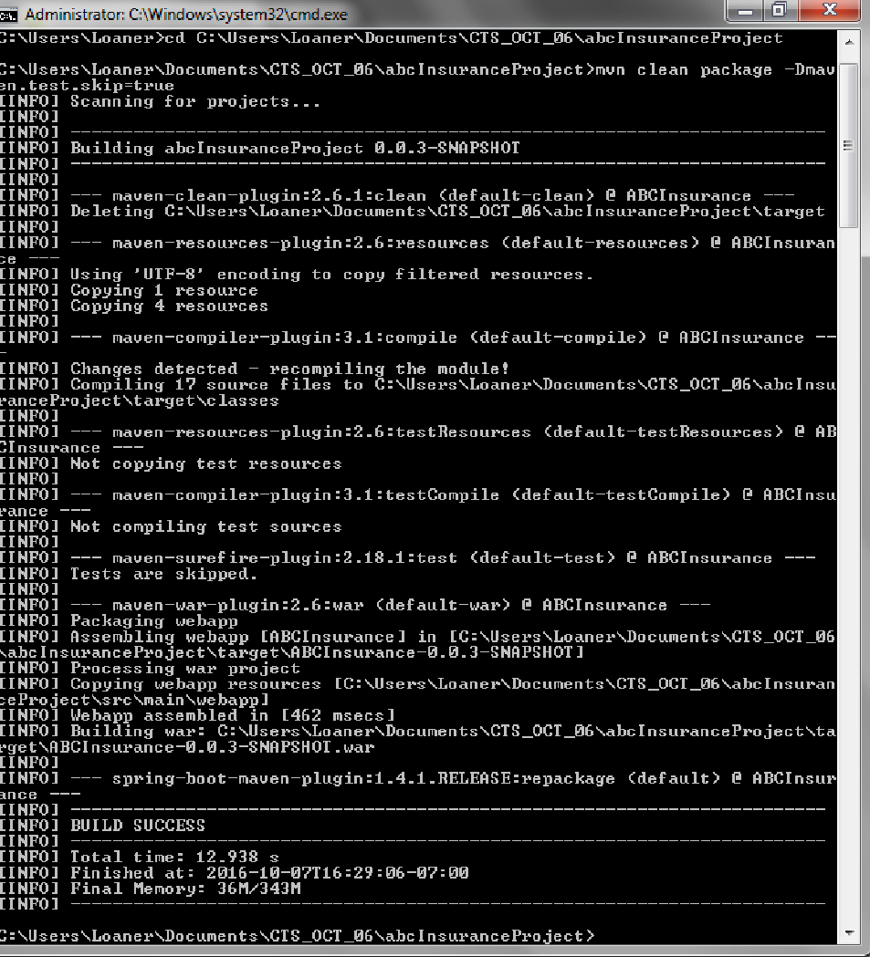
* Enter below command to run the application

**java -jar target/ABCInsurance-0.0.3-SNAPSHOT.war inputFilePath=<input file path and name> outputFilePath=<output file path and name>**

Ex : java -jar target/ABCInsurance-0.0.3-SNAPSHOT.war inputFilePath=C:\Users\Loaner\Documents\Documents\SampleInputTransactionFile.csv outputFilePath=C:\Users\Loaner\Documents\Documents\SampleOutputTransactionFile.csv

* 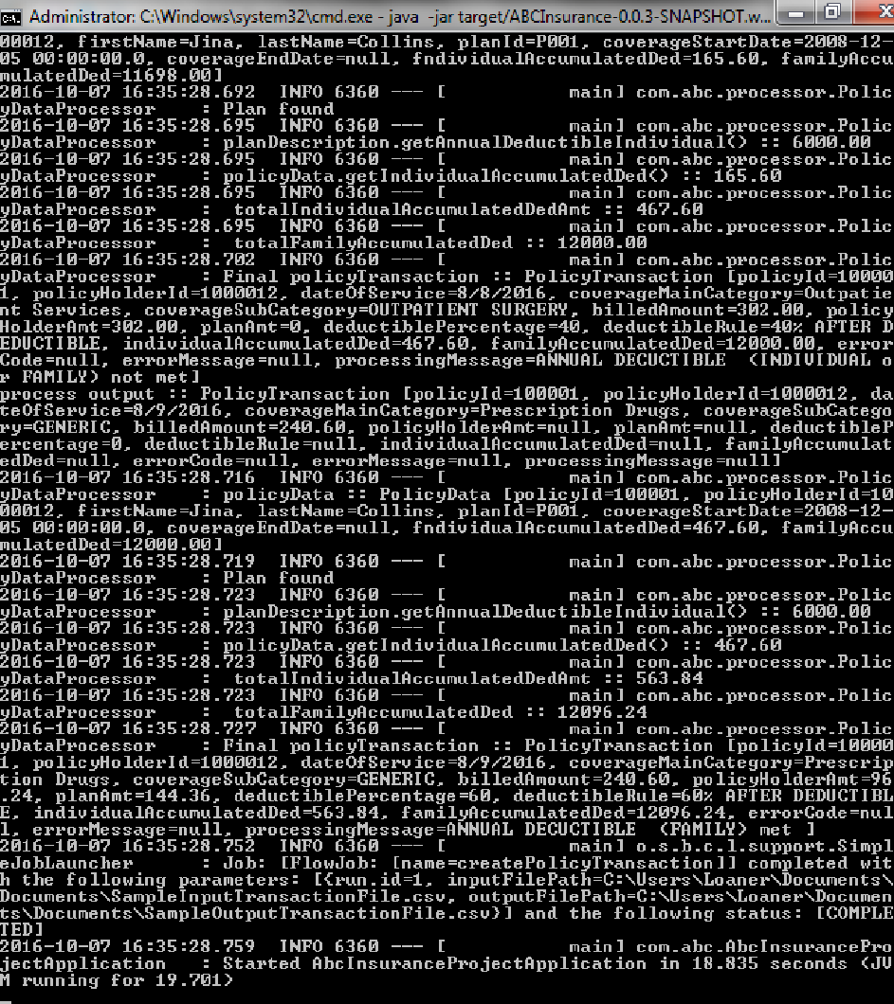
* View the log files at path /abcInsuranceProject/logs/
* Go to the output folder path specified in the command and check the output file created.

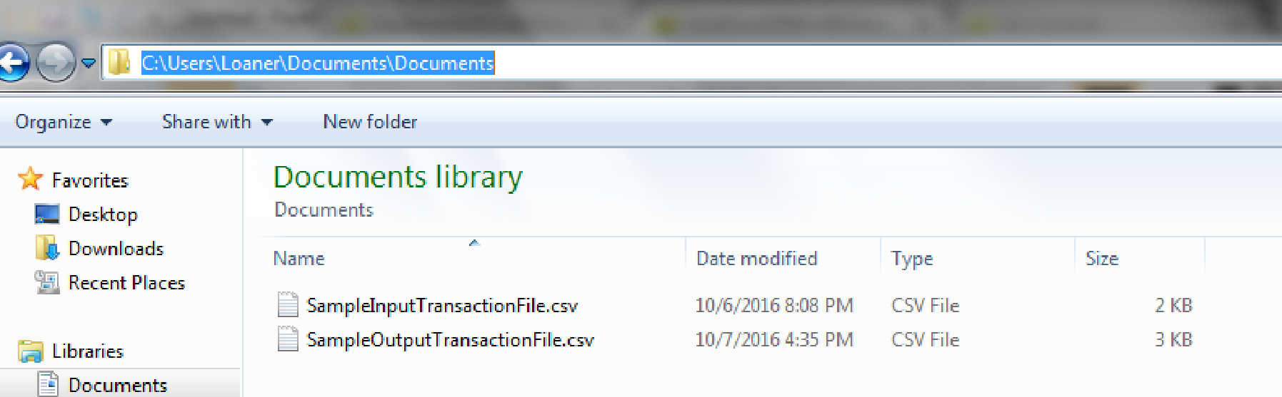

**Curl command steps :**

* Start the application tomcat server.
* Open the command prompt and type the below command
* curl "[http://localhost:8080/processPolicy?policyId=100001&policyHolderId=1000011&dateOfService=5/6/2016&coverageMainCategory=Inpatient%20Hospital%20Care&coverageSubCategory=ROOM%20AND%20BOARD&billedAmount=1000](http://localhost:8080/ABCInsurance/processPolicy?policyId=100001&policyHolderId=1000011&dateOfService=5/6/2016&coverageMainCategory=Inpatient%20Hospital%20Care&coverageSubCategory=ROOM%20AND%20BOARD&billedAmount=1000)"
* The individual and family accumulated amounts will be fetched from the **Policy Data DB** table

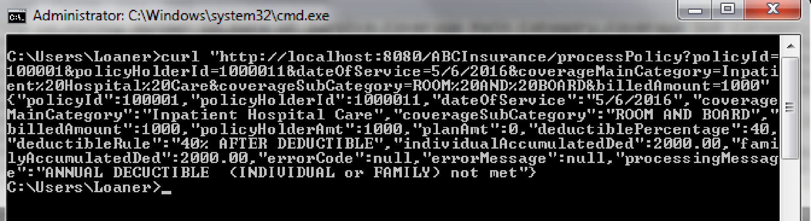

* Also can be done through browser. Open the browser and enter the below URL [http://localhost:8080/processPolicy?policyId=100001&policyHolderId=1000011&dateOfService=5/6/2016&coverageMainCategory=Inpatient%20Hospital%20Care&coverageSubCategory=ROOM%20AND%20BOARD&billedAmount=1000](http://localhost:8080/ABCInsurance/processPolicy?policyId=100001&policyHolderId=1000011&dateOfService=5/6/2016&coverageMainCategory=Inpatient%20Hospital%20Care&coverageSubCategory=ROOM%20AND%20BOARD&billedAmount=1000)
* 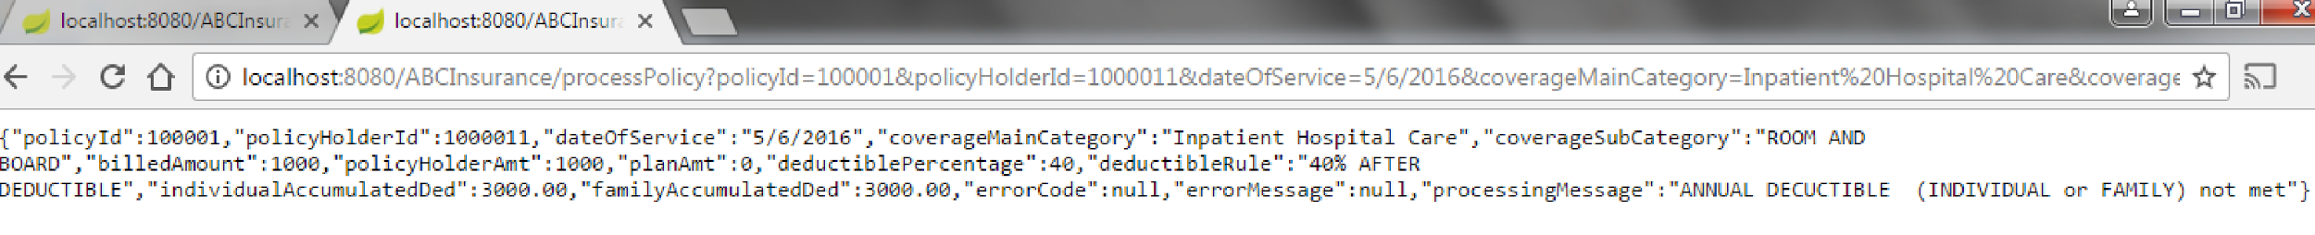
* The pretty JSON of the above URI :

{

"policyId": 100001,

"policyHolderId": 1000011,

"dateOfService": "5/6/2016",

"coverageMainCategory": "Inpatient Hospital Care",

"coverageSubCategory": "ROOM AND BOARD",

"billedAmount": 1000,

"policyHolderAmt": 1000,

"planAmt": 0,

"deductiblePercentage": 40,

"deductibleRule": "40% AFTER DEDUCTIBLE",

"individualAccumulatedDed": 3000,

"familyAccumulatedDed": 3000,

"errorCode": null,

"errorMessage": null,

"processingMessage": "ANNUAL DECUCTIBLE (INDIVIDUAL or FAMILY) not met"

}

**Run using Junit test cases :**

* The input file is placed in /abcInsuranceProject/src/main/resources/SampleInputTransactionFile.csv
* The test case classes can be found under /abcInsuranceProject/src/test/java package. Right click on these files and run as JUnit.
* 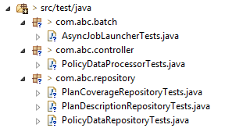
* Verify the output at path "/abcInsuranceProject/src/main/resources/SampleOutputTransactionFile.csv". This file will be overridden for each test case run.

**Database Details :**

* Start the application tomcat server.
* Go to the browser and enter [http://localhost:8080/console/](http://localhost:8080/ABCInsurance/console/)
* Click Connect. No password required.
* 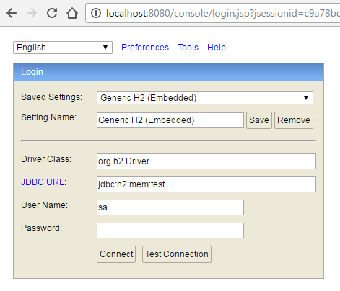
* 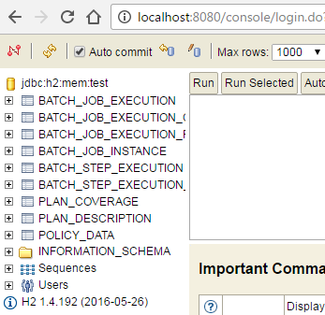

**Logging :**

Logback.xml is used for logging. Check log info in the path /abcInsuranceProject/logs/applicationLog.log

SkipPolicy is implemented on reading the input file. Check the file /abcInsuranceProject/logs/skipRecordsLog.log for the skipped record details