**CSCI 232**: Data Structures and Algorithms

Midterm Study Guide

**Logistics**

* Thursday, March 21st @ 10:50 AM in Barnard Hall 103
* Time length: 75 minutes.
* Open notes. You are allowed to use your laptop, your IDE, any notes, slides, lecture recording/examples, previous assignments, and Java documentation. This exam can be completed without a laptop.
* You are NOT allowed to use the internet to access external resources (Google, Stack Overflow, W3 Schools, etc)
* The midterm exam will consist of different types of question, such as:
  + Multiple choice questions
  + True/False
  + Short answer
  + Describe an algorithm (no code) that does X
  + Compare and Contrast different data structures.
  + Given some code, critique the code, or describe what it prints out

**Content**

The following topics are all fair game for the midterm exam.

* Arrays, Linked Lists, Stacks, Queues
* Trees
* Binary Search Trees
* Red-Black Trees (you wont have to add or remove something from a RB tree)
* Heaps (Both tree and array representation)
* Hash Tables
* Hash Maps/Hash Sets
* Hashing Functions
* Hashing Collisions
* Running time of operations for data structures we’ve discussed.

Sample Test Questions

1. Given the following BST:

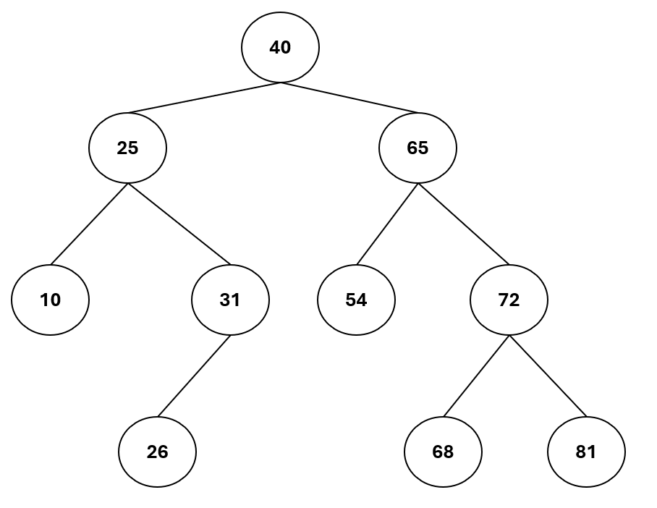

1. What is the Breadth-First printout of this tree?
2. Fill in the blank: 54 is a _______ node.
3. Suppose we want to insert 35 into the tree. Where would it go?
4. Suppose we are implementing our own Hash Table with an array size of 20 with the following Hash Function:

F(x) = X % (table size)

The Hash table already has some contents inside of it, and uses **separate chaining** to handle collisions.

|  |  |
| --- | --- |
| 0 |  |
| 1 | 41 |
| 2 | 122 |
| 3 | 23 |
| 4 |  |
| 5 |  |
| 6 |  |
| 7 |  |
| 8 |  |
| 9 |  |
| 10 | 90 |
| 11 |  |
| 12 |  |
| 13 |  |
| 14 |  |
| 15 |  |
| 16 | 56 |
| 17 |  |
| 18 |  |
| 19 |  |

Where would the following values be inserted at in the hash table?

1. 67
2. 131
3. 61

What are some weaknesses of this hash table schema?

1. True or False: Java HashSets can hold duplicate values
2. Suppose we have a Hash Table where collisions cannot happen. If the user has the key, what is the running time for retrieving the value for that key?
3. O(1)
4. O(n)
5. O(logn)
6. O(n^2)
7. In a tree, a sequence of multiple, connected-nodes is called what?
8. BST
9. Parent
10. Path
11. Edge
12. What is the running time of breadth-first on a tree? (n = # of nodes in the tree)

a. O(1)

b. O(n)

c. O(logn)

d. O(n^2)

1. Is the following Red-Black tree a **valid** red-black tree? If not, what rule is it violating, and how would you fix it?

1. ArrayLists and HashMaps are both dynamic data structures that are just an array. What are two differences between these data structures?
2. A diagram of a tree

   Description automatically generatedConsider the following maximum heap:

1. Suppose 95 is inserted in the tree. Sketch the new heap after 95 has been inserted.
2. What is the running time of adding a value in the heap?