# Understanding MarcEdit’s Settings

|  |
| --- |
| **[Image result for question icon](https://www.google.com/url?sa=i&rct=j&q=&esrc=s&source=images&cd=&cad=rja&uact=8&ved=2ahUKEwit4ILD9p3gAhXD1IMKHZO4CykQjRx6BAgBEAU&url=https%3A%2F%2Fen.wikipedia.org%2Fwiki%2FFile%3AIcon-round-Question_mark.svg&psig=AOvVaw1xH8FoGEBzGZ8eJXhI8XZr&ust=1549226469471150)Overview** |
| **Teaching:**  **Exercises:**  **Questions**   * What role do the settings play in configuring MarcEdit’s interaction with MARC? * How does MarcEdit handle Accessibliltiy options? * How do you increase font size/type in the application/MarcEditor?   **Objectives**   * Explain how MarcEdit’s Settings impact how the tool interacts with MARC data * Describe Accessiblity options and where to set them * Describe MarcEditor Options and settings |

## MarcEdit Preferences

Within the application, MarcEdit’s preferences control a wide range of interactions. They control the user experience (fonts, sizes, colors), they determine MARC characteristics (defining title, author, subject fields), and they set options related to data normalization guidelines. If MarcEdit’s core application is data agnostic, the preferences are how users place guard-rails around the application and fill in specific gaps that allow MarcEdit to work better with a user’s particular flavor of MARC.

To simplify the preferences process, MarcEdit employs a set of wizards when a user first installs the application that configures the application to match answers to questions based on how the user will utilize the application. The wizards simplify the installation process in an attempt to get the preferences out of the way of the user.

|  |
| --- |
| **Digging Deeper: MarcEdit 7/3’s installation Wizard** |
|  |

## Preferences: In-depth

*MarcEditor Preferences*

MarcEdit Preferences configure both the UI options and functional options of the MarcEdit MarcEditor.

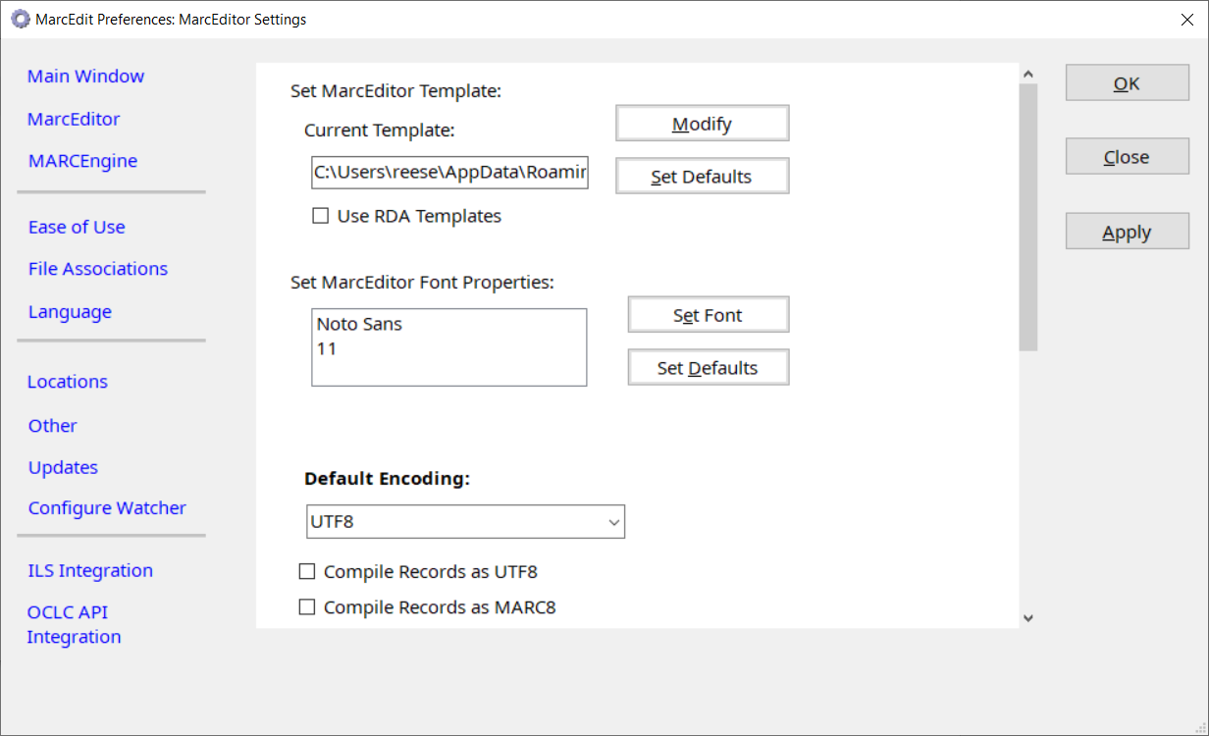

Within the MarcEditor preferences, users can set Font properties, new record templates, default record encoding, shortcuts to enable record compilation to allow compile to UTF8 or MARC8, as well as options related to Logging and Autosave.

**Exercise 1: MarcEditor Appearance**

1. Open 851_sample_records_with_880_data.mrc data file in the MarcEditor
2. Observe the font and font size
3. Close the MarcEditor and select the Preferences from the Main Window
4. Change the Font type and size in the MarcEditor and click OK
5. Reopen the MarcEditor and re-open the 851_sample_records_with_880_data.mrc file.

**Exercise 2: MarcEditor Encoding**

1. Open MARC21_big5.mrc into the MarcEditor
2. In the top right corner, change encoding from UTF8 to Big5

*Accessibility Preferences*

There are two locations where MarcEdit Accessibility options are set: in the Ease of Use Area and the Language Area.

Ease of Use

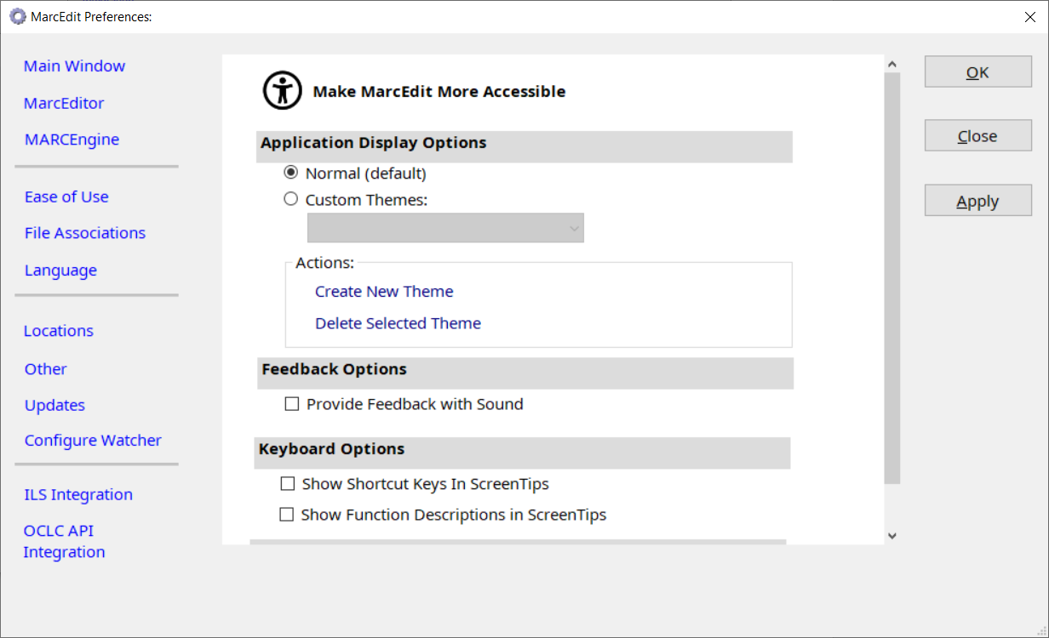

Ease of Use enables users to configure their overall user interface, configuring MarcEdit to work with a number of pre-defined themes, or to create their own.

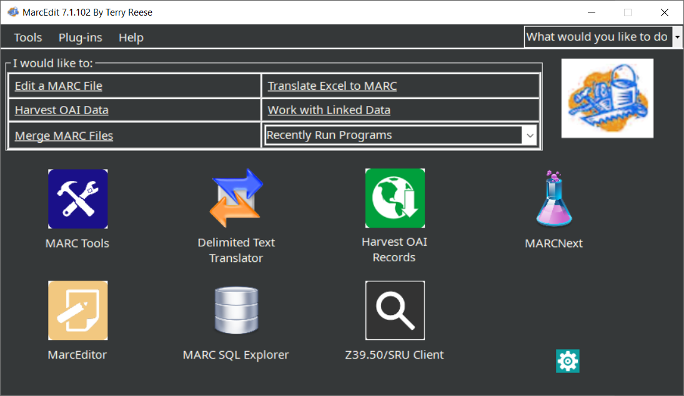  
Figure 1: MarcEdit in High Contrast (Dark) Mode

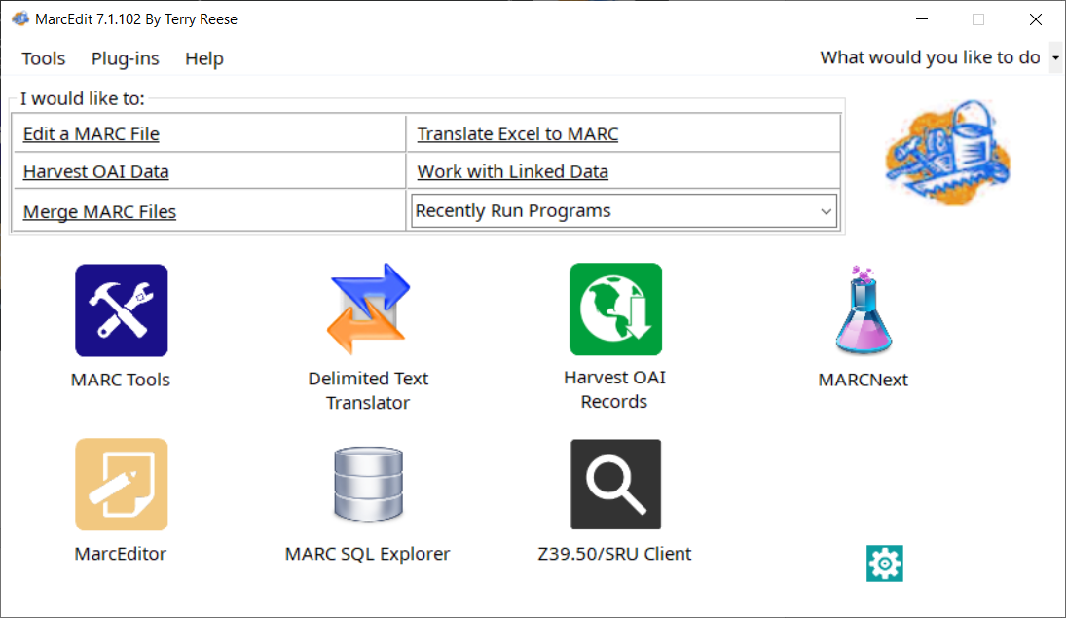  
Figure 2: MarcEdit running in (light) mode

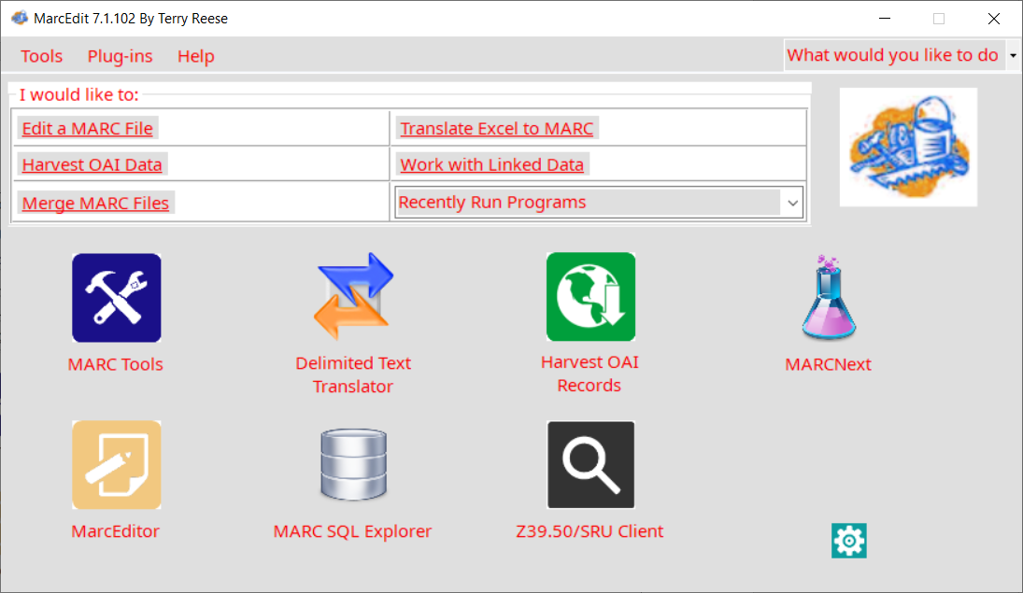

Figure 3: MarcEdit running in (custom) mode

In addition to appearance, users can select options related to tooltips and descriptions (essentially alt tags) for all image based content, sound indicators (to denote clicks) and window transparency.

Languages

Font and language properties are set in the Language’s tab.

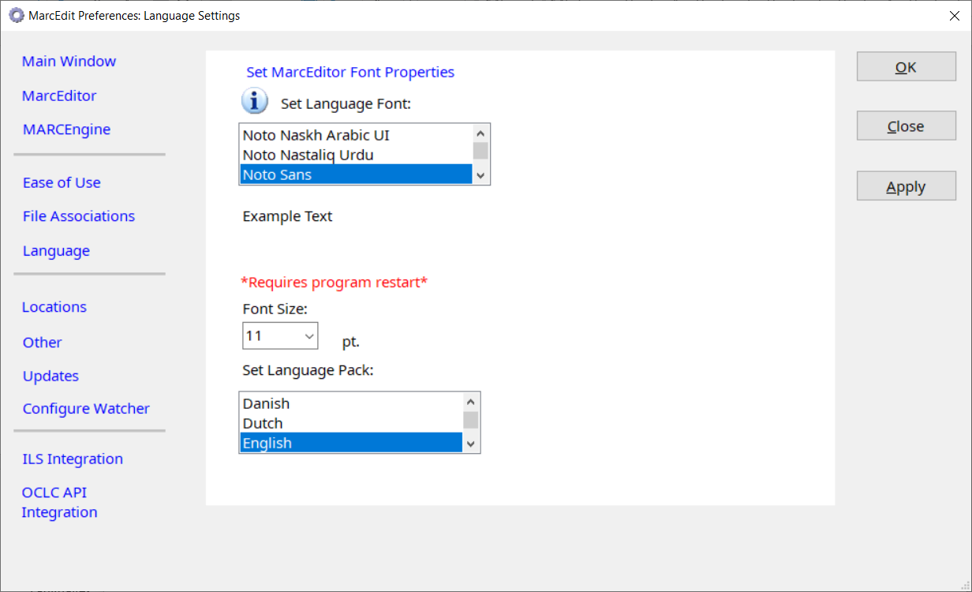

MarcEdit has been translated using an AI process into ~30 different languages. From here, users can select their preferred language and reset the font and windows sizes of the application.

*MARCEngine Properties*

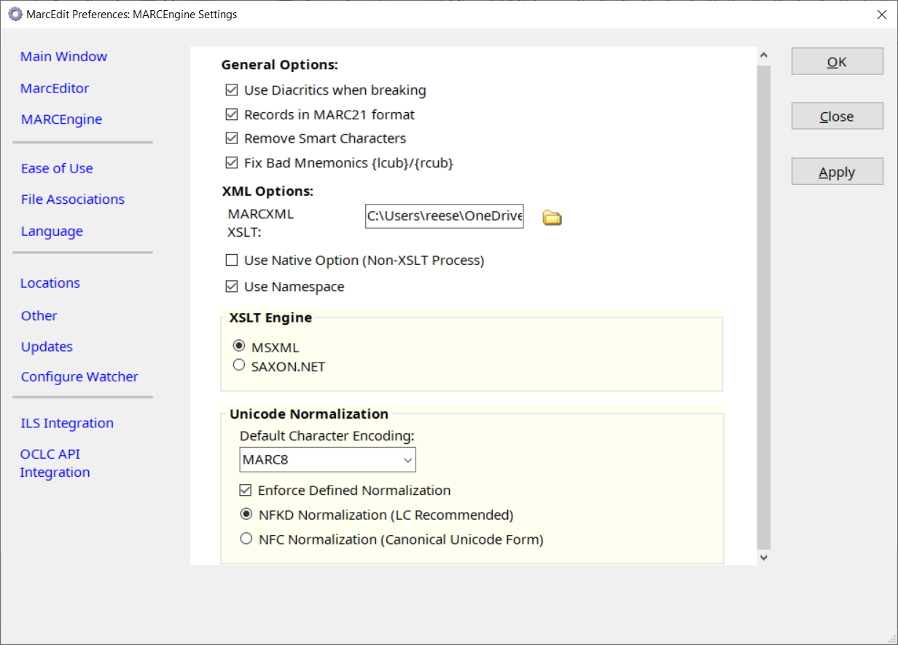

The MARCEngine properties define how MarcEdit’s MARCEngine will interact with a particular MARC data file. This includes setting options for XML process (XML Engine) and Unicode Normalizations. For more information related to character encodings and normalizations, please see: Character encodings: What are they and how does MarcEdit support them [link].

*Other Preferences*

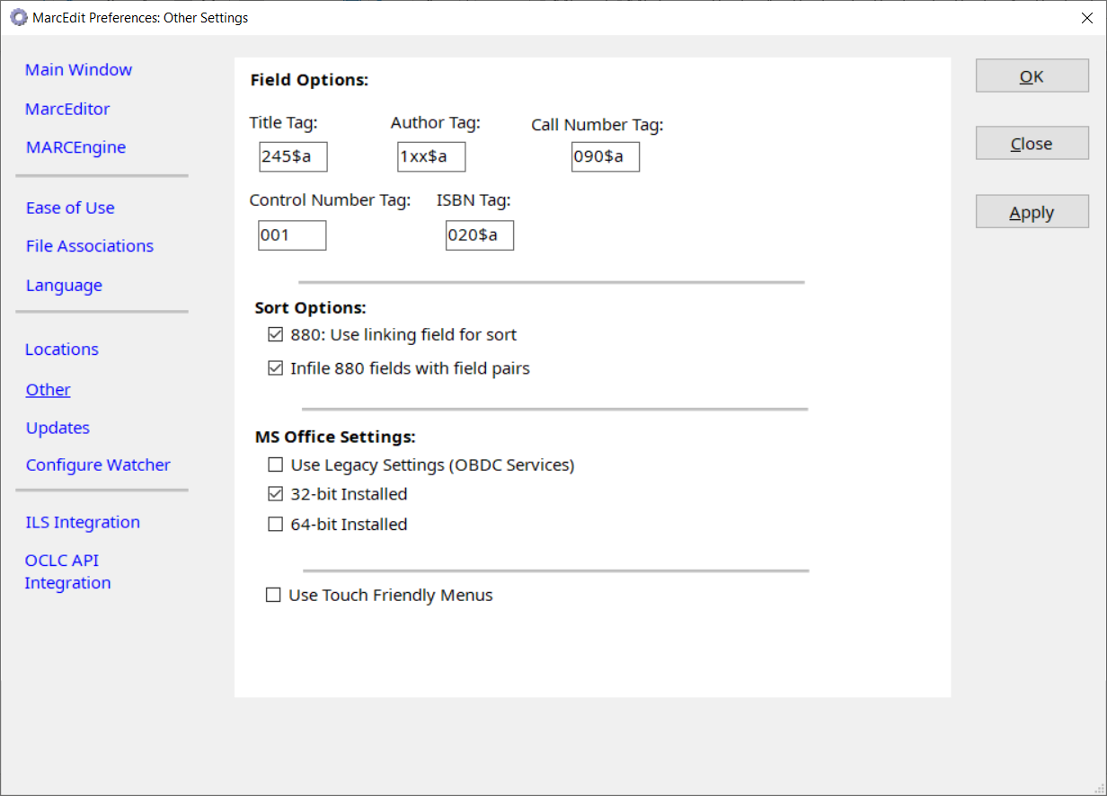

The Other Preference tab is used to provide links and settings to resources related to the interpretation of MARC data. Because MarcEdit is MARC agnostic, it doesn’t know what a title, author, call number, etc. is or where the data is located. Likewise, the tool isn’t aware of how vernacular data is stored (are their 880 fields?).

By default, the program configures values in this tab for MARC21 as this information is utilized anytime the program displays a title, author, enables sorting, etc.

|  |
| --- |
| [Image result for key icon](https://www.google.com/url?sa=i&rct=j&q=&esrc=s&source=images&cd=&cad=rja&uact=8&ved=2ahUKEwjfkJiMo6DgAhWGxYMKHVBgAe8QjRx6BAgBEAU&url=https%3A%2F%2Fwww.iconfinder.com%2Ficons%2F368107%2Faccess_key_lock_locked_old_key_security_vintage_key_icon&psig=AOvVaw0SWPdptez3s59pt6RA1gCe&ust=1549307685507838)Key Points |
| * MarcEdit is MARC agnostic meanig that it will work on any MARC data * MarcEdit’s preferences determine how MarcEdit will interpreate MARC data * Accessiblity and Language options are a key component of the application, and are available in the Preferences. * MarcEdit’s MarcEditor’s Font and Size options are separate from the Main Accessiblity options and must be configured in this tab. |