# MarcEdit Lesson Plans: Setup

|  |
| --- |
| **[Image result for question icon](https://www.google.com/url?sa=i&rct=j&q=&esrc=s&source=images&cd=&cad=rja&uact=8&ved=2ahUKEwit4ILD9p3gAhXD1IMKHZO4CykQjRx6BAgBEAU&url=https%3A%2F%2Fen.wikipedia.org%2Fwiki%2FFile%3AIcon-round-Question_mark.svg&psig=AOvVaw1xH8FoGEBzGZ8eJXhI8XZr&ust=1549226469471150)Overview** |
| **Teaching:** NA  **Exercises:** NA |

## Getting Ready

To complete the sections in this lesson plan, you will need to download MarcEdit and download the available data files.

## Downloading MarcEdit

The MarcEdit software should only be downloaded from the MarcEdit website: <https://marcedit.reeset.net>. These installers have been digitally signed by the author, Terry Reese.

MarcEdit is officially supported on Windows and MacOS, though MarcEdit can be run on Linux using Mono (<https://www.mono-project.com/>).

These lessons have been testing using MarcEdit 7.1.101+

## Installing and Running MarcEdit

The most current version of MarcEdit can be downloaded from: <https://marcedit.reeset.net/downloads>. The program is available in multiple version and multiple bit types.

**Windows:**

Windows users can download MarcEdit in 32-bit or 64-bit versions. Users should select the bit type that corresponds to their operating system. Since 2016, this will generally be 64-bit if a user is running Windows 10. However, if you are unsure you can determine your operating system bit type one of two ways.

*Pre-Windows 10*

Select the My PC icon and right click and select properties. You will get a dialog like the one below providing a variety of information about one’s system, including the Operating System bit type.

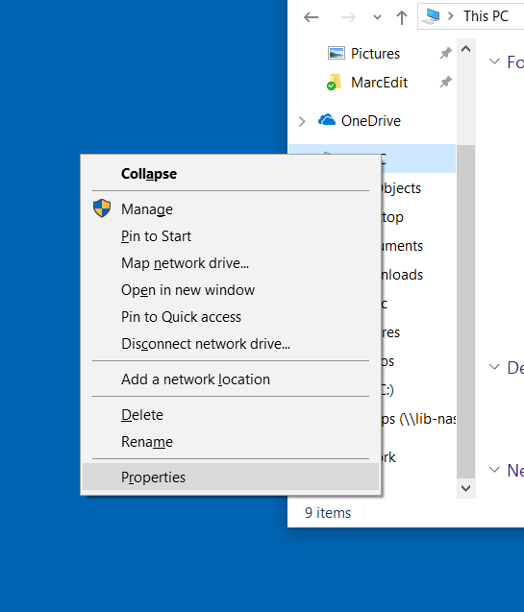

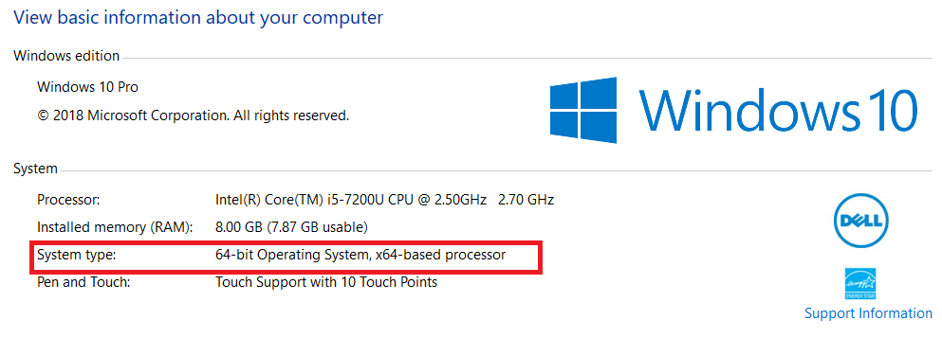

*Windows 10*

In Windows 10, users can type into the search box: About Your PC. This will show the following dialog

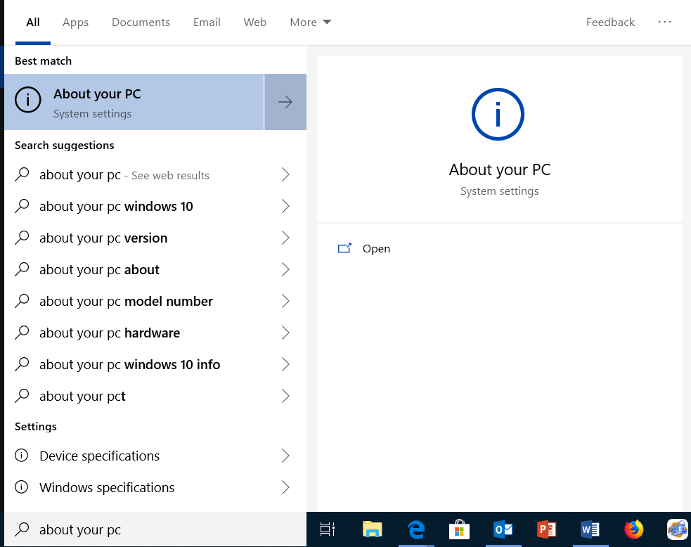

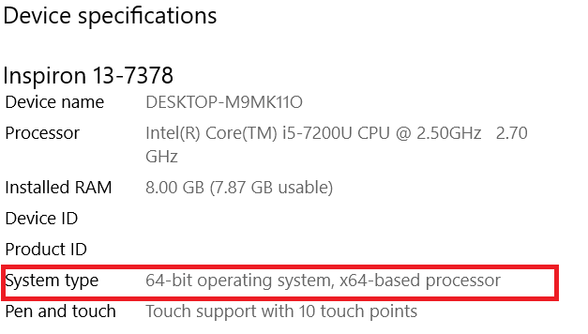

When you have determined the bit type to download, select this from the downloads page. You will then be given two download options:

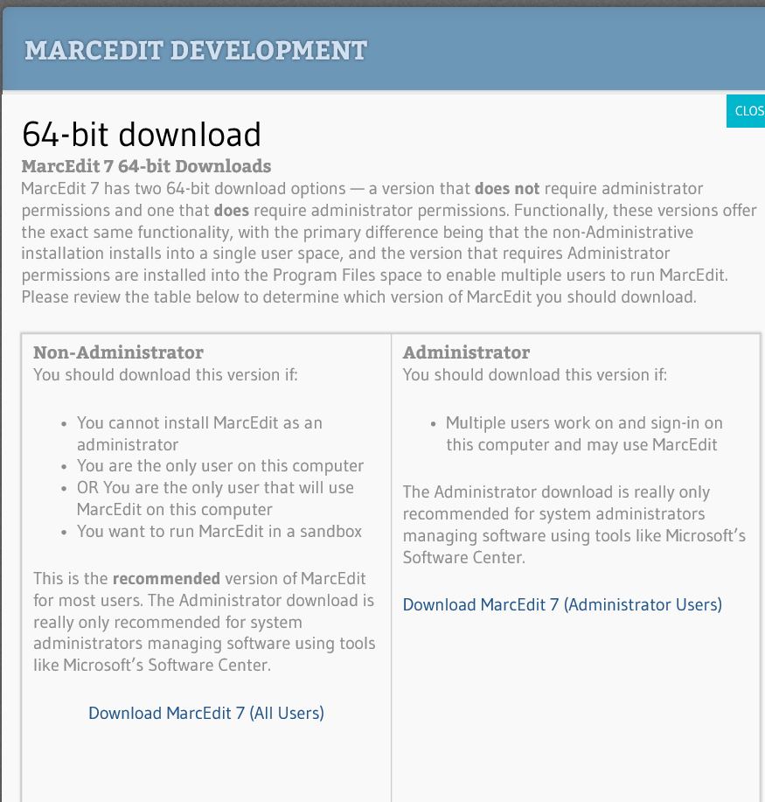

Users can choose between two versions of the installer – an installer for users without administrative permissions, and one for users with administrator permissions. The program functionality is identical for both, with the single exception being that the non-administrative user download only installs the program onto the current user profile. The administrative download installs the program so that all users on the PC can access the program.

|  |  |
| --- | --- |
| Digging Deeper | Click image to view video |
|  | |

**MacOS**

MarcEdit 3.x has been developed to run natively on MacOS 10.10+. Simply download the MacOS version and unzip the file. The installer is provided in the form of a dmg. Simply open the installer and drag the MarcEdit icon into the application shortcut.

**Linux**

A zip file and an executable .bin file has been provided for Linux users. To run the program on Linux, users will need to install the most current version of Mono. Please be aware, some functionality isn’t available on the Linux version.

## Getting Help

The MarcEdit application has a large and vibrant user community. The application has been available for nearly 20 years, and during that time, a wide range of resources have been developed and made available for users needing help.

If you encounter problems working with MarcEdit, you may be able to get help from one of the following resources:

* *MarcEdit Listserv*

URL: <http://listserv.gmu.edu/cgi-bin/wa?A0=marcedit-l>

The MarcEdit Listserv is hosted by George Mason University and provides users an opportunity to send questions to the MarcEdit user community. What’s more, the list includes a searchable archive.

* *MarcEdit Knowledge Base*

URL: <https://marcedit.reeset.net/archives/category/knowledge_base>

Provides topical answers and contributed content on how to work with MarcEdit.

* *MarcEdit 101 Webinar*

URL: <https://marcedit.reeset.net/marcedit-101-workshop>

Collection of videos created in 2015 for a CARLI webinar series.

* *Videos*

URL: <https://www.youtube.com/playlist?list=PLrHRsJ91nVFScJLS91SWR5awtFfpewMWg>

A wide range of YouTube videos have been provided covering a range of topics related to the program.

* *Contact the Author*

URL: reeset@gmail.com

I’m always open to people contacting me and asking questions.

## Downloading the Data

In order to provide real-world examples, a set of sample data has been created from a wide range of different data sources. These records include data from MarcEdit users, national libraries, vendors, and derived data sets from XML translations. These resources will be utilized throughout these lessons to demonstrate real-world tasks and applications as one works through the MarcEdit application.

Data can be downloaded at: <https://github.com/reeset/data_packs>