Submitted by: Reesha L22_6666

Supply Chain Management DApp using Blockchain
This project implements a decentralized supply chain management system using blockchain technology. The system ensures transparency, traceability, and security by recording all transactions on the Polygon Amoy test network.

Introduction
The objective of this project is to design and implement a blockchain-based supply chain system that tracks products from manufacturer to consumer. The system uses smart contracts to enforce rules and ensure data integrity.

Technologies Used
Solidity – Smart contract development
Hardhat – Development and deployment
Ethers.js – Interaction with blockchain
MetaMask – Wallet and transaction signing
Polygon Amoy Testnet – Deployment network
HTML/JavaScript – Frontend interface

Compilation
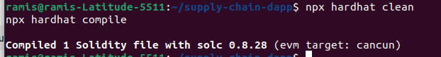
The smart contract was compiled using Hardhat.

Deployment
The contract was deployed on the Polygon Amoy Testnet using Hardhat.
Contract Address: 0x7F02c311F8360C2A7A6E55135ab9C0Fa51cb0566
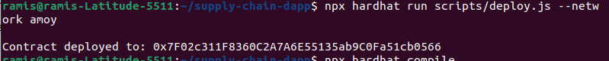
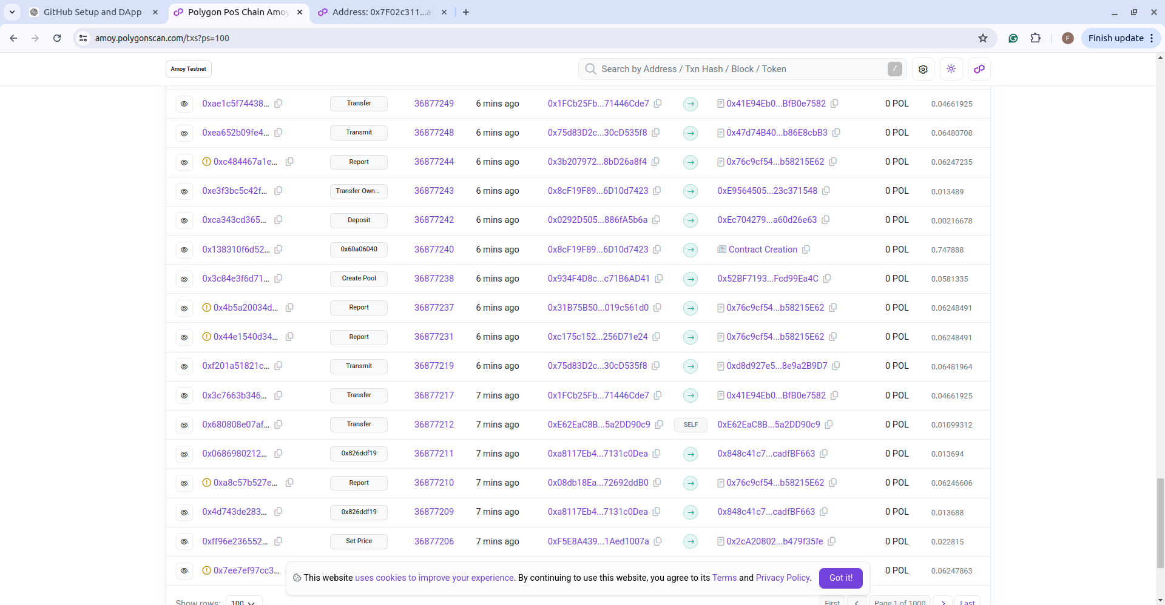

Wallet Setup
MetaMask was configured with multiple accounts to simulate different roles in the supply chain.

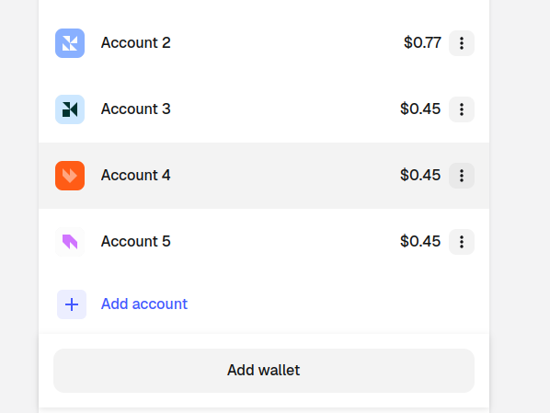
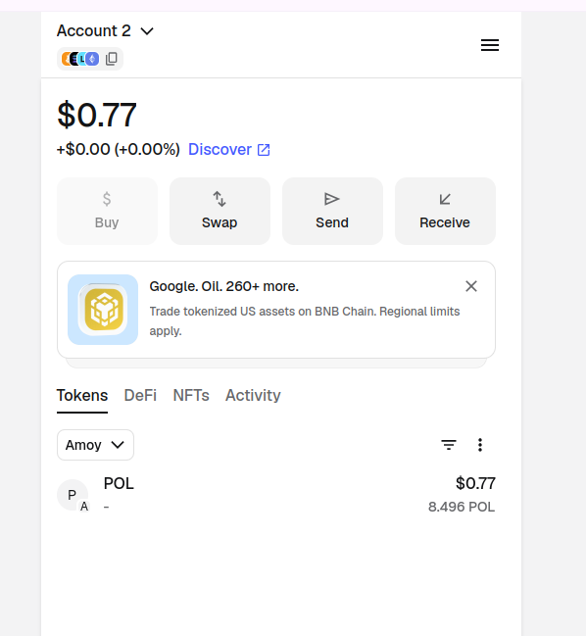

Role Assignment
Roles were assigned using the smart contract. The roles are:
Manufacturer, Distributor, Retailer, Customer
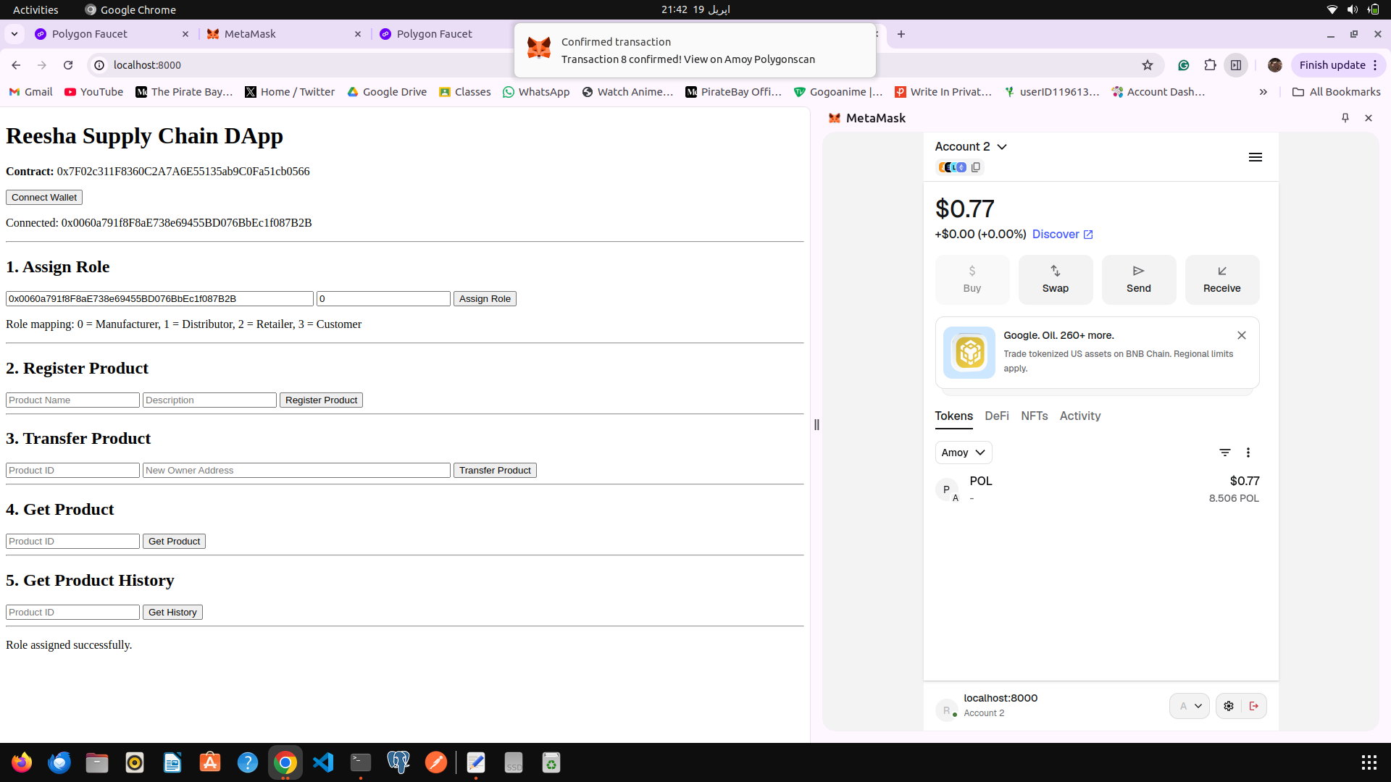

Product Registration
A product was registered by the Manufacturer using the frontend interface.
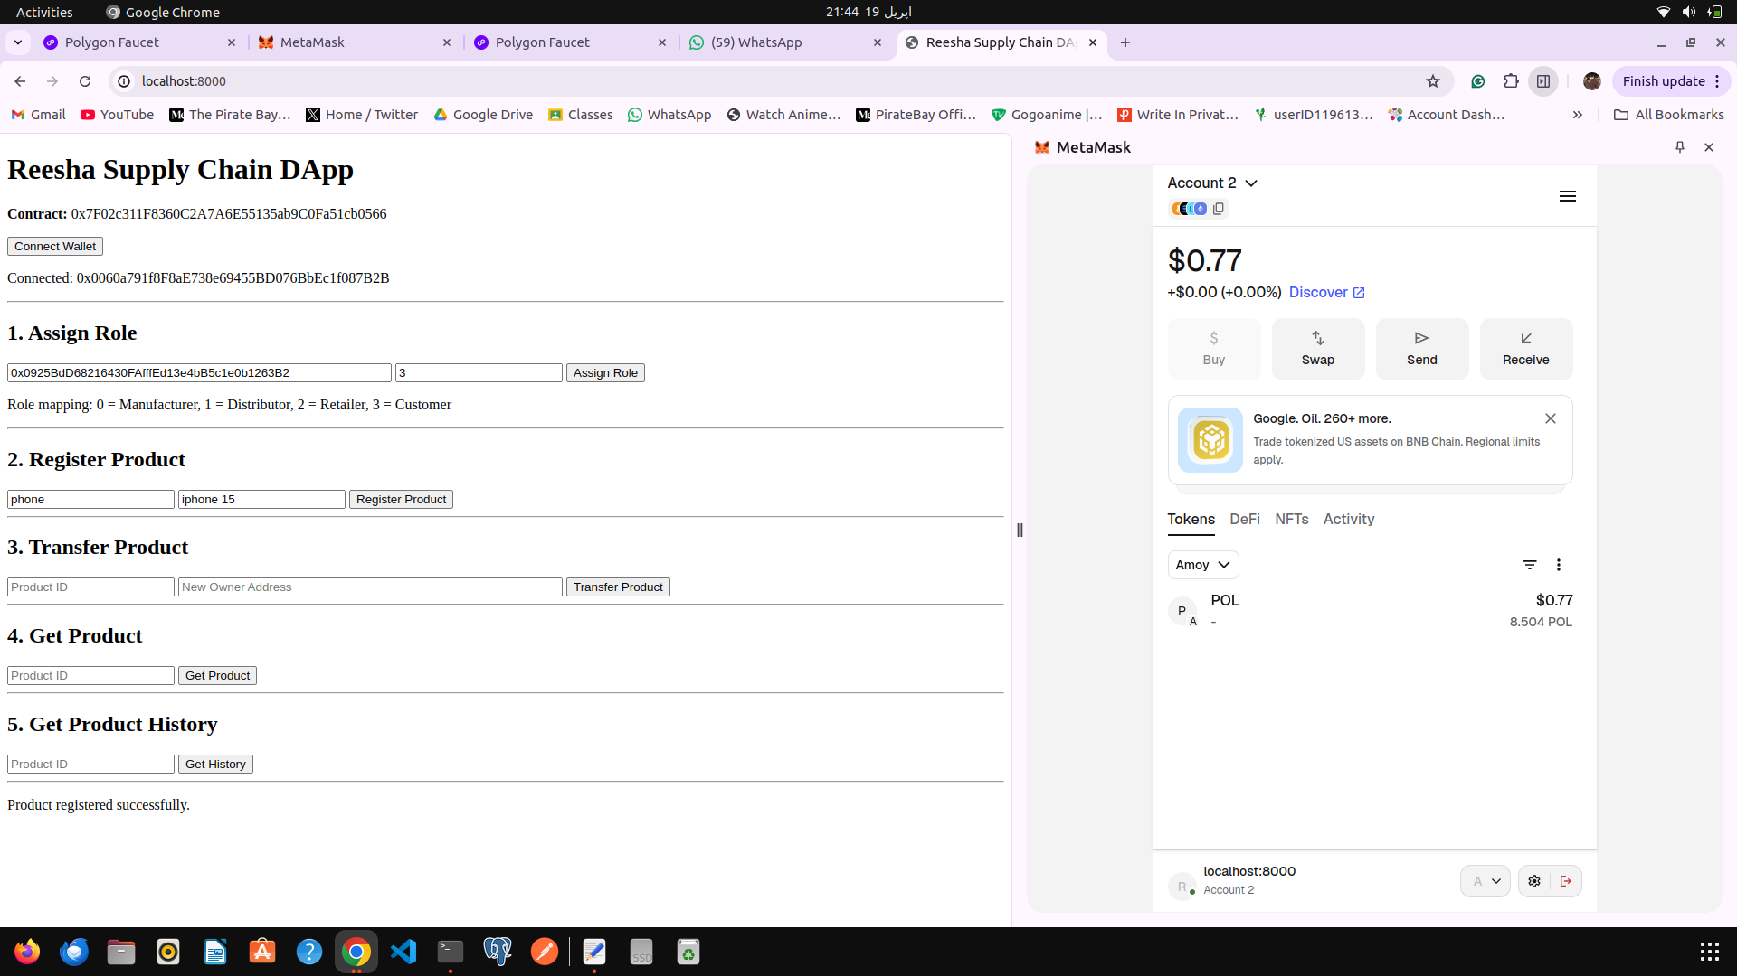

Product Transfer
The product was transferred across the supply chain:
Manufacturer → Distributor
Distributor → Retailer
Retailer → Customer
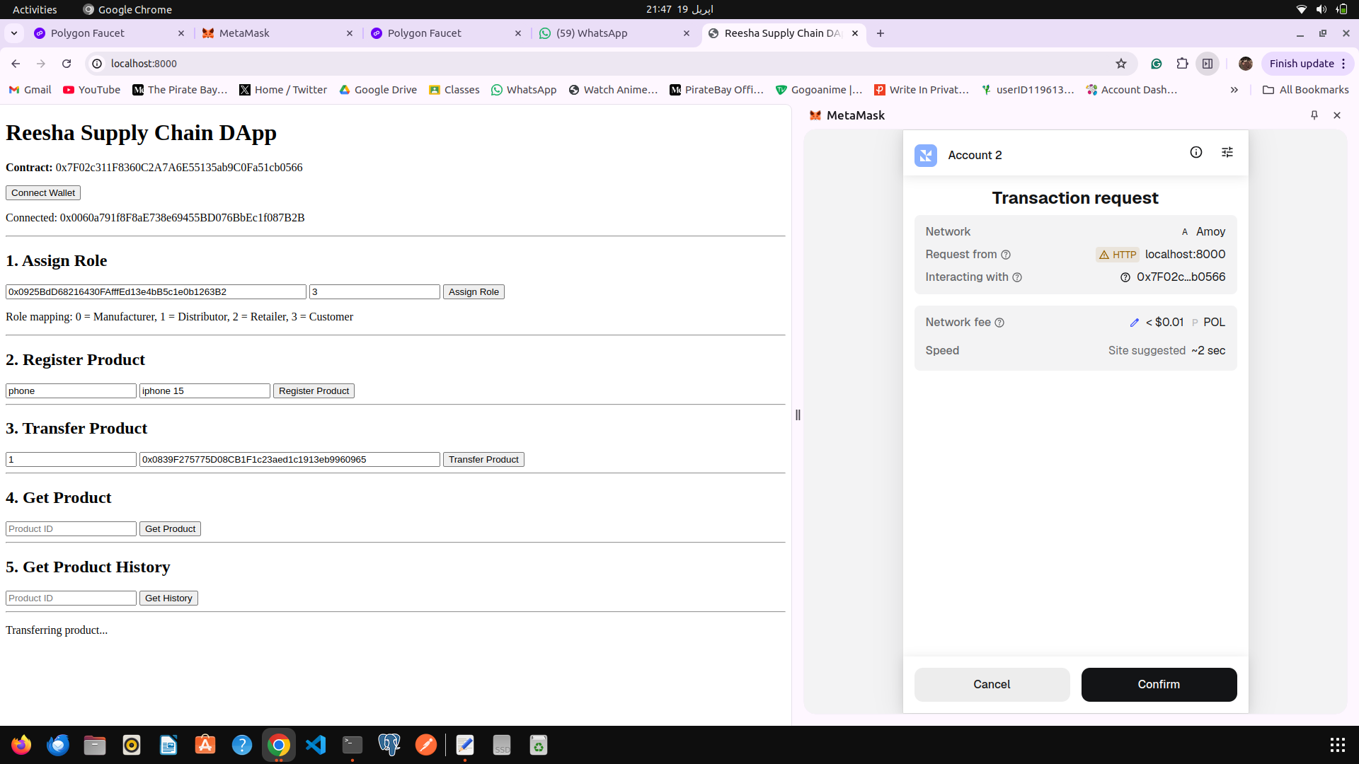

Product Details
The final product details were fetched using the frontend.
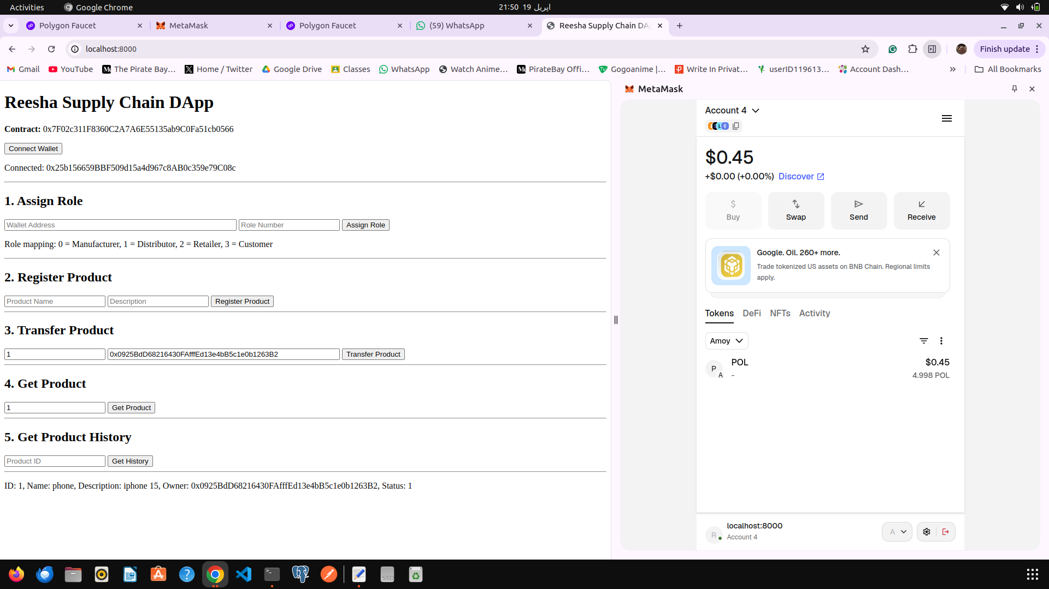

Product History
The full audit trail of the product was retrieved from the blockchain.
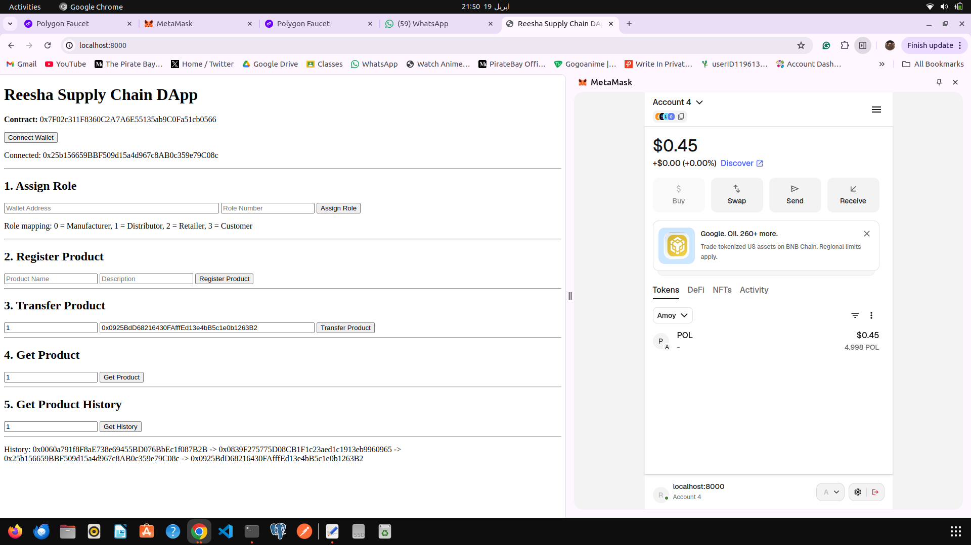

Conclusion
The project successfully demonstrates a decentralized supply chain system using blockchain. It ensures transparency, immutability, and secure tracking of products across multiple stakeholders.

