BCIS 5610
ra1163
Reeshmaa Anitha Venkatachalam
Assignment 3
Backend:
Step 1:
Created Dimension Tables
DimCustomer
DimListing
DimExperience
DimDate
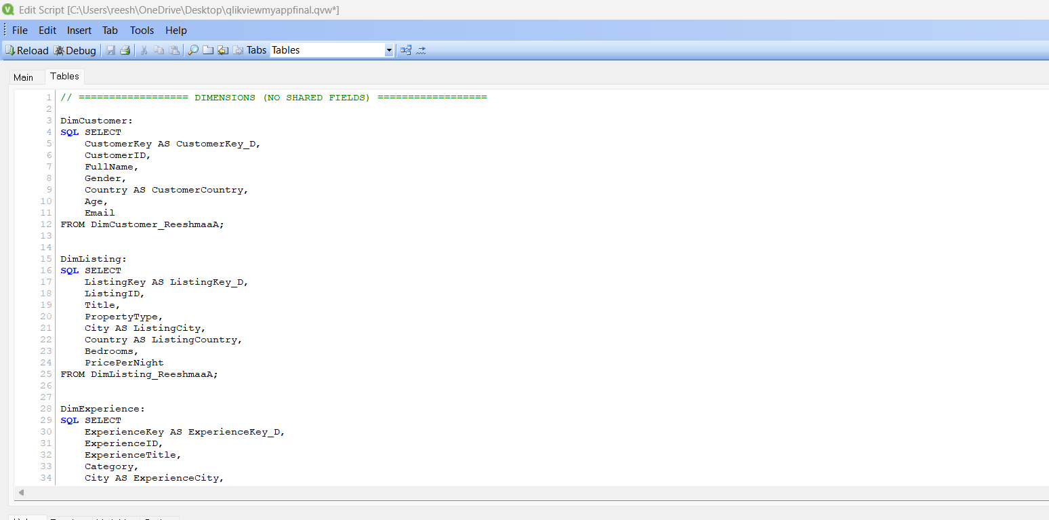
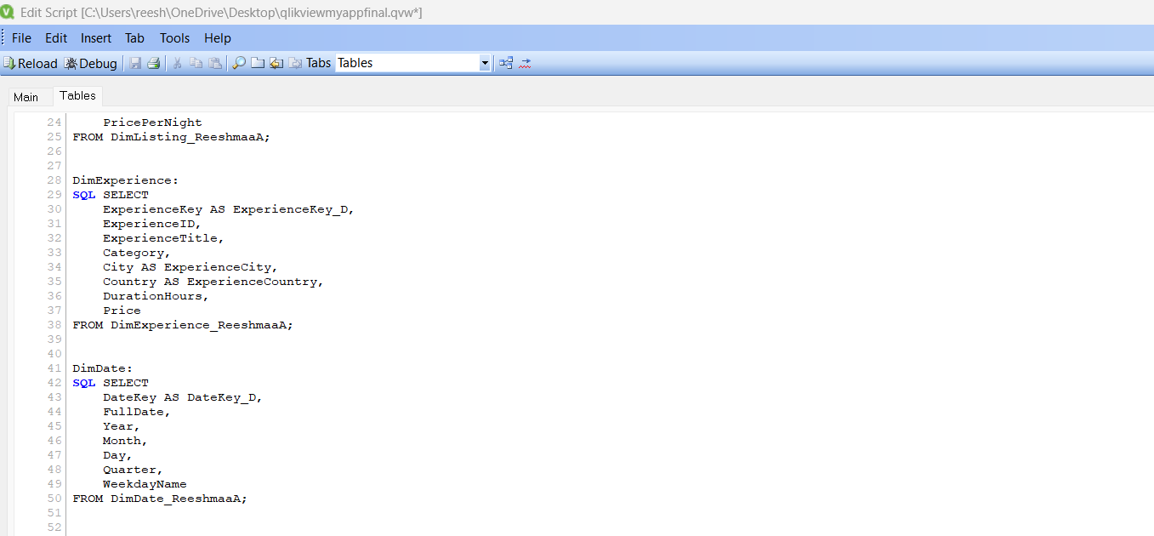
Step 2:
Created Raw Fact Tables:
FactTransaction_raw
FactListingReview_raw
FactExperienceReview_raw
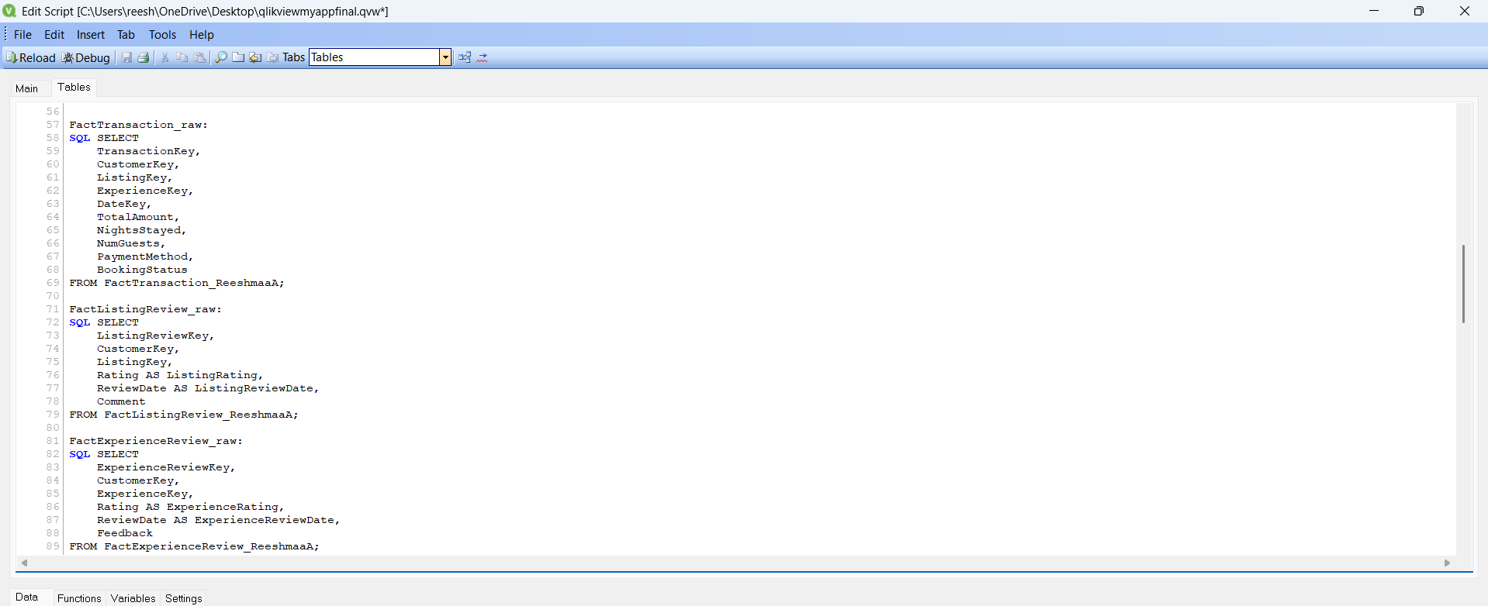
Step 3:
Created Link Table:
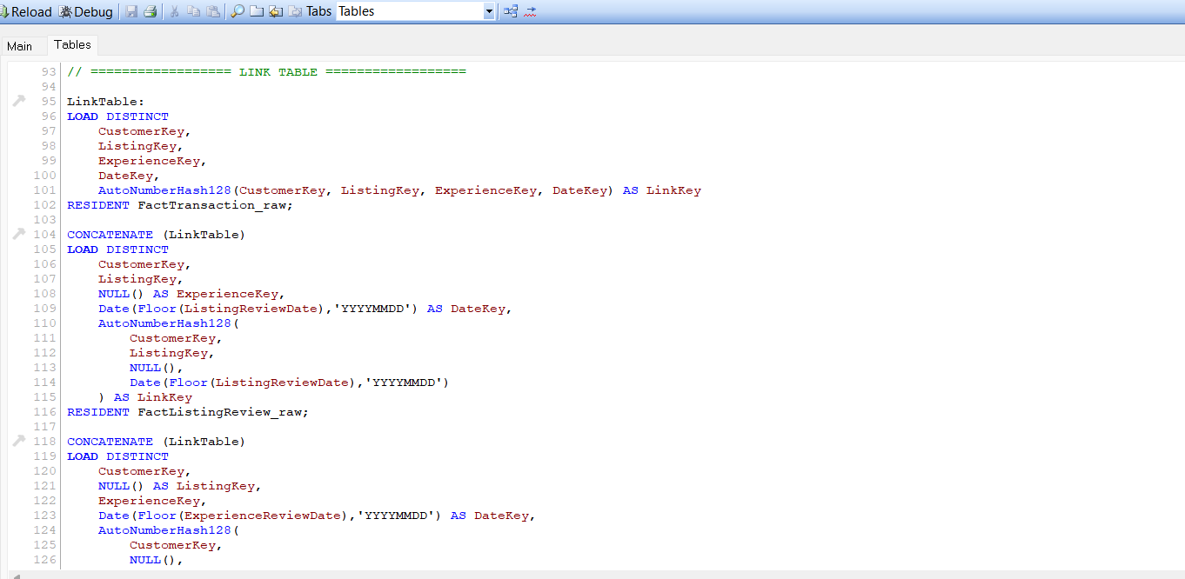
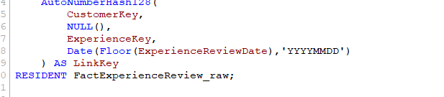
Step 4:
Created Final Fact Tables:
FactTransaction_raw
FactListingReview_raw
FactExperienceReview_raw
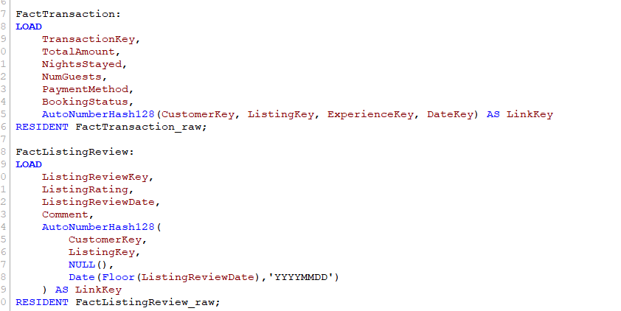
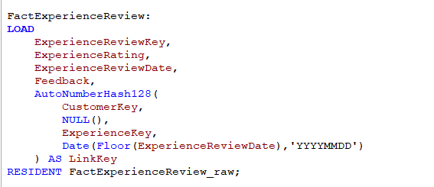

Step 5:
Cleanup Fact Tables
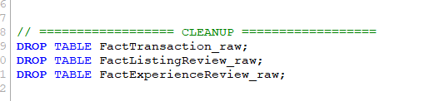
Step 6:
Table Viewer:
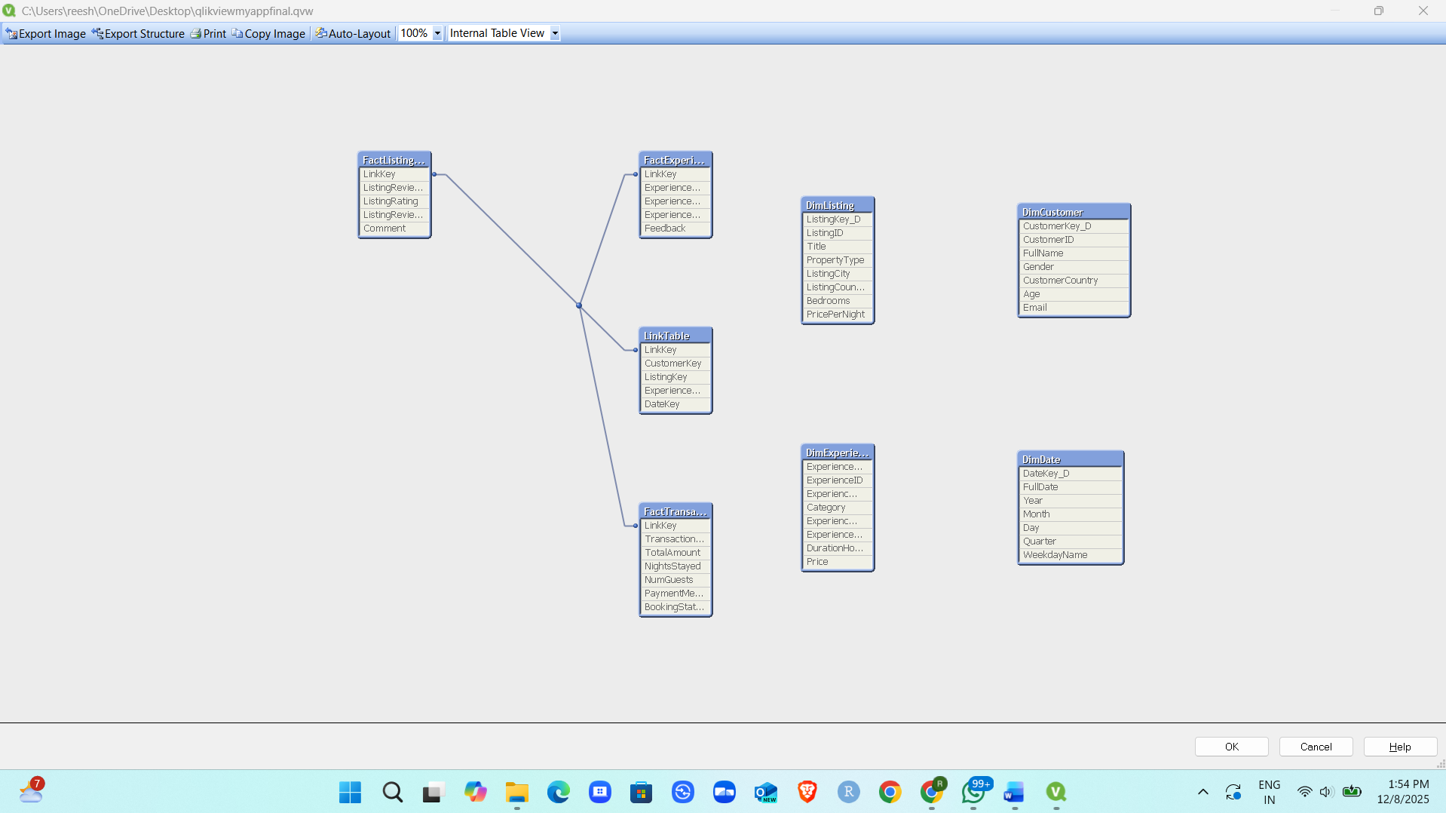Front-end:
Created 4 sheets:
Sheet 1: Introduction:
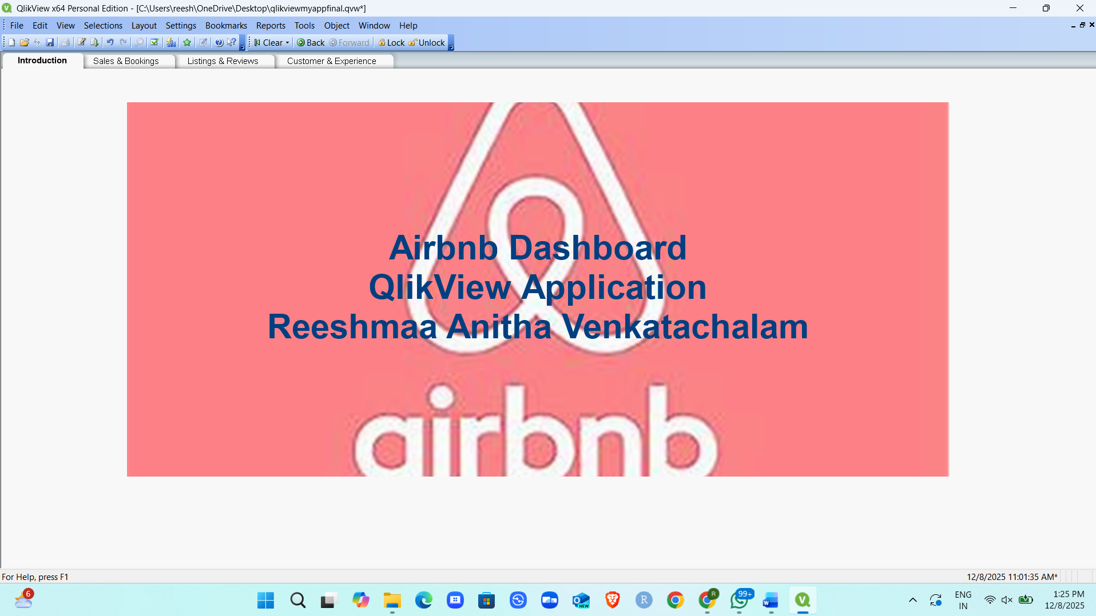
List Boxes in all 3 sheets:
Month
Year
PropertyType
Gender
ListingCountry
Sheet 2: Sales & Bookings:

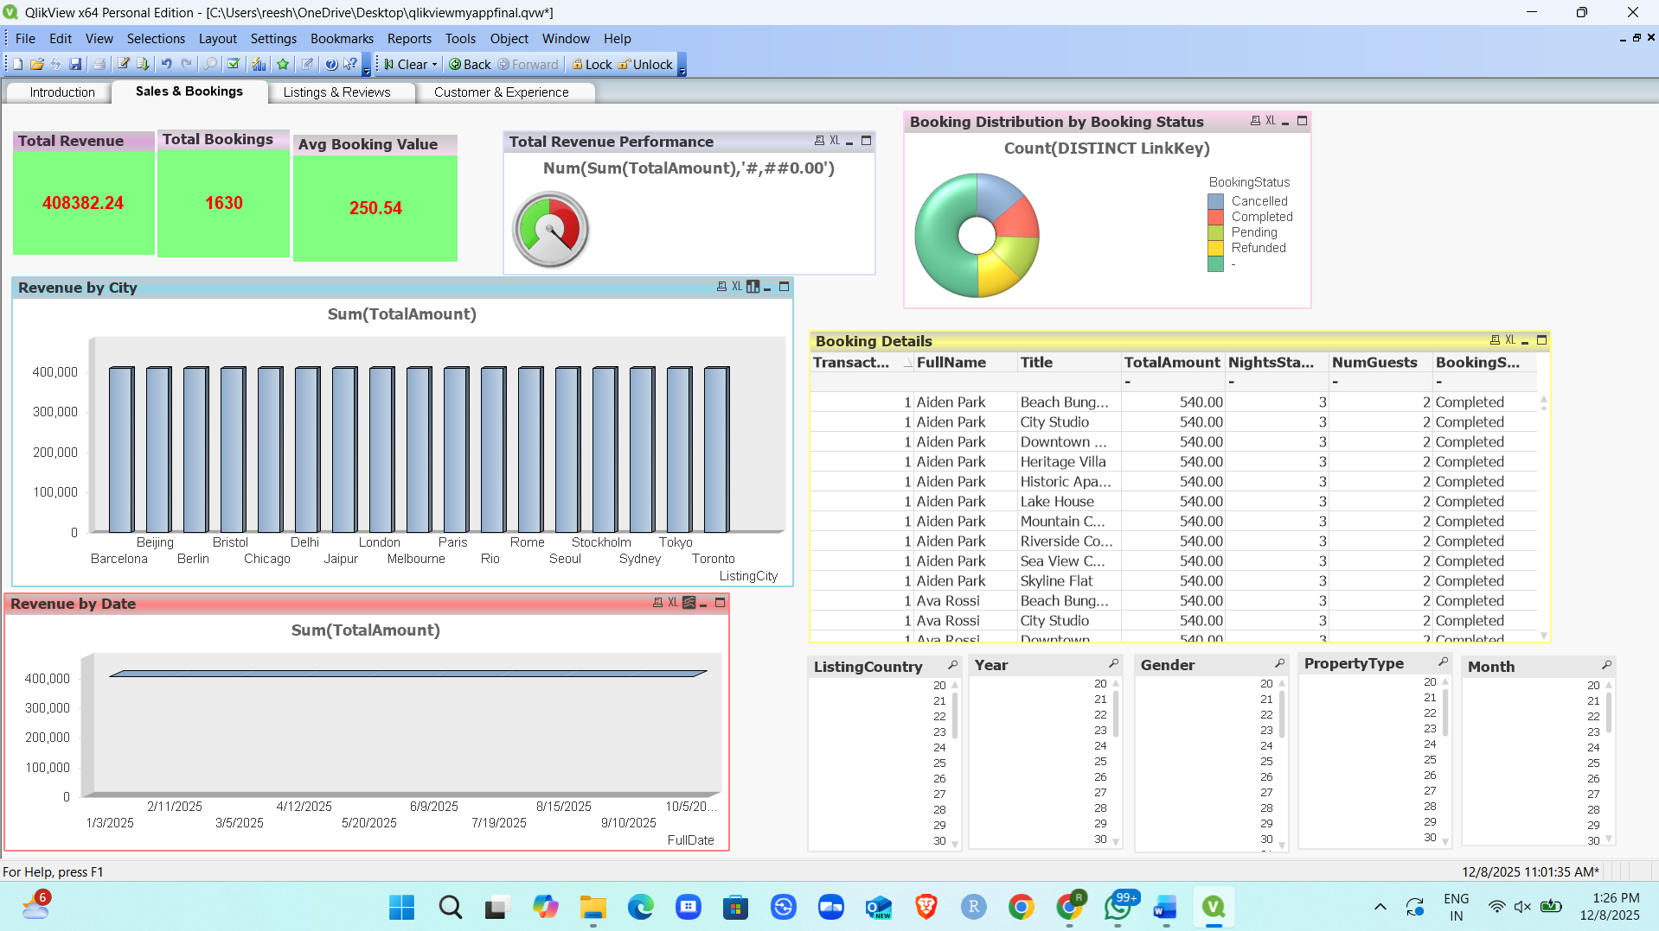
KPI:
Total Revenue
Total Bookings
Avg Booking Value
Charts:
Gauge Chart – Total Revenue Performance
Pie Chart – Booking Distribution by Booking Status
Bar Chart – Revenue by City
Line chart – Revenue by Date
Straight Table – Booking Details
Sheet 3: Listings & Reviews:
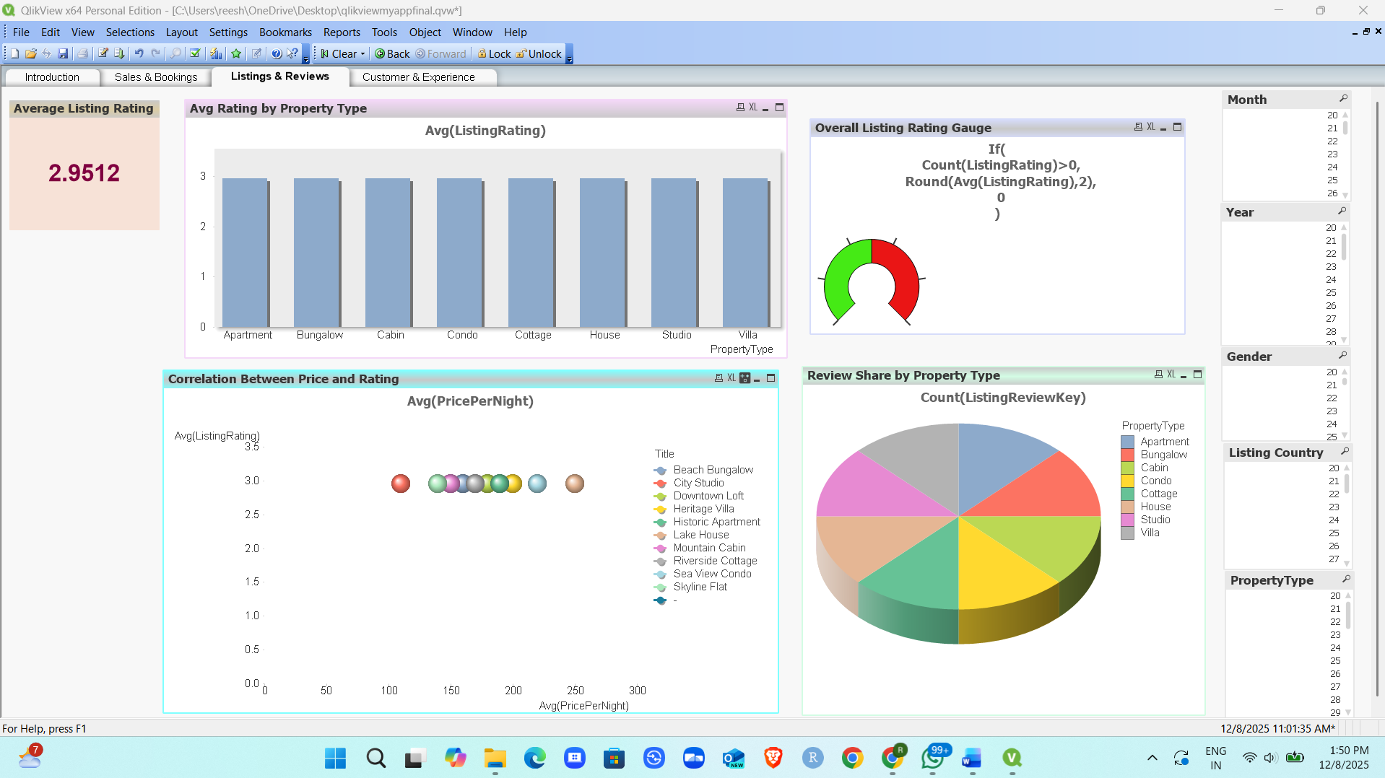
KPI:
Average Listing Rating = 2.9512
Charts:
Average Rating by Property Type – Bar chart
Correlation between Price and Rating – Scatter Plot
Overall Listing Rating Guage – Guage Chart
Review Share by Property Type – Pie Chart

Sheet 4: Customer & Experience:
KPI:
Total Customers = 120
Chart Types:
Customer By Gender – Pie Chart
Revenue by Experience Category – Line Chart
Top Customers – Straight Table
Avg Spend by Age – Bar Chart
