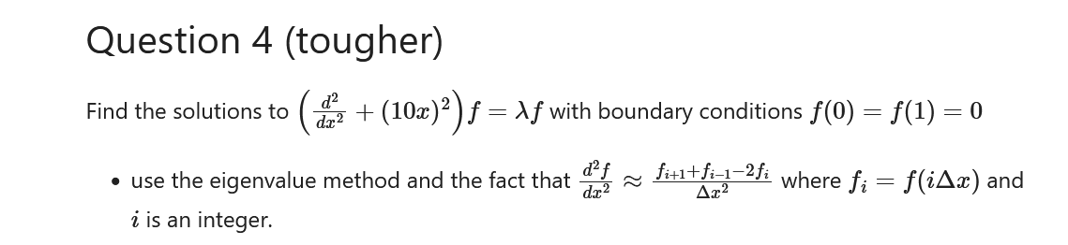………………………..

import matplotlib.pyplot as plt

import numpy as np

N = 1000

x = np.linspace(0,1,N+1) #no of points required to have n steps size.

dx = x[1]-x[0] #step size

#matrix form of differentail equation

main_diag = -2*np.ones(N-1)

off_diag = np.ones(N-2)

derivative_matrix = (np.diag(main_diag) + np.diag(off_diag, k=1)+ np.diag(off_diag, k=-1))/dx**2

x2_matrix = np.diag((10*x[1:-1])**2)

LHS_matrix = derivative_matrix #+ x2_matrix

w, v = np.linalg.eigh(LHS_matrix)

print(' 1st eigenvalue',w[-1])

plt.plot(-1*v[:,-1],label='1-eigenvector')

plt.plot(-1*v[:,-2],label='2-eigenvector')

plt.plot(-1*v[:,-3],label='3-eigenvector')

plt.plot(-1*v[:,-4],label='4-eigenvector')

plt.axhline(y = 0, color = 'black', linestyle = '-')

plt.legend()

plt.show()

……………………………………………………………………………………………………………………