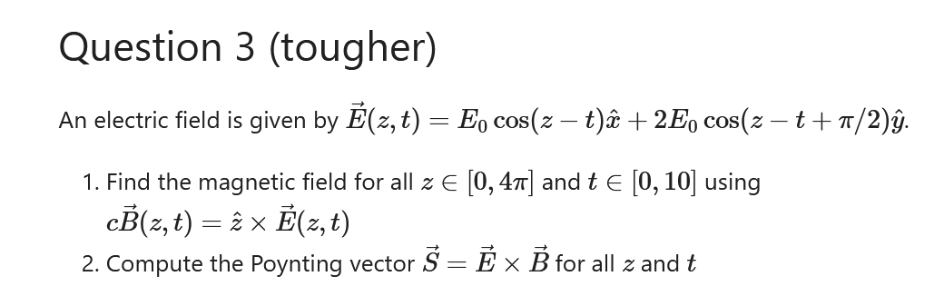

………………………………..

z=np.linspace(0,4\*np.pi,100)

t=np.linspace(0,10,100)

tv,zv=np.meshgrid(t,z)

Ex = np.cos(zv-tv)

Ey = 2\*np.cos(zv-tv+np.pi/2)

Ez = 0\*zv

#here E is dimensionless quantity E/E(NOT)

#plt.plot(t, Ex[0])

#plt.plot(t, Ey[0]) #ploting Ex and Ey as function of t at z=0

#plt.plot(Ex[:,0]) #Ex as function of z at t =0

#if we take same kind of argunment as for above there,

#will be 100 value of z which makes graph messy.

E = np.array([Ex, Ey, Ez])

E = np.swapaxes(E, 0, -1) #making array of form x,y,z points set,

#from x set points,yset ,z set points.

B = np.cross(np.array([0,0,1]), E)

E = np.swapaxes(E, 0, -1) #swaping back to original form (Bx, By, Bz = B)

B = np.swapaxes(B, 0, -1)

Bx, By, Bz = B

#plt.plot(t,Ey[0])

#plt.plot(t,Bx[0])

S = np.cross(np.swapaxes(E, 0, -1), np.swapaxes(B, 0, -1))

S = np.swapaxes(S, 0, -1)

Sx, Sy, Sz = S

print(S)

plt.plot(Sz[0])

……………………………………………………..