
School of Computing Science Engineering and Artificial Intelligence
(SCAI)

VITYARTHI PROJECT
Computer Vision
(CSE3010)

Interim Semester 2025-26

Name: Reeteesha Roy
Reg No: 23BHI10173
Class No.: BL2025260400063
Slot: B11+ B12 +B13 + E11 + E12
Faculty Name: Dr. Rudra Kalyan Nayak
1. Aim:
Primary Objective
The main objective was to create and implement an integrated, object-oriented computer vision pipeline for the advanced analysis of medical images focusing on Brain Magnetic Resonance Imaging (MRI) scans, through the sequential use of three different image processing methods.
Strategic Objectives
- Contrast Enhancement: To apply Contrast Limited Adaptive Histogram Equalization (CLAHE) for the purpose of local contrast restoration, visibility improvement of minor anatomical or pathological features, and, as a result, optimized local contrast enhancement.
- Region of interest (ROI) Segmentation: To use the GrabCut algorithm for semi-automatic high accuracy delineation of foreground/background, thus isolating the ROI that is critical (the brain structure or pathology case, for instance).
- Structural Feature Extraction: To use the Canny edge detection algorithm for the precise determination and mapping of the structural boundaries and contours in the segmented image.
- System Integration: To create a continuous, integrated workflow that processes medical images through the specified algorithmic stages without interruption.
- Analytical Visualization: To create high-quality visual outputs that allow for comparison and that are very important for quantitative analysis and clinical interpretation.

2. Data Resource and Characteristics

- Primary Source: Brain Tumor Dataset.( https://universe.roboflow.com/roboflow-100/brain-tumor-m2pbp)
- Organizational Structure: The dataset is clearly divided into train, test, and validation subsets. Each subset includes a directory of images that contains the medical scans (JPG, JPEG, PNG format).
- Sampling Protocol: An automatic and randomized selection procedure is followed to guarantee that the pipeline is evaluated with a diverse and representative sample set.

Data Characteristics
The dataset comprises medical-grade MRI brain scans characterized by:
- Variations in image resolution and quality.
- Inclusion of both normal (control) and pathological (tumor-bearing) cases.
- It is pre-arranged and ready to use within a machine learning (ML) or computer vision architecture.

3. System Architecture and Prerequisites
Software Dependencies
The system relies on a minimal, high-performance library stack:
- Core Libraries:
  - OpenCV (cv2) : Essential for all core computer vision operations.
  - NumPy: Foundation for efficient numerical and array-based computations.
  - Matplotlib: Used for data and comparative result visualization.
- System Libraries: Pathlib, Logging, Random, and OS for robust file handling, execution monitoring, and system interaction.

Hardware Specifications
- Minimum Requirement: 4GB RAM, 2GHz single-core processing unit.
- Recommended Specification: 8GB RAM, multi-core processor for enhanced parallel processing, 500 dedicated storage.
- Display: Required for graphical visualization output.

Environmental Setup
# Installation of dependencies
pip install opencv-python numpy matplotlib

4. Methodology
Technical Architecture
The project adopts a modular object-oriented programming (OOP) design. The architecture consists of three specialists, independent classes, and adheres to principles of high cohesion, low coupling, and easy extensibility.

Algorithmic Implementation
4.1 Contrast Limited Adaptive Histogram Equalization (CLAHE)
- Function: To accomplish local contrast enhancement while appropriately preserving the suppression of noise artifacts associated with global histogram equalization.
- Implementation Detail: The image is converted into the LAB color space. CLAHE is applied to the Luminance (L) channel only to preserve the image's original colors.
Key Parameters:
  - `clip_limit=2.0: Configured to set the contrast limiting threshold.
  - `tile_grid_size=(8 x 8): Defines the size of the local processing region.

4.2 GrabCut Segmentation
- Function: This operation allows for accurate, automatic extraction of the foreground required for extracting the location of medical interest away from the background.
- Implementation Detail: From the inception point, we define a bounding box rectangle that includes the entire image plus a 15% margin around its exterior. The algorithm relies on Gaussian Mixture Models (GMMs) for probabilistic pixel classification and the model was iteratively refined over 5 rounds of processing.
- Output: Outputs to a binary mask and shows the segmented output.

4.3 Canny Edge Detection
- Function: To perform robust, high accuracy detection of boundaries and contours.
- Implementation Detail: Pre-processing includes a conversion to grayscale, followed by the application of a 5 x 5 Gaussian blur to suppress noise. Detection is based on a dual-threshold hysteresis method.
- Key Parameters:
  - Threshold1=50: Defines the lower threshold for weak edges.
  - Threshold2=150: Defines the upper threshold for strong edges.

5. System Implementation and Workflow
Architecture Design
The code implementation has been shown as follows:
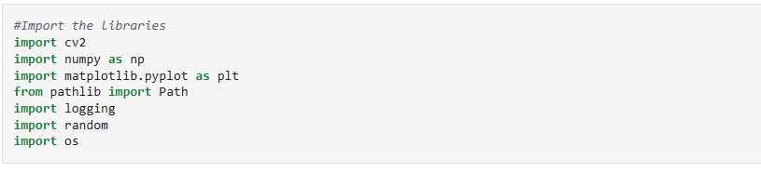
1. CLAHE Enhancement
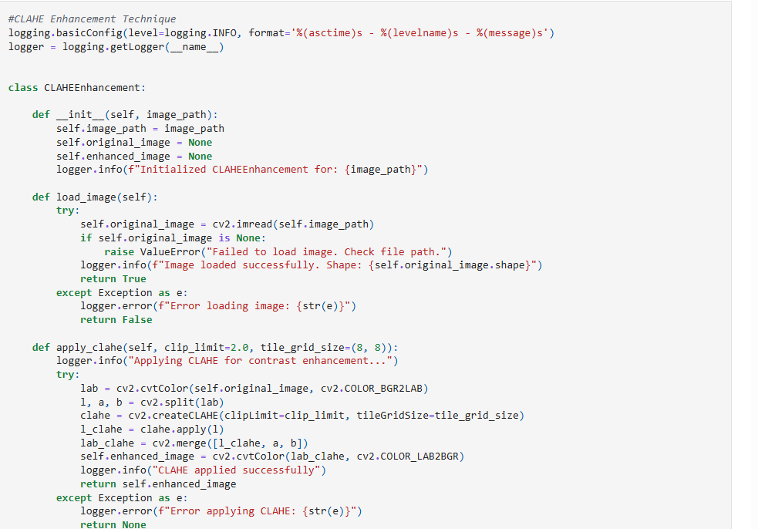
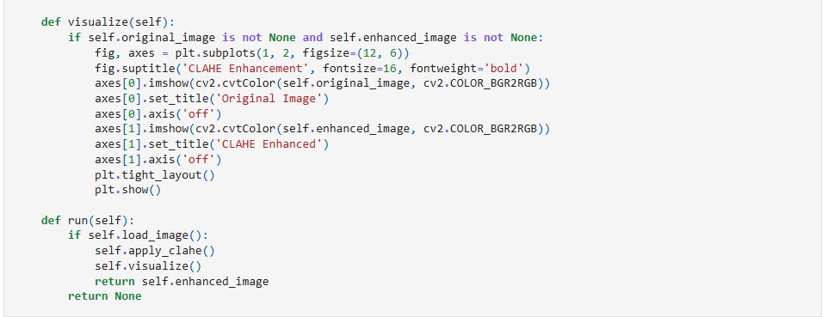
2. GrabCut Segmentation
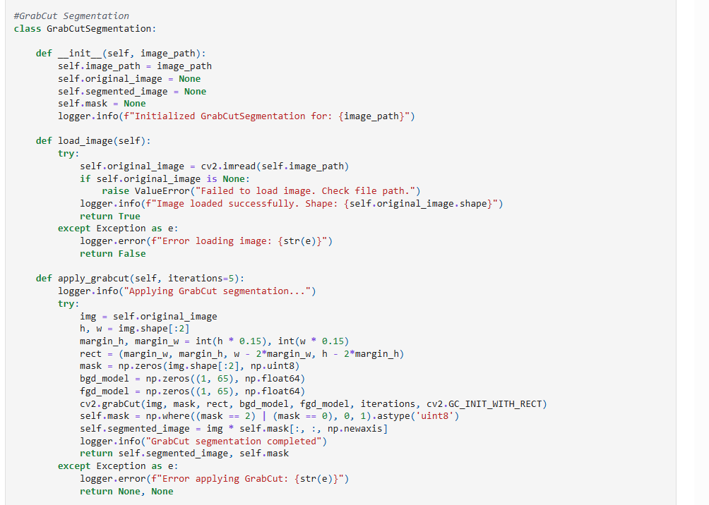
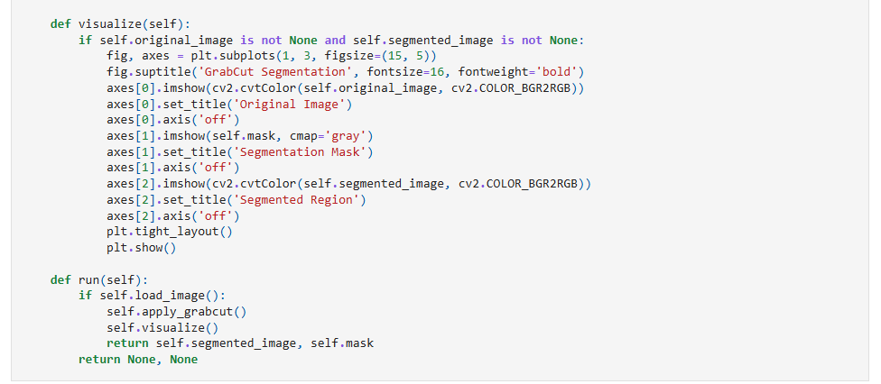
3. Canny Edge Detection
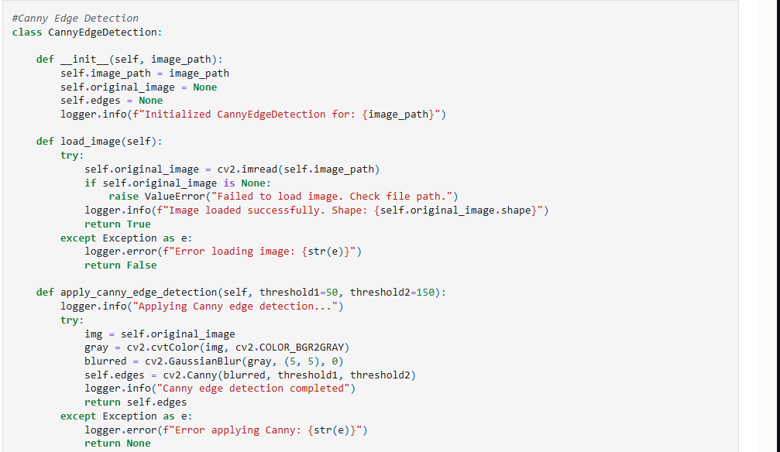
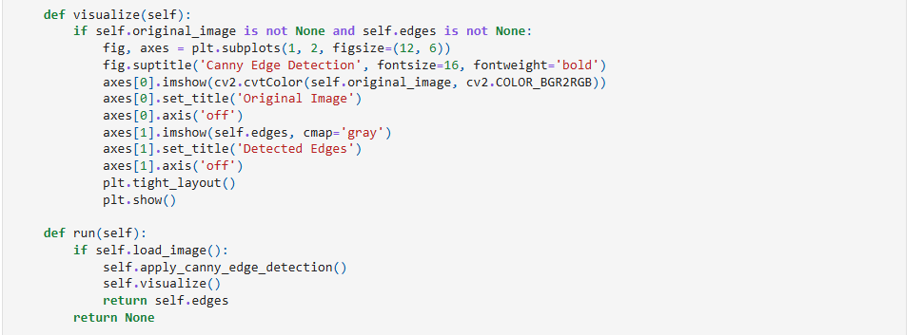
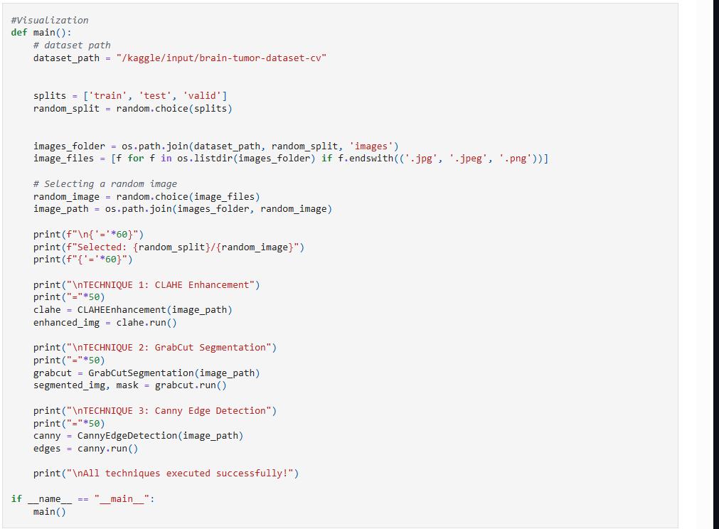
Core System Capabilities
- Modularity and Extensibility: By utilizing a detached class structure, the system is flexible, maintainable, and easily able to add in new processing approaches in a short timeframe.
- Comprehensive Error Handling: The system employs solid exception handling with structured logging for documenting detailed failure states while providing accurate operational stability.
- Visual Analytics: A significant feature is to see original and processed outputs side-by-side for immediate assessment and analytical purposes..
- Operational Logging: Structured logging provides traceable audit trails in debugging and monitoring performance.

Workflow
1. Data Loading: The random selection of images from the given dataset path.
2. Pre-processing: Validation of images and application of standard loading procedures.
3. CLAHE Processing: Contrast enhancement carried out in the LAB color space.
4. Semantic Segmentation: The application of the GrabCut algorithm to isolate foreground.
5. Feature Extraction: Canny Edge Detection for boundary detection.
6. Visualization: Creation of comparative results for the purpose of output display.
7. Output Generation: The processed images, masks, and edge maps are saved.

6. Results and Performance
Each processing stage yields distinct analytical visualizations:
- CLAHE Enhancement: Displays the Original as well as the Enhanced image showcasing the improved contrast and details while preserving the original color profile.
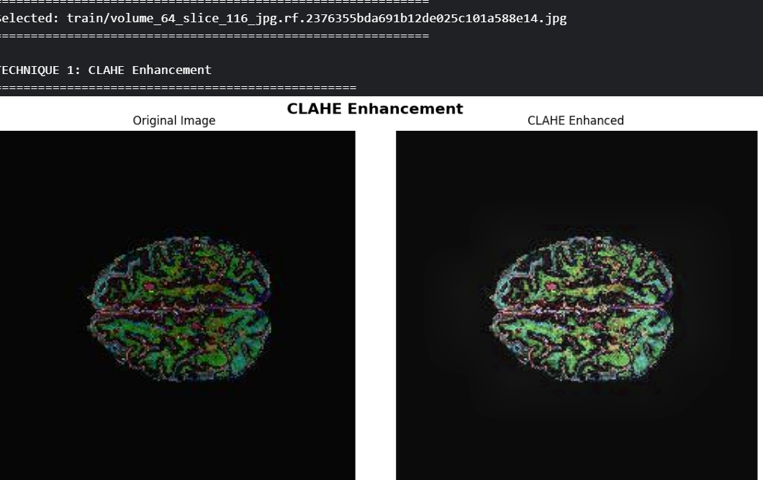
- GrabCut Segmentation: A three-panel display (Original, Binary Mask, Segmented ROI) validates accurate foreground selection and isolation of the region of interest.
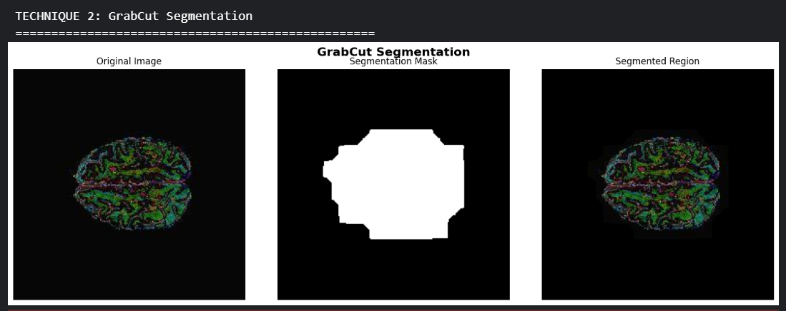

- Canny Edge Detection: Presents the Original image alongside the final Edge Map, demonstrating clear, noise-reduced boundary identification.

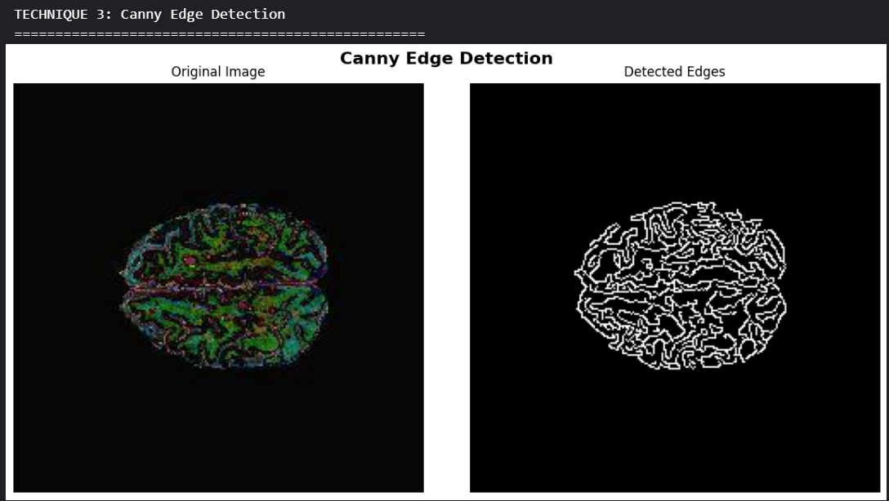

  - Conclusion and Future Development

- Pipeline Validation: A reliable and fully functional medical image analysis pipeline has been created and verified.
- Algorithmic Integration: A coherent, sequential workflow was created by skillfully integrating three cutting-edge computer vision techniques.
- Architectural excellence: The main design is highly modular, object-oriented, and maintainable.
- Analytical Output: Clinical and research-based interpretation is supported by thorough, valuable visualizations.

Specifically designed to address the difficulties of medical image analysis, this project is a production-ready implementation of basic computer vision algorithms. Important requirements like boundary detection, ROI isolation, and contrast enhancement are effectively met by the final pipeline. Advanced applications in medical AI and clinical support systems can be built on a scalable and dependable foundation thanks to the modular architecture.

