PROJECT REPORT
Financial Transactions & Loans
Performance Dashboard
Interactive analysis of customers, accounts, loans and transactions using Microsoft Power BI
Submitted By
Detail | Information
Name | Reethi
Student ID | E25FA037
Programme | BCom FinTech and Artificial Intelligence (FTAI), First Year
Institution | SDNB Vaishnav College for Women, Chennai
Tool Used | Microsoft Power BI Desktop
Dataset | Dataset 4 – Financial Transactions & Loans

1. Introduction
Power BI is a business intelligence and data visualisation tool developed by Microsoft. It converts raw data into meaningful information through interactive reports, dashboards, charts and tables.
For this project, a Financial Transactions and Loans dataset was used to build a three-page interactive report in Microsoft Power BI. The dashboard covers customers, account types, loan status, transaction values and transaction trends over months and years.
The main purpose of the dashboard is to analyse the overall financial activity of a retail banking-style portfolio: how many customers and accounts exist, how loans are performing, and how much money moves through each account type over time. KPI cards, bar charts, line charts, a donut chart and a table are used to present the information clearly, while slicers and drill-down pages allow deeper analysis.

2. Objectives of the Project
- To build an interactive financial dashboard using Microsoft Power BI.
- To track key indicators: total customers, active accounts, active loans and total transaction value.
- To compare the number of accounts across different account types.
- To analyse the status of loans (Active, Paid Off and Overdue).
- To compare total transaction value and transaction count across account types.
- To study how transaction value changes month by month and year by year.
- To provide filtering by year, account type and transaction type through slicers.
- To provide a drill-down page and a tooltip page for additional detail.

3. Dataset Description
The dataset contains information required to analyse customers, their accounts, the loans they hold and the transactions made. Lookup fields such as account type, transaction type and loan status are used to group and filter the data.
The major fields used in the dashboard are:
Field | Description
Customer | Identifies the customers in the dataset (used for Total Customers)
Account / TypeName | Identifies accounts and their type: Business, Youth, Savings, Payroll or Checking
Transaction Type | Identifies the kind of transaction performed on an account
Transaction Value | The monetary amount of each transaction, in ₹
Loan / StatusName | Identifies loans and their status: Active, Paid Off or Overdue
Date, Month, Year | Used for month-wise and year-wise trend analysis

4. Data Preparation
Before creating the dashboard, the data was organised in Power BI so that the different tables and fields could be used together for analysis. The main preparation activities were:
- Importing the required dataset into Power BI Desktop.
- Checking the fields for customers, accounts, loans, transactions and dates.
- Establishing relationships between the tables so that account type, transaction type and loan status can filter the visuals.
- Preparing date fields for month and year-based analysis.
- Reviewing blank values: some transactions have no account type and the first point of the monthly trend has no month (shown as “(Blank)”).
- Creating measures for the key financial indicators.
Proper data preparation is important because the accuracy of the dashboard depends on correctly organised data and calculations.

5. Measures Used
Several measures were created in Power BI to calculate the important indicators shown on the dashboard.
Measure | What it calculates | Value on dashboard
Total Customers | Number of customers in the dataset | 1K
Active Accounts | Number of accounts that are active | 1K
Active Loans | Number of loans with Active status | 230
Total Transactions | Count of all transactions | 48,510
Total Transaction Value | Sum of the value of all transactions | ₹122.69 M (₹12,26,93,050.81)

These measures provide an overall view of the size of the customer base, the loan book and the money flowing through the accounts.

6. Dashboard
The report contains three pages: Finance Overview, Transaction Drill Down and Transaction Tooltip. The Finance Overview page is the main dashboard and brings together KPI cards, charts, a summary table and slicers on a single dark-themed screen.
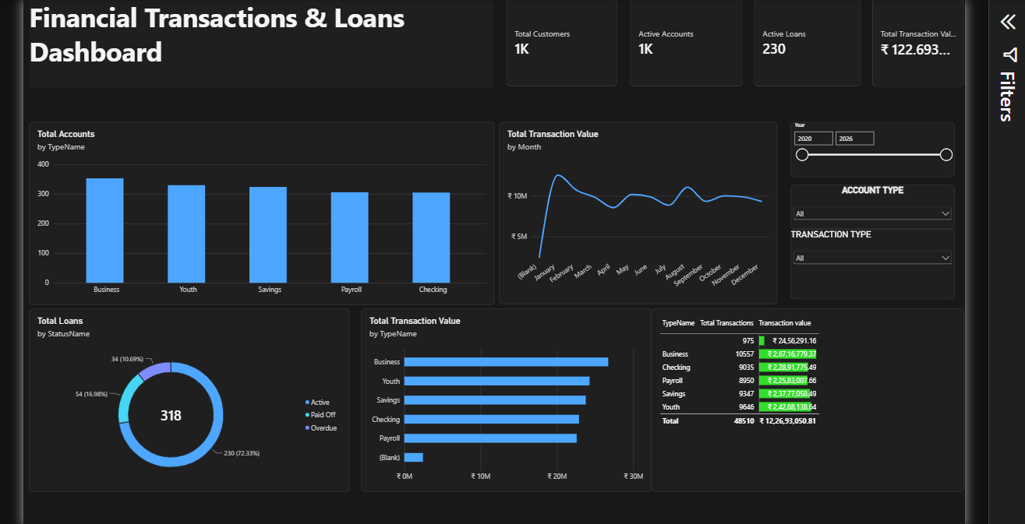
Figure 1: Finance Overview page of the Financial Transactions & Loans Dashboard
The dashboard allows the user to compare accounts and transaction values across account types, monitor the health of the loan portfolio, and observe trends over time. Slicers for year, account type and transaction type filter the whole page, so the user can focus on a specific part of the business.

7. Dashboard Components
Each visual on the dashboard provides a different view of the financial data.

→ KPI Cards
Four KPI cards at the top of the page show the headline numbers: Total Customers, Active Accounts, Active Loans and Total Transaction Value.
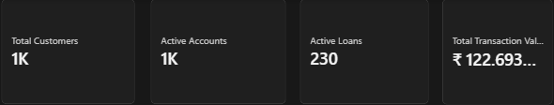
Figure 2: KPI cards
Purpose
- To give the most important figures at a glance.
- To summarise the size of the customer base and loan book.
- To show the total money moved through all accounts (₹122.69 M).

→ Total Accounts by Account Type
A Clustered Column Chart compares the number of accounts across the five account types. Business has the most accounts (around 350), followed by Youth, Savings, Payroll and Checking, which each have roughly 300–330.
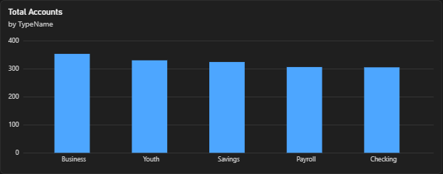
Figure 3: Total Accounts by TypeName
Purpose
- To compare the number of accounts per account type.
- To identify the most and least popular account types.

→ Total Transaction Value by Month
A Line Chart shows how total transaction value changes across the months of the year. The value rises sharply to a peak of about ₹12 M in January, then settles in a band of roughly ₹9–10 M, with small dips around April and July and a secondary rise in August.
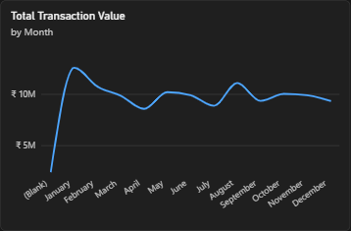
Figure 4: Total Transaction Value by Month
Purpose
- To identify seasonal patterns in transaction activity.
- To spot months of unusually high or low value.
- To understand changes in value within the year.

→ Total Loans by Status
A Donut Chart shows the 318 loans split by status. Active loans make up 230 (72.33%), Paid Off loans 54 (16.98%) and Overdue loans 34 (10.69%).
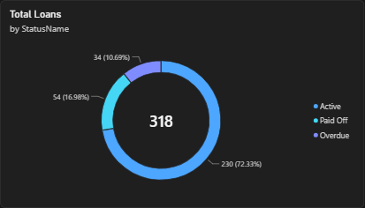
Figure 5: Total Loans by StatusName
Purpose
- To show the overall health of the loan portfolio.
- To highlight the share of overdue loans that may need follow-up.
- To compare active, paid-off and overdue loans visually.

→ Total Transaction Value by Account Type
A Clustered Bar Chart compares the total value of transactions across account types. Business accounts lead, followed by Youth and Savings, with Checking and Payroll slightly lower. A small “(Blank)” bar represents transactions without an account type.
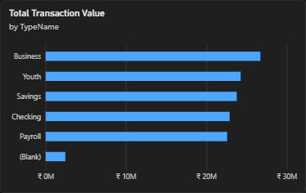
Figure 6: Total Transaction Value by TypeName
Purpose
- To compare the value contributed by each account type.
- To identify the account types that generate the most money movement.

→ Transaction Summary Table
A Table visual lists each account type with its number of transactions and total transaction value, with data bars on the value column. The table totals 48,510 transactions worth ₹12,26,93,050.81.
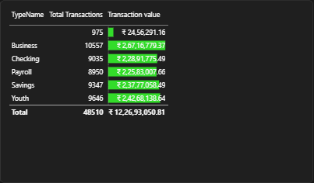
Figure 7: Transaction summary table
Purpose
- To show exact figures behind the charts.
- To compare transaction count and value together.
- To identify the data-quality gap of blank account types.

→ Transaction Drill Down Page
The second page contains a Line Chart of total transaction value by year from 2018 to 2026. Value stays at roughly ₹28–30 M per year from 2018 to 2021, then falls steeply in 2022 to about ₹2.5 M and keeps declining to below ₹1 M by 2025–2026.
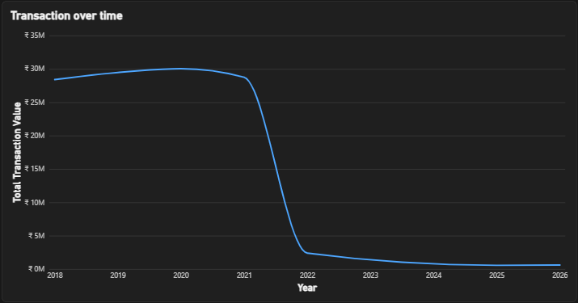
Figure 8: Transaction over time (year-wise)
Purpose
- To study the long-term trend of transaction value.
- To identify the point where activity changed sharply.
- To allow the user to drill down from year to finer time periods.

→ Transaction Tooltip Page
The third page is a tooltip page. When the user hovers over a visual on the main page, this page appears and shows the Total Transaction Value (₹122.69305081 M) for the selected context along with supporting values.
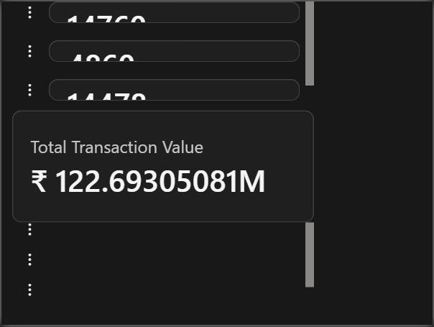
Figure 9: Transaction tooltip page
Purpose
- To give extra detail on hover without crowding the main page.
- To keep the main dashboard clean and easy to read.

8. Slicers Used
Three slicers are included on the Finance Overview page:
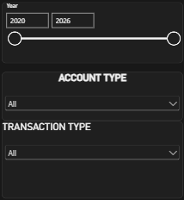
Figure 10: Year, Account Type and Transaction Type slicers
1. Year – A range slicer (2020 to 2026) that filters the dashboard by year.
2. Account Type – A drop-down that lets the user select Business, Youth, Savings, Payroll or Checking accounts.
3. Transaction Type – A drop-down that filters the dashboard by the kind of transaction.
When a selection is made, the related charts and figures update. For example, the user can choose the Business account type and a particular year to study its transaction value and trend in isolation.

9. Key Findings
The major observations from the dashboard are:
Account Type | Transactions | Transaction Value | Share | Avg per Txn
Business | 10,557 | ₹ 2,67,16,779.37 | 21.78% | ₹ 2,530.72
Checking | 9,035 | ₹ 2,28,91,775.49 | 18.66% | ₹ 2,533.68
Payroll | 8,950 | ₹ 2,25,83,007.66 | 18.41% | ₹ 2,523.24
Savings | 9,347 | ₹ 2,37,77,058.49 | 19.38% | ₹ 2,543.82
Youth | 9,646 | ₹ 2,42,68,138.64 | 19.78% | ₹ 2,515.88
(Blank) | 975 | ₹ 24,56,291.16 | 2.00% | ₹ 2,519.27
Total | 48,510 | ₹ 12,26,93,050.81 | 100.00% | ₹ 2,529.23

- Total activity: 48,510 transactions worth about ₹12.27 crore (₹122.69 M) were recorded, an average of roughly ₹2,529 per transaction.
- Business leads: Business accounts have the most accounts, the most transactions (10,557) and the highest value (about 21.8% of the total).
- Balanced portfolio: The other four account types each contribute between about 18% and 20% of the value, so no single type dominates.
- Loan portfolio: Of 318 loans, 72.33% are active, 16.98% are paid off and 10.69% (34 loans) are overdue.
- Seasonality: Monthly value peaks in January and stays fairly steady at around ₹9–10 M for the rest of the year.
- Sharp decline after 2021: Yearly transaction value drops from about ₹28–30 M to under ₹3 M in 2022 and keeps falling, meaning the large majority of total value comes from 2018–2021.
- Data quality: 975 transactions (about 2% of value) have no account type, and one month category is blank. These records should be reviewed at source.
Note: values read from chart axes (such as monthly and yearly figures) are approximate; exact figures are those shown in the KPI cards and the table.

10. Importance of the Dashboard
- Easy Data Understanding – Large volumes of financial data become easy to understand through KPI cards and charts.
- Quick Decision-Making – Headline figures for customers, loans and transaction value are visible at a glance.
- Account Comparison – The account-type charts show which products attract the most accounts and value.
- Loan Monitoring – The loan donut highlights overdue loans so that risk can be tracked.
- Trend Analysis – Monthly and yearly line charts reveal seasonality and long-term changes in activity.
- Interactive Analysis – Slicers, drill-down and tooltip pages let users explore the data in more detail.
- Better Business Insights – Combining several visuals reveals patterns that raw data alone would hide.

11. Conclusion
The Financial Transactions & Loans Dashboard demonstrates how Microsoft Power BI can turn financial data into an interactive and meaningful report. The project helped in understanding data preparation, measures, KPI cards, column and bar charts, line charts, donut charts, tables, slicers, drill-down pages and tooltip pages.
The dashboard gives clear views of customers, accounts, loans and transactions, and shows that Business accounts lead in value, that most loans are active with about one in ten overdue, and that transaction value fell sharply after 2021. Overall, the project shows how Power BI can support effective financial performance analysis.

12. References
- Microsoft Power BI Desktop
- Financial Transactions & Loans dataset (Dataset 4)
- Microsoft Power BI Documentation
- Microsoft DAX Documentation

