PROJECT REPORT
Northwind Sales & Orders
Performance Dashboard
Interactive analysis of orders, sales, freight, employees and customers using Microsoft Power BI
Submitted By
Detail | Information
Name | Reethi
Student ID | E25FA037
Programme | BCom FinTech and Artificial Intelligence (FTAI), First Year
Institution | SDNB Vaishnav College for Women, Chennai
Tool Used | Microsoft Power BI Desktop
Dataset | Dataset 2 – Northwind

1. Introduction
Power BI is a business intelligence and data visualisation tool developed by Microsoft. It converts raw data into meaningful information through interactive reports, dashboards, charts and tables.
For this project, the Northwind dataset was used to build a four-page interactive report in Microsoft Power BI. Northwind is a well-known sample trading database containing orders, customers, employees, products and product categories. The dashboard presents information on orders, sales, quantity sold, freight, employees, categories, products and customer countries.
The main purpose of the dashboard is to analyse the overall sales and order performance of the business. KPI cards, line charts, column charts, bar charts and tables are used to present the information clearly, and slicers for Year, Region and Category allow the data to be filtered. A validation page and a tooltip page support accuracy checks and extra detail.

2. Objectives of the Project
- To build an interactive sales and orders dashboard using Microsoft Power BI.
- To track key indicators: total orders, number of customers, quantity sold, total freight and average freight.
- To understand how the number of orders changes from month to month.
- To compare total sales across product categories.
- To compare order volume handled by different employees.
- To analyse product-level sales and quantity and validate DAX measures against report totals.
- To understand the geographical spread of customers by country.
- To provide filtering by year, region and category through slicers, and extra detail through a tooltip page.

3. Dataset Description
The Northwind dataset contains the information required to analyse sales and order performance. Related tables for customers, employees, products, categories and orders are combined in the Power BI model.
The major fields used in the dashboard are:
Field | Description
Order | Identifies each order placed (used for Total Orders)
Customer / Country | Identifies customers and the country they belong to (used for Number of Customers and the Region slicer)
employeeName | Identifies the employee who handled the order
productName | Identifies the individual products
categoryName | The category a product belongs to, such as Beverages or Seafood
Quantity | The number of units sold
Sales | The sales value of the order lines
Freight | The shipping cost charged for an order
Date / Month / Year | Used for month-wise and year-wise analysis

4. Data Preparation
Before creating the dashboard, the data was organised in Power BI so that the different tables and fields could be used together. The main preparation activities were:
- Importing the Northwind dataset into Power BI Desktop.
- Checking the fields for orders, customers, employees, products, categories and dates.
- Establishing relationships between the tables so that country, category and date can filter the visuals.
- Preparing date fields for month and year-based analysis.
- Reviewing blank values: some orders have no employee name and appear as “(Blank)” in the employee chart.
- Creating DAX measures for the key indicators and validating them against a product-level table.
Proper data preparation is important because the accuracy of the dashboard depends on correctly organised data and calculations.

5. DAX Measures Used
Several DAX measures were created and used in the dashboard to calculate important business indicators.
Measure | What it calculates | Value on dashboard
Total Orders | Number of orders in the dataset | 809
Number of Customers | Number of distinct customers | 91
Total Quantity Sold | Total units sold | 51K (51,317)
Total Freight | Total shipping cost | 63.96K
Average Freight | Average freight per order | 79.05
Total Sales | Total sales value | 1.27M (12,65,793.04)

The “DAX Validation” page of the report compares product-level sales and quantity with the KPI cards. The product table totals 12,65,793.04 in sales and 51,317 units, which matches the Total Sales (1.27M) and Total Quantity Sold (51K) cards, confirming that the measures are calculating correctly.

6. Dashboard
The report has four pages: Sales Overview, DAX Validation, Interactive Sales Dashboard and Category Tooltip. The Interactive Sales Dashboard is the main page. It brings together line and bar charts, KPI cards and slicers on one screen.
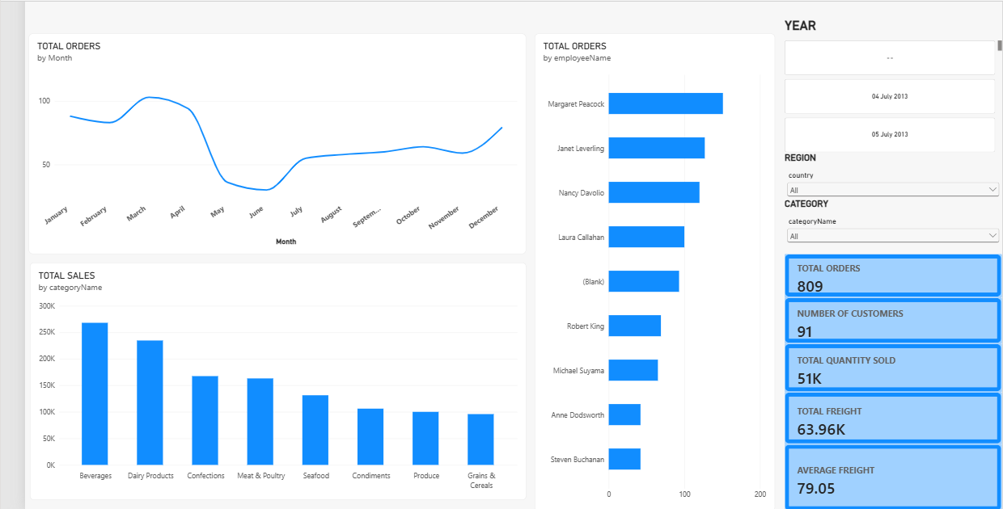
Figure 1: Interactive Sales Dashboard page (Dataset 2 – Northwind)
The dashboard lets the user compare orders across months and employees, compare sales across categories, and track freight and customer figures. Slicers for Year, Region (country) and Category filter the page so that a specific part of the business can be examined.

7. Dashboard Components
Each visual provides a different view of the business performance.

→ KPI Cards
Five KPI cards show the headline numbers: Total Orders (809), Number of Customers (91), Total Quantity Sold (51K), Total Freight (63.96K) and Average Freight (79.05).
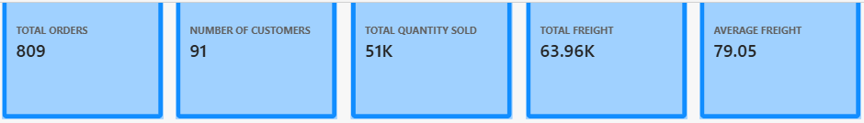
Figure 2: KPI cards
Purpose
- To give the most important figures at a glance.
- To summarise order volume, customer base and shipping cost.

→ Total Orders by Month
A Line Chart shows the number of orders in each month. Orders are high from January to April (peaking at about 100 in March), fall sharply in May and reach their lowest point in June (about 30), then recover gradually to around 80 by December.
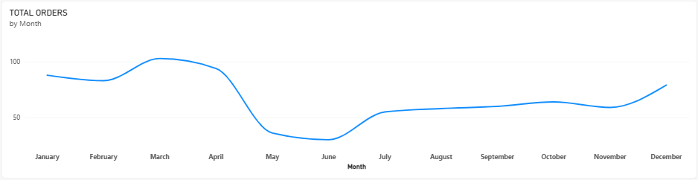
Figure 3: Total Orders by Month
Purpose
- To identify monthly and seasonal order patterns.
- To spot months of unusually high or low activity.
- To understand how order volume changes through the year.

→ Total Sales by Category
A Clustered Column Chart compares sales across the eight product categories. Beverages is the highest (about 0.27M), followed by Dairy Products (about 0.235M). Grains & Cereals, Produce and Condiments are the lowest.
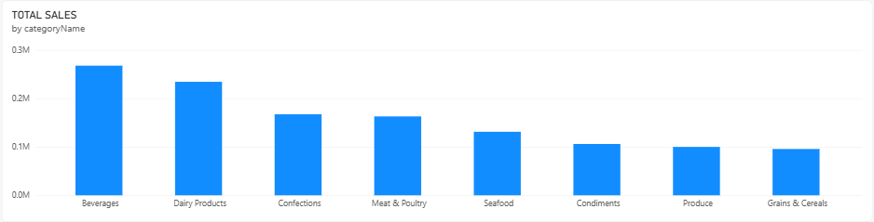
Figure 4: Total Sales by categoryName
Purpose
- To compare sales across categories.
- To identify the strongest and weakest categories.

→ Total Orders by Employee
A Clustered Bar Chart compares the number of orders handled by each employee. Margaret Peacock handles the most (about 150), followed by Janet Leverling and Nancy Davolio. Steven Buchanan and Anne Dodsworth handle the fewest (about 40 each). A “(Blank)” bar represents orders with no employee recorded.
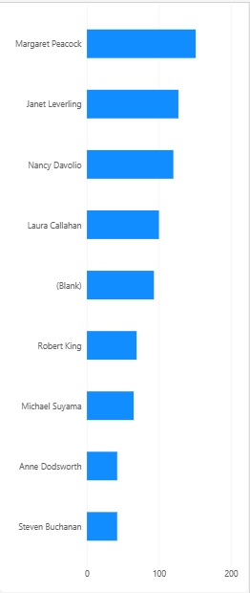
Figure 5: Total Orders by employeeName
Purpose
- To compare employee-wise order volume.
- To identify differences in workload and contribution.
- To highlight orders with missing employee information.

→ Product Sales and Quantity Table (DAX Validation)
A Table visual on the DAX Validation page lists each product with its category, sales value and quantity sold. Totals at the bottom are 12,65,793.04 in sales and 51,317 units.
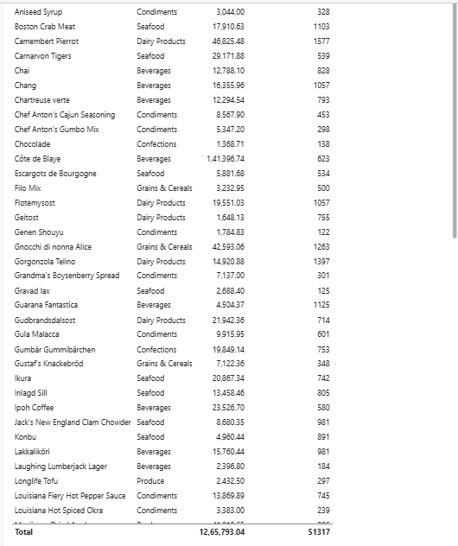
Figure 6: Product-level table with totals
Purpose
- To analyse individual product sales and quantity.
- To validate DAX measures against the KPI cards.
- To identify high-selling products, such as Côte de Blaye with the largest sales value in the visible rows.

→ Customers by Country
A Bar Chart on the DAX Validation page shows counts by country. The USA has the highest (13), followed by France and Germany (11 each), Brazil (9) and the UK (7). Several countries, such as Ireland, Norway and Poland, have just one. The counts add up to 91, which matches the Number of Customers card.
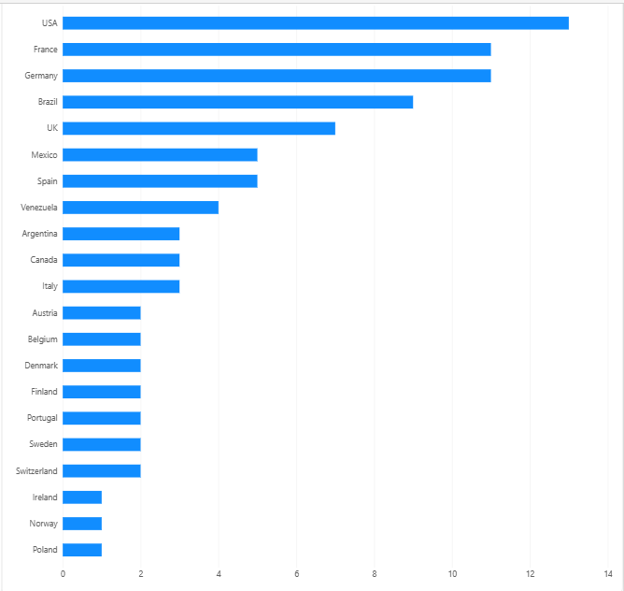
Figure 7: Count by country
Purpose
- To understand the geographical spread of customers.
- To identify the main markets.
- To support the Region (country) slicer.

→ Category Tooltip Page
The fourth page is a tooltip page. When the user hovers over a category on the main page, it appears and shows Total Sales (1.27M), Total Orders (809) and Total Quantity Sold (51K) for that selection.
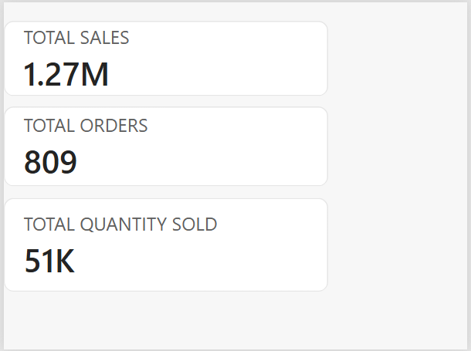
Figure 8: Category tooltip page
Purpose
- To give extra detail on hover without crowding the main page.
- To keep the dashboard clean and easy to read.

8. Slicers Used
Three slicers are included on the Interactive Sales Dashboard:
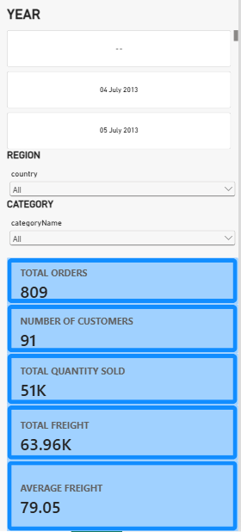
Figure 9: Year, Region and Category slicers
1. Year – Filters the dashboard by date or year.
2. Region – A drop-down on the country field that lets the user select a particular country.
3. Category – A drop-down on categoryName that lets the user select a particular product category.
When a selection is made, the related charts and figures update. For example, the user can choose a country and a category to study order and sales performance for that specific area.

9. Key Findings
The major observations from the dashboard are:
Category | Sales (approx.) | Share (approx.)
Beverages | ≈ 270K | ≈ 21%
Dairy Products | ≈ 235K | ≈ 19%
Confections | ≈ 168K | ≈ 13%
Meat & Poultry | ≈ 163K | ≈ 13%
Seafood | ≈ 130K | ≈ 10%
Condiments | ≈ 107K | ≈ 8%
Produce | ≈ 100K | ≈ 8%
Grains & Cereals | ≈ 95K | ≈ 7%
Total (KPI) | 1.27M | 100%

- Overall scale: 809 orders from 91 customers, with 1.27M in sales and 51,317 units sold.
- Derived averages: about 1,564.64 in sales per order, 63.4 units per order and 8.9 orders per customer.
- Freight: Total freight of 63.96K is about 5.1% of sales, with an average of 79.05 per order.
- Top categories: Beverages and Dairy Products together contribute roughly 40% of sales; Grains & Cereals, Produce and Condiments contribute the least.
- Seasonality: Orders peak around March, drop by more than half in May–June, and recover gradually in the second half of the year.
- Employee workload: The top three employees (Peacock, Leverling, Davolio) handle about half of all orders.
- Customer markets: The USA, France and Germany are the largest customer countries (35 of 91 customers).
- Data quality: Roughly 90 orders have no employee recorded, which should be reviewed at source.
- Validation: Product-level totals match the KPI cards, confirming the DAX measures are correct.
Note: values read from chart axes are approximate; exact figures are those shown in the KPI cards and tables.

10. Importance of the Dashboard
- Easy Data Understanding – Large amounts of order and sales data become easy to understand through KPI cards and charts.
- Quick Decision-Making – Orders, customers, quantity and freight are visible at a glance.
- Category Comparison – The category chart shows which product groups drive sales.
- Employee Analysis – The employee chart gives a simple comparison of order volume handled.
- Seasonal Planning – The monthly chart helps plan for peak and low periods.
- Reliable Numbers – The DAX validation page confirms measures match the underlying data.
- Interactive Analysis – Slicers and the tooltip page allow detailed exploration.

11. Conclusion
The Northwind Sales & Orders Performance Dashboard demonstrates how Microsoft Power BI can turn business data into an interactive and meaningful report. The project helped in understanding data preparation, DAX measures and validation, KPI cards, line, column and bar charts, tables, slicers and tooltip pages.
The dashboard gives clear views of orders, sales, freight, employees, categories and customer countries. It shows that Beverages and Dairy Products lead sales, that orders dip sharply in May and June, and that a few employees and countries account for a large share of activity. Overall, the project shows how Power BI can support effective sales performance analysis.

12. References
- Microsoft Power BI Desktop
- Northwind sample dataset (Dataset 2)
- Microsoft Power BI Documentation
- Microsoft DAX Documentation

