SALES OVERVIEW:
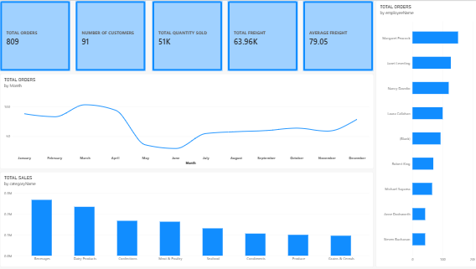
PRODUCT AND CUSTOMER ANALYSIS:
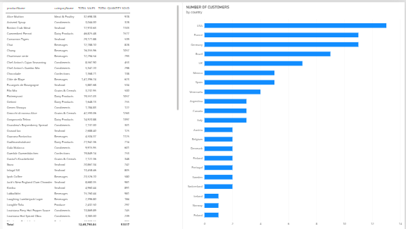
DASHBOARD:
