**A SHORT GLIMPSE OF NETFLIX WORLDWIDE**

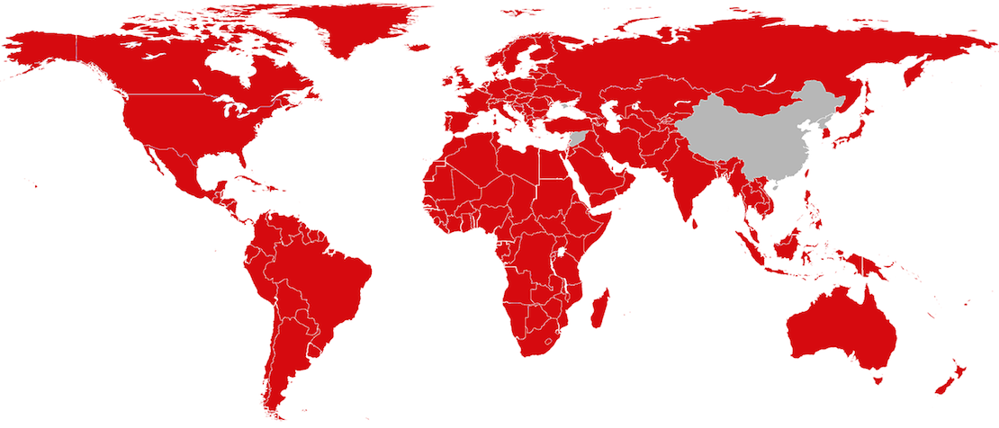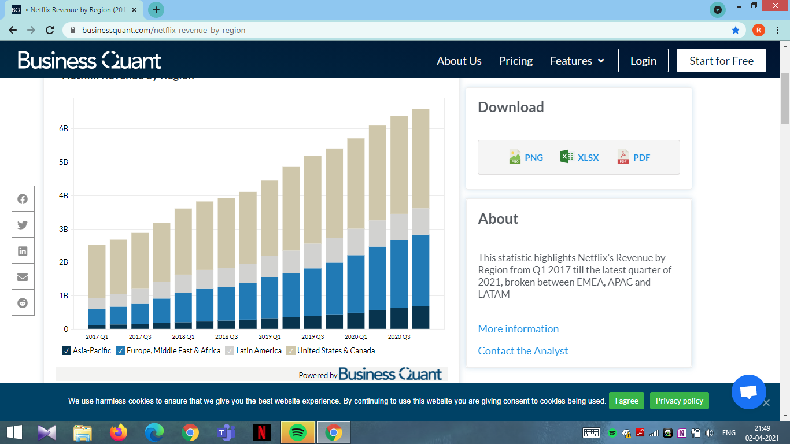

# 

# **Revenue by Region:**

Here it has been made clear that even though the United states and Canada (UCAN) had a slow growth in revenue of 11.90%, comparatively, still holds the largest number of paid memberships of Netflix, totalling 73.08 million unique users. Even with slow growth in revenue, UCAN provides more than 40% of total Netflix’s revenue from streaming service.

Latin America (LATAM) saw the slowest growth of revenue for Netflix out of all regions. Revenue from subscription was $ 789, only 6.47% YoY growth. The region makes up nearly 13% of Netflix’s total revenue from streaming service.

From European region, which includes the Middle East and Africa (EMEA), growth in revenue from subscriptions saw a boom, collecting over $ 2,019 million, 41.38% YoY growth. Total number of paid memberships at the end of Q3 were 62.24 million, second highest paid membership region for Netflix.

Netflix reported healthy growth of 66.23% of revenue for its APAC (Asia Pacific). Netflix’s APAC region was the fastest growing revenue segment in Q3 2020, totalling $ 635 million in revenue. Paid memberships from APAC region stood at 23.50 million at end of the Q3 2020.

Right from first quarter of 2017 to third quarter of 2020, Netflix witnessed 34% growth in paid memberships and 85% of quarterly revenues over the same period in the U.S. and Canada. EMEA and LATAM saw 216% and 150%, respectively, growth in their paid membership. The revenue from EMEA tripled in the latest quarter, growing by 319% in the latest quarter and for LATAM, it grew by 138%. The APAC region was the fastest growing region out of all in recent years. Even though being a small portion of the revenue segment, APAC shows great promises to be a significant part of Netflix. APAC region saw a rapid and steep increase of 404% in paid membership and 446% increase in revenue from 2017 till Q3 2020.

# **Subscriber figures:**

# 

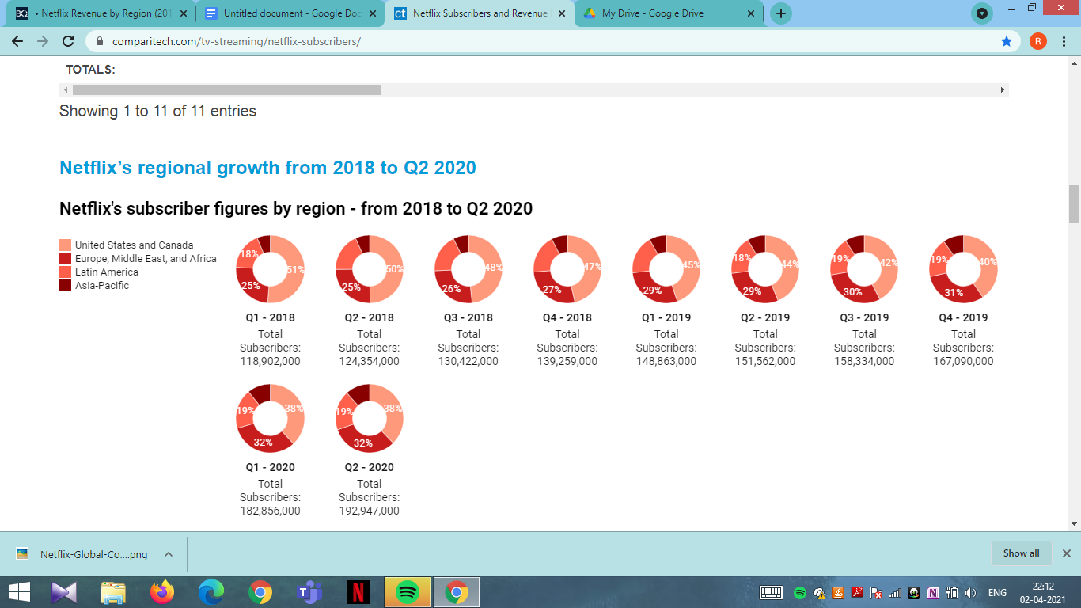

If we look at Netflix’s subscriber figures by region we can see that the predominant growth has been in the Europe, Middle East, and Africa region, with this forming a larger and larger chunk of Netflix’s subscriber base.

The US and Canada now form just over a third of Netflix’s subscriber base, compared to over half at the start of 2018, while subscriber figures within Latin America have remained pretty constant.

However, if we look at revenue growth by region, we can see that one of the biggest leaps in revenue came from Asia-Pacific.

# **Revenue growth:**

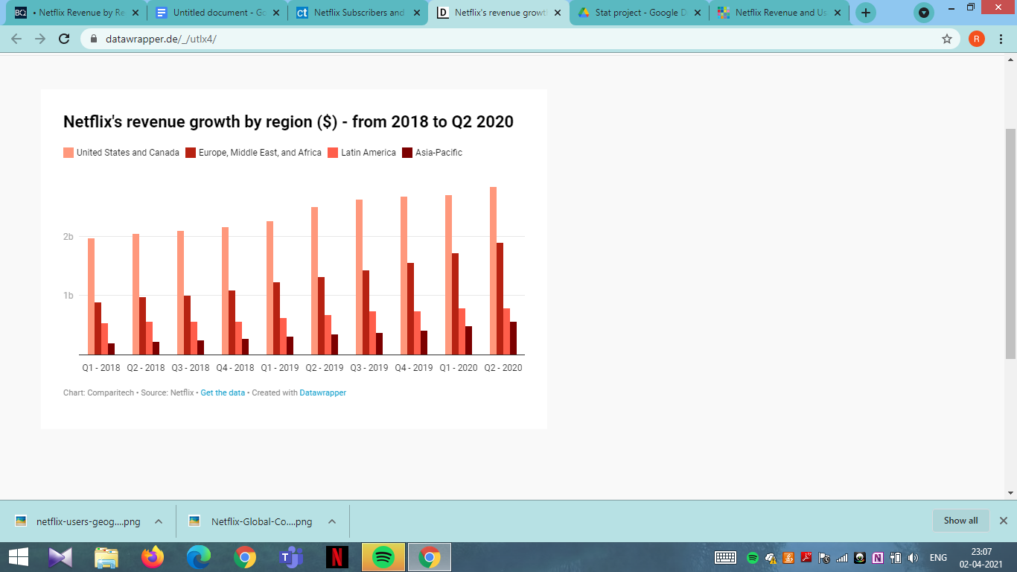

In Q1 of 2020, the Asia-Pacific region saw a 15.67 percent increase in revenue thanks to a 22.19 percent increase in subscriber figures. In Q2 of 2020, it saw a 17.67 percent increase in revenue thanks to the addition of a further 2.66 million subscribers.

Interestingly, the increases in this region aren’t due to an increase in the average monthly revenue per membership. Rather, since Q1 of 2018, the average revenue per membership has fallen in this region (from $9.37 in Q1 2018 to $8.94 in Q1 2020) or stayed much the same ($8.94 in Q1 and $8.96 in Q2 2020). This is likely due to Netflix’s attempts to further penetrate these markets,with ambitious plans to have 100 million subscribers in India alone .

In contrast, the growth in revenue in the US and Canada has plateaued somewhat over the last year. In Q1 and Q2 of this year, the revenue in this region only increased by 1.16 percent and 1.22 percent, respectively. In Europe, the Middle East and Africa, Q1 of 2020 saw a 10.3 percent increase in revenue and Q2 a 9.81 percent increase, while the Latin America region saw a 6.31 percent increase in Q1 and a 1.02 percent decrease in Q2.

**NETFLIX VS OTHER STREAMING SERVICES**

With 200+ million global subscribers, Netflix has capitalized on its position as the first and primary name in digital video streaming. Though its consumer base in the Americas has begun to plateau, the company’s growth in reach (190+ countries) and content ([70+ original movies](https://observer.com/2021/01/netflix-2021-movie-release-schedule-army-of-the-dead-red-notice/) slated for 2021) has put it more than 50 million subscribers ahead of its closest competition.There are several different competitors that threaten to chip away at market share from Netflix, they include:

### **Amazon Prime**

The biggest competitive threat to Netflix is probably Amazon (AMZN). As of the fourth quarter of 2019, Amazon Prime Video had about 150 million subscribers—a number that's been growing at a fast pace over the past two years as the company has increased production of its original content. Prime Video offers subscribers access to thousands of titles, ranging from feature films, documentaries, to television. 

**Hulu**

Hulu is an American subscription video on demand service fully controlled and majority-owned by The Walt Disney Company.The big news for Hulu came in May 2019 with the announcement of a deal between Comcast and Disney which had Disney purchasing Comcast's stake in Hulu for a reported $5.8 billion. This puts Disney in full control of Hulu and consolidates the competition as Disney makes a big push into the streaming services field.

### **Disney+**

Disney+ is an on-demand, commercial-free service which houses the entire library of Disney movies along with original Disney TV series. Included in the library are titles from Pixar, Marvel, features from the Star Wars enterprise, as well as National Geographic options. Netflix and Disney had an exclusive relationship, at least until the studio decided to jump into the streaming war. When Disney announced it was going to launch its own service, it ended the deal it had with Netflix. Netflix offered a number of titles from the studio but agreed to cut them all from its lineup in 2019.

**HBO Max**

HBO Max is an American subscription video on demand streaming service owned by AT&T through the WarnerMedia Direct subsidiary of WarnerMedia, and was launched on May 27, 2020. While built around content from namesake premium television service HBO, it principally serves as a content hub for WarnerMedia's various film and television properties, offering a range of original programming and library content from the company as well as additional content licensed through third-party distributors.

**YouTube**

YouTube is an American online video-sharing platform headquartered in San Bruno, California. TYouTube allows users to upload, view, rate, share, add to playlists, report, comment on videos, and subscribe to other users. Available content includes video clips, TV show clips, music videos, short and documentary films, audio recordings, movie trailers, live streams, video blogging, short original videos, and educational videos.

**Hotstar**

Hotstar is an Indian subscription video on-demand streaming service owned and operated by Star India, a subsidiary of The Walt Disney Company India. The service primarily features content from Star India's networks, including film, television, sports content, and original programming, as well as content from third-party partners such as HBO and Showtime.

# 

# **COMPETITORS OVER THE YEARS**

# 

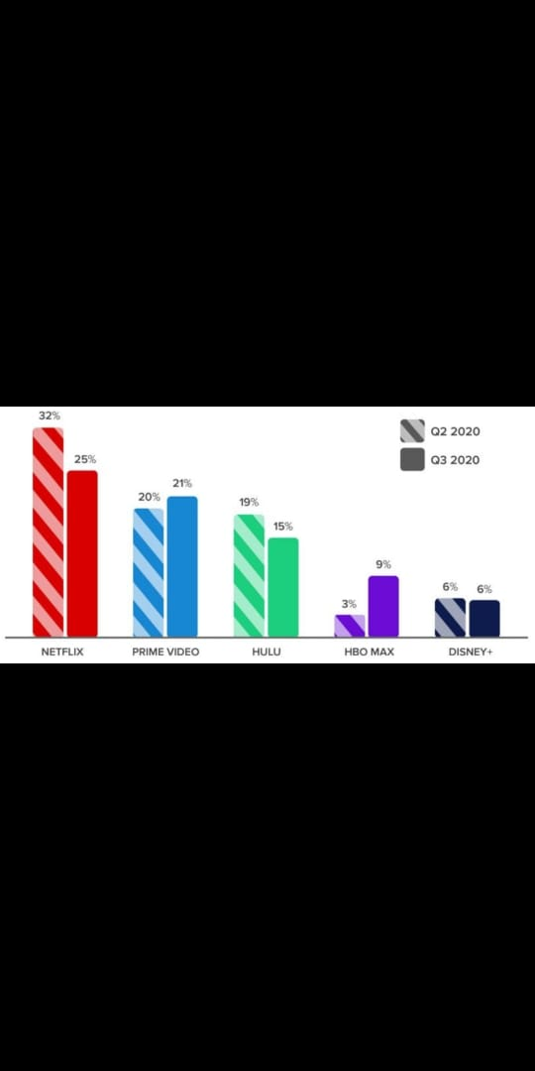

# **Subscriber figures of the platforms**

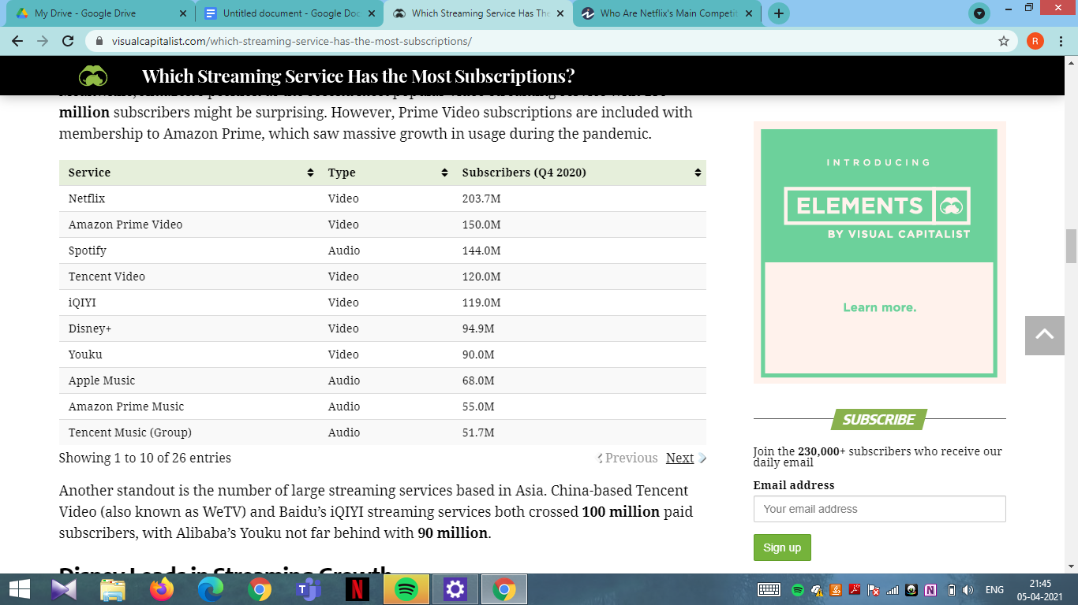

With 200+ million global subscribers, Netflix has capitalized on its position as the first and primary name in digital video streaming. Though its consumer base in the Americas has begun to plateau, the company’s growth in reach (190+ countries) and content (70+ original movies slated for 2021) has put it more than 50 million subscribers ahead of its closest competition.

Meanwhile, Amazon’s position as the second most popular video streaming service with 150 million subscribers might be surprising.

It is followed by:

### 

### **Content rated 7.5+ on IMDb**

# **Quality TV shows**

Amazon Prime Video has the most shows, but Netflix rules the competition with quality. When it comes to streaming originals, Netflix has most of the highest-rated TV show content, well ahead of the competition.