Name: Reetika Parle

# Main project (urls.py)

from django.contrib import admin

from django.urls import path,include

from core import views

urlpatterns = [

    path('admin/', admin.site.urls) ,

    path('home/',views.Home),

    path('about/',views.About),

    path('course/',include('course.urls')),

]

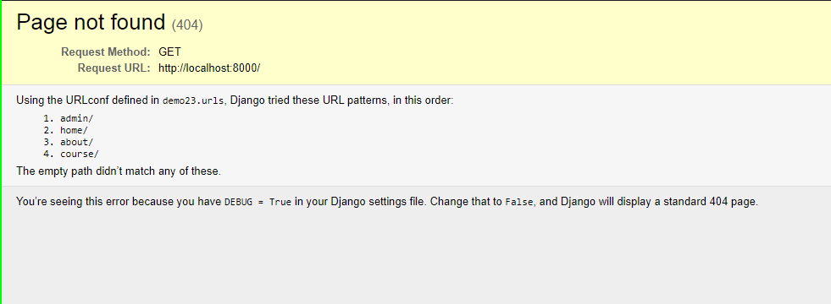

# Core

Views.py

from django.shortcuts import render

# Create your views here.

def Home(request):

    return render(request,'core/Home.htm')

def About(request):

    return render(request,'core/About.htm')

BASE FILE (base.html)

<!DOCTYPE html>

{% load static %}

<html lang="en">

<head>

    <meta charset="UTF-8">

    <meta http-equiv="X-UA-Compatible" content="IE=edge">

    <meta name="viewport" content="width=device-width, initial-scale=1.0">

    <title>{% block title %}{% endblock title %}</title>

    <link rel="stylesheet" href="{% static 'core/css/bootstrap.css' %}">

    <link rel="stylesheet" href="{% static 'core/css/all.min.css' %}">

    {% block corecss %}

    <link rel="stylesheet" href="{% static 'core/css/core.css' %}">

    {% endblock corecss%}

</head>

<body>

    <nav class="navbar navbar-expand-lg navbar-dark bg-dark">

        <a class="navbar-brand" href="#"> DJ</a>

        <button class="navbar-toggler" type="button" data-toggle="collapse" data-target="#navbarNav" aria-controls="navbarNav" aria-expanded="false" aria-label="Toggle navigation">

          <span class="navbar-toggler-icon"></span>

        </button>

        <div class="collapse navbar-collapse" id="navbarNav">

          <ul class="navbar-nav">

            <li class="nav-item active">

              <a class="nav-link" href=/home>Home <span class="sr-only"></span></a>

            </li>

            <li class="nav-item">

              <a class="nav-link" href=/about>About</a>

            </li>

            <li class="nav-item">

              <a class="nav-link" href=/course/learndj>Django course</a>

          </ul>

        </div>

      </nav>

    <h1>{% block content %}{% endblock content %}</h1>

    <script src= "{% static 'core/js/bootstrap.js' %}"></script>

    <script src= "{% static 'core/js/all.min.js' %}"></script>

</body>

</html>

CSS and JavaScript files included

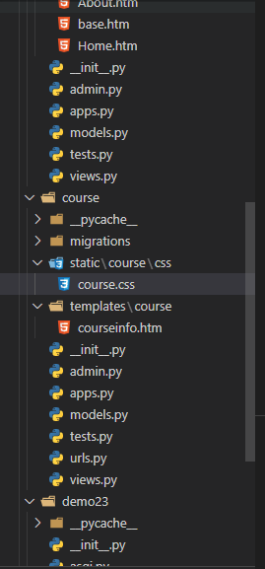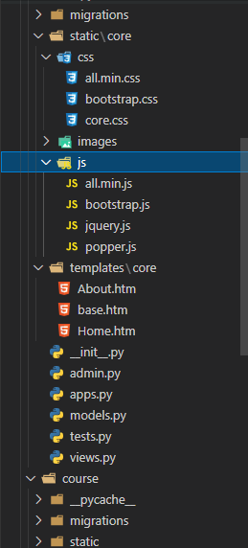

Home.html

{% extends 'core/base.htm' %}

{% block title %}Home{% endblock title %}

{% block content %}I am New Home Page<br>

<i class="fab fa-facebook-f"></i>

{% endblock content %}

About.html

{% extends 'core/base.htm' %}

{% block title %}Home{% endblock title %}

{% block content %}I am New About Page

<i class="fas fa-cart-plus"></i>

{% endblock content %}

Home page

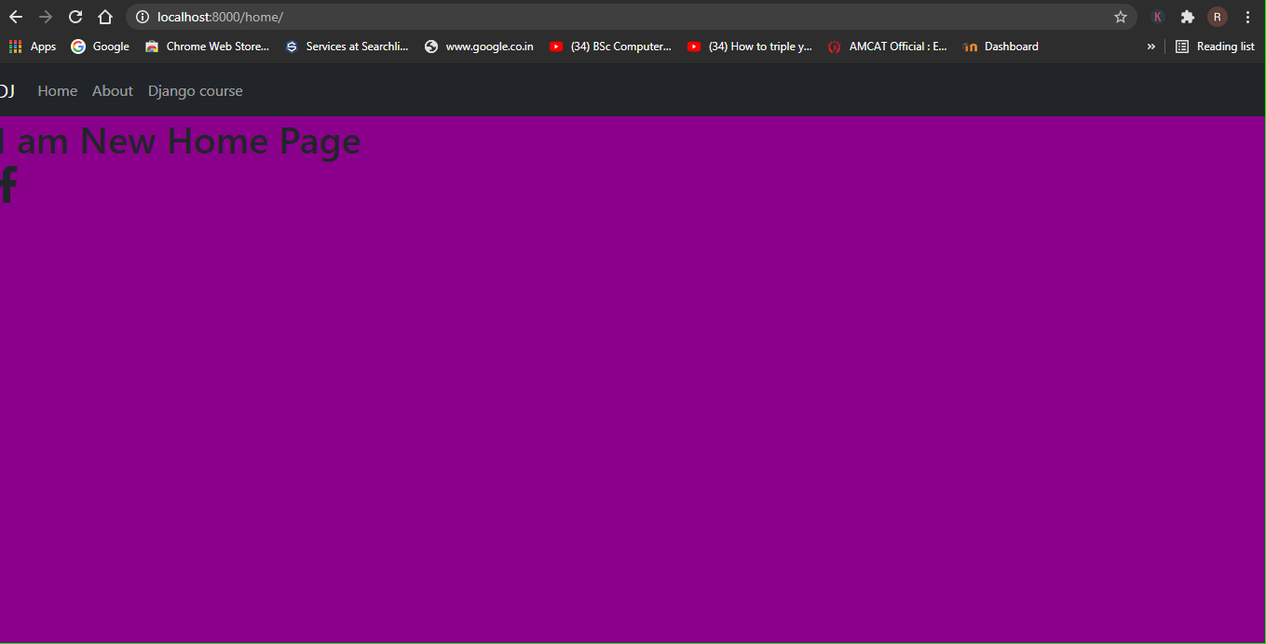

About page

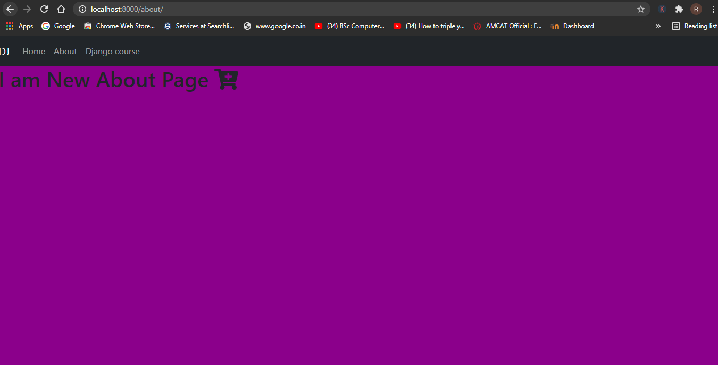

Course

# Urls.py

from django.urls import path

from .import views

urlpatterns = [

    path('learndj/',views.learn_django),

]

# Views.py

from django.shortcuts import render

# Create your views here.

def learn_django(request):

    return render(request,"course/courseinfo.htm")

# Courseinfo.html

{% extends 'core/base.htm' %}

{% load static %}

{% block corecss %}

{{block.super}}

    <link rel="stylesheet" href="{% static 'course/css/course.css' %}">

    {% endblock corecss%}

{% block title %}Course{% endblock title %}

{% block content %}I am Django course page{% endblock content %}

