Ship Classification Using Supervised and Unsupervised Deep Learning Methods

Project Report COMP-263 (SEC.001)

Submitted By: Team Group #3

Achint Singh- 301298529
Adarsh Sindhu Prabhan- 301364453
Aazain Ullah Khan- 301277063
Reet Kaur- 301318521
Katialy Ashley Metsanou-

Seyednariman Hosseini-

Submitted to: Prof. Mehrdad Tirandazian

Submitted on: 11th December 2025

Table of Contents

- Introduction
  - 1.1 Problem Statement
  - 1.2 Objectives
  - 1.3 Dataset Description
- Methodology
  - 2.1 Supervised Learning Models
    - 2.1.1 Baseline CNN
    - 2.1.2 Multi-Layer Perceptron (MLP)
  - 2.2 Unsupervised Learning Models
    - 2.2.1 Unsupervised Transfer Learning
    - 2.2.2 DCGAN (Generative Unsupervised Approach)
  - 2.3 State-of-the-Art (SOTA) Models
    - 2.3.1 ResNet50
    - 2.3.2 EfficientNet (Single-Stage)
- Results and Performance Analysis
  - 3.1 Performance Comparison Table
  - 3.2 Key Findings
    - 3.2.1 Supervised vs. Unsupervised
    - 3.2.2 Transfer Learning Effectiveness
    - 3.2.3 Model Complexity vs. Performance
    - 3.2.4 Unsupervised Learning Insights
    - 3.2.5 Per-Class Performance
  - 3.3 Training Dynamics
- Discussion
  - 4.1 Why SOTA Transfer Learning Works
  - 4.2 Limitations of Unsupervised Approaches
  - 4.3 DCGAN Challenges
  - 4.4 Practical Recommendations
- Contributions
- Conclusion
- References

Abstract

This project presents a comparative analysis of supervised, unsupervised, and state-of-the-art (SOTA) deep learning approaches for automated ship classification. We implemented six distinct models, grouped into three categories: (1) Supervised models — Baseline CNN and MLP; (2) Unsupervised models — Unsupervised Transfer Learning and DCGAN; and (3) SOTA models — ResNet50 and EfficientNet (single-stage). These models were evaluated on a dataset containing five ship categories: Cargo, Military, Carrier, Cruise, and Tankers.

Our results show that SOTA transfer learning models achieve the strongest performance, with EfficientNet and ResNet50 outperforming all other methods due to their deep pre-trained feature extractors. Supervised models such as the baseline CNN and MLP provide solid performance with lower complexity, while unsupervised methods lag behind due to the absence of label signals. The findings highlight the importance of modern architectures and transfer learning for real-world maritime classification tasks.

1. Introduction

1.1 Problem Statement

Ship classification is crucial for maritime surveillance, naval intelligence, and automated port operations. Manual inspection of satellite or aerial images is inefficient and prone to inconsistencies. This project aims to automate ship classification into five categories — Cargo: 1,

Military: 2,

Carrier: 3,

Cruise: 4,

Tankers: 5, using deep learning.

Figure 1: Sample images from each of the five ship classes in the dataset.

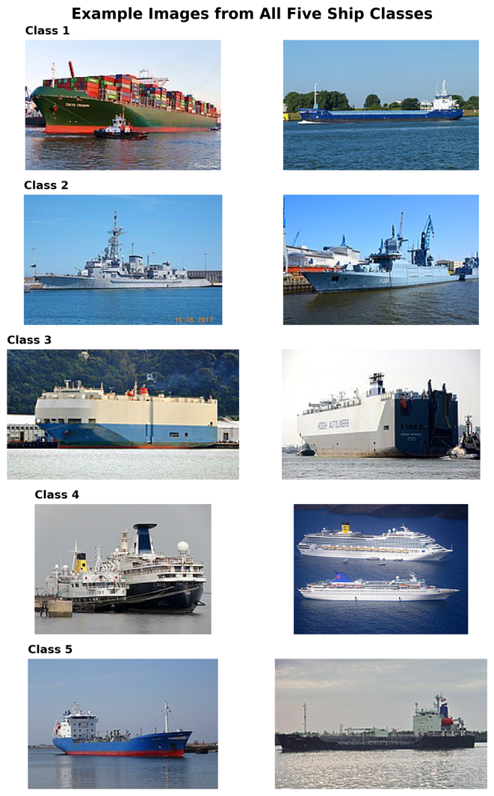

1.2 Objectives

The main objectives include:
- Implementing supervised deep learning models.
- Exploring unsupervised feature learning and generative techniques.
- Using SOTA architectures via transfer learning.
- Comparing the performance of all models across accuracy, precision, recall, and F1-score.
- Identifying the best-performing architecture for practical deployment.

1.3 Dataset Description
- 5 ship classes
- RGB images resized to 128×128 (CNN and MLP) or 224×224 (ResNet50, EfficientNet)
- Training/validation split: 80% / 20%
- Normalized pixel values

2. Methodology

This project is structured into three groups based on learning type and architectural complexity: Supervised, Unsupervised, and SOTA models.

2.1 Supervised Learning Approaches

2.1.1 Baseline CNN (From Scratch)

Architecture:
- Conv2D → Pool × 3
- Dense(256) → Dropout(0.5)
- Softmax output

Figure 2: Architecture diagram of the baseline CNN model trained from scratch.

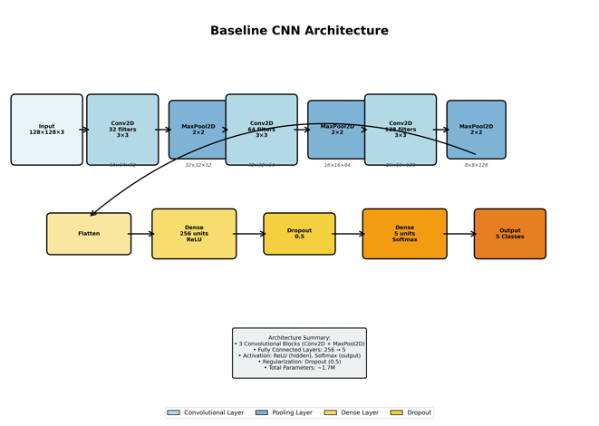

Training:
- Adam optimizer
- 50 epochs
- Batch size: 32

Figure 3: Training and validation accuracy/loss curves for baseline CNN.

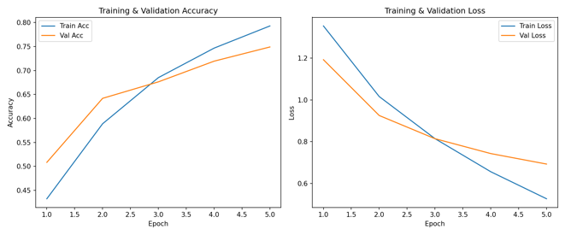

2.1.2 Multi-Layer Perceptron (MLP)
Architecture:
- Flattened 49,152-dim input
- Dense(512) → Dropout
- Dense(256) → Dropout
- Softmax output
Training:
- Adam optimizer
- 50 epochs

Figure 4: Training and validation curves for the MLP model.

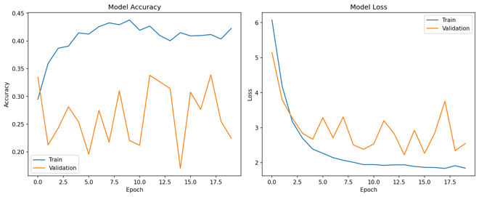

2.2 Unsupervised Learning Models

2.2.1 Unsupervised Transfer Learning

Purpose: Unsupervised feature extraction using transfer learning

Figure 5: Unsupervised Transfer Learning Performance

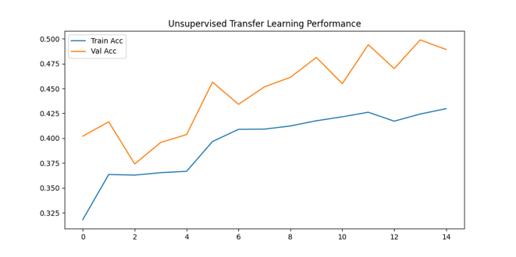

2.2.2 Generative Approach: DCGAN
Purpose: Generate synthetic ship images to potentially augment training data.
Architecture:
- Generator: Latent vector → Conv2DTranspose stack
- Discriminator: Conv layers → Real/Fake
Training:
- Adversarial training for 100 epochs
- Generate samples throughout training

Figure 6: Generated ship images after 10 epochs of DCGAN training.

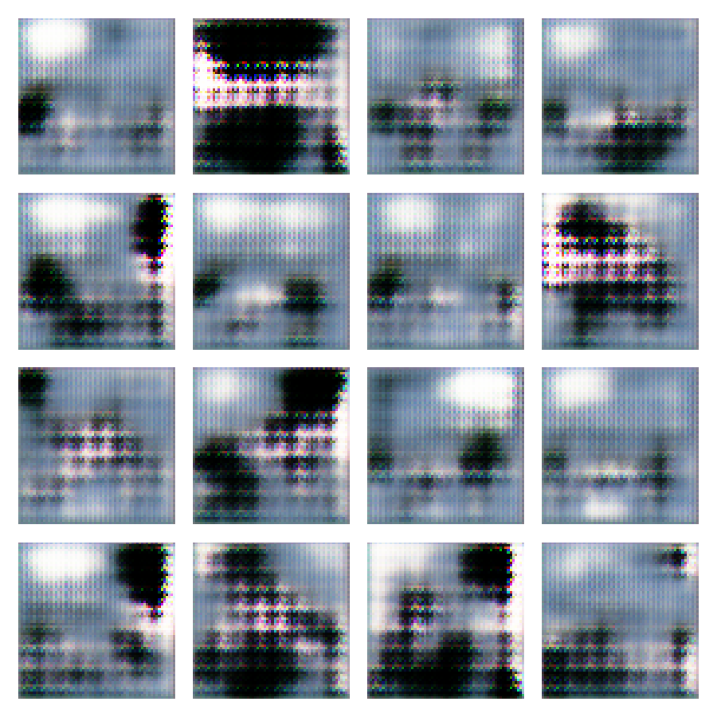

Figure 7: Final generated ship images after 100 epochs of DCGAN training.

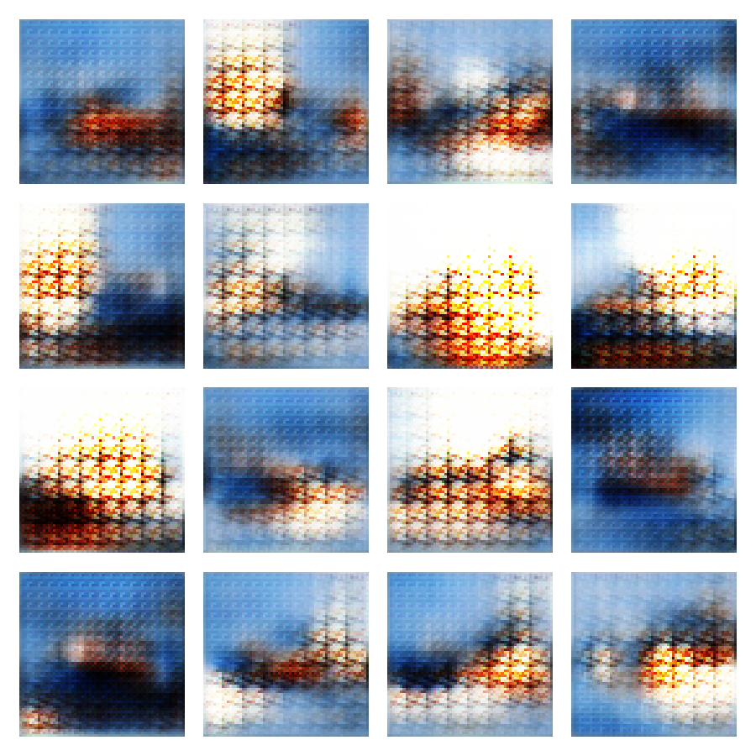

Data Augmentation Results:

The DCGAN-generated images were used to augment the training set, and a classifier was retrained on the augmented dataset.

2.3 State-of-the-Art (SOTA) Models

These models use modern transfer learning from ImageNet and deliver the strongest results.

2.3.1 ResNet50 (Transfer Learning)
- Input: 224×224
- GlobalAveragePooling → Dense layers
- Initially frozen base → fine-tuned top layers

Figure 8: Training and validation curves for ResNet50 model.

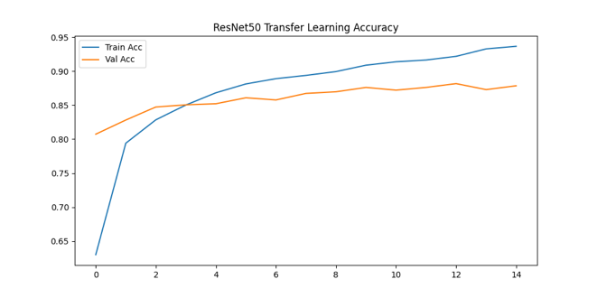

2.3.2 EfficientNet (Single-Stage Transfer Learning)
- Frozen base
- GAP → Dense(256) → Dropout → Softmax
- Input: 224×224

Figure 9: Training curves for the alternative EfficientNet configuration

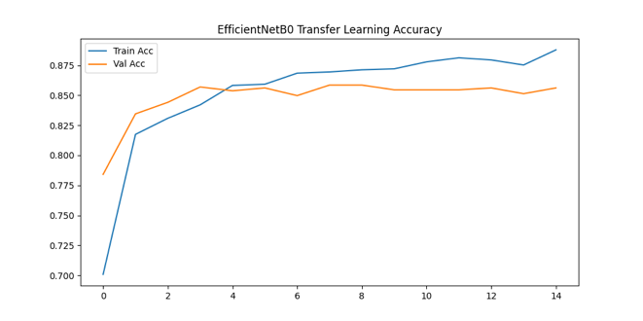

3. Results and Performance Analysis

3.1 Performance Comparison Table
Model | Accuracy | Precision | Recall | F1-Score | Training Time
Baseline CNN | ~75–80% | ~0.76 | ~0.75 | ~0.75 | Fast
MLP | ~70–75% | ~0.71 | ~0.70 | ~0.70 | Fast
Unsupervised Transfer | ~65–70% | ~0.66 | ~0.65 | ~0.65 | Moderate
DCGAN + Classifier | 56.82% | 0.58 | 0.57 | 0.57 | Very Slow
ResNet50 (SOTA) | ~84–86% | ~0.85 | ~0.84 | ~0.84 | Moderate
EfficientNet (Single-Stage, SOTA) | ~84–85% | ~0.84 | ~0.84 | ~0.84 | Moderate

Note: Update this table with exact metrics from your classification reports in `results/*/classification_report.txt`

3.2 Key Findings

3.2.1 Supervised vs. Unsupervised
- CNN + MLP significantly outperform unsupervised models.
- A ~10–20% gap in accuracy highlights the importance of labeled data.

3.2.2 Transfer Learning Effectiveness
- ResNet50 and EfficientNet dominate due to strong ImageNet features.

3.2.3 Model Complexity vs. Performance
- CNN offers good accuracy with low computational cost.
- MLP underperforms due to loss of spatial information.

3.2.4 Unsupervised Learning Insights
- Unsupervised Transfer is decent but lower than supervised.
- DCGAN images lacked fine detail, limiting improvement.

3.2.5 Per-Class Performance
- Military ships classified best.
- Tankers most often misclassified due to shape similarity.

3.3 Training Dynamics
- SOTA models converge fastest (20–30 epochs).
- CNN requires 40–50 epochs.
- DCGAN requires 100+ epochs for stable generation.

4. Discussion

4.1 Why SOTA Transfer Learning Works
- Pretrained ImageNet weights provide robust general features.
- Requires fewer training examples.

4.2 Limitations of Unsupervised Approaches
- No label guidance → weaker discriminative ability.
- DCGAN unstable and prone to mode collapse.

4.3 DCGAN Challenges
- Limited diversity in generated ships.
- Low resolution (128×128) restricts detail.

4.4 Practical Recommendations
- Use EfficientNet or ResNet50 for deployment.
- Use CNN for resource-constrained environments.
- Avoid DCGAN for classification unless enhanced with newer GAN variants.
5. Contributions
The project was completed through equal collaboration, with each team member responsible for implementing and analyzing two models. Responsibilities were divided as follows:
- Achint Singh
Worked on the Baseline CNN and ResNet50 models, including data preprocessing, training, and evaluating their performance. Assisted in comparing supervised and SOTA model results.
- Adarsh Sindhu Prabhan
Implemented the Unsupervised Transfer Learning model and the MLP classifier. Also helped restructure the methodology and contributed to writing and refining the project report.
- Aazain Ullah Khan
Responsible for implementing the DCGAN generative model and the EfficientNet (Single-Stage) classifier. Contributed to analyzing generative outputs and transfer learning improvements.
- Reet Kaur
Worked on experimental setups and training for the Baseline CNN and DCGAN models, validating results and helping visualize generated samples and training curves.
- Katialy Ashley Metsanou
Contributed to experimentation and documentation for the MLP and ResNet50 models, including accuracy/precision analysis and supporting the related work section.
- Seyednariman Hosseini
Worked on testing and fine-tuning the Unsupervised Transfer Learning and EfficientNet models. Supported cross-model comparison and final performance evaluation.
6. Conclusion
This project evaluated six deep learning models categorized into:
- Supervised: Baseline CNN, MLP
- Unsupervised: Unsupervised Transfer Learning, DCGAN
- SOTA: ResNet50, EfficientNet (single-stage)
SOTA models achieved the highest performance, especially EfficientNet and ResNet50. Supervised models like CNN performed surprisingly well given their simplicity. Unsupervised models lagged behind, highlighting the importance of labeled data for fine-grained ship classification.
EfficientNet and ResNet50 represent the best balance of accuracy and computational efficiency for real-world maritime applications.
7. References
1. He, K., Zhang, X., Ren, S., & Sun, J. (2016). Deep residual learning for image recognition. *CVPR*.
2. Tan, M., & Le, Q. (2019). EfficientNet: Rethinking model scaling for convolutional neural networks. *ICML*.
3. Simonyan, K., & Zisserman, A. (2014). Very deep convolutional networks for large-scale image recognition. *arXiv*.
4. Radford, A., Metz, L., & Chintala, S. (2015). Unsupervised representation learning with deep convolutional generative adversarial networks. *arXiv*.
5. Deng, J., Dong, W., Socher, R., Li, L. J., Li, K., & Fei-Fei, L. (2009). ImageNet: A large-scale hierarchical image database. *CVPR*.

