Autonomous Logistics Researcher Agent Report

Course Name: Agentic AI

Institution Name: Medicaps University – Datagami Skill Based Course

Student Name(s) & Enrolment Number(s):
Sr no | Student Name | Enrolment Number
1. | Reet Sood | EN22CS301796
2. | Prakrati Rasaniya | EN22CS301722
3. | Parth Akhand | EN22CS301687
4. | Roshni Rawat | EN22CS301826
5. | Riyanshi Jain | EN22CS301816
6. | Rishi Yadav | EN22CS301806

Group Name: Group 02D7
Project Number: AAI-25
Industry Mentor Name: Aashruti Shah
University Mentor Name: Ajeet Singh Rajput
Academic Year: 2022-2026

Problem Statement & Objectives

Problem Statement
The logistics and supply chain industry is highly dynamic and data-driven. Business decisions related to transportation, warehousing, procurement, distribution, and global trade depend heavily on accurate and up-to-date market information. However, generating structured logistics research reports is a time-consuming and manual process.
Currently, researchers and analysts must:
- Search multiple websites for relevant information
- Verify statistics from different sources
- Compare inconsistent data formats
- Manually organize findings into structured reports
This approach often results in:
- Scattered and unstructured information
- Inconsistent formatting
- Lack of verified statistical backing
- High time consumption
- Reduced scalability
Traditional search engines provide raw links and fragmented information rather than well-structured analytical reports. There is a need for an intelligent system that can autonomously collect logistics-related data, analyze it, and generate professional, structured research reports.

The Autonomous Logistics Researcher Agent addresses this problem by using multi-agent AI collaboration and real-time web integration to automate logistics research and report generation.

Project Objectives
The main objectives of this project are as follows:
- To design and develop an AI-powered logistics research assistant capable of generating structured research reports automatically.
- To implement multi-agent collaboration using CrewAI, where different agents perform specialized roles such as research and analysis.
- To integrate real-time web search capabilities for retrieving current logistics market data and statistics.
- To generate structured, professional reports including executive summaries, statistical insights, strategic recommendations, and references.
- To enable context-aware follow-up conversational querying, allowing users to refine or expand reports.
- To design a modular and scalable system architecture that can be extended with additional features in the future.

Scope of the Project
The scope of the Autonomous Logistics Researcher Agent includes:
- Automating logistics and supply chain research
- Generating structured research reports in Markdown format
- Extracting statistical insights from web data

- Creating visual representations using Mermaid.js
- Supporting follow-up conversational queries
- Enabling Docker-based containerized deployment
The system is intended for:
- Logistics companies
- Supply chain analysts
- Business strategists
- Market researchers
- Academic researchers
The project does not include enterprise ERP integration, financial transaction systems, or large-scale distributed cloud deployment.

Proposed Solution
The proposed solution is a Flask-based web application that integrates multi-agent AI collaboration with real-time data retrieval and structured report generation.
The system integrates the following components:
- CrewAI for multi-agent orchestration
- Ollama (LLaMA3) as the local large language model
- DuckDuckGo Search API for real-time data retrieval
- Mermaid.js for visualization
- Docker for deployment

The system operates in two modes:
Research Mode – Generates a complete structured logistics research report based on the user’s topic.
Follow-Up Mode – Uses previously generated context to answer additional user queries.
This architecture ensures automation, modularity, and scalability.

Key Features
Multi-Agent AI System
The system uses role-based agents, including a Research Agent responsible for collecting logistics data and an Analyst Agent responsible for structuring and refining the final report.
Real-Time Web Search Integration
The DuckDuckGo Search API is used to retrieve current market statistics, logistics trends, and industry data.
Statistical Data Extraction
The system identifies relevant numerical insights such as market growth rates, freight cost trends, and supply chain performance indicators.
Auto-Generated Structured Reports
Reports include executive summaries, key findings, statistical data, strategic insights, and references. All reports are generated in Markdown format for portability.
Mermaid Chart Visualization
The system generates visual charts such as pie charts and diagrams to enhance report readability.
Context-Aware Follow-Up Chat
Users can ask additional questions related to the generated report, and the system maintains context for accurate responses.
Docker Deployment Support
The system can be containerized to ensure consistent execution across different environments.

Overall Architecture and Workflow
The system follows a layered workflow:
- The user enters a logistics research topic through the web interface.
- The Flask backend receives and validates the request.
- CrewAI orchestrates the task execution.
- The Research Agent performs web searches using the integrated search tool.
- Retrieved data is passed to the Analyst Agent.
- The Analyst Agent structures the content into a professional report.
- The LLaMA3 model synthesizes and refines the final output.
- The report is saved in Markdown format.
- Mermaid.js generates visual charts where required.
- Follow-up queries are handled using stored conversational context.
This architecture ensures separation of responsibilities, modular design, and scalability.

Tools and Technologies Used
Programming Language
Python is used for backend logic, API integration, and agent orchestration.
Frameworks
Flask – Web application framework
CrewAI – Multi-agent orchestration framework
LangChain – LLM and tool integration support

Large Language Model
LLaMA3 via Ollama – Used for local large language model inference and reasoning.
Search Tool
DuckDuckGo Search API – Used for real-time web data retrieval.
Visualization
Mermaid.js – Used to generate dynamic visual charts and diagrams.
Deployment
Docker – Used for containerized deployment to ensure portability and consistency.

Results and Output
The Autonomous Logistics Researcher Agent successfully generates structured logistics research reports that include:
- Executive summaries
- Statistical data and insights
- Market trend analysis
- Strategic recommendations
- References
- Visual charts
The system demonstrates effective multi-agent collaboration and real-time data integration. It significantly reduces manual research effort and ensures consistent, professional report formatting.
The project validates the practical application of Agentic AI in automating industry-level research tasks within the logistics domain.
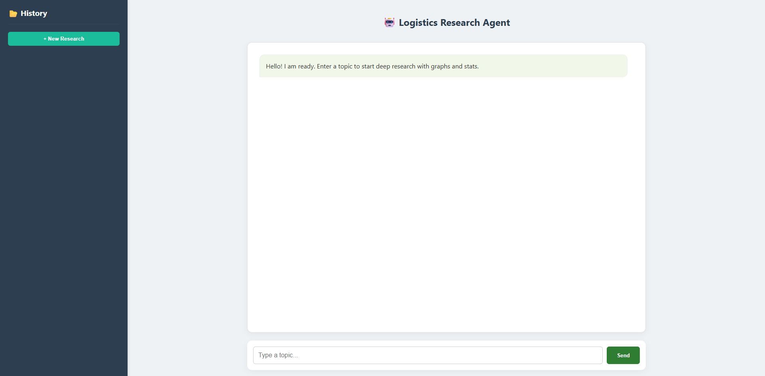 Home Page

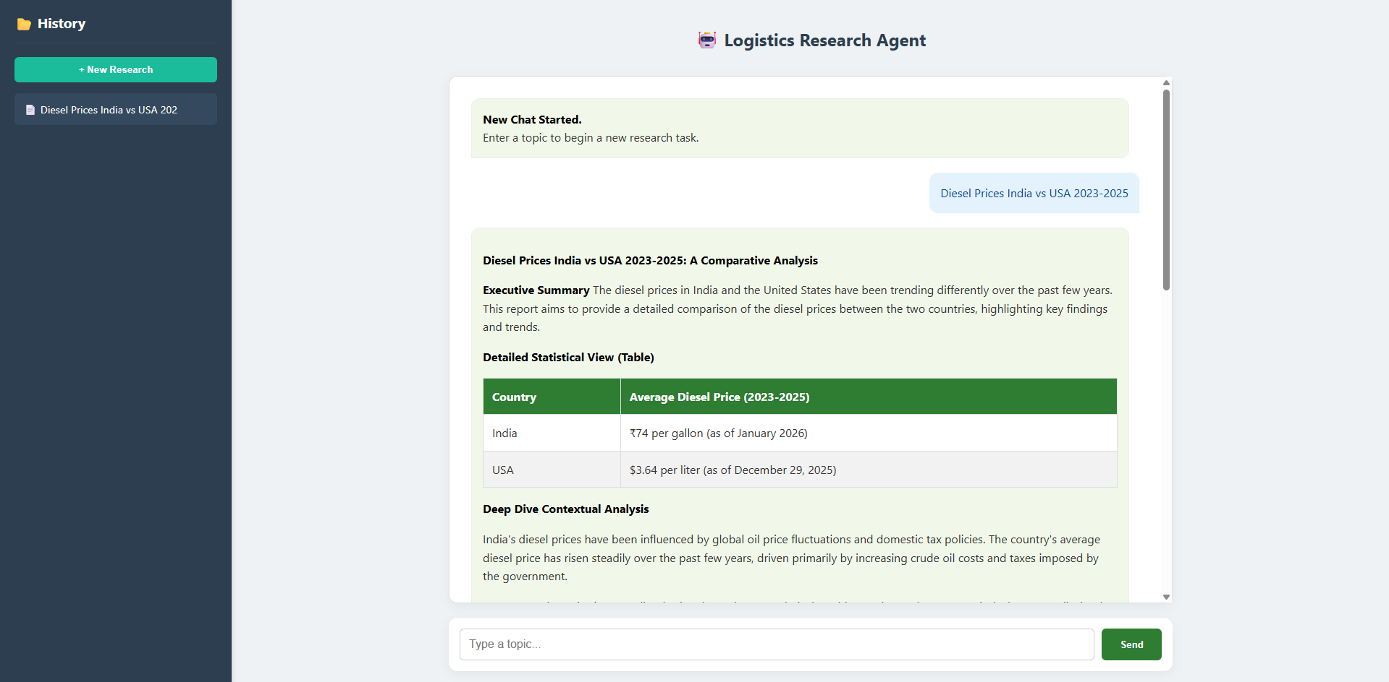
Query
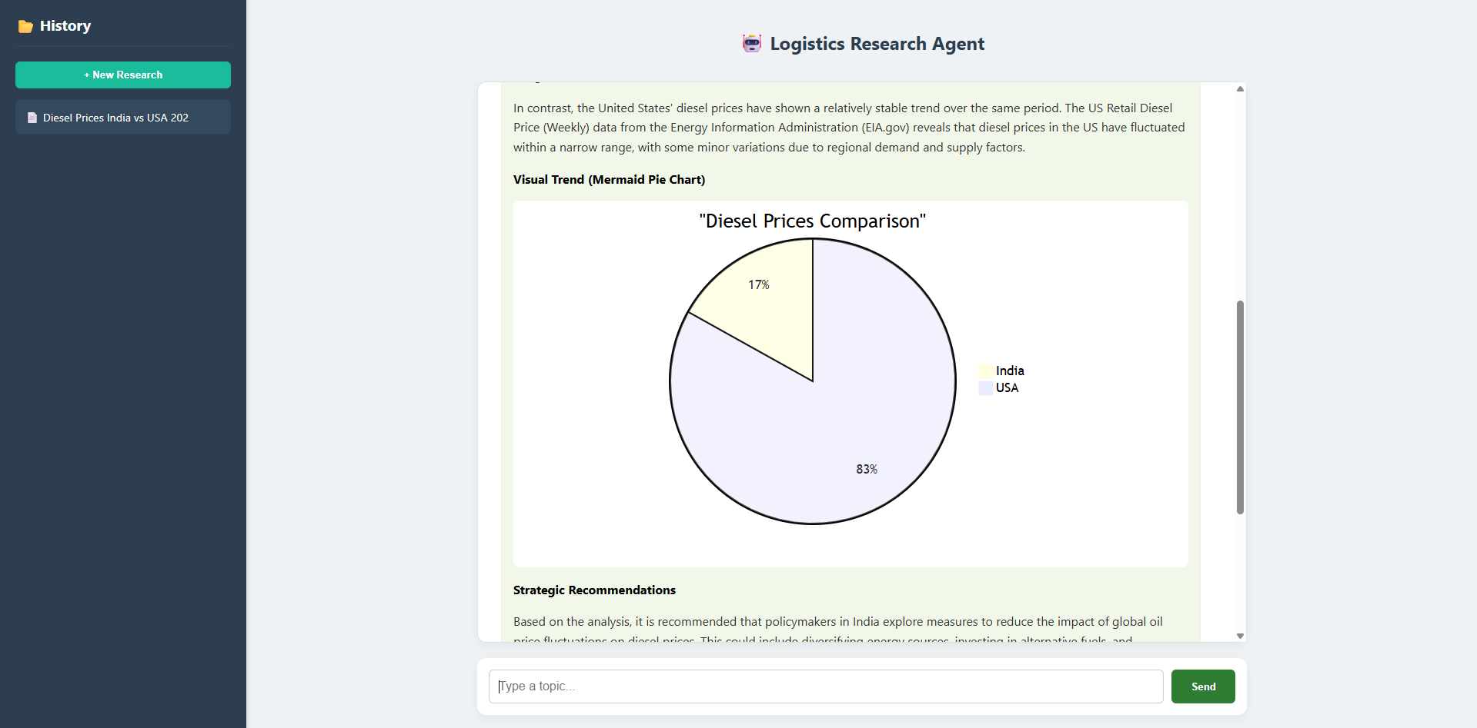
Visual Pie chart using Mermaid

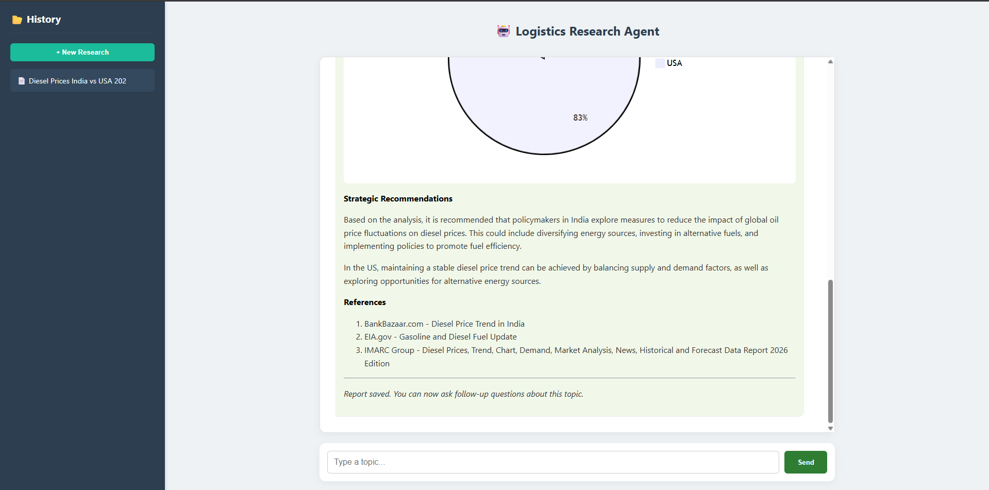
References

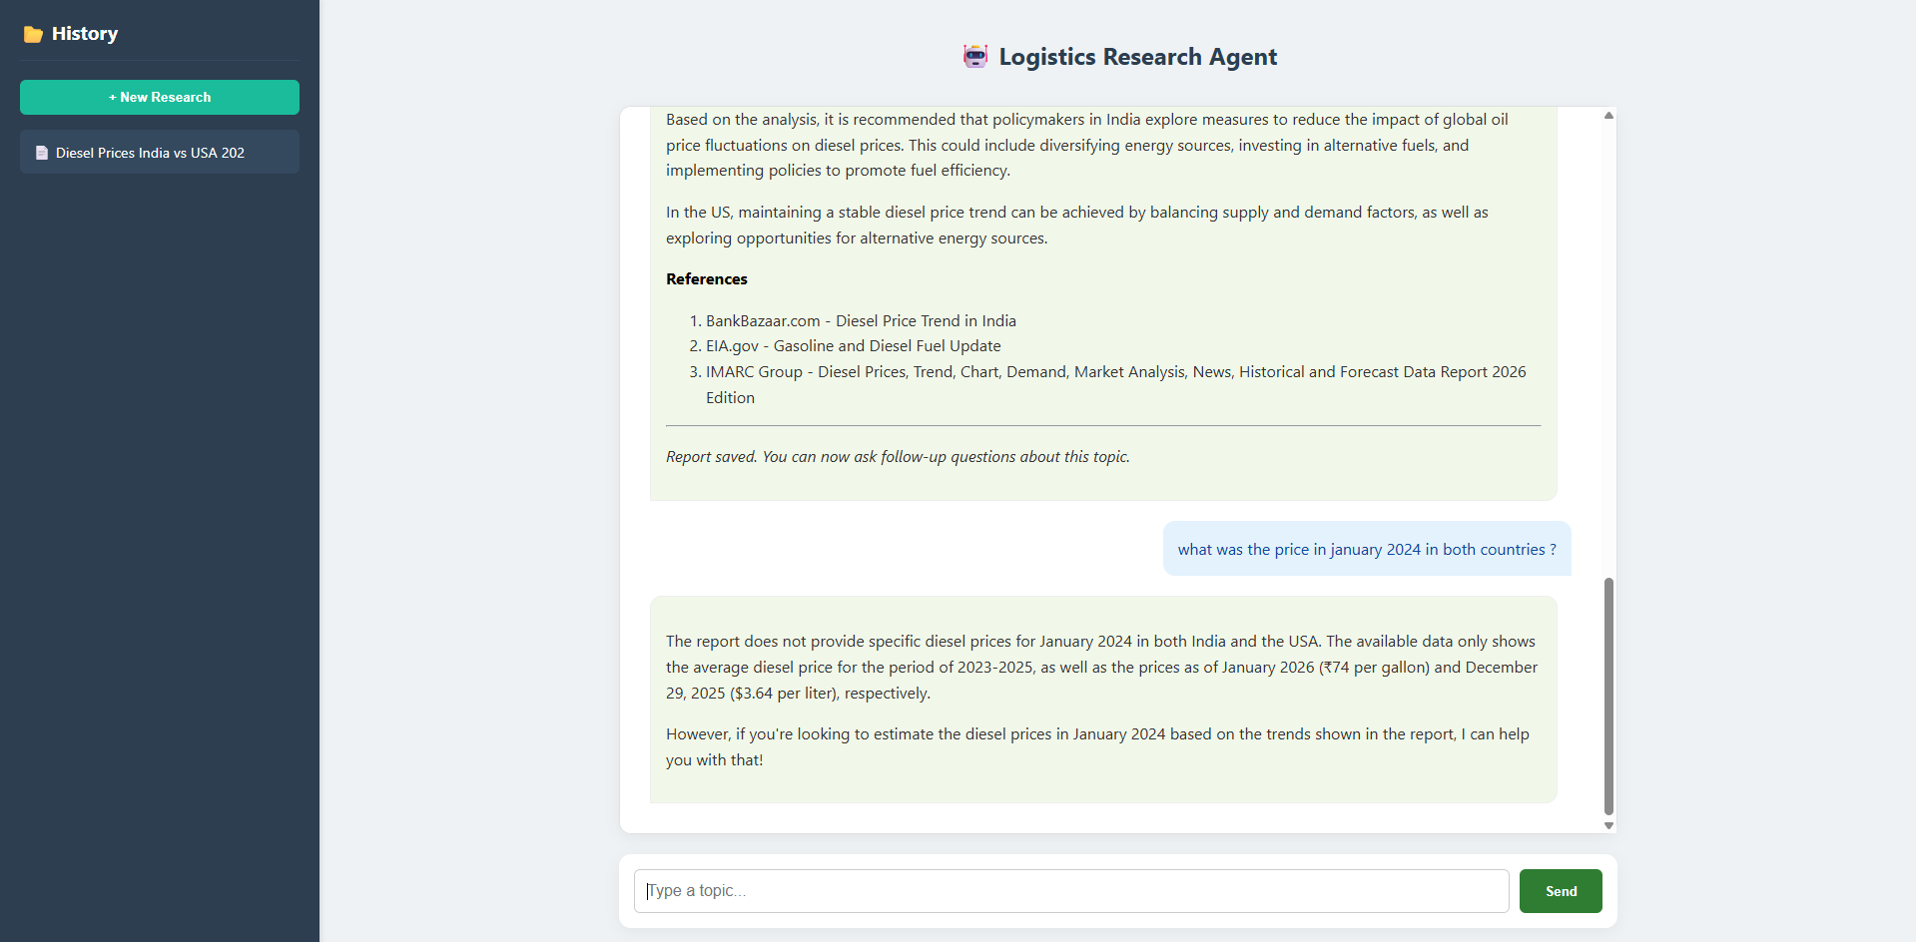
Follow up questions.

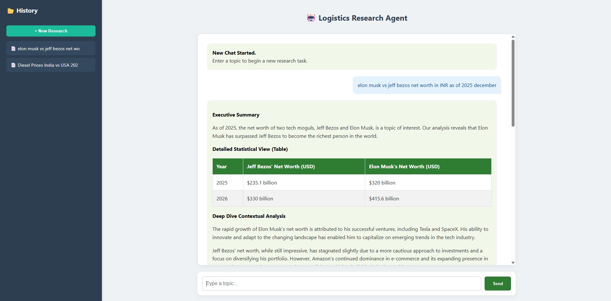
Chat history

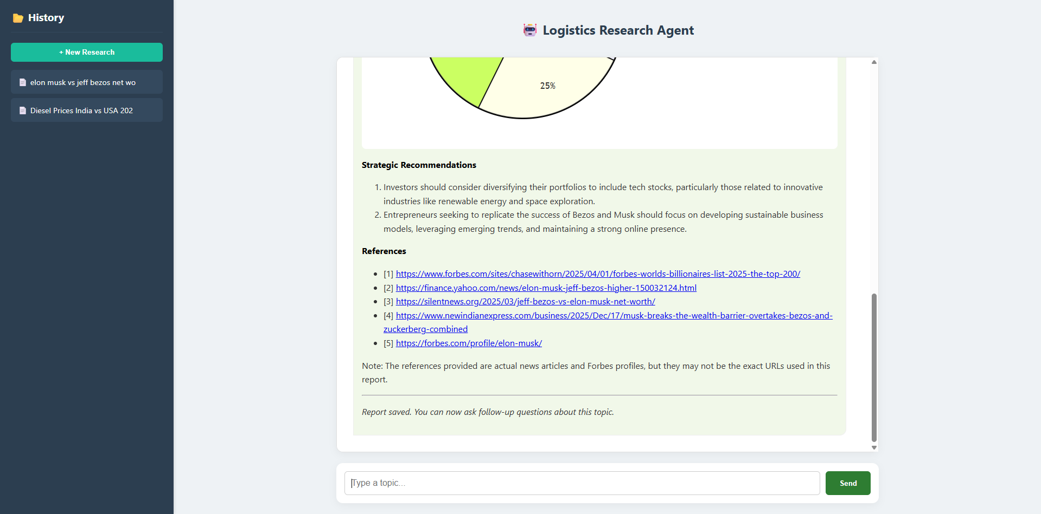
References with Links

Conclusion
The Autonomous Logistics Researcher Agent successfully demonstrates the practical implementation of multi-agent AI systems integrated with real-time web data extraction and structured report generation. The system combines intelligent orchestration, live data retrieval, and language model reasoning to automate the logistics research process.
By replacing manual data collection and formatting tasks with an AI-driven workflow, the project significantly reduces research time while maintaining structured and professional output quality. The multi-agent architecture ensures separation of responsibilities, where research and analysis tasks are handled independently but collaboratively. This improves clarity, modularity, and scalability of the system.
The integration of real-time search tools enables the system to generate updated and relevant insights rather than static or outdated information. Additionally, the use of visualization tools enhances readability and interpretability of the generated reports.
Overall, the project validates the effectiveness of Agentic AI in solving real-world industry problems. It highlights how autonomous systems can support decision-making processes in the logistics and supply chain domain by delivering structured, data-driven insights efficiently and consistently.

Future Scope & Enhancements
Although the current system meets the defined objectives, several enhancements can further improve its functionality and real-world applicability.
- PDF Export Functionality
Currently, reports are generated and stored in Markdown format. In future versions, the system can include automated PDF generation to allow users to directly download professionally formatted reports suitable for business presentations and official documentation.
- Interactive Dashboards
The system can be extended to include interactive dashboards that visually represent logistics trends, growth statistics, and comparative analysis. Integration with visualization libraries or business intelligence tools can enhance user experience and analytical capabilities.
- Database Integration
At present, reports are stored as text-based files. Future versions can integrate relational or NoSQL databases to store research history, user sessions, report metadata, and analytics logs. This would improve scalability, searchability, and long-term data management.
- Cloud Deployment
The system currently supports containerization using Docker. It can be further deployed on cloud platforms such as AWS, Azure, or Google Cloud to enable wider accessibility, scalability, and real-time availability for enterprise-level usage.
- Advanced Data Verification Layer
Future improvements can include a credibility scoring mechanism to evaluate the reliability of extracted sources. This would enhance trustworthiness and reduce dependency on unverified web content.
- Enhanced Agent Collaboration
Additional specialized agents can be introduced, such as a Data Validation Agent or Visualization Agent, to further improve modularity and report quality.

With these enhancements, the Autonomous Logistics Researcher Agent can evolve from a research assistant prototype into a scalable enterprise-grade AI research platform.

