**GRAPHS AND CHARTS**

# How People feel during lockdown

data1<-read.csv("dataset.csv",header=TRUE)

data1

data1 %>%select(feel_during)

data2<-data.frame(data1)

detach(data2)

attach(data2)

class(data2)

summary(data2$feel_during)

Length Class Mode

92 character character

table(feel_during)

Content Happy Restless

27 20 45

So mode is restless as it has appeared maximum no of times

(table(feel_during)/92)*100

lbls<-paste(names(table(feel_during)),(table(feel_during)/92)*100,"%")

pie(table(df$feel_during),labels = lbls,main="How People feel during lockdown",col=c("red","orange","purple"))

legend("bottomleft", c("Happy","Content","Restless")ex = 0.8,fill=c("orange","red","purple"))

box()

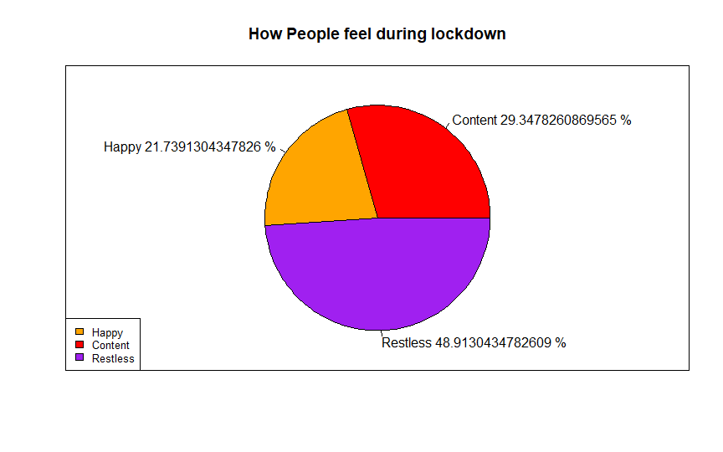

# Was there an increase in screen time

table(screen_time)

screen_time

No Yes

11 81

names(table(screen_time))

[1] "No" "Yes"

(table(screen_time)/92)*100

screen_time

No Yes

11.95652 88.04348

lbls_1<-paste(names(table(screen_time)),(table(screen_time)/92)*100,"%")

pie(table(df$screen_time),labels = lbls_1,main = "Was there an increase in screen time",col = c("red","orange"))

legend("bottomleft",c("Yes","No"),cex = 0.8,fill = c("orange","red"))

box()

|  |
| --- |
|  |

|  |
| --- |
|  |
|  |

# How often do you hear from your teachers

table(teacher)

teacher

Always Never Sometimes

22 11 59

> names(table(teacher))

[1] "Always" "Never" "Sometimes"

> (table(teacher)/92)*100

teacher

Always Never Sometimes

23.91304 11.95652 64.13043

> lbls_2<-paste(names(table(teacher)),(table(teacher)/92)*100,"%")

> pie(table(df$teacher),labels = lbls_2,main = "How often do you hear from your teachers",col = c("red","orange","purple"))

> legend("bottomleft",c("Always","Sometimes","Never"),cex = 0.8,fill = c("orange","red","purple"))

> box()

# Difference in monthly expense

table(monthly.expense)

monthly.expense

Decreased Increased Remains the same

30 36 26

> names(table(monthly.expense))

[1] "Decreased" "Increased" "Remains the same"

> (table(monthly.expense)/92)*100

monthly.expense

Decreased Increased Remains the same

32.60870 39.13043 28.26087

> lbls_3<-paste(names(table(monthly.expense)),(table(monthly.expense)/92)*100,"%")

> pie(table(df$monthly.expense),labels = lbls_3,main = "Difference in monthly expense",col = c("red","orange","purple"))

> legend("bottomleft",c("Increased","Decreased","Remains the same"),cex = 0.8,fill = c("orange","red","purple"))

> box()

# Importance of climate change

table(climate)

climate

No Yes

20 72

> names(table(climate))

[1] "No" "Yes"

> (table(climate)/92)*100

climate

No Yes

21.73913 78.26087

> lbls_4<-paste(names(table(climate)),(table(climate)/92)*100,"%")

> pie(table(df$climate),labels = lbls_4,main = "Importance of climate change",col = c("red","orange"))

> legend("bottomleft",c("Yes","No"),cex = 0.8,fill = c("orange","red"))

> box()

# College re-opening

table(college)

college

No Yes

33 59

> names(table(college))

[1] "No" "Yes"

> (table(college)/92)*100

college

No Yes

35.86957 64.13043

> lbls_5<-paste(names(table(college)),(table(college)/92)*100,"%")

> pie(table(df$college),labels = lbls_5,main = "College re-opening",col = c("red","orange"))

> legend("bottomleft",c("Yes","No"),cex = 0.8,fill = c("orange","red"))

> box()

working_hours_before<-table(working_hours_before)

working_hours_before

0-2 hours 2-5 hours More than 5

6 41 45

Mode of working_hours_before is More than 5

working_hours_during<-table(working_hours_during)

0-2 hours 2-5 hours More than 5

40 26 26

Mode of working_hours_during is 0-2 hours

ta=rbind(working_hours_before,working_hours_during)

ta

0-2 hours 2-5 hours More than 5

working_hours_before 6 41 45

working_hours_during 40 26 2

barplot(height=ta,beside = TRUE,col=c('red','yellow'),xlab='Hours spent on working',ylab='no of students')

legend('topright',legend=c('working hours before','working hours during'),fill=c('red','yellow'))

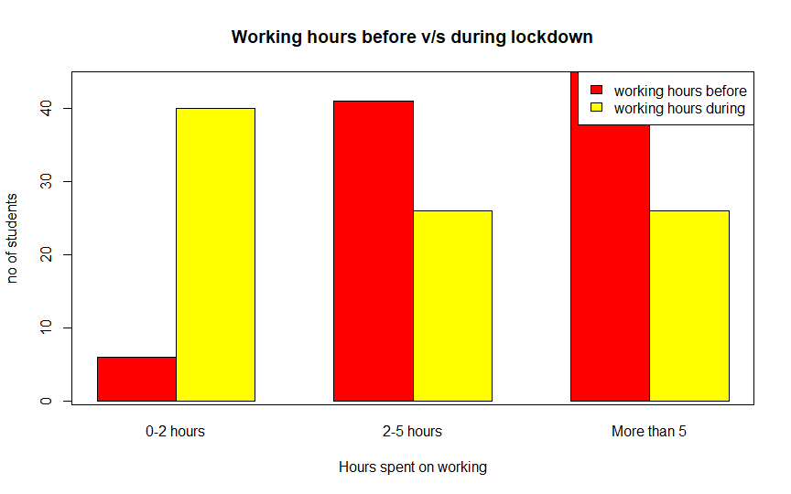

rate_offline<-table(data2$rate_offline_learning_platform)

rate_offline

Ratings : 1 2 3 4 5

No. of students:5 3 8 41 35

rate_online<-table(data2$rate_online_learning_platform)

rate_online

rate_offline<-table(data2$rate_offline_learning_platform)

rate_offline

Ratings : 1 2 3 4 5

No. of students:5 3 8 41 35

rate_online<-table(data2$rate_online_learning_platform)

rate_online

Ratings: 1 2 3 4 5

No. of students:8 25 32 17 10

gg=rbind(rate_offline,rate_online)

gg

1 2 3 4 5

rate_offline 5 3 8 41 35

rate_online 8 25 32 17 10

Maximum people finds offline as better learning platform

barplot(height=gg,beside = TRUE,col=c('red','yellow'),xlab='Rating scale',ylab='no of students')

legend('topleft',legend=c('online learning platform','offline learning platform'),fill=c("yellow","red"))

box()

data10<-read.csv("dataset2.csv",header=TRUE)

data10

social_median no_of_people

1 WhatsApp 79

2 Instagram 66

3 Facebook 21

4 Telegram 19

5 Twitter 11

6 Other 5

|  |
| --- |
|  |
|  |
|  |

indices<-data10[,2]!=0

pie(data10[,2][indices],labels = data10$social_media,col=c("red","orange","green","pink","purple","yellow"),main="social media platform that students mostly during covid lockdown")

legend("topright",legend=data10$social_media,fill=c("red","orange","green","pink","purple","yellow"))

box()

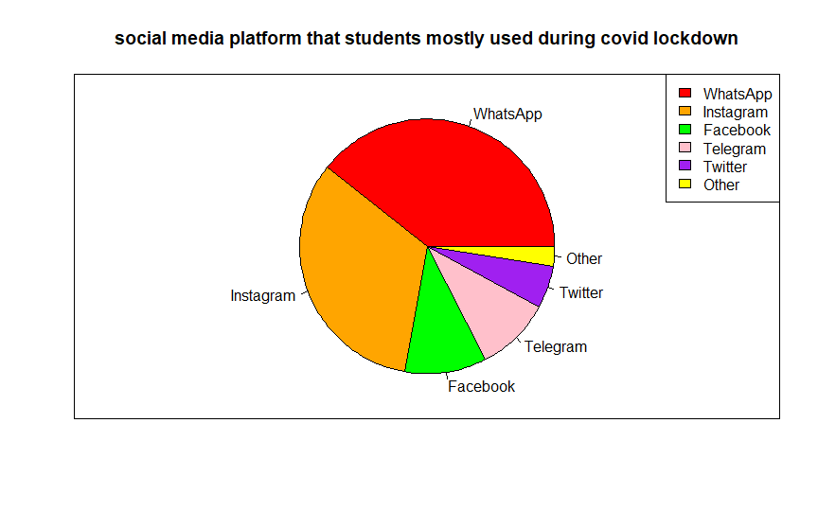

data20<-read.csv("dataset3.csv",header=TRUE)

data20

subscribed no_of_subscriptions

1 Amazon Prime 55

2 Netflix 60

3 Hotstar 35

4 Zee 5 12

5 other 2

6 None 7

indice<-data10[,2]!=0

pie(data10[,2][indice],labels = data20$subscribed,col=c("red","orange","green","pink","purple","yellow"),main="OTT platforms that students subscibed during covid lockdown")

legend("topright",legend=data20$subscribed,fill=c("red","orange","green","pink","purple","yellow"))

box()

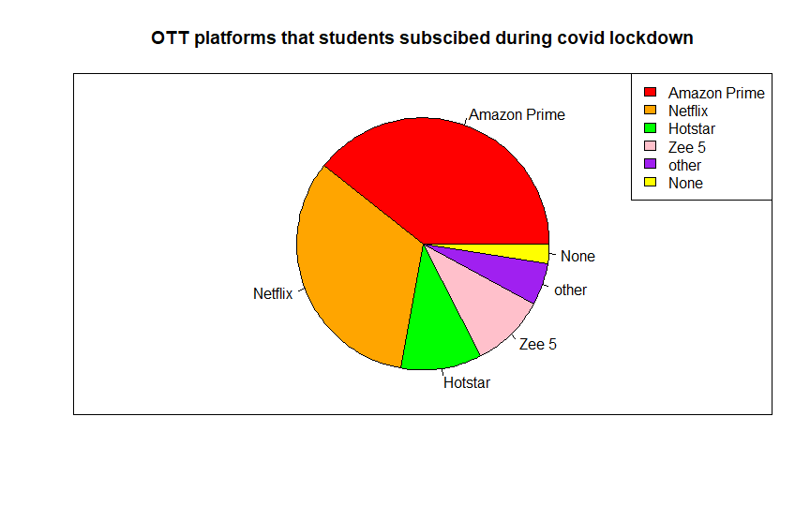

d<-read.csv("dataset.csv",header=TRUE)

d$physically_active_before

physically_active_during<-table(d$physically_active_during)

physically_active_before<-table(d$physically_active_before)

physically_active_during

Ratings: 1 2 3 4 5 6 7 8 9 10

No_of_students:8 7 7 15 16 13 12 5 2 7

physically_active_before

Ratings: 1 2 3 4 5 6 7 8 9 10

No_of_students: 1 1 1 1 9 5 18 29 15 12

t5=rbind(physically_active_before,physically_active_during)

t5

Ratings 1 2 3 4 5 6 7 8 9 10

physically_active_before 1 1 1 1 9 5 18 29 15 12

physically_active_during 8 7 7 15 16 13 12 5 2 7

barplot(height=t5,beside = TRUE,col=c('red','yellow'),xlab='Rating scale',ylab='no of students')

legend('topleft',legend=c('working hours before','working hours during'),fill=c("yellow","red"))

box()

