Modeling A Primate Technological Niche: Supplementary Tables and Figures

Runs where no tool use events occurred. Note that the majority of runs that did not faciliate tool use are runs with only 100 Trees

|  |  |  |  |
| --- | --- | --- | --- |
| Number of Sources | Number of Trees | Trees Die | Number of Runs |
| 10 | 100 | 0 | 11 |
| 10 | 100 | 1 | 14 |

A summary of number of uses by raw material quality

|  |  |  |  |  |  |  |
| --- | --- | --- | --- | --- | --- | --- |
| Number of Sources | Number of Trees | Material Quality | min N uses | Mean N Uses | Max N Uses | Max Distance to Source |
| 100 | 10 | 0 | 1 | 22.35648 | 412 | 11.704700 |
| 100 | 10 | 25 | 1 | 22.85039 | 250 | 8.544004 |
| 100 | 10 | 50 | 1 | 26.27872 | 171 | 10.816654 |
| 100 | 10 | 75 | 1 | 18.75368 | 172 | 8.000000 |
| 100 | 100 | 0 | 1 | 21.99876 | 531 | 15.652476 |
| 100 | 100 | 25 | 1 | 19.93934 | 379 | 13.601470 |
| 100 | 100 | 50 | 1 | 22.05582 | 247 | 15.811388 |
| 100 | 100 | 75 | 1 | 17.06763 | 171 | 12.806249 |
| 100 | 500 | 0 | 1 | 18.39440 | 543 | 15.297059 |
| 100 | 500 | 25 | 1 | 17.14202 | 392 | 13.601470 |
| 100 | 500 | 50 | 1 | 15.73572 | 251 | 13.892444 |
| 100 | 500 | 75 | 1 | 15.29275 | 177 | 15.264337 |
| 500 | 10 | 0 | 1 | 31.41484 | 585 | 19.209373 |
| 500 | 10 | 25 | 1 | 33.45985 | 323 | 20.518285 |
| 500 | 10 | 50 | 1 | 23.87386 | 272 | 17.204650 |
| 500 | 10 | 75 | 1 | 25.15970 | 184 | 18.110770 |
| 500 | 100 | 0 | 1 | 30.15344 | 653 | 30.083218 |
| 500 | 100 | 25 | 1 | 26.05296 | 357 | 25.942244 |
| 500 | 100 | 50 | 1 | 24.66192 | 299 | 23.769729 |
| 500 | 100 | 75 | 1 | 22.61916 | 219 | 17.029386 |
| 500 | 500 | 0 | 1 | 23.96524 | 766 | 27.018512 |
| 500 | 500 | 25 | 1 | 22.34021 | 394 | 26.172505 |
| 500 | 500 | 50 | 1 | 20.18316 | 326 | 24.186773 |
| 500 | 500 | 75 | 1 | 18.39001 | 251 | 24.413111 |
| 1000 | 10 | 0 | 1 | 46.39870 | 729 | 30.016662 |
| 1000 | 10 | 25 | 1 | 38.46537 | 374 | 25.059928 |
| 1000 | 10 | 50 | 1 | 33.47645 | 250 | 23.345235 |
| 1000 | 10 | 75 | 1 | 25.61091 | 199 | 27.294688 |
| 1000 | 100 | 0 | 1 | 45.44604 | 775 | 37.947332 |
| 1000 | 100 | 25 | 1 | 36.09471 | 430 | 30.886890 |
| 1000 | 100 | 50 | 1 | 30.44730 | 315 | 30.000000 |
| 1000 | 100 | 75 | 1 | 26.91404 | 225 | 29.000000 |
| 1000 | 500 | 0 | 1 | 31.02060 | 843 | 34.176015 |
| 1000 | 500 | 25 | 1 | 26.84863 | 454 | 32.310989 |
| 1000 | 500 | 50 | 1 | 23.62872 | 289 | 27.166155 |
| 1000 | 500 | 75 | 1 | 21.82335 | 216 | 27.586228 |
| 2000 | 10 | 0 | 1 | 79.22782 | 770 | 52.392748 |
| 2000 | 10 | 25 | 1 | 55.00552 | 501 | 44.011362 |
| 2000 | 10 | 50 | 1 | 43.50328 | 295 | 38.013156 |
| 2000 | 10 | 75 | 1 | 36.11156 | 186 | 35.846897 |
| 2000 | 100 | 0 | 1 | 67.89652 | 802 | 51.400389 |
| 2000 | 100 | 25 | 1 | 50.82848 | 495 | 49.040799 |
| 2000 | 100 | 50 | 1 | 40.48315 | 342 | 36.878178 |
| 2000 | 100 | 75 | 1 | 34.36357 | 227 | 36.715120 |
| 2000 | 500 | 0 | 1 | 41.97819 | 833 | 51.078371 |
| 2000 | 500 | 25 | 1 | 33.46640 | 484 | 40.024992 |
| 2000 | 500 | 50 | 1 | 28.84229 | 309 | 37.215588 |
| 2000 | 500 | 75 | 1 | 25.52693 | 258 | 35.777088 |

Runs where the repeated transport of tools did not result in the increased availability of trees

|  |  |  |  |
| --- | --- | --- | --- |
| Number of Sources | Number of Trees | Trees Die | Number of Runs |
| 10 | 100 | 0 | 28 |
| 10 | 100 | 1 | 18 |
| 10 | 500 | 0 | 11 |
| 10 | 500 | 1 | 2 |
| 10 | 1000 | 0 | 1 |
| 100 | 100 | 0 | 19 |
| 100 | 100 | 1 | 6 |
| 500 | 100 | 0 | 6 |
| 500 | 100 | 1 | 1 |

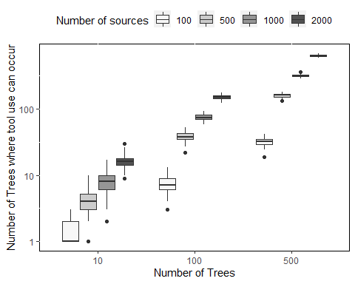

The relationship between the number of places where it is possible for a nut-cracking event to occur and the number of trees and sources at the beginning of each model run. Increasing both the number of Trees and Sources included in the model has a positive effect on the number of places where nut-cracking events can occur. Note that the Y axis is in log 10 scale

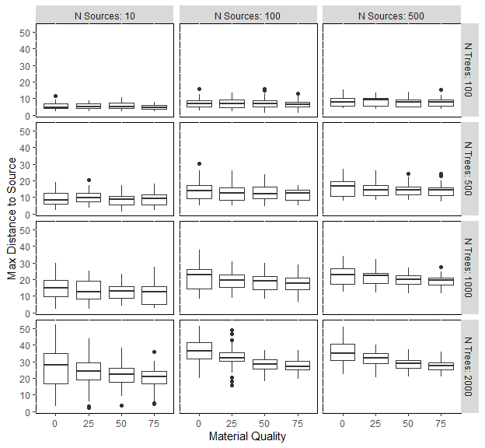

Both plots showing the maximum distance a *Pounding Tools* were moved according to their material quality. When the number of Trees is low, material quality has little influence on the maximum distance a *Pounding Tools* travel, this is due to the fact that there is little opportunity for tools to move substantial distances from their sources. However, as the number of *Trees* increases, so does the distance *Pounding Tools* can move from their *Source*. In cases where the number of *Trees* is great, the maximum distance tools can move is influenced by its raw material quality. Note that a raw material quality of 0 reflects 25% chance of breaking whereas a raw material quanlity of 75 represents a 100% change of breaking.

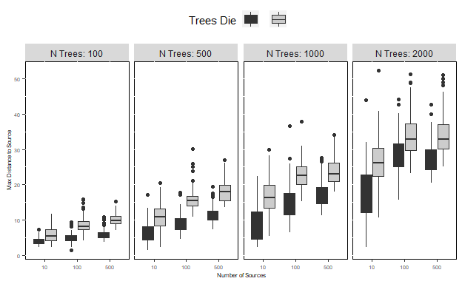

The effect tree death and growth on the maximum distance tools can move from the source. When holding the number of *Trees* and *Sources* constant *Pounding Tools* the maximum distance a pounding tool can move is greater when *Trees* are able to change their location due to death and regrowth.

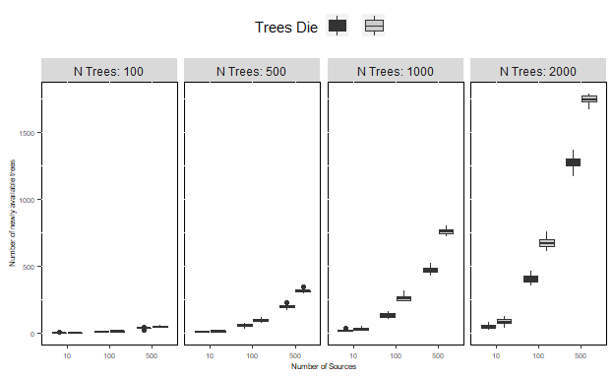

The effect tree life cycles on the number of trees that become accessible due to the transport of tools. Black: Static Trees, Grey: Dynamic Trees

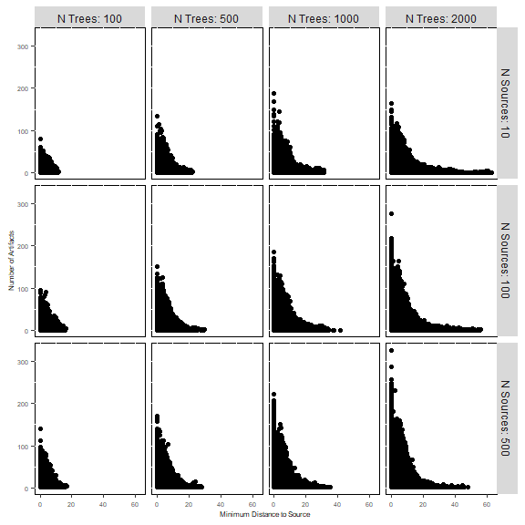

The relationship between the number of artifacts found in a grid cell and its distance to the nearest source. Note how the number of *Trees* attenuates the scale and strength of the distance decay relationship

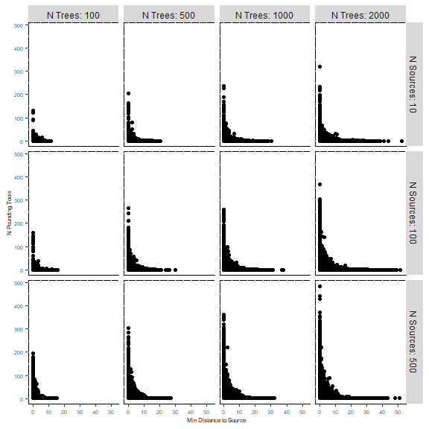

The relationship between the number of Pounding Tools found in a grid cell and its distance to the nearest source. Note how the number of *Trees* attenuates the scale and strength of this relationship

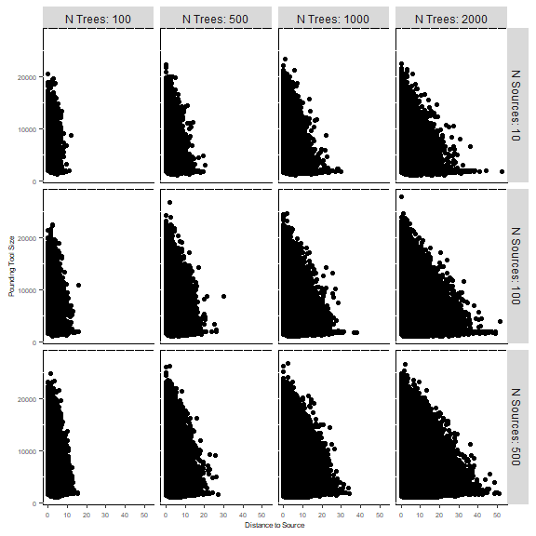

The relationship between the size of Pounding Tools and distance to their sources. Note how the number of *Trees* attenuates the scale and strength of this relationship

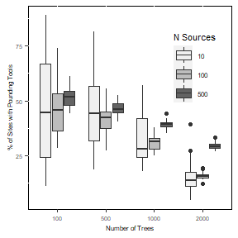

The effect of the environment on the representation of Pounding tools in the simulated material record in runs where Tree locations are static. Increasing the number of sources increases the percentage of assemblages that contain Pounding Tools. In comparison with figure 4 (right) in the main text, individual assemblages contain greater proportions of Pounding Tools