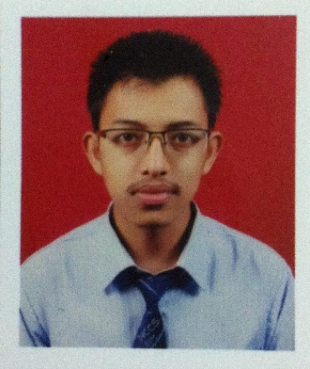**Aaditya Manandhar**

Mobile: 9818701979

Email: [manandharaaditya@gmail.com](mailto:manandharaaditya@gmail.com)

**VISION AND OBJECTIVES**

To enhance my knowledge and capabilities by working in a dynamic organization that prides itself in giving substantial responsibility to new talent.

**PERSONAL INFORMATION**

Date of birth: 16th March 1996

Religion: Hinduism

Nationality: Nepali

**TRAININGS**

|  |  |  |
| --- | --- | --- |
| Training | Institute | Date |
| Computer Hardware and networking | Computer Planet, Kalimati | 4th April- 3rd July 2012 |
| Accounting Package Training | Computer Planet, Kalimati | 28th May-24th July 2014 |
| Android Workshop | Planet Innovative, Exhibition road | 3rd December 2017 |

**TECHNICAL SKILLS HIGHLIGHTS**

|  |
| --- |
| Basic Knowledge of Android Programming |
| Basic Knowledge of Java, PHP, CSS, Photoshop |
| Concept of UML, SQL Server, MVC |
| Knowledge of Microsoft Office Package |

**PROJECT WORKS**

1. **Title: Student Information Management System**

* **Description**: It is a desktop based application designed to keep and manage the records of the students. It performs the CRUD (Create, Read, Update, and Delete) operations on the records.
* **Platform Used**: Java with MVC framework
* **Contribution:** Designing and Coding

1. **Title: Rent Management System**

* **Description**: It is a desktop based application designed to keep and manage the rent information. It manages the rent information of the tenants and also helps to save the data of the tenants. We can also generate a simple bill for the tenants regarding the rent of the basis of information provided.
* **Platform Used**: Java with MVC Framework
* **Contribution**: Design, Analysis and Coding

1. **Title: Green KTM**

* **Description**: It is an android based mobile application designed to manage the reservation or booking of the cycles for the customer. The objective of this app is to ensure the reservation of the cycles by the customers from the available vendors.
* **Platform Used:** Android (Java based)
* **Contribution:** Layout designing and coding

**ACADEMIC QUALIFICATIONS**

|  |  |  |  |  |
| --- | --- | --- | --- | --- |
| S. N | Qualification | Institute | Year | Percentage |
| 1. | Bachelors (in Information Management BIM) | National College of Computer Studies, Paknajol, Kathmandu | 2070 - running | - |
| 2. | Intermediate Level (+2) | NCCS Higher Secondary  School, Paknajol, Kathmandu | 2070 | 65.70% |
| 3. | School leaving certificate | Little Buddha’s Academy, Bijeshwori, Kathmandu | 2068 | 70.0% |

**HOBBIES AND INTREST**

I am a tech loving guy and love to see the reviews and hands-on of the new gadgets and I keep interest in bikes and cars. I am a person with positive thinking having hardworking and growth seeking as my strength and motive.