Ram Chapagai

Mrs. Debra Hunking

ENGL 101-T

02 July 2018

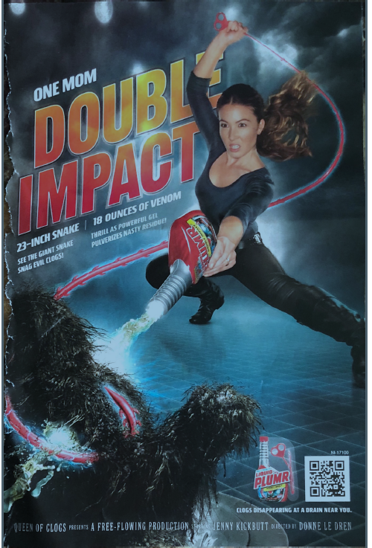 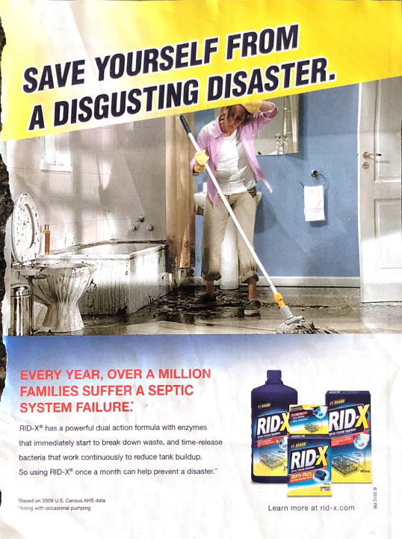

Comparative Analysis Sentence Outline

1. Introduction
2. Hook *(stat/quote/startling fact + citation)*: According to Jean Kilbourne, ads sell more than products because they sell values, images, and love and sexuality concepts and most importantly, they tell us who we are and how we should be (“Killing Us Softly 4”).
3. Background: Advertisements are displayed everywhere in different forms. We cannot walk down the road without being touched by advertisement (“The Persuaders”). While we view ads everywhere, it makes impossible to get away from it. Finally we get immunized by ads and it became the atmosphere where we live (“The persuaders”).
4. Thesis *(template wording + essay map)*: Although the RID-X ads found in *Family Circle August 2012* and the LIQUID PLUMR ad found in *Good Housekeeping July 2012,* have spirit of luring consumers to buy their product, the two advertisements have distinction on description, performances, serotypes, and fear appeals; the creator of RID-X use real life situation with images focusing on effect making it more effective ads than the LIQUID PLUMR ad which focus on prevention using imaginary image of wonder women and clog.
5. Body *(using Block or Point-by-Point)*
6. Description: RID-X ad have image of house where a women seem to be on her middle 50’s moping the floor in bathroom. It looks like the drain backup. The women looks like upset and confusing. She is wearing cleaning gloves and with her left hand moving hair backward which might have fallen on her face. It has dark liquid on the toiler and bath tub. According to ad it is septic tank failure.

In contrast, LIQID PLUMR ad have a wonder women on her late 30’s in the space. Further, it present scene of action movie. While she is holding drain snake and bottle of LIQUID PLUMR, it looks like she is fighting for clog in the sink.

1. Model Description: Women on her 50’s is shown in the RID-X ad. She might be the homeowner and a housewife. She looks upset, tired and distracted.

Whereas, LIQID PLUMR ad have wonder women carrying drain snake on her right hand and pouring LIQUID PLUMR with left hand. She look energetic and serious. But, according to the ad she is mom acting as wonder women.

1. Stereotypes: House bathroom is transferred to disgusting place filled with dirty water. No one was able to use toilet or bathroom. Damaged part of property, especially bathroom is displayed in the picture.

Whereas, LIQUID PLUMR ad show space and clog are removed by drain snake and it is on the air. Women facial expression is serious and looks like she is in the warrior mode.

1. Fear Appeals: RID-X ad use appeal of fear. It is oversimplified to present fear of not using their product. Advertiser creator find a way to fear consumer so deep inside them that even they do not feel like persuasion at all (“The Persuaders”).

In similar manner, LIQUID PLUMR ad also shows the image of clog and the result of not using their product. They use the word evil to develop fear on consumer and picture of giant clog is shown.

1. Emotional Branding *(cite: PBS):* RID-X ad makes the environment to believe in their product. It describe septic backup as an ugly mess with disgusting smelling waste water.

Similarly, LIQUID PLUMR ad shows how a bottle can fight giant clog. It is claimed that their product snag clogs and penetrate nasty residue left. The creator of ad focus on how consumer feel after viewing their ad.

1. Text/Wording: On the top of page, dark blue color and larger font in used to present the appeal to save our self from a disgusting disaster. On the other hand it use red color and bold font which is the symbol of danger, to present the statistics of septic system failure. It also use small font and blue color to cite the source for that, which will further help consumer to believe their claim. Above the cite sentence on the bottom left they use medium font and blue color text to describe their product.

However, LIQUID PLUMR ad use white font color to describe mom. The result of their product description “DOUBLE IMPACT” is orange and red font color and font size covering 25 percent of page. Below that white font color is used to compare LIQUID PLUMBER with 23 inch snake and 18 oz. of venom. It is described that snake will snag evil clogs and venom will pulverizes nasty residue.

On the bottom of page it uses white font color and text looks like movie poster writing.

1. Analysis: The RID-X advertisement clearly imprint the picture in consumer mind by making them to think of consequences of not using their product. Presenting women in the ad plays significant important in selling household cleansing products, which is done well here. Real life situation is presented without much editing the scene which will create real world environment.

Whereas, LIQUID PLUMR ad is presented more like artificial movies. There is no clear evidence to prove snake story used. Clog is displayed in space. Due to this it is hard to figure out what the ad is about if consumer are not aware of their brand. Also use of QR code on the bottom right, make to feel that the ad is targeted to mom who use the smartphone.

1. Conclusion
2. Summary of Essay Map: Both the ad use women as a mother to advertise the product. In both ad appeal of fear can be clearly seen. While both ad try to sell the product by branding RID-X ad use appropriate environment to present how their product work that the LIQUID PLUMR ad that use artificial appearance of women and environment to reach potential consumer.
3. Restatement of Thesis: The two advertisement persuade the consumer with the appeal of fear, description, emotion and the formula used to advertise.

Works Cited

Fowles, Jib. “Emotional Appeals.” 1996. Classroom article.

“LIQUID PLUMR ad.” *Good Housekeeping* July 2012. Print.

Kilbourne, Jean. *Killing Us Softly 4*. Media Education Foundation. 2010. Video.

“RID-X ad.” *Family Circle August 2012*. Print

*The Persuaders*. PBS Frontline documentary. Posted November 2004.