**Overview**

This Python script processes data from a CSV file, performs various data manipulations, cleans the data, calculates derived metrics, and generates visualizations. The purpose of this code is to:

1. Read and clean data from a CSV file.
2. Transform and structure the data into a more organized format.
3. Handle missing or malformed data.
4. Perform statistical calculations like the mean salary and median age.
5. Generate visualizations to analyze the data.

**Required Libraries**

The following libraries are required to run the code:

* csv: To read data from CSV files.
* json: To write and read JSON files.
* pandas: For handling data in DataFrame format and performing data analysis.
* seaborn: For creating statistical plots.
* matplotlib: For creating static, animated, and interactive visualizations.
* datetime: For working with date and time data.

Ensure that these libraries are installed in your Python environment:

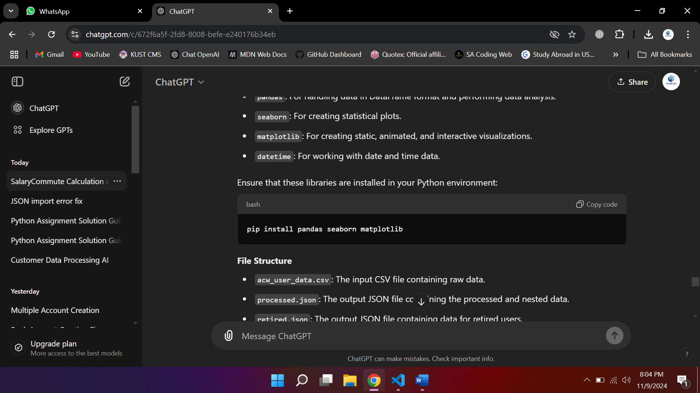

**File Structure**

* acw_user_data.csv: The CSV file containing raw data.
* processed.json: The output JSON file containing the processed and nested data.
* retired.json: The output JSON file containing data for retired users.
* employed.json: The output JSON file containing data for employed users.
* remove_ccard.json: The output JSON file containing data for users with outdated credit card information.
* commute.json: The output JSON file containing data sorted by SalaryCommute.
* age_distribution.png, dependents_distribution.png, commute_vs_salary.png, age_vs_salary_dependents.png: Visualization images generated by the script.

**Step-by-Step Breakdown**

1. **Read the CSV File (read_csv)**:
   * The read_csv(file_path) function reads the input CSV file and returns the data as a list of dictionaries where each dictionary represents a row from the CSV file.

Example usage:

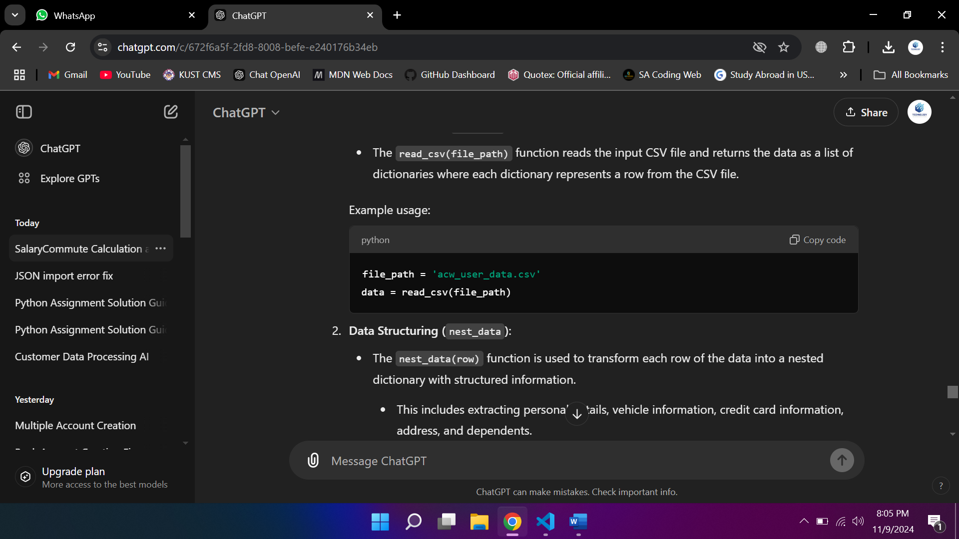

1. **Data Structuring (nest_data)**:
   * The nest_data(row) function is used to transform each row of the data into a nested dictionary with structured information.
     + This includes extracting personal details, vehicle information, credit card information, address, and dependents.
     + The function also handles missing values for dependents by defaulting to 'N/A' if the value is missing.

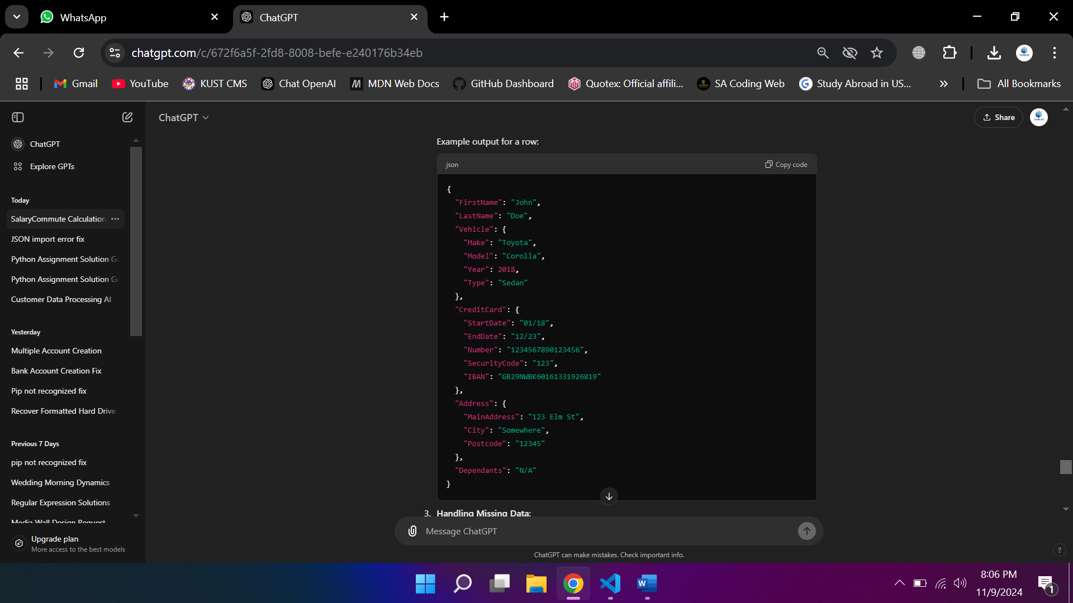Example output for a row:

1. **Handling Missing Data**:
   * **Missing Dependents**: The code identifies rows where the "dependants" field is missing and prints the indices of the problematic rows.
   * **Missing or Invalid Salary**: Missing or invalid salary data is handled by checking if the key exists, and setting a default value if not.
   * **Invalid Commute Data**: If the commute distance is missing or invalid, it defaults to a value of 1 km.
2. **Saving Processed Data (processed.json)**:
   * After transforming and structuring the data, the script saves the processed data into a JSON file called processed.json.

Example output in processed.json:

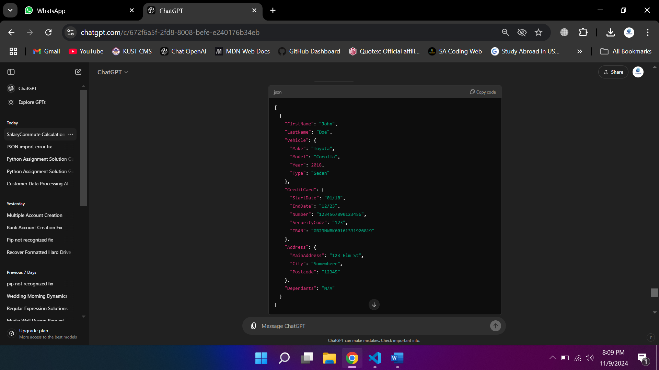



1. **Separation by Retirement Status (retired.json and employed.json)**:
   * The code separates individuals into two categories:
     + **Retired**: Individuals who are retired (flagged by Retired = 'Yes').
     + **Employed**: Individuals who have an employer field.
   * These filtered lists are then saved as separate JSON files, retired.json and employed.json.
2. **Flagging Outdated Credit Cards (remove_ccard.json)**:
   * The code flags credit cards that are over 10 years old (based on the start and end dates). These records are saved into a separate JSON file remove_ccard.json.
3. **Salary-Commute Calculation and Sorting**:
   * A new metric called SalaryCommute is calculated for each individual:
     + If the commute distance is less than or equal to 1 km, the salary remains unchanged.
     + If the commute distance is greater than 1 km, the salary is divided by the commute distance.
   * The data is then sorted by the SalaryCommute value and saved to a new JSON file commute.json.
4. **Data Visualization**:
   * **Age Distribution**: A histogram of the age distribution is plotted and saved as age_distribution.png.
   * **Dependents Distribution**: A histogram showing the distribution of dependents is plotted and saved as dependents_distribution.png.
   * **Commute Distance vs Salary**: A scatterplot that shows the relationship between commute distance and salary is generated and saved as commute_vs_salary.png.
   * **Age vs Salary by Dependents**: A scatterplot showing the relationship between age and salary, colored by the number of dependents, is plotted and saved as age_vs_salary_dependents.png.
5. **Error Handling**:
   * The script handles missing or malformed data gracefully by using default values or skipping invalid entries.
   * It also ensures that non-numeric values (such as salary fields) are properly converted to numeric values before performing calculations.

**Output Files**

* processed.json: Contains the structured and processed data.
* retired.json: Contains data of retired individuals.
* employed.json: Contains data of employed individuals.
* remove_ccard.json: Contains data of individuals with outdated credit cards.
* commute.json: Contains sorted data based on SalaryCommute.
* age_distribution.png: Visualizes the age distribution of individuals.
* dependents_distribution.png: Visualizes the distribution of dependents.
* commute_vs_salary.png: Visualizes the relationship between commute distance and salary.
* age_vs_salary_dependents.png: Visualizes the relationship between age and salary, grouped by dependents.

**Potential Enhancements**

* **Error Logging**: The code can be enhanced by adding detailed error logging (using Python's logging module) for better traceability of issues.
* **Dynamic File Paths**: Make the file paths dynamic or pass them as arguments to the script for more flexibility.
* **User Input Validation**: Implement further input validation checks for other fields (e.g., ensuring that Salary, Age, and CommuteDistance are numeric).

**Conclusion**

This script serves as a robust tool for data cleaning, transformation, and analysis. It can be adapted to process similar datasets and provide insights into various metrics and relationships within the data, while also handling missing or malformed entries effectively.