Rey Anthony M. Novero

166-C Tres de Abril Street, Barangay Labangon, Cebu City, Cebu
reyanthonynovero@gmail.com (Primary Account)
https://github.com/reeyyyxd (GitHub Account)
+639991072942

Aspiring IT professional seeking to enhance my technical expertise by contributing to a growing and innovative company. Passionate about leveraging technology to drive success and collaborating with skilled professionals to develop impactful solutions.

EDUCATIONAL BACKGROUND

Tertiary
Cebu Institute of Technology University
Bachelor of Science in Information Technology
Senior High School
Tagbilaran City Science High School
TVL – Information Communications Technology

Junior High School
Immaculate Heart of Mary Seminary
2021-2025

2019-2021

2015-2019

SKILLS

Programming Languages: C, C++, Java, Python, HTML, JavaScript, SQL
- Networking and Systems Administration
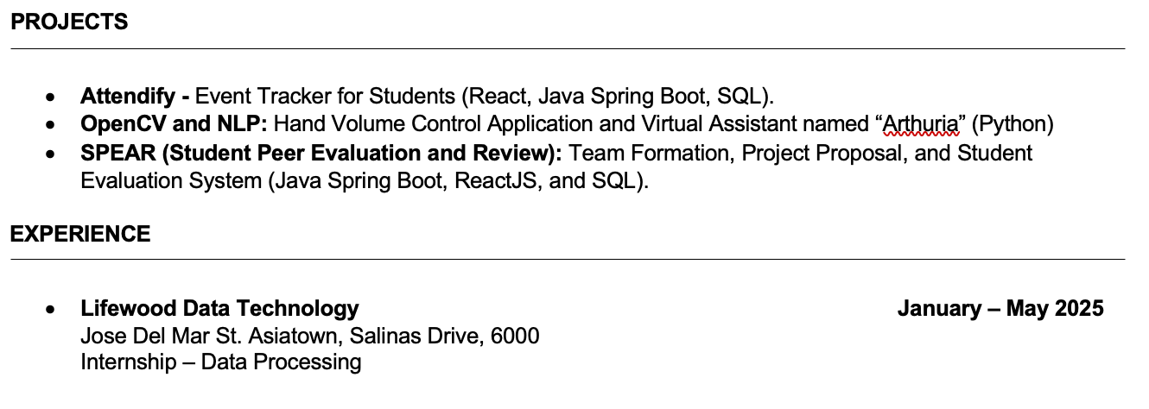
- Experienced in developing backend solutions using Java and Python and implementing AI tools like OpenCV and NLP for real-world applications.
- Basic knowledge with Machine Learning and Data Analytics
- Proficient in Microsoft Office Tools (Word, Excel, PowerPoint)
- Willing to work with team collaboration and project coordination.
- Can adapt to new concepts and technologies
- Open and willing to learn

