Ahmed Refaay

900141806

Computer Vision

Assignment 2

11/19/2017

Money Detection

**Project Description**:

This project detects the rectangular money notes and circular money coins.

**Code Description**:

The code parts are:

1. Preprocessing: Changing the image size, gray scale image, and gradient image. Calculating the r-tables and the image angles.
2. Calculating the circles’ centers and drawing them.
3. Calculating the rectangles centers’ and drawing them.
4. Used thresholds for: circle and rectangle Hough transforms center count, and nearby centers.
5. Used paper note colors for different values for the money calculation of the bonus.

**Test Cases**:

* 1. image1: at least 2 coins and 1 paper note non-overlapping on a plain  
     background: (2-a.jpg)

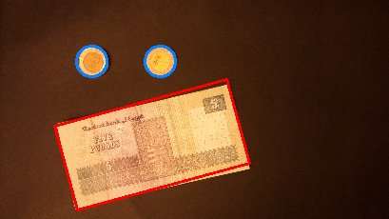

Bonus:

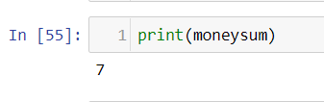

* 1. image2: at least 2 coins and 1 paper note on a complex/noisy  
     background: (2-b.jpg)

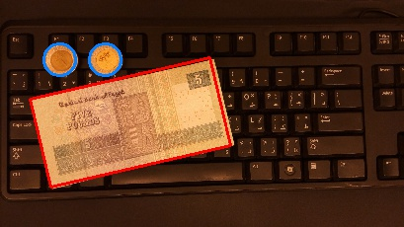

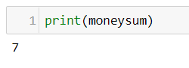Bonus:

* 1. image3: at least 5 coins and 2 paper notes with partial overlap on a  
     plain background: (2-c.jpg)

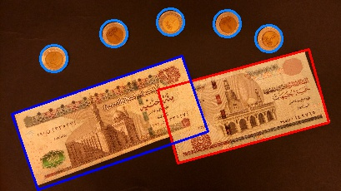

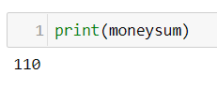Bonus:

* 1. image4: at least 5 coins and 2 paper notes with partial overlap on a  
     complex/noisy background: (2-d.jpg)

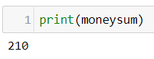Bonus: (assumed all coins 1 pounds)

