Ahmed Refaay

900141806

Deep Machine Learning

Assignment 3

11/21/2017

Caltech-256 CNN

**Project Description**:

This project implements a CNN using the Keras and Tensorflow frameworks on Python 2.7.

**Code Description**:

Xception model is loaded and added a top-model that fits the dataset’s classes’ number. The data is loaded using the flow-from-file function. The data is normalized.

* Input layer: size = (299, 299, 3).
* Seed = 5050.
* learn_rate = 1e-4 # learning rate
* decay_rate = 1e-6 # lr decay rate
* Output layer: 257 neurons and activation function = softmax.

ReduceLROnPlateau: reduces the learn rate to avoid saturation.

fit_generator: runs the neural network for training and validation.

Accuracy presentation:

Summary function prints the neural network formation.

TensorBoard function: makes files for graphs than can be viewed in an internet browser.

Both the test loss and accuracy top-1 and top-5 are printed.

**Training and validation accuracies and losses plots (overall)**:

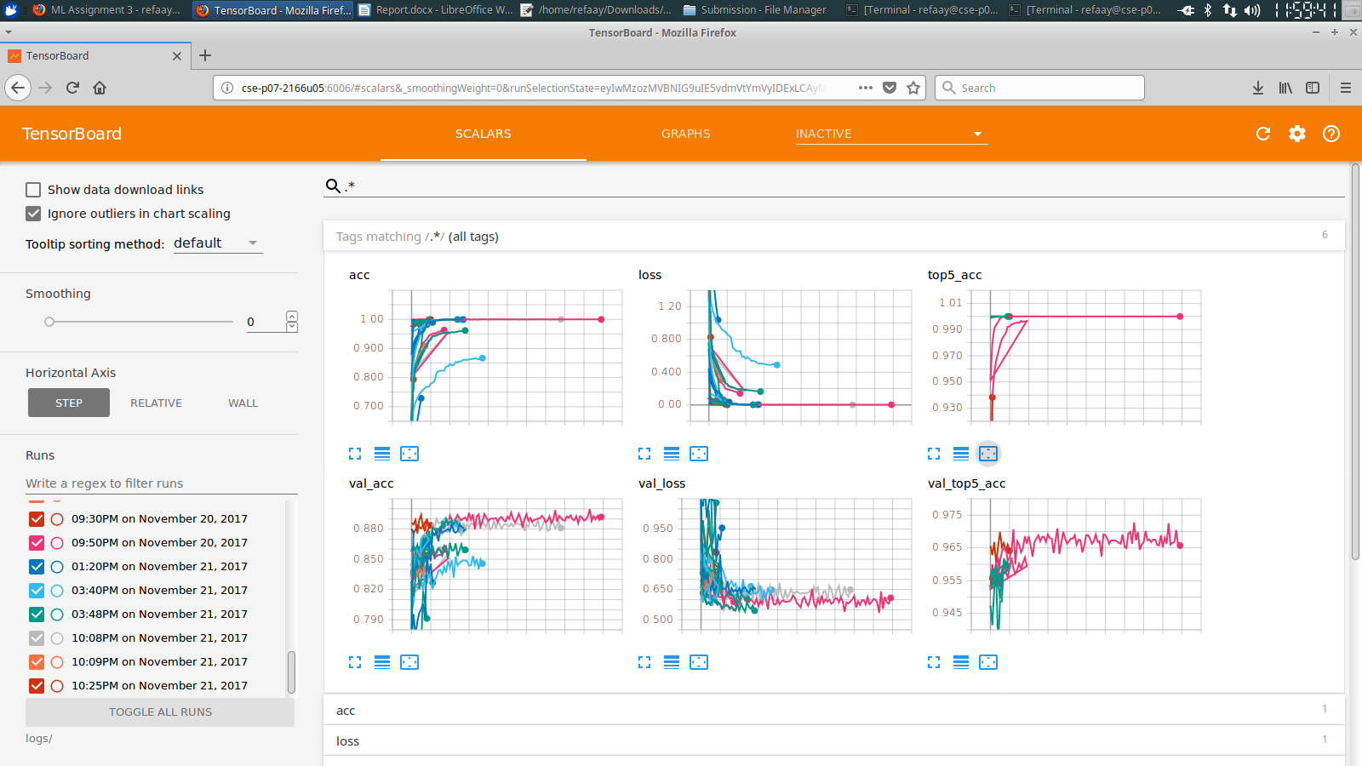

**Best accuracy and losses plots (stopped training after around 120 epochs)**:

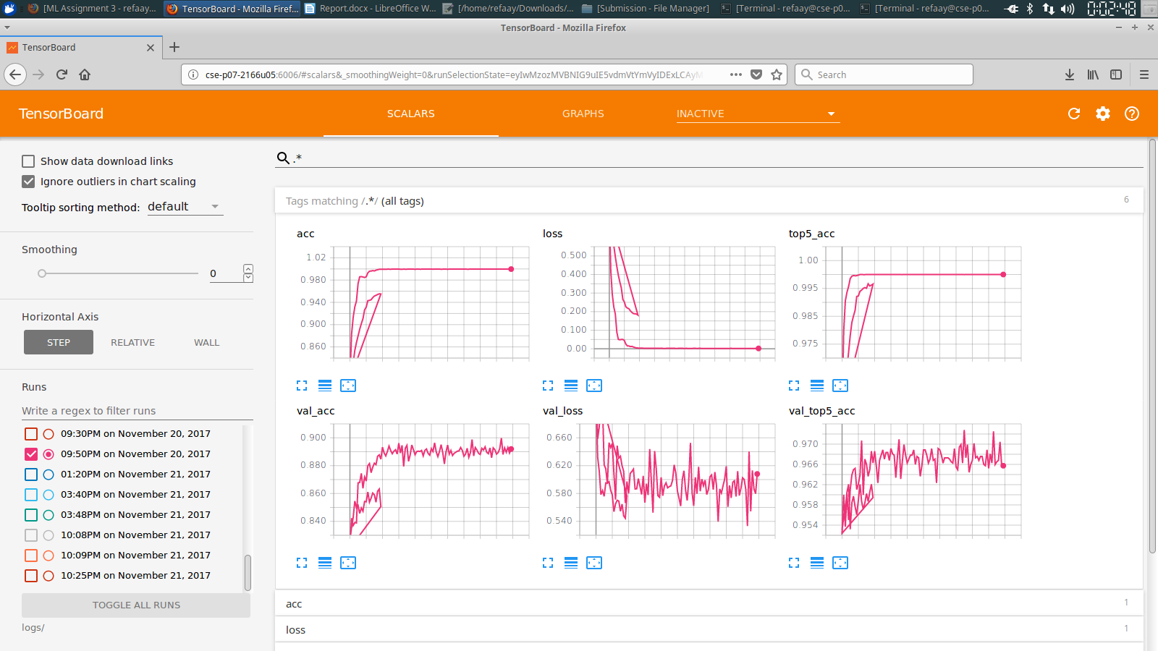

**Best model weights**:

21,388,073.

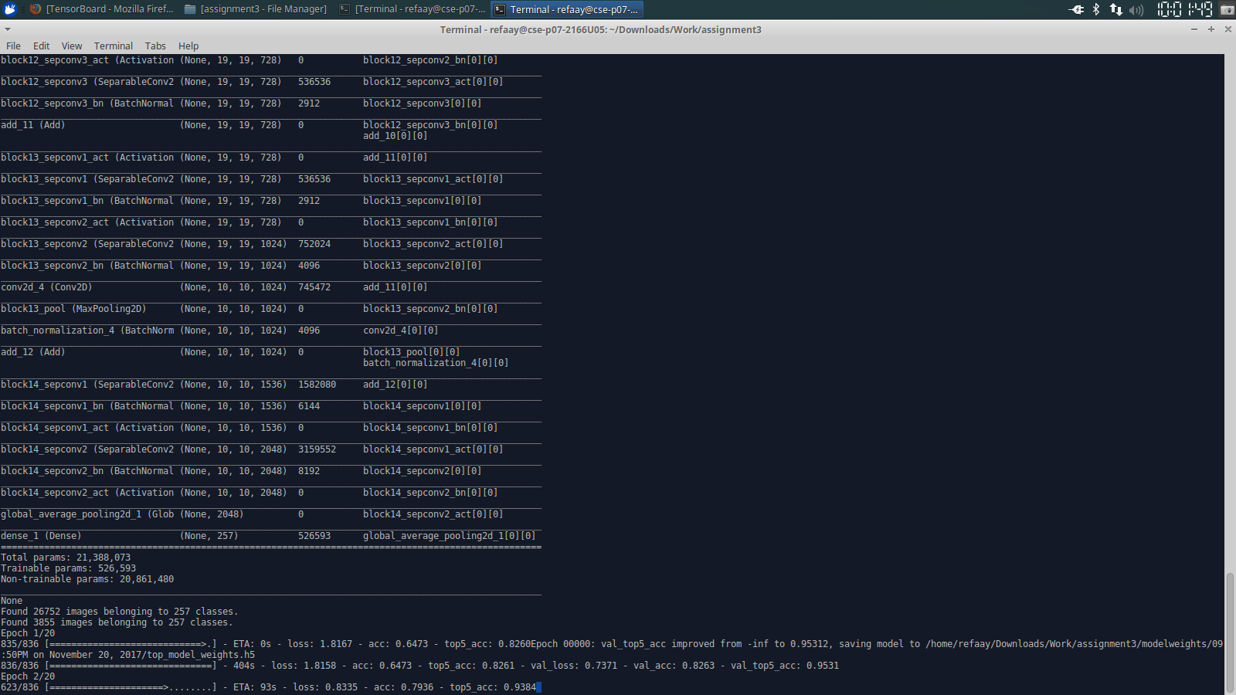

**Best accuracy**:

ACCR1 = 0.8998

ACCR5 = 0.9728

