Ahmed Refaay
900141806
Deep Machine Learning
Assignment 3
11/21/2017
Caltech-256 CNN
Project Description:
This project implements a CNN using the Keras and Tensorflow frameworks on Python 2.7.
Code Description:
I ran two models for this assignment to compare the accuracies versus weights for different ready packages: Keras’ Xception vs MobileNet. If one model only is considered for the grade, please consider the MobileNet submission.
Each model is loaded and added a top-model that fits the dataset’s classes’ number. The data is loaded using the flow-from-file function. The data is normalized.
- Input layer: size = (299, 299, 3) for Xception, and (224, 224, 3) for MobileNet.
- Seed = 5050.
- learn_rate = 1e-4 # learning rate
- decay_rate = 1e-6 # lr decay rate
- Output layer: 257 neurons and activation function = softmax.
ReduceLROnPlateau: reduces the learn rate to avoid saturation.
fit_generator: runs the neural network for training and validation.
Accuracy presentation:
Summary function prints the neural network formation.
TensorBoard function: makes files for graphs than can be viewed in an internet browser.
Both the test loss and accuracy top-1 and top-5 are printed.

Training and validation accuracies and losses plots (overall):
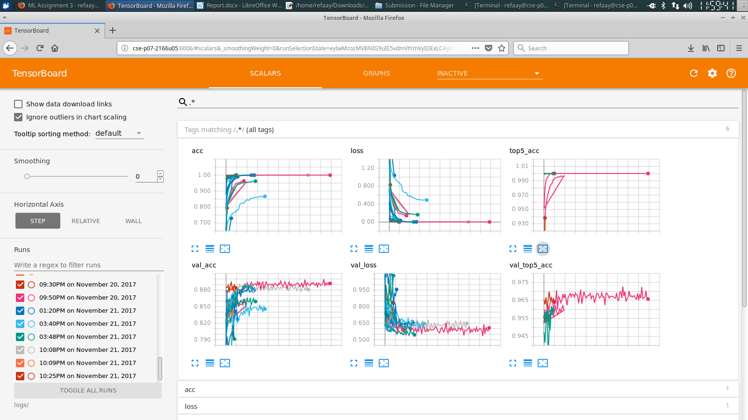

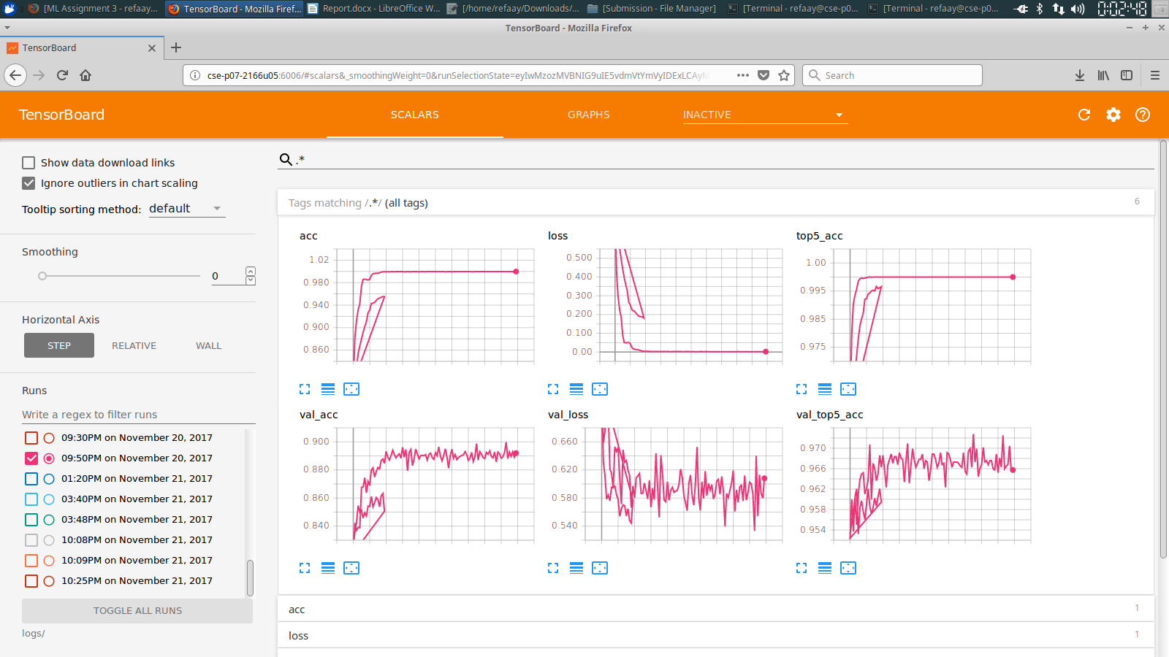
Best accuracy and losses plots for Xception (stopped training after around 120 epochs):

Best accuracy and losses plots for MobileNet (stopped training after around 60 epochs):
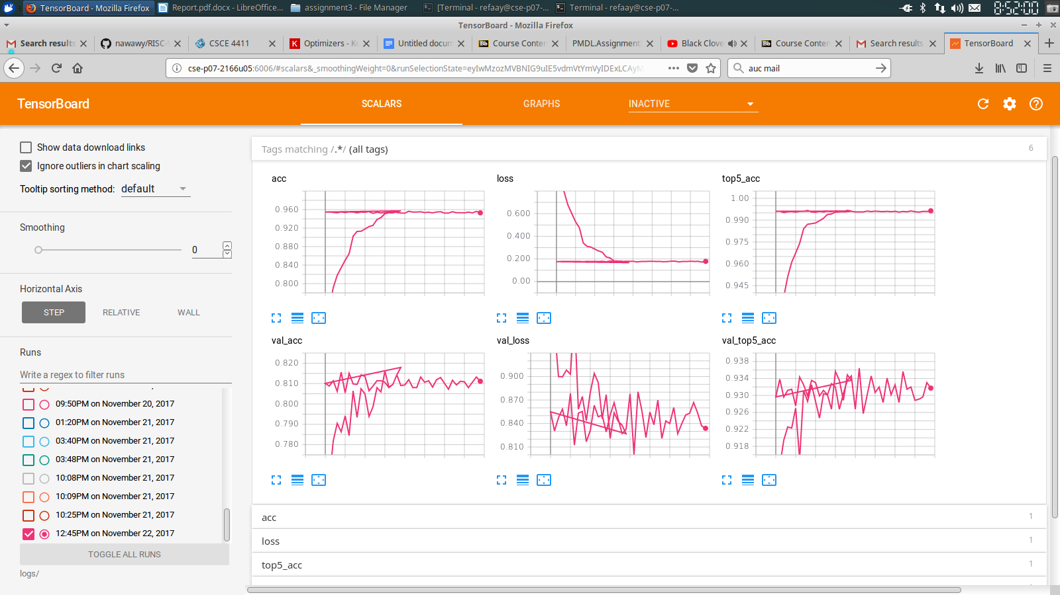
Best model weights (Xception):
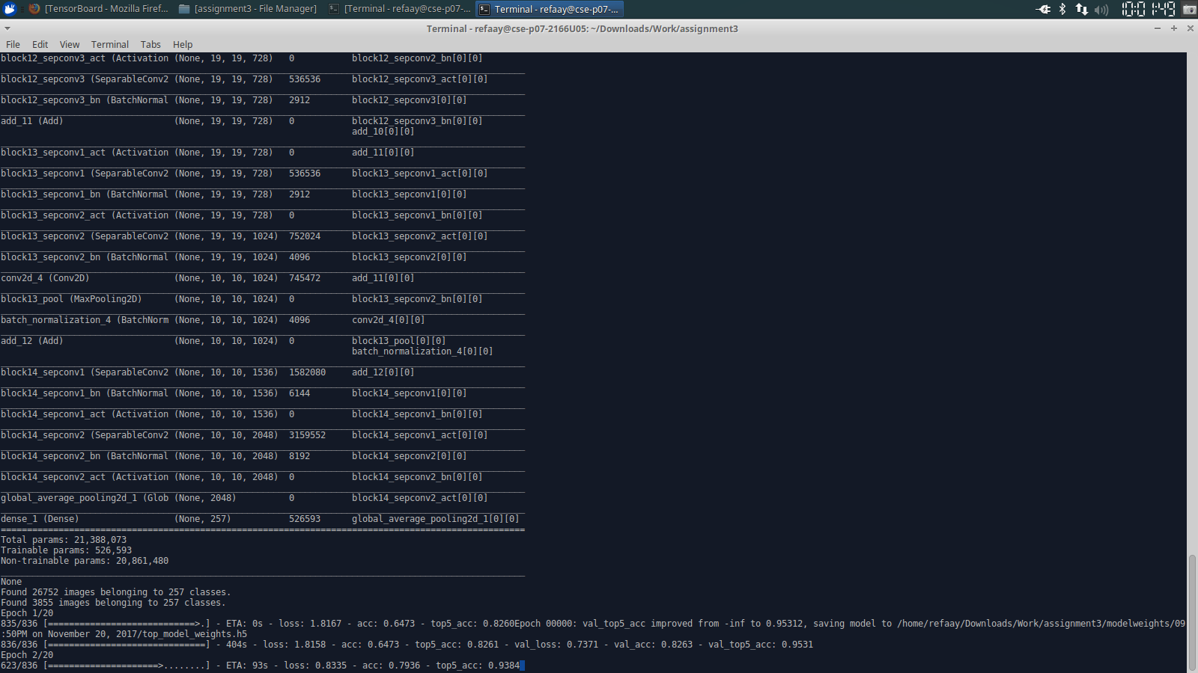
21,388,073.

Best model weights (MobileNet):
3,492,289.

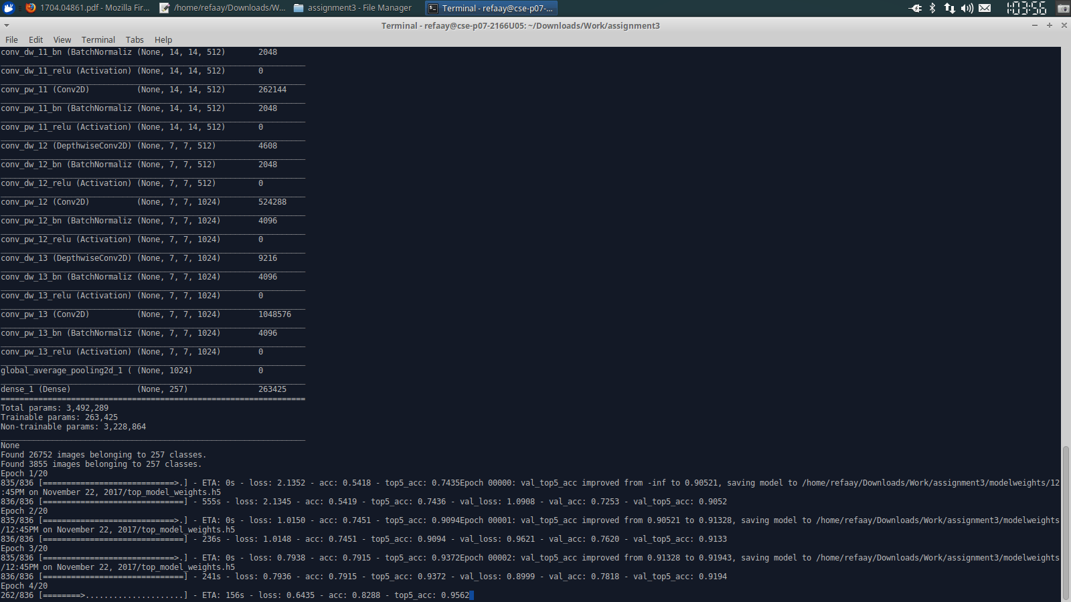

Best accuracy (Xception):
ACCR1 = 0.8998
ACCR5 = 0.9728
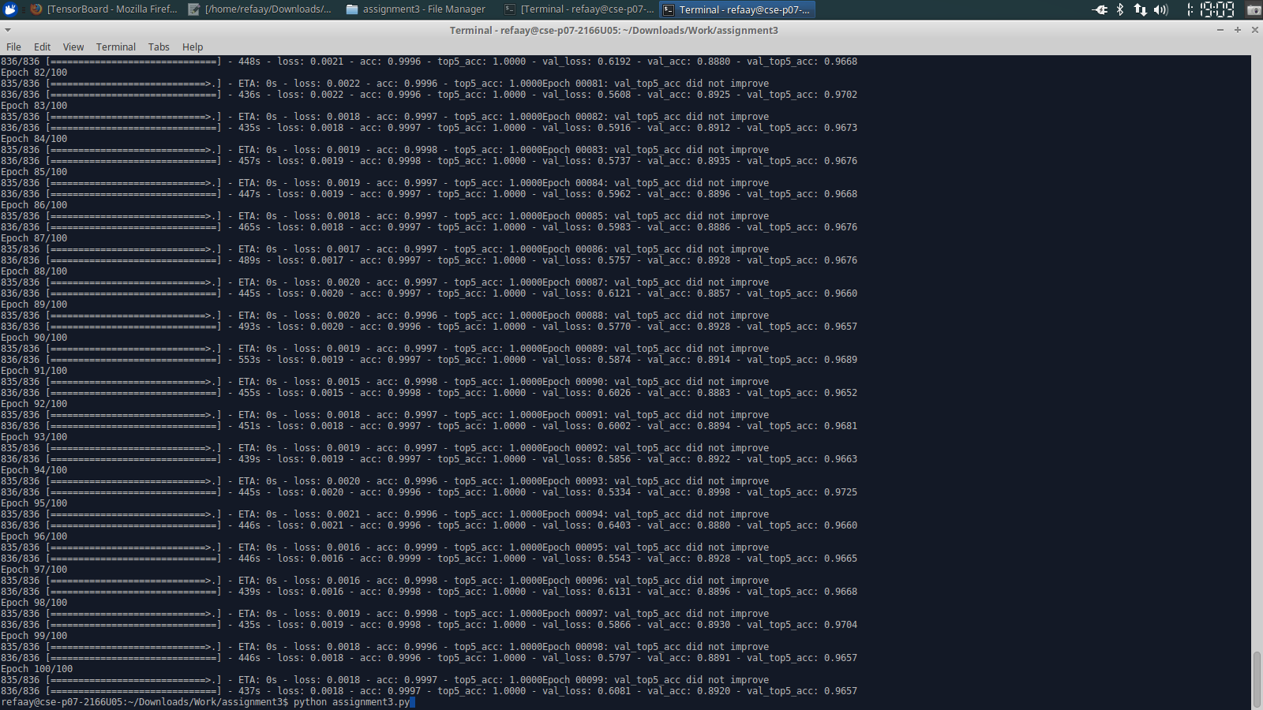

Best accuracy (MobileNet):
ACCR1 = 0.8119
ACCR5 = 0.9364
