Ahmed Refaay

900141806

Deep Machine Learning

Assignment 4

12/11/2017

PASCAL VOC 2007 Detection Challenge

**Project Description**:

This project implements a neural network that can best detect the 20 different object classes of the PASCAL VOC 2007 challenge using the Keras and Tensorflow frameworks on Python 2.7.

**Code Description**:

Faster R-CNN resnet50 model is loaded with pre-trained weights.

**Parameters:**

20 epocs.

lr=1e-5

epoch_length = 1000

**Model weights**:

**28,536,850**

**mAP using the testing set**:

approx. = 52%

**Plot (stopped training after 20 epocs):**

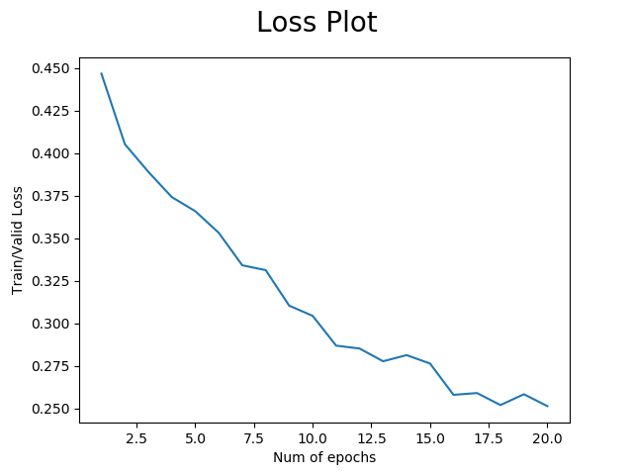

**References:**

https://github.com/yhenon/keras-frcnn