Ahmed Refaay

900141806

Computer Vision

Assignment 3

11/30/2017

Traffic Signs Detection

**Project Description**:

This project detects the red and yellow traffics signs.

**Code Description**:

The code parts are:

1. Preprocessing: Changing the image size to half the dimensions, converting the color space from BGR to HSV, making 2 image masks for the red and yellow color ranges chosen, adding them, and doing bitwise_and with the input image to get the color segmented image.
2. CCL: looping on the colored pixels in the masked image, getting neighbor pixels for each pixel, equating current label with any of the neighbor labels and adding the other labels to the label equality table. If all neighbor pixels have no labels, we give the pixel a new label.
3. We get the biggest blob by counting the pixels connected with equal labels from the equality table. The provided code looks for only one traffic sign in an image.
4. We get the dimensions for the rectangle enclosing the biggest blob by looping over the blob and getting the min and max x and y values. Then we draw the enclosing rectangle in blue.

**Results**:

22 traffic signs were correctly detected.

1. 19 traffic signs were totally enclosed by the output blue rectangle. These didn’t need ground truth calculation as they are apparent by the human eye. Here are some examples:

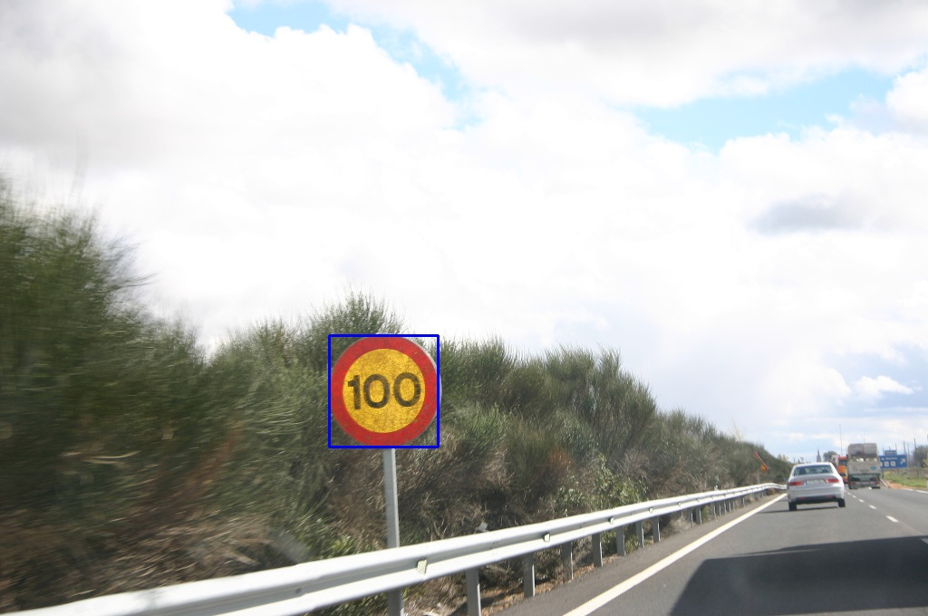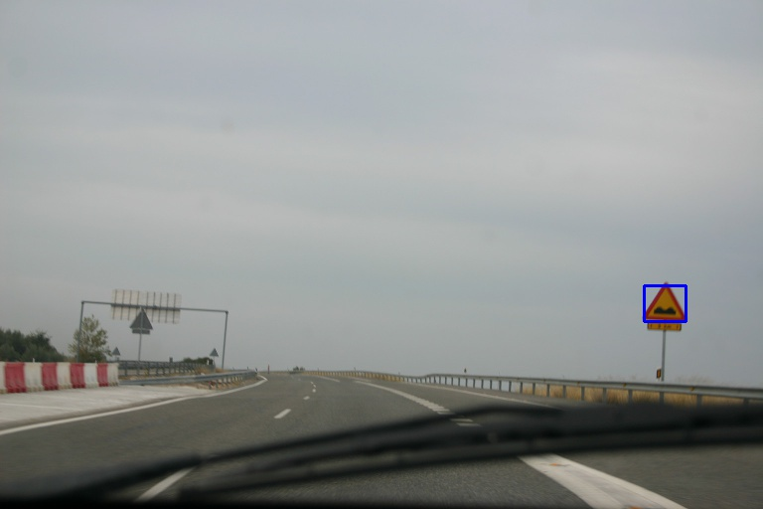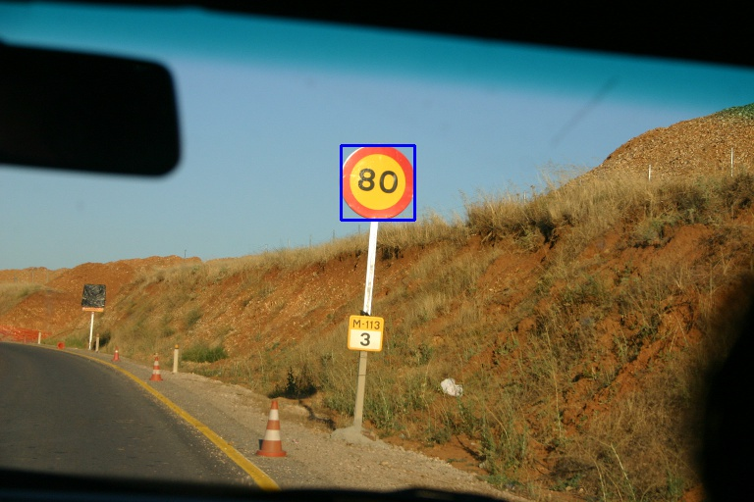

1. 3 traffic signs were partially enclosed but had IoU>0.5. The correct rectangle is in yellow. Here are the images:

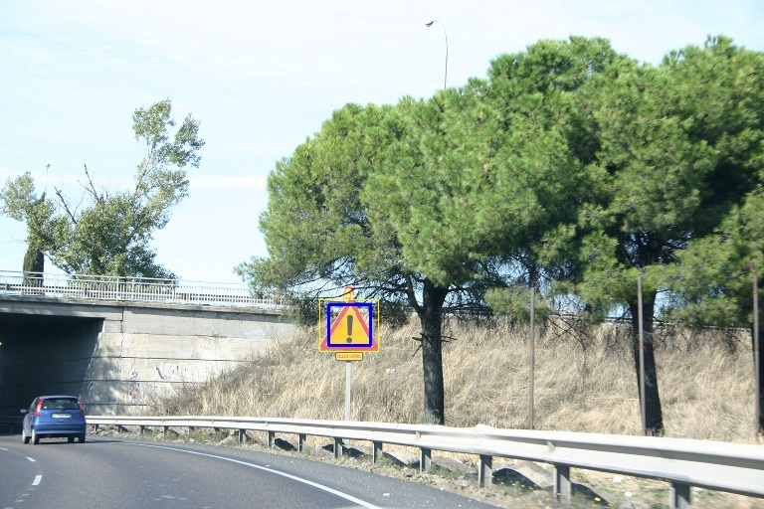

**Image 8**: True rectangle: (322, 301) and (380, 352). True area = 2958 pixels squared.

Detected rectangle: (330, 306) and (372, 346). Detected area = 1680. IoU = 0.57.

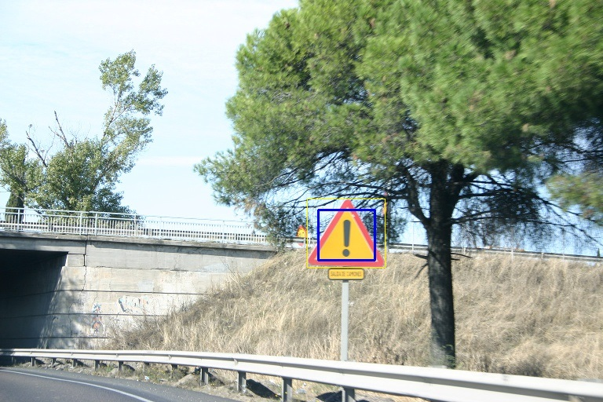

**Image 9**: True rectangle: (391, 253) and (488, 340). True area = 8439 pixels squared.

Detected rectangle: (405, 267) and (477, 331). Detected area = 4608. IoU = 0.55.

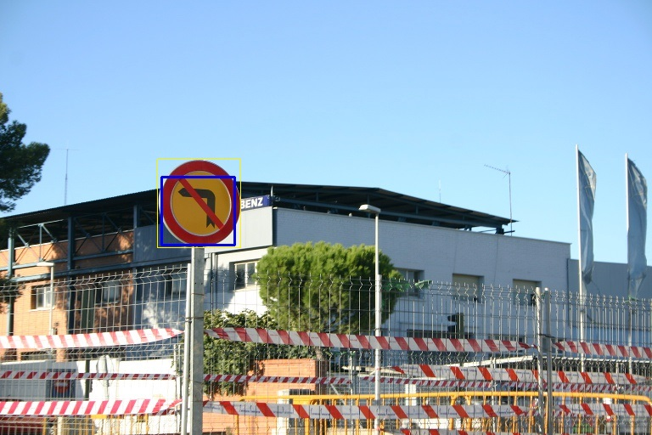

**Image 12**: True rectangle: (186, 187) and (283, 290). True area = 9991 pixels squared.

Detected rectangle: (190, 208) and (276, 288). Detected area = 6880. IoU = 0.69.

1. All other traffic signs were not correctly detected. Here are the wrong outputs:

