Instructions for how to install MySQL under Windows XP

1) Download current releases of MySQL Community Server and MySQL Tools from:
http://mysql.org/downloads/
I have downloaded mysql-5.0.27-win32.zip and mysql-gui-tools-5.0-r9a-win32.msi.

2) Run Setup.exe from mysql-5.0.27-win32.zip. You can select Typical setup type, Skip Sign-Up, Standard Configuration, Enter the root password, Retype the password. I have received following error on my machine during installation process:
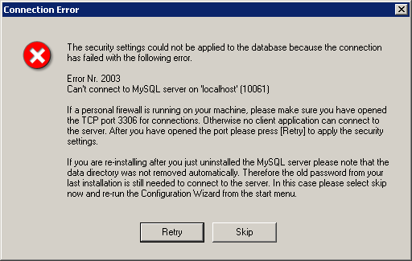
In this window two reasons are described. My case is first. Therefore I have opened setting of Firewall (in Control Panel/Security) and have added TCP port 3306 to Exceptions.

3) Run mysql-gui-tools-5.0-r9a-win32.msi. I have used Complete option and other default settings.

4) Run MySQL Query Browser. Execute queries:

CREATE DATABASE `db_ftp`;

CREATE TABLE `db_ftp`.`indexfile` (
`Id` INT(10) UNSIGNED NOT NULL auto_increment,
`Path` VARCHAR (26),
`Name` VARCHAR (11),
`DateFiled` DATETIME,
`FTPDate` DATETIME,
`DownloadedDate` DATETIME,
PRIMARY KEY (`Id`)
);

CREATE TABLE `db_ftp`.`datafile` (
`IndexFileId` INT(10) UNSIGNED DEFAULT 0,
`CompanyName` VARCHAR(60),
`FormType` VARCHAR(10),
`CIK` INT(10) UNSIGNED,
`DateFiled` DATETIME,
`FileName` VARCHAR(43),
`FTPDate` DATETIME,
`DownloadedDate` DATETIME,
PRIMARY KEY (`FileName`, `FormType`),
KEY (`IndexFileId`),
KEY (`CompanyName`),
KEY (`FormType`),
KEY (`CIK`),
KEY (`DateFiled`),
KEY (`FileName`),
KEY (`FTPDate`),
KEY (`DownloadedDate`),
CONSTRAINT `FK_datafile_1` FOREIGN KEY `FK_datafile_1` (`IndexFileId`)
REFERENCES `indexfile` (`Id`)
ON DELETE CASCADE
ON UPDATE CASCADE
);

Sergey V. Rylkov
e-mail: sergey@rylkov.com

