

Ben-Gurion University of the Negev
Faculty of Engineering Science
School of Electrical and Computer Engineering
Dept. of Electrical and Computer Engineering

Fourth Year Engineering Project
Final Report
Towards Feedback Loops Design

 | s-2022-217 / p-2022-110 | Project number:
 | Ron Eretz Kdosha , 315920330  Refael Ben Maor , 307999151 | Students  (name & ID):
 | Prof. Lewkowicz Izchak | Supervisors:
 | 24.07.2022 | Submitting date:

Table of Contents

Table of Contents 2
תקציר 3
Abstract 4
Introduction 5
Research Approach and Milestones 8
Validation Method 12
Problems and Solutions 12
Conclusions and Recommendations 13
References 14
Appendix A : Task Management Table 15
Appendix B : PR (LC) Functions Generator MATLAB Code 16

לקראת תכנון מערכות משוב
שמות הסטודנטים : רון ארץ קדושה, רפאל בן מאור
כתובת דואר אלקטרוני : roneretz@post.bgu.ac.il
מנחה : פרופ' יצחק לבקוביץ'

תקציר
קיים מתאם בין תיאור חוג משוב בודד ותיאור מעגל חשמלי המכיל משרן (L) וקבל (C). כאשר עוברים לרשת מעגלי משוב- המתאם הוא למעגלים חשמליים בהם אי אפשר להחליף את המיקום בין שני רכיבים (המחוברים בטור או במקביל)
מטרת הפרויקט היא מציאת פונקציות LC (Positive Real Odd) בהן המשתנים לא מתחלפים (non-commutative).
על מנת להשיג את המטרה, יישמנו שיטת קידוד עבור יצירה של כל פונקציות ה-LC ב-MATLAB תחת אילוצים מסוימים. אנחנו השתמשנו באופרטורים מתמטיים ובהרכבת פונקציות בכדי לייצר פונקציות LC סקלריות. לאחר מכן, ניסינו לייצר פונקציות LC מרובות כניסות ויציאות לא קומוטטיביות בשימוש הפונקציות הסקלריות שקיבלנו.
אנחנו ייצרנו ובדקנו בהצלחה את כל פונקציות LC ממעלה שנייה ב-MATLAB תחת אילוצים מוגדרים מראש של כמות משתנים, אופרטורים וסוגריים. עם זאת, ישנה עבודה רבה במציאת פונקציות LC לא קומוטטיביות מרובות כניסות ויציאות בגלל משאבים מוגבלים של תמיכה של תוכנות בפונקציות LC לא קומוטטיביות ובגלל שזה הוא תחום מתמטי קשה מאוד.
מילות מפתח: פונקציות LC (PR), מערכות מרובות כניסות ויציאות, מעגלים חשמליים, לולאות משוב.

Towards Feedback Loops Design
Student Names : Ron Eretz Kdosha , Refael Ben Maor
Email Address : roneretz@post.bgu.ac.il
Advisor : Prof. Lewkowicz Izchak

Abstract
There is a correlation between description of a single feedback loop and an electrical circuit which contains an inductor (L) and a capacitor. In feedback loop networks, the correlation is to electrical circuits which two components of the circuit are non-commutative.
The goal of the project is finding NC (non-commutative) LC (Positive Real Odd) functions.
In order to achieve that goal, we implemented an encoding method for generation all LC functions on MATLAB under certain varying constraints. We used mathematical operations and function compositions in order to generate scalar LC functions. Then, we tried to generate MIMO LC functions from those scalar LC functions.
We generated and verified successfully all scalar second-degree LC functions under certain constraints of number of variables, operations and brackets. However, there is a lot of job ahead in finding NC-LC-matrix-valued functions because of limited resources of supporting NC LC functions programs and because it's hard mathematical aspect.
Key words: LC (PR) functions, MIMO, electrical circuits, feedback loops.

Introduction
A rational positive-real (PR) function is a function which follows :
is the right half of the complex plane.
We also calling PR functions as LC functions because PR functions can represent a LC transfer function circuit.
For example, the following electrical circuit in figure 1 has the following transfer LC function in equation 1.2.
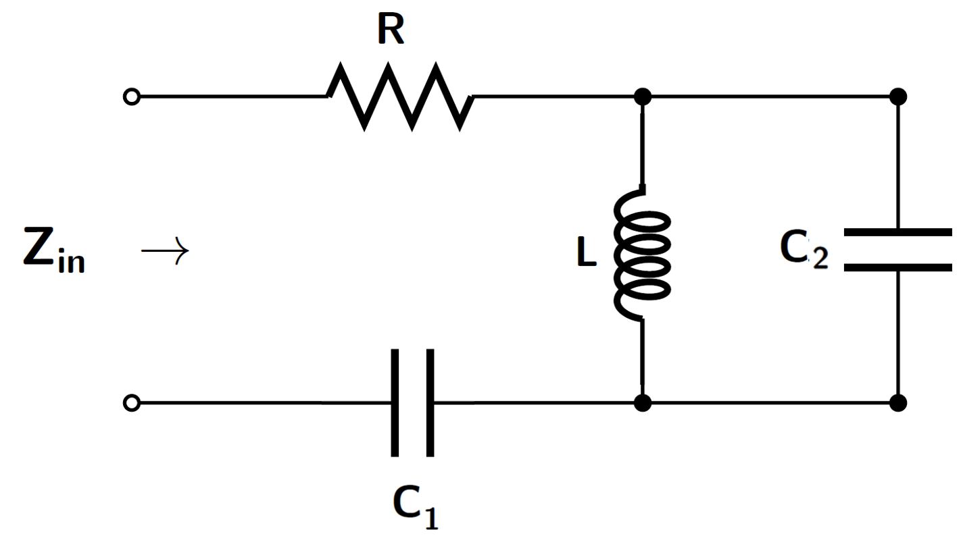
Figure 1 : RLC Electrical Circuit

While the function is defined in equation 1.3:
The function is useful because it is the transfer function of a feedback loop, which is shown on figure 2:
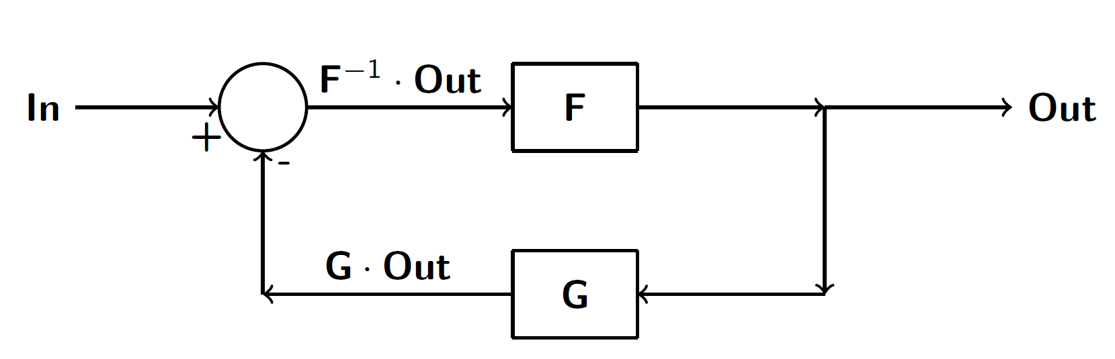
Figure 2 : Feedback Loop

The feedback loop input-output relation is shown in equation 1.4:

We also know that the components of a basic parallel electrical LC circuit as shown in figure 3 are commutative (the functionality of the circuits is equal):
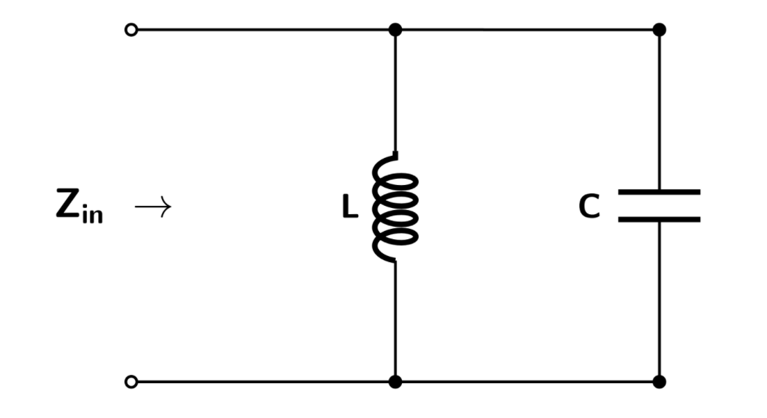
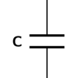
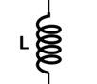

Figure 3 : Commutative Basic Parallel LC Circuits
The two circuits have the same functionality because the impedances are commutative as shown on equation 1.5:
Which also can be represented as function, which shown on equation 1.6:
Although the components of the basic parallel LC circuit are commutative, the components of a basic feedback loop are non-commutative as shown on figure 4:
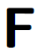


Figure 4 : Non-Commutative Basic Feedback Loop Networks

However, we can be creative and sometimes to overcome this problem by using inversed components as shown below in figure 5:
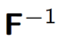
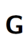
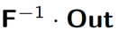
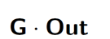

Figure 5 : Basic Feedback Loop Networks Equality
A disadvantage of this solution that the physical components that put together the inversed components in the right feedback loop might be different than the physical components of the original components in the left feedback loop.
The problems above are complex, and for MIMO (Multiple-Input-Multiple-Output) systems have more complexity (which represented by matrix valued rational PR functions).
The main goal in this project is identification of large groups of matrix-valued non-commutative PR (LC) functions. Also, an invalidation of a function family as matrix-valued rational non-commutative PR (LC) function family is an achievement.
In order to achieve this goal, we generated a method to parameterize PR (LC) functions using alphabet symbols which we will represent later. Using this parameterization method, mathematical theorems about PR functions and pre-defined constraints which we chose for generation (as amount of operations and variables), using Mathematica and MATLAB platforms, we generated PR functions. We also generated functions by-hand in order to investigate properties of PR functions.

Research Approach and Milestones
In order to implement a parameterization method for PR (LC) functions, we needed at first to understand mathematical properties of LC functions:
- The addition of PR functions and , is also a PR function.
- The inverse of a PR function , , is also a PR function.
- If is a PR function, then , .
- If is a PR function, then for .
- If is a PR function, then is analytic for .
- The composition function of two PR functions and , is also a PR function.
- All the poles and zeroes on the imaginary axis are simple.
- A matrix-valued rational function is Positive Real if the Hermitian part of is a positive definite matrix.
By understanding the properties above of the PR functions, we created codes which generates compositions of PR functions by using alphabet parameterization method. The functions described in array and we generate all possible functions under pre-defined constraints which we chose: number of variables, additions, inverses, multiplications, parentheses and maximum array size.
The alphabet parameterization method dictionary is shown in table 1 (the variables have the same alphabet letters as themselves):
(
)

Table 1 : Alphabet Parameterization Dictionary for Function Representation

For example, the parameterization array of the function in equation 1.7 is shown at table 2:

Table 2 : Function Parameterization Array Example
However, not all arrays are legal for function parameterization representation (such as empty parentheses and multiplication operation after addition). we defined constraints which we can't ignore and divide them to different constraints families:
Combinatorial constraints:
- Alphabet letters that can't be after A: A, B, C, E.
- Alphabet letters that can't be after B: A, B, C, E.
- Alphabet letters that can't be after C: variable letters as X and Y, D, C.
- Alphabet letters that can't be after D: A, B, C, E.
- Alphabet letters that can't be after E: variable letters as X and Y, D.
- Alphabet letters that can't be after variable letters as X and Y: variable letters, D.
Parentheses constraints:
- In order to verify the order of the parentheses, we used a counter which does counter++ when a D is generated and counter-- when an E is generated. If the counter is negative at some point, the array will be defined as an illegal array.
- The parentheses can't be empty- E can't be right after D (already covered at the combinatorial constraints).
Addition Duplication Constraint:
- The addition operation is a commutative operation, and some functions that we get are identical, so this constraint might help us to find if we already created the function by using alphabet order of the variables in the array.

We need to check that every possible function is created, and we achieved it by using combinatorics. For example, an upper-bound for the number of arrays with fixed array size of with using each operation (A, B, C, D and E) once is shown in equation 1.8 below:
  - 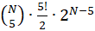
The upper-bound is used as sanity check to see if our MATLAB simulation didn't exceed the upper-bound.
The algorithm for functions generation has a runtime of .
All the possible functions with the pre-defined constraints (we usually checked the algorithm correctness if we got a functions composition as we expected) we succeeded to generate, we exported from MATLAB platform to a text file (the output of our simulation in MATLAB).
For example, here are two results in equations 1.9 and 1.10, that we got by using four variables, three additions, one pair of parentheses and three inversions:
As mentioned earlier, we also got the function composition in the mentioned simulation:
And this function composition can be realized to an electrical circuit which shown in figure 6, and to a complex feedback loop which shown in figure 7:
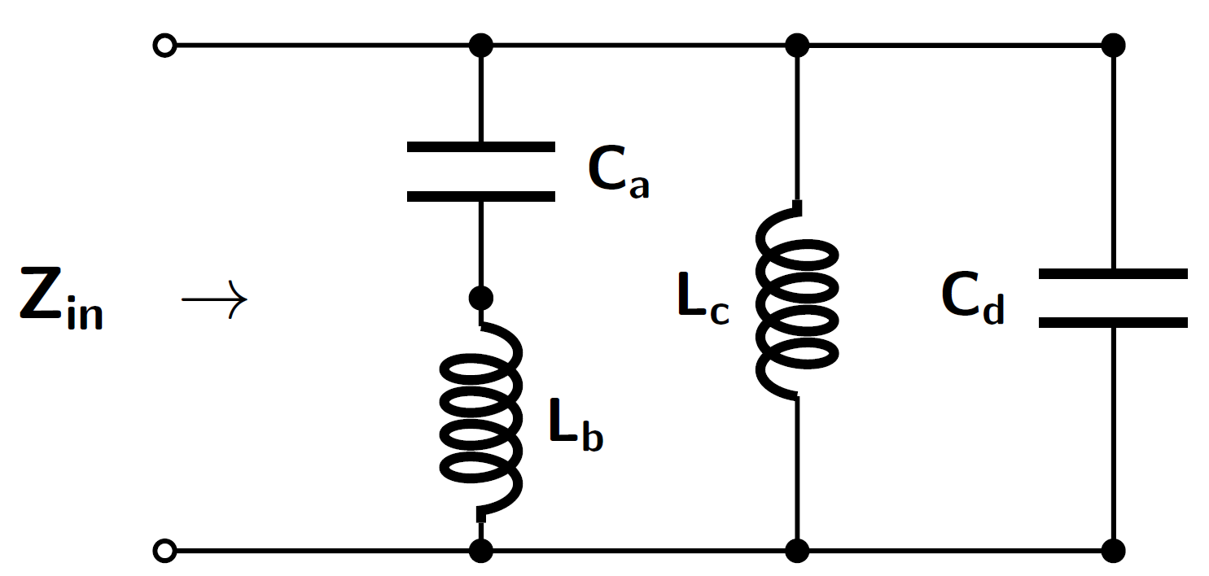
Figure 6 : Electrical Circuit of Functions Composition

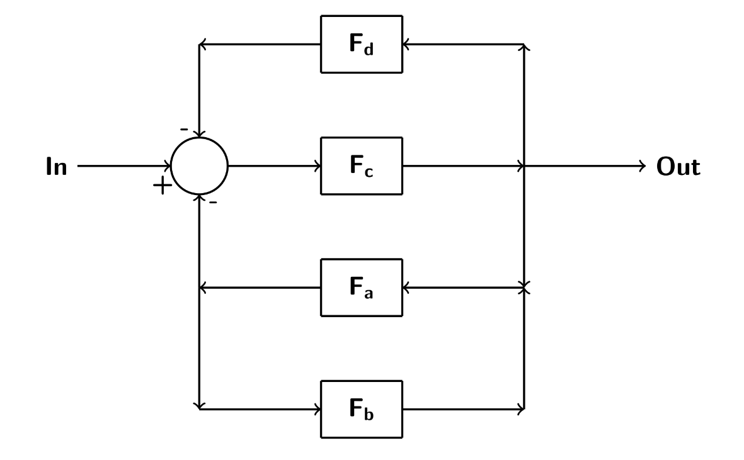
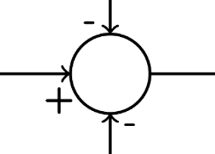
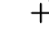

Figure 7 : Feedback Loop Network of Functions Composition
In addition to MATLAB simulations, we also generated and analyzed MIMO functions (usually with two inputs and two outputs) by-hand, as:
  - 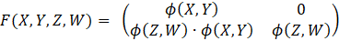
and analyzed their mathematical properties.

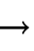
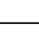
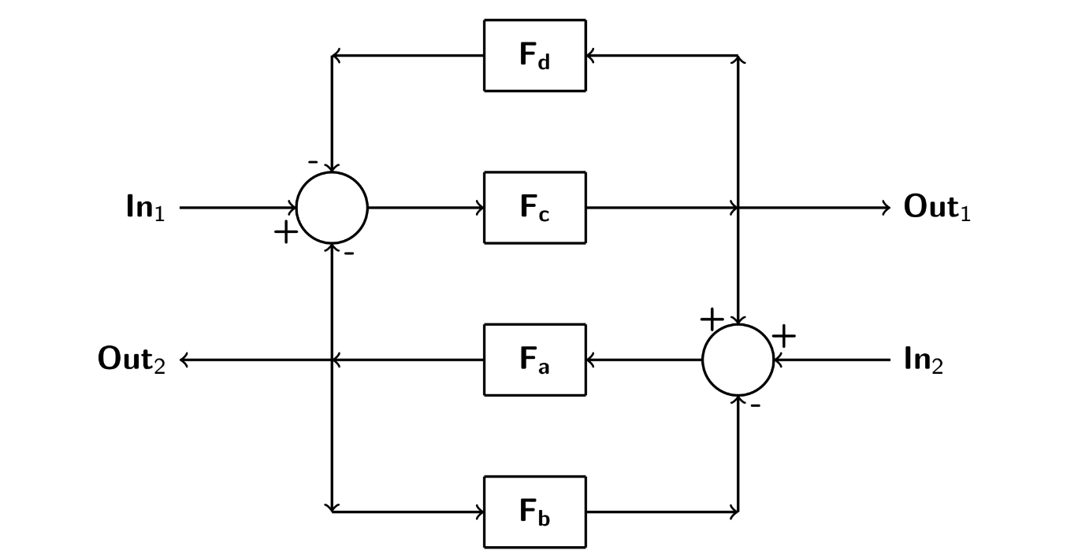
The MIMO function above can be realized to a system which contains two feedback loops that connected in series as shown in figure 8:

Figure 8 : Two Feedback Loops Connected in Series

Validation Method
In order to verify and validate our results, we checked the text file, that was generated by MATLAB code activation, if it stands the constraints that we defined him by-hand.
We used combinatorics and symbolic mathematics in order to verify that the number we got in our MATLAB simulation makes sense with the theory.
We also sketched LC circuits and feedback loops of the results we got on the text file, in order to see if a function we generated can really represent a system.

Problems and Solutions
In our project, we had problems and difficulties. First, we generated a database of arrays of alphabet letters to text files via MATLAB code. The storage memory in MATLAB for the functions was not enough. In order to overcome this, we printed each array directly to the text file and deleted it from the MATLAB running RAM memory itself. This is tradeoff because in order to check duplications, we need to import and read the functions in the text file, which costs us in the run time.
Second, the running time of the code and the program was slow. We reconsidered the pre-defined constraints to put in our code in order to decrease the runtime and changed the code to work in recursion mode.
In addition, we needed to confirm that we generated all PR functions under the pre-defined constraints. In order to overcome this, we used combinatorics and calculated upper bounds.
Lastly, analyzing non-commutative MIMO LC (PR) functions requires high level of mathematical knowledge. We studied about the mathematical properties of those functions.

Conclusions and Recommendations
We have conclusions about this project and recommendations for the continuation of the research in this field.
First, we successfully created a LC (PR) function generator, which uses alphabet dictionary parameterization. The constraints we defined are working well and defines all legal functions that can be generated. However, under large pre-defined constraints (as large maximum size of array), the MATLAB code is slow, so one recommendation is improving the runtime of the generator code in order to process results faster.
Second, we realized PR (LC) functions by-hand and by Mathematica and MATLAB simulations. We sketched LC circuits and feedback loops that represented the functions we discovered. Our recommendation for the continuation of the research is continuation of studying relevant mathematical disciplines and to realize the functions carefully to feedback loops or to electrical circuits.
Third, the output of the MATLAB code, the text file, is including PR functions, which can be part of a memory for PR functions and to use them for PR functions compositions and analyzing mathematical properties of those kinds of functions.
The NC-Algebra is limited in Mathematica and very inconvenient with very little amount of information online, so our recommendation for this difficulty is to implement algorithms for validation of NC (Non-Commutative) PR matrix-valued functions in MATLAB.
In addition, the parameterization method we chose can't analyze mathematical properties as checking if a function is a real function. The researchers in this field may find a new way for functions generation, which also can be used to check some mathematical properties easily and not just for generation.
We recommend reading the articles in the references, to learn about PR (LC) functions and to advise with our supervisor, Prof. Izchak Lewkowicz, for further information in this discipline.

References
[1] O. Brune, “Synthesis of a Finite Two Terminal Network whose Driving Point Impedance is a Pre-scribed Function of Frequency”, Journal of Mathematical Physics, Vol. 10, pp. 191-236, 1931.
[2] A. Morelli and M.C. Smith, "Passive Network Synthesis: An Approach to Classification" no. DC33 in Advances in Design and Control series by SIAM, 2019.
[3] B. Brogliato "Dissipative Systems Analysis and Control: Theory and Applications" , International Journal of Adaptive Control and Signal Processing, 2007.
[4] I. Lewkowicz, "Passive Linear Continuous-Time Systems: Characterization Thorough Structure" , School of Electrical and Computer Engineering Ben-Gurion University of The Negev, 2020.
[5] M.Z.Q Chen and M.C Smith, "A Note on Tests for Positive-Real Functions", IEEE Transactions on Automatic Control, Vol. 54, No.2, pp. 390-393, 2009.

Start Date | End Date | Task | Status
21/11/2021 | 21/11/2021 | Preliminary report submission | Done
25/11/2021 | 30/11/2021 | Learning how to use the mathematical software | Done
1/12/2021 | 03/12/2021 | Testing the computational tools | Done
8/12/2021 | 30/12/2021 | Determining and investigating set of functions | Done
28/02/2022 | 04/03/2022 | Process the findings | Done
5/03/2022 | 12/03/2022 | Working on the Progress report | Done
13/03/2022 | 13/03/2022 | Progress report submission | Done
19/03/2022 | 24/03/2022 | Learning more material | Done
27/03/2022 | 31/03/2022 | Looking for new functions to add for our database | Done
3/04/2022 | 12/05/2022 | Determining and investigating the new set of functions | Done
15/05/2022 | 30/05/2022 | Working on the Poster and the Presentationֲ | Done
1/06/2022 | 22/06/2022 | Working on the Presentation and the Final report | Done
6/06/2022 | 06/06/2022 | Poster report submission | Done
23/06/2022 | 23/06/2022 | Presentation submission | Done
25/06/2022 | 30/06/2022 | Process the new info about the Final report from our supervisor | Done
1/07/2022 | 23/07/2022 | Working on the Final report | Done

Appendix A : Task Management Table

Table 3 : Task Management Table

Appendix B : PR (LC) Functions Generator MATLAB Code
clear all
clc

%% Main code
%% First input
X_amount = 2;
Y_amount = 2;
W_amount = 2;
Z_amount = 2;
Multiplication_amount = 0;
Addition_amount = X_amount + Y_amount + W_amount + Z_amount - 1;
Inverse_amount = 4;
BracketR_amount = 1;
BracketL_amount = 1;
bracket_counter = 0;

Amount_of_matmtical = Multiplication_amount + Addition_amount + Inverse_amount + BracketR_amount + BracketL_amount;
Total = X_amount + Y_amount + Multiplication_amount + Addition_amount + Inverse_amount + BracketR_amount + BracketL_amount + W_amount + Z_amount;

%% Creating the vector of rucrsie sets

Sets = CreatingSets(Total-1);

%% Creating a vector with all the input
Vector = zeros(1,Total);

X_amount_temp = X_amount;
Y_amount_temp = Y_amount;
W_amount_temp = W_amount;
Z_amount_temp = Z_amount;
Multiplication_amount_temp = Multiplication_amount;
Addition_amount_temp = Addition_amount;
Inverse_amount_temp = Inverse_amount;
BracketR_amount_temp = BracketR_amount;
BracketL_amount_temp = BracketL_amount;

for i = 1:Total
if(X_amount_temp>0)
Vector(i) = 'X' ;
X_amount_temp = X_amount_temp - 1;
elseif(Y_amount_temp>0)
Vector(i) = 'Y' ;
Y_amount_temp = Y_amount_temp - 1;
elseif(W_amount_temp>0)
Vector(i) = 'W' ;
W_amount_temp = W_amount_temp - 1;
elseif(Z_amount_temp>0)
Vector(i) = 'Z' ;
Z_amount_temp = Z_amount_temp - 1;
elseif(Addition_amount_temp>0)
Vector(i) = 'A' ;
Addition_amount_temp = Addition_amount_temp - 1;
elseif(Multiplication_amount_temp>0)
Vector(i) = 'B' ;
Multiplication_amount_temp = Multiplication_amount_temp - 1;
elseif(Inverse_amount_temp>0)
Vector(i) = 'C' ;
Inverse_amount_temp = Inverse_amount_temp - 1;
elseif(BracketL_amount_temp>0)
Vector(i) = 'D' ;
BracketL_amount_temp = BracketL_amount_temp - 1;
elseif(BracketR_amount_temp>0)
Vector(i) = 'E' ;
BracketR_amount_temp = BracketR_amount_temp - 1;
end
end

%% Test vecor of known function X+Y^-1+(W+Z^-1)^-1 = Phi(Phi(W,Z),Phi(X,Y))^-1 = (((W+Z^-1)^-1 + ((X+Y^-1)^-1)^-1)^-1)^-1
% Phi(X,Y) = (X+Y^-1)^-1
Test = zeros(1,Total);
Test(1) = 'X' ;
Test(2) = 'A' ;
Test(3) = 'Y' ;
Test(4) = 'C' ;
Test(5) = 'A' ;
Test(6) = 'D' ;
Test(7) = 'W' ;
Test(8) = 'A' ;
Test(9) = 'Z' ;
Test(10) = 'C' ;
Test(11) = 'E' ;
Test(12) = 'C' ;

tic %%%%%%

%% Function Generate with constrains
Counters = zeros(1,9);
for i = 1:Total
if((Vector(i) == 'A' || Vector(i) == 'B' || Vector(i) == 'C' || Vector(i) == 'E')) % Array can't start with '+','*','^-1',')'
continue ;
end
V = Vector(i);
if(~RepetCondtion(V,Counters)) %To prevent returning on the same latter
continue;
end

if(V == 'D') % bracket_counter no need for ')' becuse that already drop at the first if
bracket_counter = bracket_counter + 1 ;
else
bracket_counter = 0;
end
if(i==1)
vector_temp = FunctionCreate(Vector(2:end),Total-1,V(1),Total,Test,bracket_counter);
elseif(i==Total)
vector_temp = FunctionCreate(Vector(1:end-1),Total-1,V(1),Total,Test,bracket_counter);
else
vector_temp = FunctionCreate([Vector(1:i-1) Vector(i+1:end)],Total-1,V(1),Total,Test,bracket_counter);
end
if(i==1) % First input
function_gen = vector_temp;
else
function_gen = [function_gen ; vector_temp];
end

if(V == 'A')
Counters(1)= 1;
elseif (V == 'B')
Counters(2)= 1;
elseif (V == 'C')
Counters(3)= 1;
elseif (V == 'D')
Counters(4)= 1;
elseif (V == 'E')
Counters(5)= 1;
elseif (V == 'W')
Counters(6)= 1;
elseif (V == 'X')
Counters(7)= 1;
elseif (V == 'Y')
Counters(8)= 1;
elseif (V == 'Z')
Counters(9)= 1;
end
end

toc
tic

function_without_dup = function_gen;
function_without_dup( all(~function_without_dup,2), : ) = [] ; %% Clear zeros row

toc

function_without_dup1 = function_without_dup;

tic
%% Taking only one type of function for example f(x,y) and delete f(y,x) when that the same function but diffrent virable spots
TheFunctions(1,:) = function_without_dup1(1,:);
Check_vector(1,:) = MatmticVector(function_without_dup1(1,:),Total,Multiplication_amount,Addition_amount,Inverse_amount,BracketR_amount,BracketL_amount);

for i = 2:size(function_without_dup1)
flag = 1;
Check_vector_temp = MatmticVector(function_without_dup1(i,:),Total,Multiplication_amount,Addition_amount,Inverse_amount,BracketR_amount,BracketL_amount);
for j = 1:size(TheFunctions)
if(isequal(Check_vector(j,:),Check_vector_temp))
% Checking if we have the same function but different variable spots
flag = 0;
break ;
end
end
if(flag)
TheFunctions = [TheFunctions ; function_without_dup1(i,:)];
Check_vector = [Check_vector ; Check_vector_temp];
end
end
toc

tic
%% Creating the string of the functions
temp = CreateStringMatrix(TheFunctions(1,:),Total);
TheFunctions_Strings(1,:) = temp;
for i=2:size(TheFunctions) %% Creting the string of the function into the matrix
temp = CreateStringMatrix(TheFunctions(i,:),Total);
TheFunctions_Strings = [TheFunctions_Strings ; temp];

end

toc

%% Function to create our matrix string

function Vector = CreateStringMatrix(V,size)

for i=1:size
if(V(i) == 'A')
Char = '+';

elseif(V(i) == 'B')
Char = '*';

elseif(V(i) == 'C')
Char = '^-1';

elseif(V(i) == 'D')
Char = '(';

elseif(V(i) == 'E')
Char = ')';

elseif(V(i) == 'X')
Char = 'X';

elseif(V(i) == 'Y')
Char = 'Y';

elseif(V(i) == 'Z')
Char = 'Z';

elseif(V(i) == 'W')
Char = 'W';

end
if(i==1) % First char to the string
Vector_temp(i) = Char;
else
Vector_temp = [Vector_temp Char];
end
end
Vector = Vector_temp ;
end

%% Function to find the spot of '+','*','^-1','(',')' and create a new vector of data

function vector = MatmticVector(V,size,Multiplication_amount,Addition_amount,Inverse_amount,BracketR_amount,BracketL_amount)
vector = zeros(1,Multiplication_amount + Addition_amount + Inverse_amount + BracketR_amount + BracketL_amount+5);
vector(1) = 'A' ;
A_amount = 1;
B_amount = 1;
C_amount = 1;
D_amount = 1;
E_amount = 1;
for i=1:size
if(V(i) == 'A')
A(A_amount) = i;
A_amount = A_amount + 1;
elseif(V(i) == 'B')
B(B_amount) = i;
B_amount = B_amount + 1;
elseif(V(i) == 'C')
C(C_amount) = i;
C_amount = C_amount + 1;
elseif(V(i) == 'D')
D(D_amount) = i;
D_amount = D_amount + 1;
elseif(V(i) == 'E')
E(E_amount) = i;
E_amount = E_amount + 1;
end
end
if(A_amount == 1)
A = 0;
Addition_amount = 1;
end
if(B_amount == 1)
B = 0;
Multiplication_amount = 1;
end
if(C_amount == 1)
C = 0;
Inverse_amount = 1;
end
if(D_amount == 1)
D = 0;
BracketL_amount = 1;
end
if(E_amount == 1)
E = 0;
BracketR_amount = 1;
end
vector(2:2+Addition_amount-1)=A(:);
vector(2+Addition_amount)= 'B';
vector(2+Addition_amount+1:3+Addition_amount+Multiplication_amount-1)=B(:);
vector(3+Addition_amount+Multiplication_amount) = 'C' ;
vector(3+Addition_amount+Multiplication_amount+1:4+Addition_amount+Multiplication_amount+Inverse_amount-1)=C(:);
vector(4+Addition_amount+Multiplication_amount+Inverse_amount) = 'D' ;
vector(4+Addition_amount+Multiplication_amount+Inverse_amount+1:5+Addition_amount+Multiplication_amount+Inverse_amount+BracketL_amount-1)=D(:);
vector(5+Addition_amount+Multiplication_amount+Inverse_amount+BracketL_amount) = 'E' ;
vector(5+Addition_amount+Multiplication_amount+Inverse_amount+BracketL_amount+1:6+Addition_amount+Multiplication_amount+Inverse_amount+BracketL_amount+BracketR_amount-1)=E(:);
end

%% Checking for repeating variable
function check = RepetCondtion(V,Counter)
if(V == 'A' && Counter(1)>0)
check = 0;
return ;
elseif (V == 'B' && Counter(2)>0)
check = 0;
return ;
elseif (V == 'C' && Counter(3)>0)
check = 0;
return ;
elseif (V == 'D' && Counter(4)>0)
check = 0;
return ;
elseif (V == 'E' && Counter(5)>0)
check = 0;
return ;
elseif (V == 'W' && Counter(6)>0)
check = 0;
return ;
elseif (V == 'X' && Counter(7)>0)
check = 0;
return ;
elseif (V == 'Y' && Counter(8)>0)
check = 0;
return ;
elseif (V == 'Z' && Counter(9)>0)
check = 0;
return ;
end
check = 1;
end

function Set = CreatingSets(Total)

if(Total == 0)
Set = 0;
return;
end
if(Total <= 2 && (Total >= 1) || Total < 0)
Set = -1;
return;
end

Check = CreatingSets(Total - 6);
if(size(Check,2) == 1)
if(Check == -1)
Set = -1;
elseif(Check == 0)
Set = 6;
return ;
elseif(Check > 0)
Set = [ 6 Check ] ;
return ;
end
elseif(size(Check,2) > 1)
Set = [ 6 Check ] ;
return ;
end

Check = CreatingSets(Total - 5);
if(size(Check,2) == 1)
if(Check == -1)
Set = -1;
elseif(Check == 0)
Set = 5;
return ;
elseif(Check > 0)
Set = [ 5 Check ] ;
return ;
end
elseif(size(Check,2) > 1)
Set = [ 5 Check ] ;
return ;
end

Check = CreatingSets(Total - 4);
if(size(Check,2) == 1)
if(Check == -1)
Set = -1;
elseif(Check == 0)
Set = 4;
return ;
elseif(Check > 0)
Set = [ 4 Check ] ;
return ;
end
elseif(size(Check,2) > 1)
Set = [ 4 Check ] ;
return ;
end

Check = CreatingSets(Total - 3);
if(size(Check,2) == 1)
if(Check == -1)
Set = -1;
elseif(Check == 0)
Set = 3;
return ;
elseif(Check > 0)
Set = [ 3 Check ] ;
return ;
end
elseif(size(Check,2) > 1)
Set = [ 3 Check ] ;
return ;
end

end

המלצת ציון לדו"ח מסכם
אם יש צורך, לכל סטודנט/ית בנפרד
מספר הפרויקט: p-2022-110
הפרויקט:
שם המנחה החיצוני:
שם המנחה מהמחלקה:
שם הסטודנט/ית: ת.ז.:
% |  | חלש  55-64 | בינוני  65-74 | טוב  75-84 | ט"מ  85-94 | מצוין  95-100
20 | הצגת הגישה והתכנון ההנדסי
20 | הצגת התוצאות וניתוח השגיאות
20 | הסקת מסקנות
10 | גילוי יוזמה וחריצות
20 | פתרון בעיות, מקוריות ותרומה אישית (מעבר למילוי ההנחיות)
10 | עמידה בלו"ז ורמת הביצוע המעשי
אם יש כוונה לפרסם/ יפורסם מאמר, שם כתב העת ומועד משוער להגשה:
ציין אם יש כוונה לשקול המלצה כפרויקט מצטיין:
הערות נוספות:

