Corner the Blue
  - A small French abstract strategy game implemented in C# and Windows Forms

1. Game overview
Corner the Blue is a two-player abstract strategy game inspired by the classic French “hare games” (also known as the French Military Game / Hare and Hounds). One player controls three red pieces that advance together like a small squad; the other player controls a single blue piece that moves more freely but is outnumbered. The rules are very simple, but the positions can be surprisingly rich: there is no randomness and no hidden information – every game is decided purely by planning and tactics.

2. Objective

Red (three pieces)
Red tries to drive the blue piece into a corner or against the edge of the board so that the blue piece has no legal moves left. When the blue piece is completely blocked and cannot move anywhere, Red wins.

Blue (one piece)
Blue tries to slip past the red defensive line. As soon as the blue piece reaches a position below all red pieces (i.e., closer to the bottom of the board than any red piece), Blue wins immediately. Because red pieces are not allowed to move backwards, they can no longer rebuild a blocking line behind the blue piece.

3. Setup
The game is played on a small fixed board (see Screenshot 1 – Starting position). Initially:
- • Place three red pieces at the “top” side of the board on their starting points.
- • Place one blue piece closer to the “bottom” side on its starting point.
The exact starting layout is shown in the screenshot; the digital implementation uses fixed coordinates for these starting positions.

4. Movement rules
Players take turns. Red always moves first. On each turn, a player moves exactly one of their own pieces by one step along the board lines to a free neighbouring point.

Red pieces (three red tokens)
- On Red’s turn, the player must move exactly one red piece:
- • A red piece can move one step forward (towards the blue side of the board).
- • A red piece can also move one step sideways (left or right), if there is a line/connection there.
- • Red pieces are not allowed to move backward.
There are no captures and no jumps – a red piece can only move to an adjacent, empty point connected by a board line.

Blue piece (single blue token)
- On Blue’s turn, the player moves the blue piece:
- • The blue piece may move one step in any direction – forward, backward, sideways or diagonally, following the board lines.
- • The blue piece also cannot jump over pieces and cannot land on an occupied point.

5. End of the game

Red victory – cornering the blue piece
If it is Blue’s turn and the blue piece has no legal moves (every adjacent point is either off the board, occupied by a red piece, or not connected by a line), then the blue piece is considered trapped and Red wins the game (see Screenshot 2 – Red has trapped the blue piece).

Blue victory – slipping past the reds
If at any moment the blue piece moves to a position below all red pieces (in other words, it is closer to the bottom side of the board than any red piece), then Blue wins immediately. This represents the blue piece breaking through the defensive line (see Screenshot 3 – Blue has broken through the red defense).

6. Strategy tips

For Red (three pieces)
- • Keep your red pieces close together and avoid opening large gaps.
- • Advance slowly and carefully – moving too far forward with one piece can create a hole.
- • Try to push the blue piece towards a corner or the edge where it has fewer escape squares.

For Blue (one piece)
- • Use your ability to move in any direction to keep options open.
- • Sometimes a small retreat or sideways move will tempt Red into breaking formation.
- • Look for moments when one red piece drifts away from the others – that is your chance to slip through.

7. Implementation details (C# / Windows Forms and AI)
This digital version of Corner the Blue is implemented as a classic desktop application using C# and .NET Windows Forms. The goal was to keep the code small, readable and suitable as an example project for beginners who want to study basic game loops and event handling in C#.
- Technical highlights:
- • The game board is drawn using standard Windows Forms drawing (GDI+).
- • Mouse events are used to select and move pieces on the board.
- • Game state is stored in simple C# classes (board, pieces, current player, legal moves).
- • Win detection (Red traps Blue / Blue breaks through) is checked after every move.

AI / move-selection algorithm
For another board game project (Renzo) a classic minimax algorithm with an evaluation function in the range 0–1 was used. For Corner the Blue, the AI uses a different approach that is better suited to this small, highly tactical game. Here the evaluation is essentially binary: every position is treated as either a win (1) or a loss (0) for the side to move.
Instead of trying to brute-force all possible moves on the game graph in real time, the algorithm focuses on a carefully selected subset of positions. It treats each reachable board position as a node in a directed graph and performs a graph walk to identify positions whose outcome can be proven exactly:
- • Any position that immediately leads to a forced loss for the opponent is marked as winning.
- • Any position where all legal moves lead only to positions that are winning for the opponent is marked as losing.
By iterating this process over the relevant part of the state graph, the engine builds a set of “anchor” positions whose outcome (win or loss) is known with certainty. During actual play, the move-selection routine does not explore the full game tree. It expands only a subset of candidate moves until it reaches one of these pre-classified positions; at that moment the algorithm already knows the final outcome of that line and can stop searching deeper.
In practice this allows the engine to find a strong move almost instantly, without having to enumerate every possible move on the graph in real time, while still relying on exact win/loss information instead of a vague heuristic score.
Because all logic is encapsulated in a few small classes, this project can be used as a starting point for experiments with AI (search trees, evaluation functions, partial retrograde analysis) or for porting the game to other frameworks such as WPF, Unity, or a web-based frontend.

8. Screenshots
Screenshot 1 – Starting position
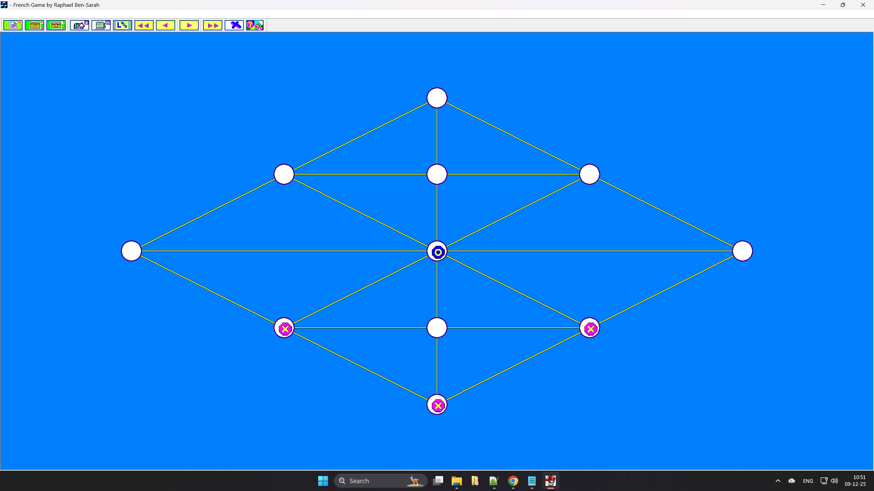Screenshot 2 – Red victory: blue is completely blocked
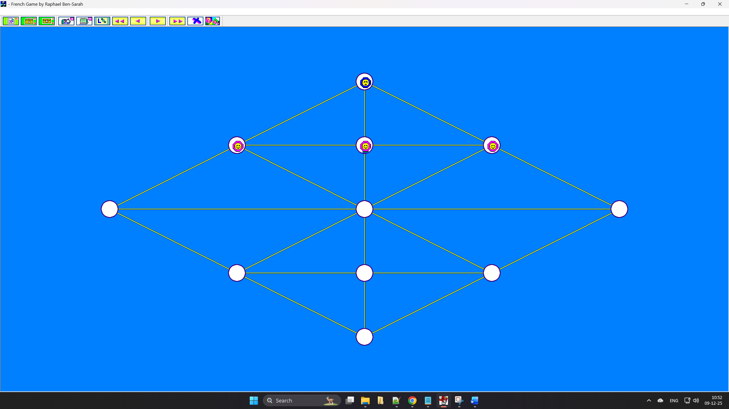Screenshot 3 – Blue victory: blue has slipped past the red line

