# Audio to Software - ATS

Audio o Software (ATS) is a service that run in the background and know to listen to specific Audio Device and on Connection/Disconnected to Open/Close Any Desire Software on your computer.

# Installation

To install, simplify run the exe file and follow the steps.

Download Link

After Installation, the program will be startup automatic.  
In any time, you can find the program on the taskbar tray (close to the clock)

# Usage

1. Open the ATS

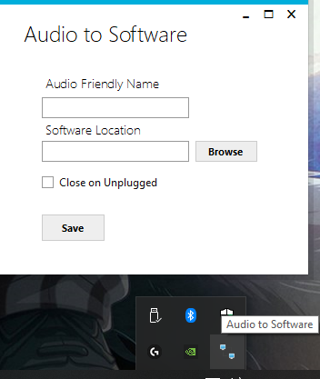

1. Insert Audio Friendly Name that you want to listen to.

( do not worry about spaces and sensitive case )

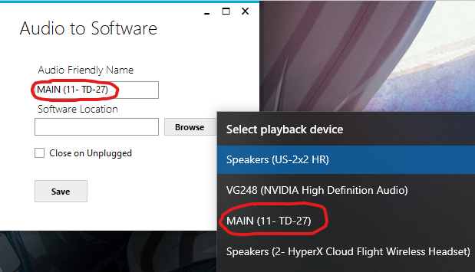

1. Select Software Location by press on Browse

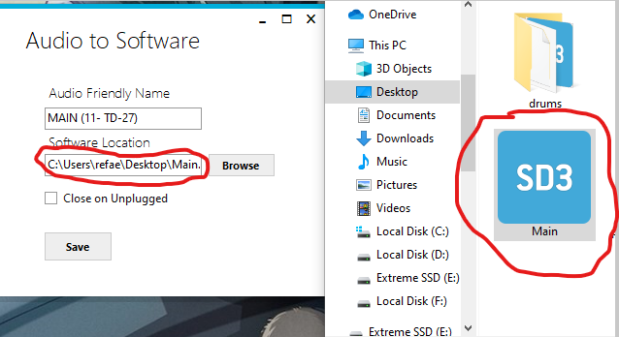

1. Check “Close on Unplugged” if you want to close the application when audio disconnected.  
   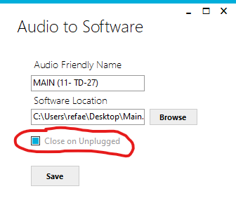
2. Press “Save” to save the changes and then “OK” to minimize ATS.

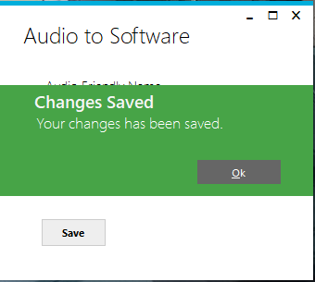

1. Congratulations, your Device are ready to listen and open desire software accordingly.

# Contact Information

For any issue or question you can contact to me via my mail: [refaeloknin@gmail.com](mailto:refaeloknin@gmail.com)