LAB Logbook

Lab 1
- The DataFrame class is utilized to store and manipulate the entire cybersecurity dataset, providing a tabular structure with labeled axes for rows and columns.
- The Series class represents individual columns like 'Attack Type' and 'Timestamp', offering a one-dimensional labeled array capability for efficient data access and computation.
- The Resampler class is produced by the resample method and is instrumental in handling time-series data, specifically for grouping attacks into monthly intervals for trend analysis.
- The DataFrameGroupBy class, resulting from the groupby method, allows the data to be split into groups based on 'Year' and 'Attack Type' for aggregate analysis and summary generation.
- The RangeIndex class serves as the default immutable integer index for the DataFrame, ensuring that each of the 40,000 attack records has a unique sequential identifier.
Lab 2
Attack Type:
MOVEit File Transfer Hack (2023)

Key Source:
CISA Cybersecurity Advisory AA23-158a
https://www.cisa.gov/news-events/cybersecurity-advisories/aa23-158a

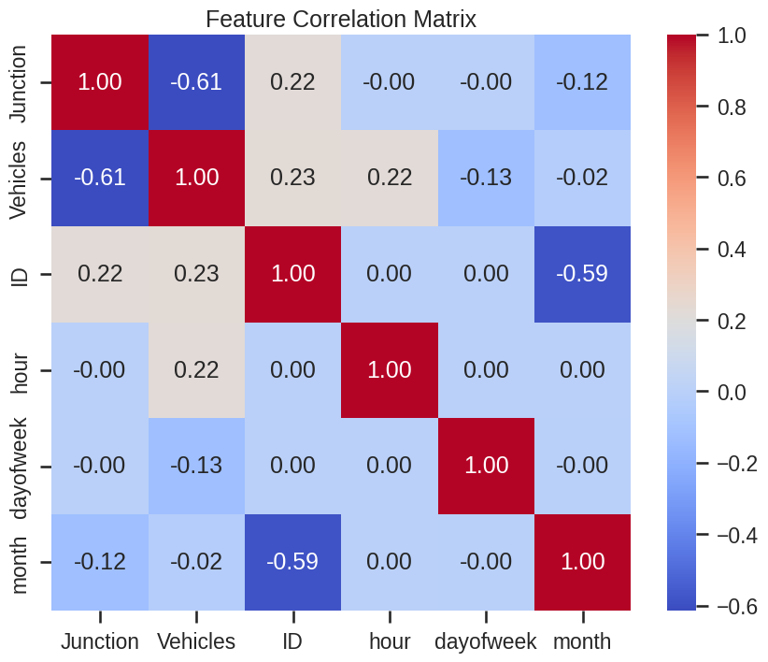
Lab 3

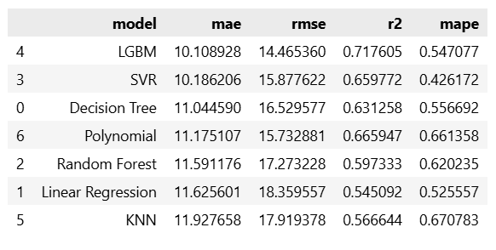

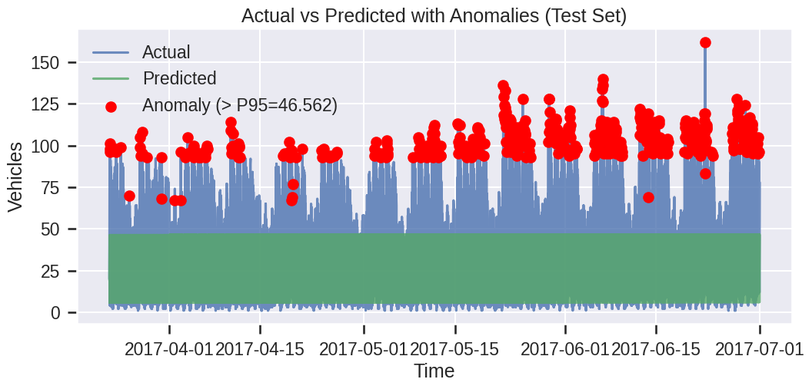

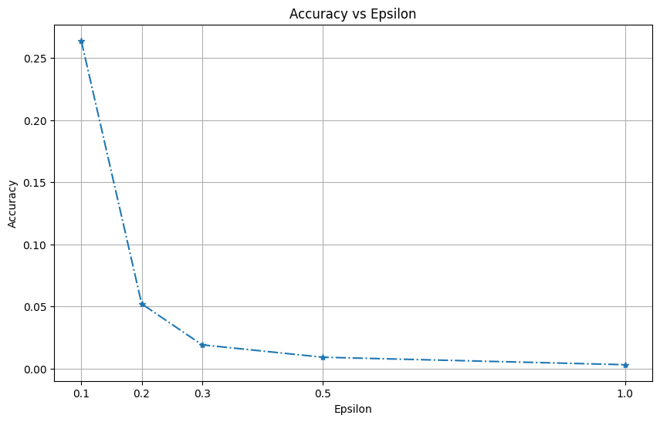
Lab 4

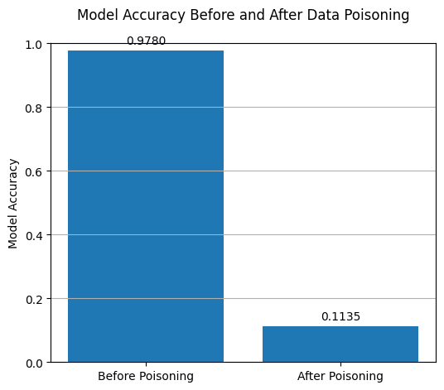
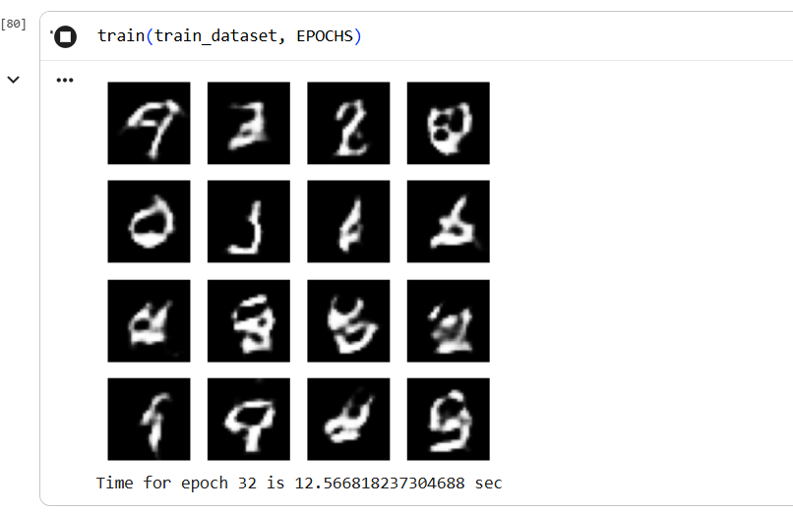
Lab 5

Lab 6
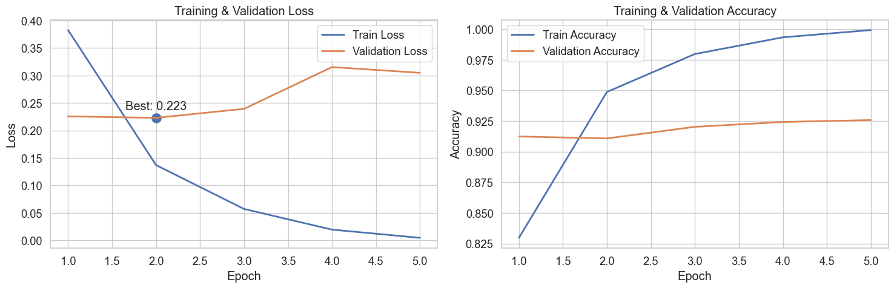

Lab 7
1. Sample of plain and cypher text for AES and DES
AES Plaintext: HelloCrypto
AES Ciphertext: GivAPqcdNy0zbxUWJl3mdw==
DES Plaintext: HelloCrypto
DES Ciphertext: HQqgsqSEljgBPH7L4con0w==



2. Real image and cipher image for the image of any choice using AES.

Real image: input.jpg Cipher image: encrypted_ecb.png

3. Explain in one word - 'YES' or 'NO' whether your encryption method for the images is good.
NO
(The original image's outline and pattern are still visible in the encrypted version.)

Lab 8
Partner Name: Vishnu
Public Values: p = 23, g = 5
My Private Key: a = 6
Shared Secret: s = 2
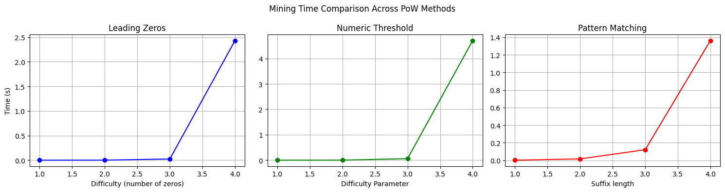
Lab 9



Lab 10

Lab 11

Lab 12

