Regression

Notes
Output Created |  | 14-JAN-2025 08:26:38
Comments
Input | Active Dataset | DataSet0
Input | Filter | <none>
Input | Weight | <none>
Input | Split File | <none>
Input | N of Rows in Working Data File | 20
Missing Value Handling | Definition of Missing | User-defined missing values are treated as missing.
Missing Value Handling | Cases Used | Statistics are based on cases with no missing values for any variable used.
Syntax |  | REGRESSION  /MISSING LISTWISE  /STATISTICS COEFF OUTS R ANOVA  /CRITERIA=PIN(.05) POUT(.10)  /NOORIGIN  /DEPENDENT Y  /METHOD=ENTER X  /RESIDUALS NORMPROB(ZRESID).
Resources | Processor Time | 00:00:02,78
Resources | Elapsed Time | 00:00:26,16
Resources | Memory Required | 2400 bytes
Resources | Additional Memory Required for Residual Plots | 296 bytes

[DataSet0]

Variables Entered/Removedª
Model | Variables Entered | Variables Removed | Method
1 | X^{b} | . | Enter

a. Dependent Variable: Y
b. All requested variables entered.

Model Summary^{b}
Model | R | R Square | Adjusted R Square | Std. Error of the Estimate
1 | .416ª | .173 | .127 | 4.892

a. Predictors: (Constant), X
b. Dependent Variable: Y

ANOVAª
Model |  | Sum of Squares | df | Mean Square | F | Sig.
1 | Regression | 90.354 | 1 | 90.354 | 3.775 | .068^{b}
1 | Residual | 430.846 | 18 | 23.936
1 | Total | 521.200 | 19

a. Dependent Variable: Y
b. Predictors: (Constant), X

Coefficientsª
Model |  | Unstandardized Coefficients |  | Standardized Coefficients | t | Sig.
 |  | B | Std. Error | Beta | t | Sig.
1 | (Constant) | 35.462 | 4.629 |  | 7.661 | .000
1 | X | .139 | .072 | .416 | 1.943 | .068

a. Dependent Variable: Y

Residuals Statisticsª
 | Minimum | Maximum | Mean | Std. Deviation | N
Predicted Value | 41.02 | 47.96 | 44.20 | 2.181 | 20
Residual | -6.576 | 10.981 | .000 | 4.762 | 20
Std. Predicted Value | -1.459 | 1.726 | .000 | 1.000 | 20
Std. Residual | -1.344 | 2.245 | .000 | .973 | 20

a. Dependent Variable: Y

Charts

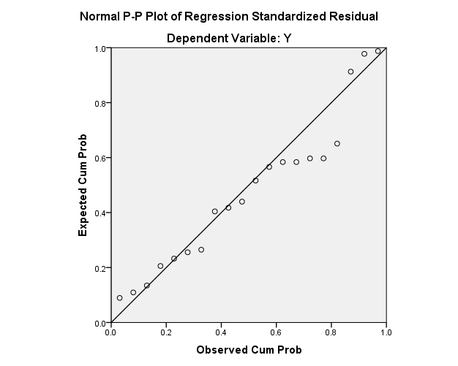

CORRELATIONS
/VARIABLES=Y X
/PRINT=TWOTAIL NOSIG
/MISSING=PAIRWISE.

Correlations

Notes
Output Created |  | 14-JAN-2025 08:38:36
Comments
Input | Active Dataset | DataSet0
Input | Filter | <none>
Input | Weight | <none>
Input | Split File | <none>
Input | N of Rows in Working Data File | 20
Missing Value Handling | Definition of Missing | User-defined missing values are treated as missing.
Missing Value Handling | Cases Used | Statistics for each pair of variables are based on all the cases with valid data for that pair.
Syntax |  | CORRELATIONS  /VARIABLES=Y X  /PRINT=TWOTAIL NOSIG  /MISSING=PAIRWISE.
Resources | Processor Time | 00:00:00,00
Resources | Elapsed Time | 00:00:00,00

Correlations
 |  | Y | X
Y | Pearson Correlation | 1 | .416
Y | Sig. (2-tailed) |  | .068
Y | N | 20 | 20
X | Pearson Correlation | .416 | 1
X | Sig. (2-tailed) | .068
X | N | 20 | 20

