Refo Yudhanto

CS455

HW3

Chap 3

P1.a. H3 are forwarded through interface 3 so forwarding table will look like:

|  |  |
| --- | --- |
| Destination | Interface |
| H3 | Interface 3 |

b. Router A will only have 1 forwarding rule, so having 2 different rote is not possible. So, router A can only have run through interface 3 or interface 4, but not both.

P5. A.

|  |  |
| --- | --- |
| Prefix | Link Interface |
| 11100000 00 | 0 |
| 11100000 01000000 | 1 |
| 1110000 | 2 |
| otherwise | 3 |

B.1st address = link interface 3

2nd address = link interface 2

3rd address = link interface 3

P8.

Subnet 2: 90 interface = 7bits w/128 addresses prefix=32-7=25 = 223.1.17.0-127/25

Subnet 1: 60 interface = 6 bits w/ 64 addresses prefix=32-6=26 = 223.1.17.128-191/26

Subnet 3: 12 interface = 4bits w/ 16 addresses prefix=32-4=28 = 223.1.17.192-207/28

P10.

|  |  |
| --- | --- |
| Prefix | Link Interface |
| 224.0.0.0/10 | 0 |
| 224.64.0.0/16 | 1 |
| 224.0.0.0/8 | 2 |
| otherwise | 3 |

P13.

WSU: Net Range = 216.186.59.128 - 216.186.59.255, CIDR = 216.186.59.128/25

UofI: Net Range = 129.101.0.0-129.101.255.255, CIDR = 129.101.0.0/16

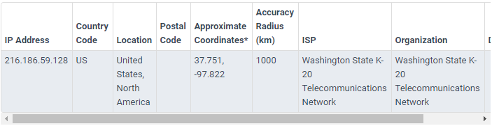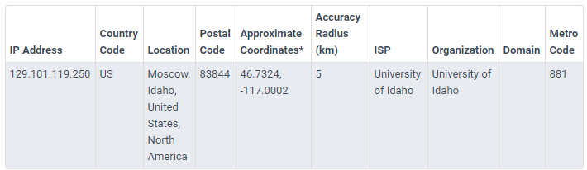

WhoIs does not show geographical location, but you use maxmind to find it.

P16. A. Home = 192.168.1.1-3 and router = 192.168.1.4

B.

NAT translation table:

|  |  |
| --- | --- |
| Global | Local |
| 24.34.112.235, 4000 | 192.168.1.1, 3345 |
| 24.34.112.235, 4001 | 192.168.1.1, 3346 |
| 24.34.112.235, 4002 | 192.168.1.2, 3445 |
| 24.34.112.235, 4003 | 192.168.1.2, 3446 |
| 24.34.112.235, 4004 | 192.168.1.3, 3545 |
| 24.34.112.235, 4005 | 192.168.1.3, 3546 |

P22.

a)h1 and h6 to h3/h4

|  |  |  |  |  |  |
| --- | --- | --- | --- | --- | --- |
| Source IP | Destination IP | Source Host | Destination Host | Interface | Action |
| 10.1.0.2 | Any | H2 | any | Any | Block |
| 10.3.0.5 | any | H5 | Any | Any | Block |
| 10.1.0.1 | 10.2.0.3 | H1 | H3 | 2 | Forwarded |
| 10.1.0.1 | 10.2.0.4 | H1 | H4 | 2 | Forwarded |
| 10.3.0.6 | 10.2.0.3 | H6 | H3 | 1 | Forwarded |
| 10.3.0.6 | 10.2.0.4 | H6 | H4 | 1 | Forwarded |
| b) only tcp allowed for h3 or h4, UDP blocked | | | | | |
|  |  |  |  | Protocol |  |
| Any | 10.2.0.3 | Any | H3 | TCP | Forwarded |
| Any | 10.2.0.4 | Any | H4 | TCP | Forwarded |
| any | Any except both | any | Any except both | UDP | Block |
| c)only traffic for h3 is delivered, h4 is blocked | | | | | |
| Any | 10.2.0.3 | any | H3 | any | Forwarded |
| Any | 10.2.0.4 | any | H4 | any | Block |
| d)only UDP from h1 to h3 is delivered, all other is blocked | | | | | |
| 10.1.0.1 | 10.2.0.3 | H1 | H3 | UDP | Forwarded |
| Any except | Any except | Any except | Any except | Any except | Blocked |

Chapter 5

P3.

|  |  |  |  |  |  |  |  |
| --- | --- | --- | --- | --- | --- | --- | --- |
| Step | N’ | D(t),p(t) | D(u),p(u) | D(v),p(v) | D(w),p(w) | D(y),p(y) | D(z),p(z) |
| 0 | X | ∞ | ∞ | 3,x | 6,x | 6,x | 8,x |
| 1 | Xv | 7,v | 6,v | 3,x | 6,x | 6,x | 8,x |
| 2 | Xvu | 7,v | 6,v | 3,x | 6,x | 6,x | 8,x |
| 3 | Xvuw | 7,v | 6,v | 3,x | 6,x | 6,x | 8,x |
| 4 | Xvuwy | 7,v | 6,v | 3,x | 6,x | 6,x | 8,x |
| 5 | Xvuwyt | 7,v | 6,v | 3,x | 6,x | 6,x | 8,x |
| 6 | xvuwytz | 7,v | 6,v | 3,x | 6,x | 6,x | 8,x |

P12. BGP uses AS routing protocol. AS have 2 useful attributes which is AS-PATH and NEXT-HOP. Detection of loops in path is detected by using AS-PATH attribute.

P14.a. eBGP

b. iBGP

c. eBGP

d. iBGP

P.15. a. value of I will be equal to I1 for this matter sinceI1 is the least cost path with 2 hops from router 1d to 1c.

b. For this matter, I will be set to I2 as both have the same AS-PATH length but I2 has the closest NEXT-HOP router next.

c. I will be equal to I1 as I1 has the shortest AS-PATH.