TASK 1

Step 1. 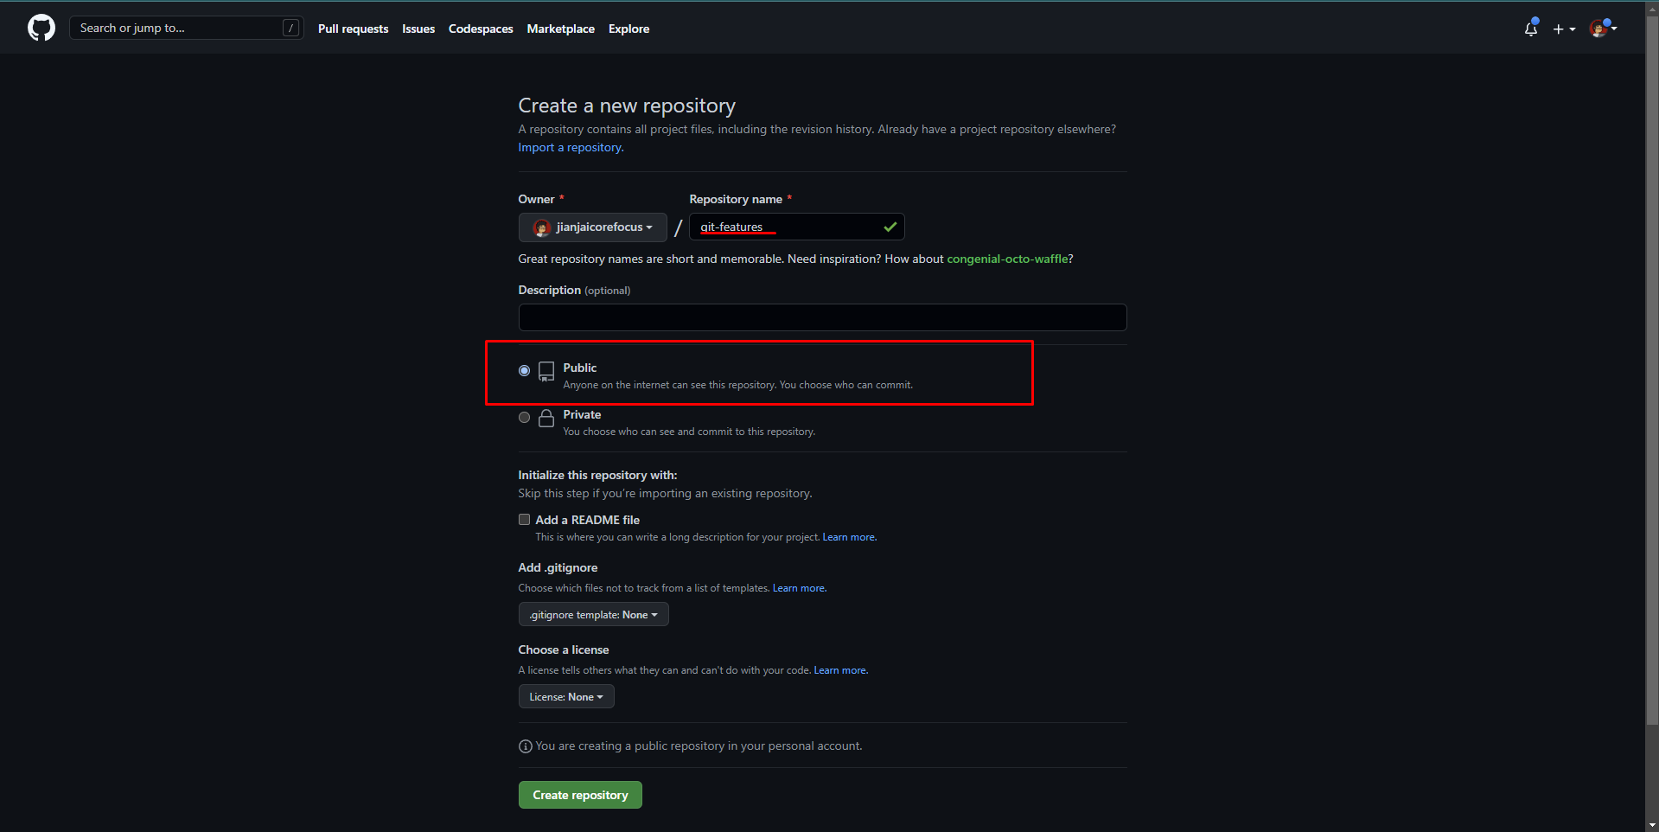

Step 2.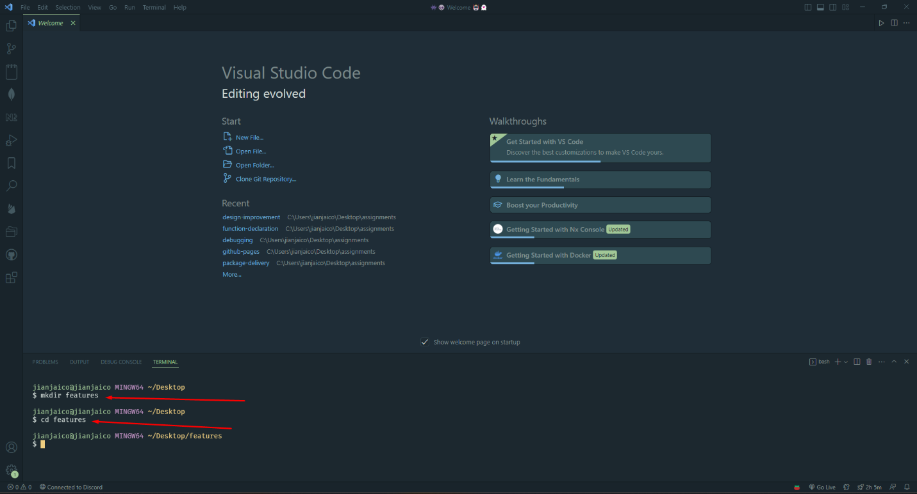

Step 3. 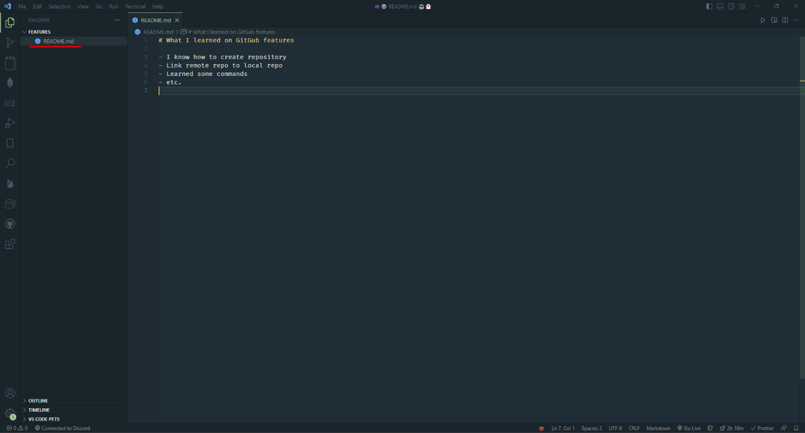

Step 4.  
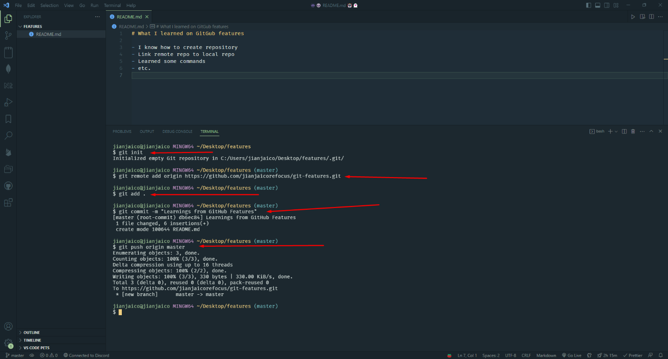

Project 1 link: https://github.com/jianjaicorefocus/CAJITA-CV