# Address Manager Application

## Overview

The proposed solution consists of several different components:

* Client Interface - Unspecified but could be web, mobile or desktop based.
* Web API – Chosen for its flexibility to support any of the above client types.
* DataStore – A database offering reliable and secure means of data access, storage and offline backup.
* ETL – SSIS which is perfectly suited for bulk extract, transform and load activities. Either direct into another database or via csv/xml or other file format. No backend system integration requirements were available so this is a best guess of how they might consume the data during an offline update.

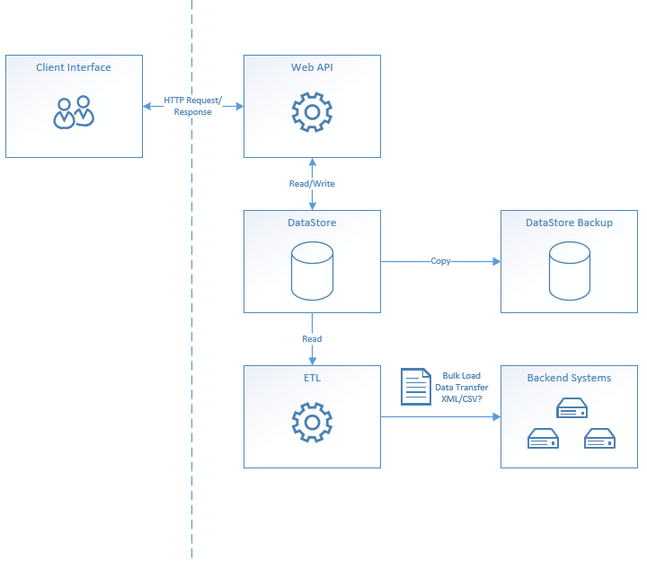

## Approach

As the requirement stated C# should be used, I have focused my efforts on the Web API and supporting database. The API is written in .Net Core and Visual Studio 2017. Due to limited time, not all functionality is available, but is hopefully enough to get a flavour of what I was aiming for.

## Web API Setup

Run the two database scripts to create the database and populate it with some sample data. Open the solution in Visual Studio 2017, restore the nugget packages, build and run the WebAPI project. As no client application is available, I have embedded Swagger into the application to document the API and provide a means of easily testing it.

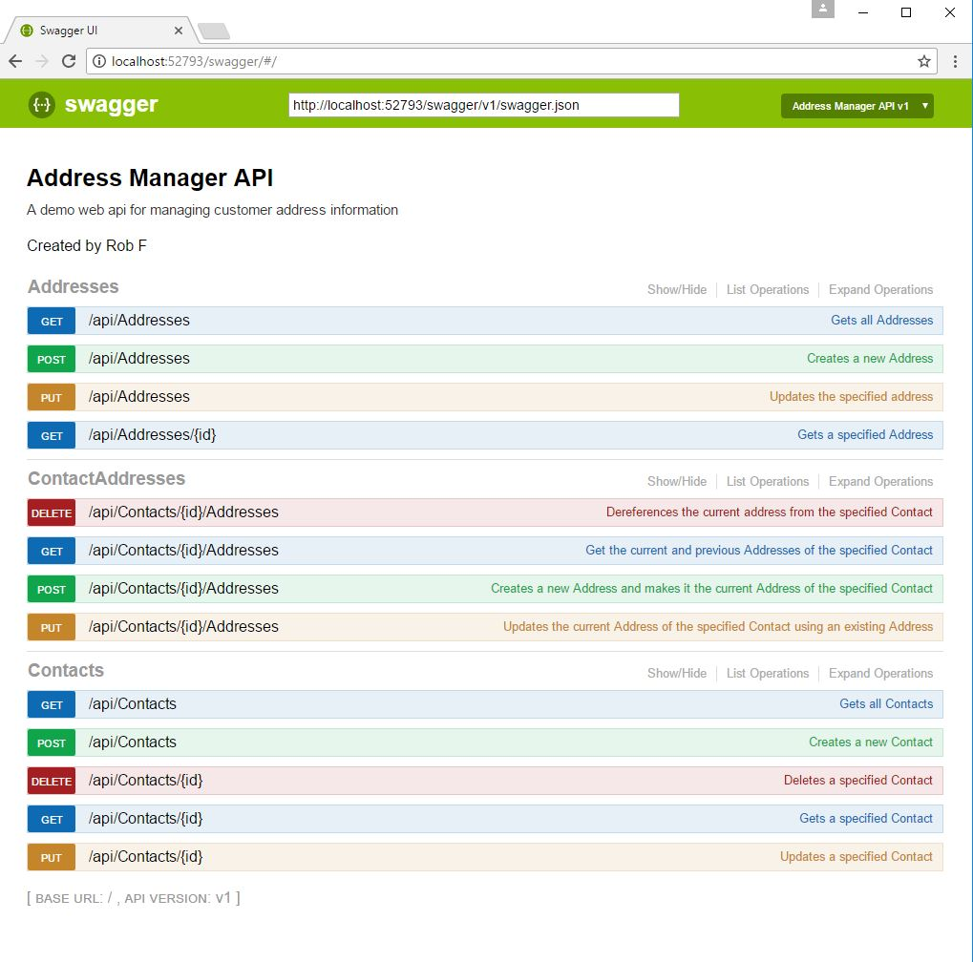

Enjoy. ☺