1000-The CAN_Connect_System (CCT)

This document is the index to the system so it carries the number 1000. Constituent designs are numbered from 1003 upwards. Perversely 1 used 1001 and 1002 for two DCC wiring accessories called “Connection_Unit” and “Connection_Unit_Mini”. These two devices each allow current detection close to the track and feed a signal into a TOTI that does not have current detection ability.

The CANConnect System provides a Plug and Play version of the physical CAN bus. It is a passive system consisting of a number of boards all of which will accept two 10Way IDC male headers (with latches) to allow them to be connected together using 10Way ribbon cables.

The connection between a CANConnect board and a CBUS module is made using four wires rather than using a plug-in approach. This allows the CANConnect board to be positioned where convenient with respect to the CBUS module.

There are a number of different PCBs each providing a different function. These include a “Universal Module” that will do everything, a module that connects to a 12V power supply, a module that connects to a CAN Cab and a module with a built in CANACT. A typical small system may be built with one interface to connect a CANCAB, one universal module to connect to the 12V power supply and to one CBUS module and as many Basic modules needed to connect to the remaining CBUS modules.

All types have a terminating resistor that needs a jumper to be bridged with solder to become active and a diode to isolate the CBUS module from other modules and decoupling capacitors (you can never have too many I believe.)

1003 CANConnect Basic

This board does no more than connect the ribbon cable to a CBUS module. I would expect this to be the most often used board

1004 CANConnect RJ22

This board is the Basic board with an RJ22 socket added to connect a CANCAB to the CANBUS. Probably not useful but included for completeness.

1005 CANConnect Power

This board is the Basic board with a DC power connector added to allow a 12V power supply to power all of the CBUS modules on the CANBUS. Probably not useful but included for completeness.

1006 CANConnect Power Break

This board has no continuity of the +12V power between the two headers. It is used to split the CAN bus into two districts should more than one +12V power supplies be needed.

1007 CANConnect Universal

This board performs the functions of the Basic board, the Power board and the Power-break board. There is also provision to fit an RJ22 connector for a CANCAB to be used for diagnostic purposes. Two copper links are necessary for it to propagate the +12V to the right hand IDC header.

1008 CANConnect with CANACT+

This board has a push button so that it may impress a DOMINANT STATE on the CAN bus until the CAN transceiver times out and backs off. The CAN bus transceiver receives what it transmits. Any received data (e.g. a dominant state on the CANBUS) will cause the on-board LED to flash. Useful as a preliminary test of the continuity of the CAN bus if one has a unit at each end of the bus.

1009 CANConnect CAB I/F

This board allows up to four RJ22 sockets to be connected to the ribbon cable.

There are three ways of populating this board. The first way is install two vertical sockets on the rear of the board with the rest of the components on the front of the board. The second way is to install two horizontal sockets along with the other components on the front of the board. The third way is to install four RJ22 sockets. The spacing of the rear facing sockets is 1.25 Inches. This figure was arrived at after measuring a MERG RJ22 board with a vernier showed that it is an IMPERIAL design. Maybe that is why one might have to do a bit of filing of the MERG facia plate get it to fit! The MERG documentation for it infers that its openings are on 32mm centres whereas 1.25” converts to 31.75mm.

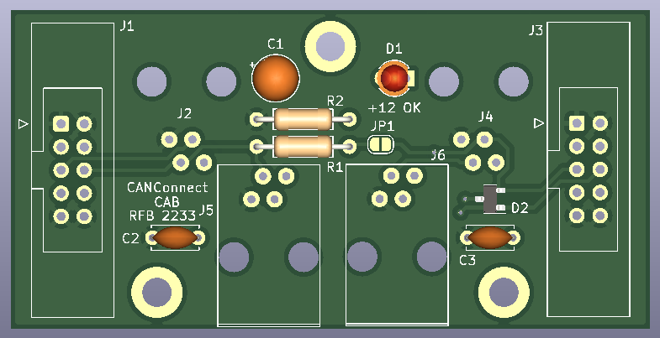
Resistor R1 (120Ω) may be permanently installed on the PCB. It will not act as a terminating resistor for the CAN bus until jumper JP1 is bridged with a blob of solder.

There is a LED on board which indicates that +12V is present for use by the CABs.

Connection to the CAN BUS is via two 10Way IDC headers. This assembly no provision for it to be directly connected to a CBUS module. The connection can made via any other CANConnect Module.

The board measures 67mm x 33mm with three mounting holes at (34,4),(16,29) and (51,29) All measurements are in mm with reference to the top left hand corner of the PCB.
