Mini(mal) Connection Unit with Current Sensing

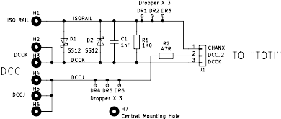
The point of this device is that the traction current on the DCC is kept local to it and it detects the current, not the TOTI. TOTIs with transformers at their inputs will not work because they never see the traction current.

The device is a subset of the full “Connection Unit”. It lacks the snubber and the transient voltage suppressor. It uses surface mounted components to reduce its size, which is 24mm x 24mm.

H1-H6 are actually Mounting Holes with an electrical connection to them. Their hole diameter 2.2mm, which is large enough to take 32/0.5mm wire. H7 will take an M3 screw.

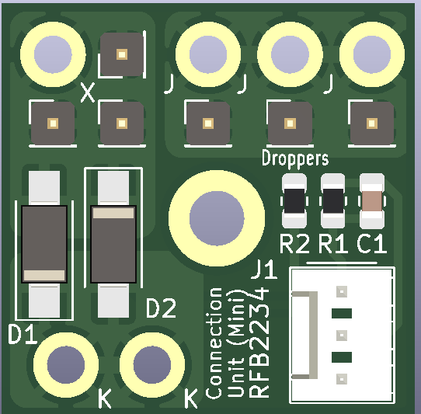
There a six intermediate size holes. Reading from the top left the hole marked with the letter “X” is the connection to the isolated rail that is being monitored. It sees the full traction current. The three “pins” round it are in fact holes to allow up to three dropper wires of gauge 7/.5 to connect to the “isolated” rail of the monitored section of track as an alternative to one heavy gauge wire.

To the right there are three similar sized holes marked “J”. They are all connected together. One is to connect DCC(J) to a TOTI such as the PMK7. The other two are for DCC(J) in and DCC(J) out to another device. The three “pins” below them are for dropper wires as an alternative to one heavy gauge wire.

Towards the bottom of the board there are two large holes marked “K”. These are connected together and allow DCC(K) to loop in and out of the board.

J1 connects the board to a TOTI and supplies power to it. The TOTI has to be powered from the DCC and has to be optically isolated from CBUS modules. A PMK7, with the 1N5819 diodes removed is suitable.

