The Connection Unit and a Compatible TOTI
Design Objectives for the Connection Units
The main objective behind the creation of the Connection Unit was to facilitate the connection of sections of track to the DCC signal. A secondary objective was to obviate the need to route the DCC traction currents to Train on Track Indicators (AKA TOTIs.)
Single TOTIs such as the PMK7 may be positioned close the track section of interest, but assemblies such as the DTC8 lead to 16 (heavy) wires being concentrated at one place. By siting the current detection components on the Connection Unit the traction current may be kept local to the track section. The connections to the TOTI carry only low currents and so may be implemented using light gauge wire.
Usage of the Connection Units
It is envisaged that the track on a layout will be divided into relative short sections, each of which is connected to the DCC signal via a connection unit whether or not it is going to employ a TOTI. If a TOTI is needed it may simply be plugged in.
It is envisaged that they will only be used for the installation of new track work, so it is not necessarily something that one might retrofit to existing track work.
The PCBs
There are two designs artworked. The full sized version is suitable for use with new trackwork. The “Connection Unit Mini” is a subset of the full design. It has no provision for connecting dropper wires, no provision for a snubber and no provision for transient voltage suppression on the DCC bus.
It is suitable for installation with existing trackwork to add a pluggable TOTI interface. It measures 25mm x 25mm, made possible by using surface mounted components (the PCB footprints used are intended for hand soldering and the smallest of them are 0805s.)
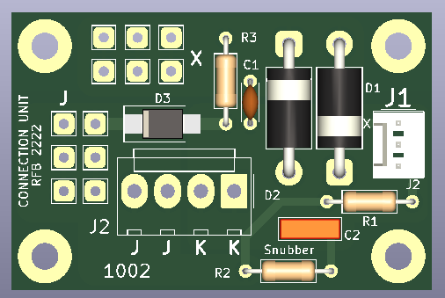
The PCB for the “Connection Unit” is shown on the left. lt measures 50mmx33mm. In its simplest manifestation it may be employed to facilitate the use of dropper wires to to the DCC bus with no components fitted other than a wire link in place of either D1 or D2. DCC is fed to “J2” and distributed to the track section using up to six dropper wires for each rail in the section.
Using the Connection Unit in this way ignores one of its main objectives which is to make the section of track ready for train detection so that all you have to do is just PLUG IN A TOTI.
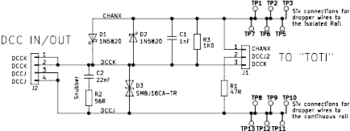
The circuit of the Connection Unit is shown below.

J1 connects the device to a remote TOTI. The pin marked CHANX is indicated on the silkscreen of the PCB with the letter “X”. It carries the signal and those marked DCCJ and DCCK carry the DCC signal to power the remote TOTI. This could be a PMK7 with its diodes removed and installed in the Connection Unit. J2 connects to the DCC bus . It has pin 1 connected to pin 2 and pin 3 connected to pin 4 to facilitates wiring between Connection Units.
Up to six dropper wires for each rail in the track section may be soldered to the square pads. The six to the left of R2 and the letter “X” connect to the isolated rail and the six above J2 connect to the “continuous” rail.
The traction current does not travel to the TOTI and back. Instead the current detection is performed in the Connection Unit by resistors R3. The diodes D1 and D2 divert the high traction currents away from the resistor. The diodes shown as type 1N5820. They will pass an average current of 3A for the larger scales. For 2mm and 4mm scales the traditional 1N5819s may be used.
Connector symbols were used for J2 and J3 for pure convenience. One would expect that the PCB would be hard wired.
The following schematic shows a dual TOTI that connects to two connection units.
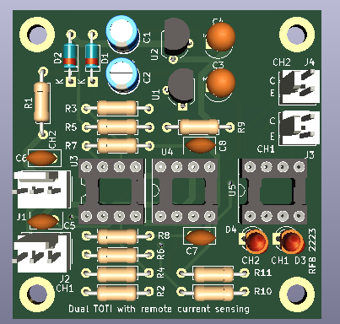
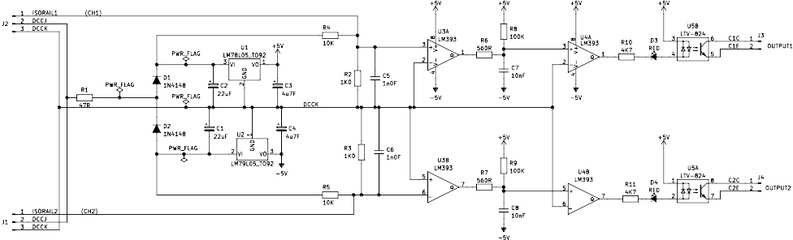
You will notice is that there are no diodes connected to the comparator inputs. That is because the detection of the traction current has been transferred to the Connection Unit. The next thing that you notice is that there are voltage regulators on board. Why?
This circuit is 100% balanced. It draws current during each half of each bit in the DCC signal. To do that the circuit uses a “dual half wave” power supply. Each half wave power supply generates a voltage close to the DCC voltage level, but of opposite polarity and so they act together as a voltage doubler.
The comparators derive their power by being connected between the two power supplies and therefore see nearly double the DCC voltage level. In the case that this circuit is driven from the DCC derived from a CANCMD2 that would nearly 24V . In the case that you are using the MERG booster, which is powered from a 15V supply, the comparators are working at nearly 30V. These figures are well within the maximum working voltage of the LM393 which is 36V. However for use with the larger scales the NMRA recommends higher DCC voltages which may cause the LM393’s working voltage to exceed their absolute maximum value. The 78L05 and 79L05 will tolerate the higher voltages and so are used in this design. The representative circuit of the TOTI given above shows just two channels, but in practice four or eight channels would be more appropriate.
The arrangement of the comparators in the above schematic differs from that in the PMK7 in two ways. Firstly the input stage has been redesigned so that the sensitivity of each channel is set by the value of one resistor and the input impedance of the circuit is definable. Secondly the integrator stage has been changed to reduce to a minimum the current that it consumes.
The resistor that sets the sensitivity for channel 1 is R4. For channel 2 it is R5. Both resistors are shown with the value of 10K which sets the sensitivity to 10K.
Each resistor injects a DC seed current of just over 1mA into (or out of) the channel input. There is a 1K0 resistor between each TOTI input and DCCK so there is ~1.0V across the resistor. The comparator input sees this voltage on its input and turns its output off. If the TOTI is connected to a Connection Unit where there is another 1K0 resistor the voltage is halved. The two resistors combined set the input impedance at 500Ω.
A 10K resistor connected between the rails of the monitored track section will cause a current to flow through R3 on the connection unit which will alternately augment and oppose the seed current from the TOTI input. When it augments the seed current nothing happens. When it opposes the seed current the polarity of the voltage at the input to the TOTI input reverses with respect to DCCK and it is detected by comparator.
R4 and R5 on the TOTI are not connected to the outputs of the regulators but to the raw DC on the anodes of the rectifier diodes. The diodes reduce the raw DC voltage with respect to DCCJ by their forward voltage drop so that the seed currents are slightly less than the current drawn by a 10K resistor across the rails of the monitored track section. Also the seed current varies with the amplitude of the DCC signal as does the current drawn by the resistor being detected. The two changes of current cancel each other out so the sensitivity of the circuit, when quoted in Ohms does not vary. The sensitivity when quoted in mA does change.
The voltage at the input to each regulator decays slightly when the rectifier diode is not conducting which leads to a reduction of the seed current at the input of the TOTI. This results in positive feed back at the comparator input so that it acts as a weak Schmitt trigger.
The polarity of the track current required to fire each the two channels in the example TOTI is different for each channel. CH1 responds to current flowing out of “ISORAIL1” and CH2 responds to current flowing in to “ISORAIL2”. This was done so that the two seed currents balance each other out and can be useful if there is another load using a half wave rectifier on the same track section.

