2201 Super TOTI

So what is so super about it?

- The circuit has a defined sensitivity that follows the value of on resistor
- The circuit has a low input impedance defined by two resistors
- The circuit has a low current drain from the DCC that is powering it
- The circuit presents a friendly load to the DCC
- Connectors are catered for easy installation
- Inputs and outputs are clearly identified on the PCB

What is not so super about it? It uses half-wave rectification of the DCC signal. If a significant number are present (and this applies to any circuit that uses half-wave rectification) they will present the DCC command station with an unbalaced load, which it might object to.

The circuit.

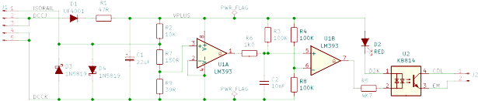
R1 limits the inrush current to the device to charge C1 when the device is first powered up.

C1 acts as a reservoir capacitor when the diode D1 is not conducting because the DCC voltage has reversed. Its value is set to 22uF because the inrush current, which could occur during each bit of the DCC signal, is eliminated.

The sensitivity of the circuit is expressed in Ohms because it is independent of the amplitude of the DCC signal. It is set by R2 which is 10K Ohms

R7 in series with R9 set the input impedance of the device and limit the negative voltage excursion on the + input of the comparator on pin 3. The specification of the LM393 limits it to be -300mV.

D3 and D4 provide a path for the traction current flowing between the isolated section of rail and DCCK. Under normal operating conditions one would expect their forward voltage to be in the region of 300mV-400mV, however under fault condition (such as a short circuit between the rails of the monitored section of track) their forward voltage could approach 1V.

The output of comparator U1A on pin 1 is normally switched off, which allows C2 to charge up to VPLUS. When the current provided by R2 flows out of the “ISORAIL” terminal the voltage on pin 3 of the comparator falls to less than the voltage on its pin 2 (=DCCK) so the comparator output switches on. C2 discharges via resistor R6 into the comparator output. The value of R6 is set to 1KΩ to limit this current to less than 20mA and stop the transistor driving the comparator output from coming out of saturation. This would momentarily increase the power dissipated by the transistor and also increase the time that C2 takes to discharge.

The voltage across C2 is monitored by the comparator U1B. The voltage is compared to VPLUS/2. Increasing this voltage would reduce the time that the circuit takes to recognise the presence of a vehicle on the track and increase the time that the circuit takes to relax when the vehicle leaves.

The values given in the circuit have been inherited from the PMP7/PMK7. I would be inclined to increase the value of C2 and to 100nF and 1MΩ respectively and increase the value of R8 to 270KΩ.

Here is the PCB. It measures 49mm wide by 33mm deep (and has no vias.)
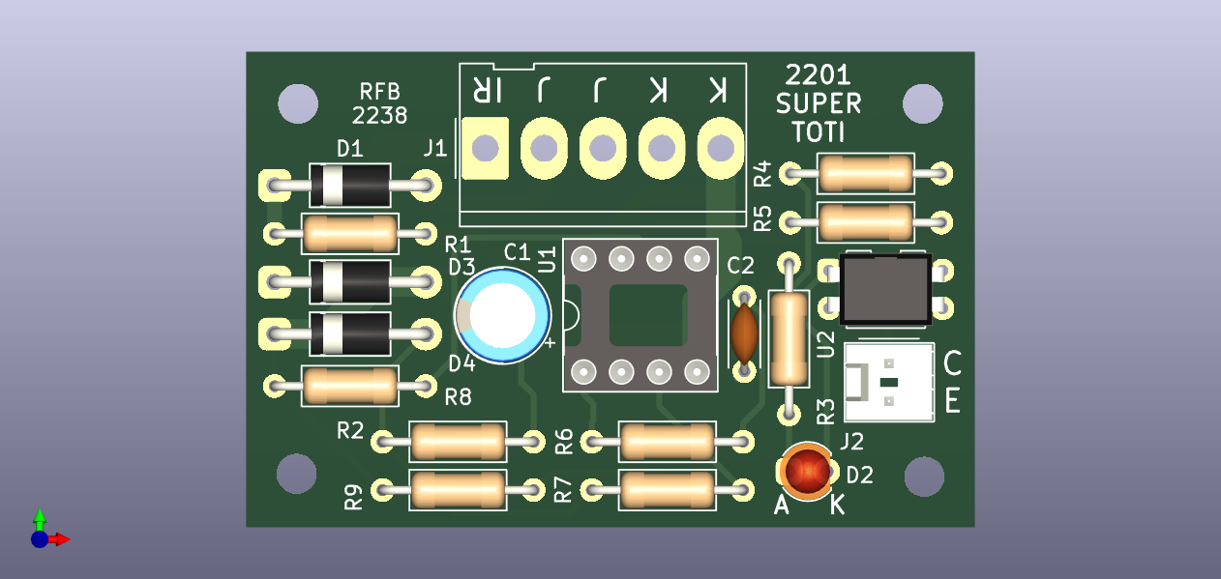

It is designed to use connectors but there is no reason why wires should not be soldered direcly to the PCB instead.

I have tried to simplify the installation by annotating the PCB. For J1 the inputs are labelled K, K, J, J, IR. K connects to DCCK, J connects to DCCJ and IR connects to the Isolated rail. For J2 C stands for the collector of the transistor in the Photo Isolator and E stands for its emitter.

