
ANALYTICS
System Design Description
Document Number: LULAFI-SDD-ANL-001
Version: 1.1
Date: 5 July 2026
Status: Second Circulation
CONFIDENTIAL
One Platform. One Experience. No Repetition.

Document Control
Control Item | Value
Document Type | System Design Description (SDD)
Project | lulaFi
Document Title | lulaFi Analytics System Design Description
Document Number | LULAFI-SDD-ANL-001
Version | 1.1
Document Date | 5 July 2026
Project Sponsor | Mr Seleke Masemola
Project Owner | Mr Seleke Masemola
Prepared By | New Dawn Technologies (NDT)
Author | Reg Courtenay
Classification | Confidential
Status | Second Circulation
Requirements Baseline | lulaFi Analytics SRS v1.0, LULAFI-SRS-ANL-001
Product Baseline | lulaFi Requirements PRD v0.2, dated 18 May 2026
Implementation Baseline | lulafi-portal-dev, lulafi-api-dev and lulafi-mobile-dev packages inspected 4 July 2026
Technology Decision Baseline | ClickHouse dedicated analytics data plane; MongoDB retained for operational and analytics control-plane data.

Revision History
Version | Date | Author | Comment
1.0 | 4 July 2026 | Reg Courtenay | Initial Analytics SDD, including Portal left-navigation integration, detailed architecture, data/API design and screen mockups.
1.1 | 5 July 2026 | Reg Courtenay | Updated the analytics database design to use ClickHouse for raw events, aggregate states, KPI snapshots and drill-down data; retained MongoDB for operational data and analytics control-plane metadata. Updated architecture, data model, deployment, security, retention, migration, testing and diagrams.

Approval Record
Role | Name | Decision / Signature | Date
Project Sponsor | Mr Seleke Masemola
Project Owner | Mr Seleke Masemola
Product / Business Representative
Technical Lead
Information Security / Privacy
Quality Assurance Lead

Distribution List
Recipient / Group | Purpose
Project Sponsor and Project Owner | Approval and governance
lulaFi Product Management | Design ownership and prioritisation
Portal and API Development Teams | Implementation
Mobile and Connector Teams | Event instrumentation
Quality Assurance Team | Test design and acceptance validation
Information Security and Privacy | Security, privacy and audit review
Platform Operations | Deployment, monitoring and support

Contact Details
New Dawn Technologies (NDT)
regc@ndt.co.za | 081 334 8834

Confidentiality
The recipient of this document must treat it as confidential and must not disclose it to any party other than the recipient’s employees on a need-to-know basis, or other individuals authorised under a written confidentiality agreement. Printed and exported copies are uncontrolled unless explicitly marked otherwise.

Contents
1. Executive Summary
2. Introduction
3. Source Baseline and Existing Implementation
4. Scope, Constraints and Design Principles
5. Key Design Decisions
6. Target Solution Architecture
7. Portal Navigation and Information Architecture
8. Front-End Application Design
9. Analytics Functional Module Design
10. Screen Design and Mockups
11. Analytics Backend Service Design
12. Event Capture and Processing Design
13. Analytics Data Architecture
14. Metric Calculation and Governance Design
15. Analytics API Design
16. Identity, RBAC and Provider-Realm Security
17. Privacy and Data Protection Design
18. Query, Filter and Drill-Down Design
19. Reporting, Export, Scheduling and Alerts
20. Performance, Caching and Scalability
21. Observability and Data Quality
22. Error Handling and User Messages
23. Deployment and Runtime Design
24. Configuration and Operational Administration
25. Migration and Compatibility Design
26. Test Design
27. Requirements Traceability and Acceptance
28. Implementation Plan
29. Risks, Assumptions and Open Decisions
30. Glossary and References
Appendix A – Portal Route and Component Map
Appendix B – API Payload Examples
Appendix C – Analytics Data Store Dictionary
Appendix D – Permission Matrix
Appendix E – Implementation Backlog
Navigation: Microsoft Word can generate an automatic table of contents from the numbered heading styles in this document.

1. Executive Summary
This System Design Description defines the implementation design for the lulaFi Analytics capability specified in the lulaFi Analytics SRS v1.0. Analytics will be launched from an Analytics item on the Portal left navigation bar. The same navigation pattern supports two secured experiences: provider analytics constrained to the logged-on provider realm, and global analytics available only to authorised lulaFi Admin users.
The existing Portal already contains a provider Analytics navigation item and route. The present screen provides basic form counts and a form-performance table backed by two analytics artifact types. This design preserves that route while replacing the page with a modular analytics workspace and introduces a separate global Admin route. The backend is expanded from form-only aggregation into a governed event, metric, query, drill-down, export and quality service.
The design is deliberately incremental. It remains aligned to the current React, Material UI, Redux Toolkit Query, Express/TypeScript, MongoDB, Redis and Authentik-oriented application architecture, while introducing ClickHouse as the dedicated analytical data plane. MongoDB remains the operational database and stores analytics control-plane metadata such as metric definitions, saved views, schedules, alerts, export jobs and processing state. ClickHouse stores approved event facts, mergeable aggregate states, KPI snapshots and bounded drill-down data. This separation provides high-volume analytical performance without coupling analytics availability to transactional operations.
Primary outcome: A provider sees only the performance of its own services and authorised organisational scope; a lulaFi Admin sees platform-wide adoption and health, with controlled provider drill-down. Both experiences use common metrics, time controls, filters, data-quality indicators and accessible visualisations.

1.1 Design Deliverables
- Portal navigation routes and role/permission behaviour.
- React page, component, state and API-client design.
- Logical, component, event-flow and deployment architecture.
- Analytics event envelope, ClickHouse fact and aggregate tables, MongoDB control-plane collections, sorting keys, partitions and retention policies.
- Provider and global Admin API endpoints, query contracts and error responses.
- Metric calculation, versioning, freshness, reconciliation and suppression rules.
- Drill-down, export, saved-view, scheduling and alert designs.
- Security, privacy, audit, performance, observability, deployment, migration and testing designs.
- Detailed Portal screen mockups using the current lulaFi visual theme.

2. Introduction

2.1 Purpose
The purpose of this SDD is to translate the approved analytics requirements into a buildable technical design. It is the implementation baseline for solution architecture, detailed development, test preparation, security review, deployment planning and operational handover.

2.2 Intended Audience
- Product and business owners
- Solution, data, security and integration architects
- Portal, API, mobile and connector developers
- Quality assurance and automation engineers
- Platform operations, support and information security teams
- Provider representatives validating dashboard and reporting behaviour

2.3 Design Conventions
Convention | Meaning
Current implementation | Behaviour or structure observed in the supplied source packages.
Target design | Required end-state defined by this SDD.
Provider realm | Stable provider-scoped tenancy and security boundary, independent of an individual provider user account.
Vendor role | Current code value used for a lulaFi administrative user. The target UI uses “lulaFi Admin”.
Permission | Fine-grained capability claim evaluated in addition to current coarse user type.
Metric snapshot | Pre-calculated metric value for a defined scope, period, dimensions and metric version.
Operational link | Link from analytics metadata to a transactional record; the destination independently re-authorises access.

2.4 Design Goals
ID | Goal
DG-01 | Integrate Analytics into the existing Portal left-navigation model without disrupting current Forms, Assets, Autofill Keys or Apps functions.
DG-02 | Use one technical analytics platform for provider and global Admin experiences while enforcing different scopes and permissions.
DG-03 | Prevent analytics failures from blocking form, chat, notification, connector or billing transactions.
DG-04 | Provide repeatable and versioned metric calculations with visible freshness and quality.
DG-05 | Support fast summary dashboards through pre-aggregation and bounded detailed queries.
DG-06 | Use privacy-preserving event metadata and prohibit sensitive content capture.
DG-07 | Allow incremental delivery from the current form analytics implementation to the full SRS.

3. Source Baseline and Existing Implementation

3.1 Source Inputs
Source | Use in this Design
lulaFi Analytics SRS v1.0 | Primary functional, security, data, UI and non-functional requirements baseline.
lulaFi Requirements PRD v0.2 | Product context, provider analytics scope, telemetry, privacy-first principles, advertising and success metrics.
lulafi-portal-dev package | Current navigation, routes, React/MUI structure, Redux Toolkit Query services, theme and provider analytics page.
lulafi-api-dev package | Current Express routes, MongoDB models, event bus, authentication middleware and basic analytics aggregation.
lulafi-mobile-dev package | Client event producer and offline-buffering context for future analytics instrumentation.

3.2 Current Portal Baseline
Area | Observed Baseline | Design Consequence
Technology | React 19, TypeScript, Vite, MUI 7, React Router and Redux Toolkit Query. | Analytics uses the same framework, theme and API client rather than introducing a parallel front end.
Left navigation | `MainLayout.tsx` defines role-filtered navigation. Provider Analytics already uses `PollOutlinedIcon`. | Retain the provider item; add a separate Admin Analytics item and permission filter.
Provider route | `/portal/provider/analytics` renders `pages/provider/Analytics`. | Keep URL for compatibility and replace implementation with AnalyticsShell + nested views.
Admin route | No global analytics route currently exists. | Add `/portal/admin/analytics` with global scope and admin-only modules.
Current analytics UI | Three form-status cards, a form performance table and quick insights. | Treat as transition screen; preserve total forms/views/responses through a compatibility endpoint.
API client | Analytics queries are currently located in `services/api/form.ts`. | Create a dedicated `services/api/analytics.ts`; retain wrappers for old hooks during migration.
Role model | Portal currently checks broad arrays for `provider` and `vendor`. | Add permission-aware guards while retaining type checks as a first gate.

3.3 Current API Baseline
Area | Observed Baseline | Design Consequence
Runtime | Express 5 and TypeScript with MongoDB/Mongoose, Redis, Winston/Loki and event bus. | Implement analytics as modules and workers in the same repository and deployment family; add the official ClickHouse JavaScript client for analytical writes and queries.
Analytics model | `AnalyticsArtifact` stores provider, form, type, IP address and user agent. Types are `form_viewed` and `form_response_submitted`. | Replace with a governed event envelope; migrate or map historical artifacts.
Current endpoints | `GET /forms/analytics` and `GET /forms/:id/analytics`. | Add versioned `/analytics` endpoints; retain existing routes as compatibility adapters.
Provider ownership | Forms, submissions and analytics artifacts refer to a provider user ObjectId. | Introduce stable `providerRealmId`; store actor/provider-user identifiers separately.
Current filtering | Provider users are scoped by `req.user.id`; Admin can optionally supply a provider user ID. | Use server-derived realm and permission scope; never trust a provider realm supplied by a provider client.
Aggregation | MongoDB `$lookup` aggregates raw artifacts at query time. | Replace repeated operational MongoDB aggregation with ClickHouse fact tables, aggregate-state tables and governed query templates; retain bounded compatibility reads during migration.
Event listeners | Internal event bus creates analytics artifacts asynchronously. | Adopt a durable outbox/stream pattern so restarts do not silently lose business events.

3.4 Current-State Gaps Resolved by this SDD
- No selectable time range, time zone, comparison period or universal filter bar.
- No provider organisational-unit filtering or granular analytics permissions.
- No global Admin analytics dashboard, platform reliability view or data-quality view.
- No governed metric catalogue, metric versions, numerator/denominator disclosure or correction windows.
- No reliable journey events for form starts, steps, abandonment, workflows, messaging, notifications, connectors, advertising or commercial usage.
- No saved views, controlled exports, schedules, alerts or sensitive drill-down audit.
- Provider identity is conflated with a provider user account, limiting multi-user tenancy and secure aggregation.
- Raw IP address and user agent collection is not aligned to the target minimisation design.
Compatibility principle: The target implementation must not require a big-bang replacement. Existing form analytics endpoints remain available until Portal consumers are migrated and historical `AnalyticsArtifact` records have been transformed or expired.

4. Scope, Constraints and Design Principles

4.1 In-Scope Design
- Provider Analytics and global lulaFi Admin Analytics in the Portal
- Navigation, routes, permission checks and responsive screen structure
- Event ingestion and reliable capture from mobile, Portal, API services, messaging, notifications, connectors, advertising and billing
- Metric definitions, calculations, aggregates, time-series and breakdowns
- Drill-down to authorised metadata and independently authorised operational records
- CSV, XLSX and PDF export jobs; saved views, schedules and threshold alerts
- Data quality, reconciliation, audit and observability
- Incremental migration from the current form analytics implementation

4.2 Constraints
Constraint | Design Response
Current technical stack must be retained | Retain React/MUI/RTK Query, Express/TypeScript, MongoDB and Redis; introduce ClickHouse as a specialised OLAP service behind the Analytics API.
Privacy-first product model | Persist only approved event metadata; prohibit field values, message content and OTPs.
Submission data may reside in provider systems | Accept governed status/outcome events and reconciliation controls instead of central payload replication.
Mobile devices may be offline | Support client event buffering, stable event IDs and late-event correction.
Current role model is coarse | Layer fine-grained permission claims over provider/vendor role checks.
Analytics volume will grow unpredictably | Use ClickHouse columnar storage, partitions, materialised views, mergeable aggregate states, query guards and cache; retain logical data separation.
Provider time zones differ | Store UTC; allocate periods using explicit selected/provider time zone.

4.3 Design Principles
Principle | Application
Realm first | Every event, aggregate, query, drill-down, export and audit entry is scoped to a stable provider realm or explicitly global platform scope.
Server-derived authority | Provider clients do not choose their provider realm. Scope is derived from the authenticated identity and access policy.
Reliable but decoupled | Business operations commit independently; analytics receives events through outbox/stream processing and can replay safely.
Governed metrics | Every displayed number references a versioned metric definition and data-quality state.
Summary before detail | Dashboard uses pre-aggregated values; drill-down progressively accesses lower-level metadata only as needed.
Privacy by construction | Identifiers are tokenised, small cohorts suppressed, content prohibited and exports controlled.
Accessible equivalents | Every chart has an equivalent accessible table and keyboard drill actions.
Incremental evolution | Compatibility adapters and migration jobs allow rollout without breaking existing Portal functions.

5. Key Design Decisions
Decision ID | Decision | Rationale / Consequence
ADR-ANL-001 | Create a dedicated Analytics module and routes under `/analytics`; retain `/forms/analytics` adapters temporarily. | Separates analytics from form management, supports additional domains and limits disruption.
ADR-ANL-002 | Use `providerRealmId` as the tenant key, with `actorIdToken` and `providerUserId` as separate attribution fields. | Supports multiple provider staff and prevents data partitioning by individual account.
ADR-ANL-003 | Use ClickHouse as the dedicated analytics data plane for raw event facts, hourly/daily aggregate states, KPI snapshots, funnels and bounded drill-down data. | Columnar storage and mergeable aggregate functions support high-volume time-series aggregation, percentiles, distinct counts and provider/global drill-down without loading the operational MongoDB cluster.
ADR-ANL-004 | Use Redis Streams for dispatch/worker coordination and MongoDB outbox records for durable business-event handoff. | Builds on existing Redis while preventing event loss if a process restarts.
ADR-ANL-005 | Store approved raw event metadata in ClickHouse for a bounded period using TTL rules and retain hourly/daily aggregates and KPI snapshots for longer governed periods. | Supports recalculation and audit while controlling privacy, storage growth and query cost.
ADR-ANL-006 | Calculate standard dashboard metrics from ClickHouse aggregate-state tables and materialised views; use bounded raw-event queries only for authorised drill-down. | Provides predictable performance and avoids repeated full scans or operational database joins.
ADR-ANL-007 | Use a permission claim model in addition to current user type. | Supports viewer, analyst, provider admin, executive, support, global analyst, platform admin and audit capabilities.
ADR-ANL-008 | Generate large exports asynchronously and store them temporarily in S3-compatible object storage. | Avoids request timeouts, applies expiry and supports secure download audit.
ADR-ANL-009 | Treat charts as a presentation of metric APIs, not as independent calculations. | Ensures screen, export and API values reconcile.
ADR-ANL-010 | Do not use IP address as an analytics dimension by default. Derive coarse geography at ingestion only when approved, then discard or irreversibly transform the source address. | Aligns collection with minimisation and privacy requirements.
ADR-ANL-011 | Retain MongoDB for the analytics control plane: metric definitions, saved views, export jobs, report schedules, alert rules, processing checkpoints and quality run metadata. | These records are transactional, frequently updated and closely aligned to the existing Mongoose application model.
ADR-ANL-012 | Use the official `@clickhouse/client` TypeScript client through repository classes; do not expose ClickHouse directly to Portal clients. | Preserves typed service boundaries, server-derived scope, parameterised queries, connection pooling and observability.

6. Target Solution Architecture

6.1 Logical Architecture
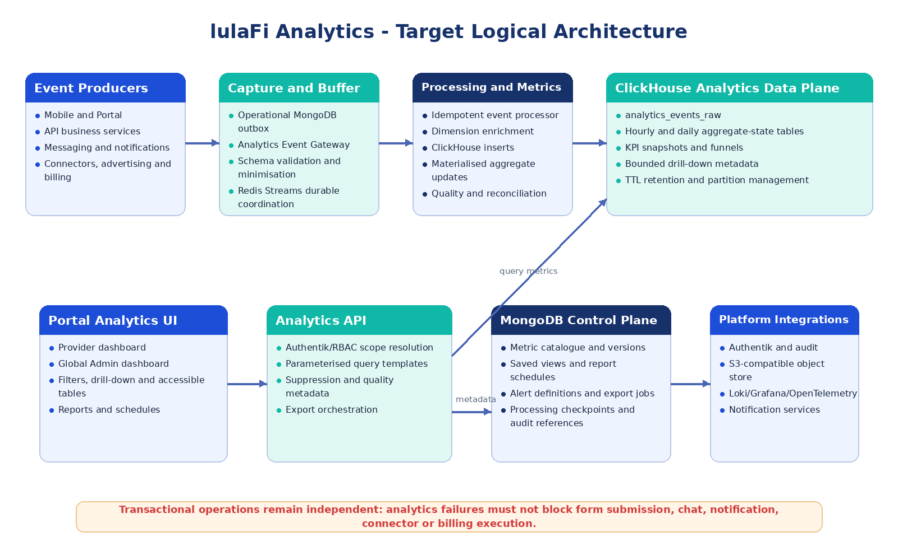
Figure 1 – Target logical architecture for provider and global Analytics.

6.2 Component Responsibilities
Component | Primary Responsibilities | Implementation Location
Portal Analytics Shell | Left-nav launch, route selection, scope header, time/filter state, accessible layout, saved views and report actions. | `src/pages/analytics`, shared components and nested provider/admin routes.
Analytics RTK Query API | Typed metric, time-series, breakdown, detail, export, catalogue and saved-view endpoints. | `src/services/api/analytics.ts`.
Analytics Controller | Validates query contracts and delegates to scope, metric, query and export services. | API `controllers/analytics.controller.ts`.
Analytics Scope Guard | Resolves provider realm, org units, permissions, sensitive-detail rights and environment. | API middleware and `analyticsScope.service.ts`.
Event Gateway | Authenticates event producers, validates schemas, removes prohibited attributes, stamps context and enforces idempotency. | API route/service, with internal service-auth path and client batch path.
Outbox Dispatcher | Moves durable business events from operational outbox to the stream. | Background worker in API deployment family.
Analytics Processor | Consumes events, enriches dimensions, inserts approved facts into ClickHouse, updates aggregate-state tables/materialised views and writes processing/quality state to MongoDB. | Dedicated worker process/container.
Metric Engine | Loads versioned definitions from MongoDB and compiles approved count, distinct, rate, duration percentile, point-in-time and SLI templates into parameterised ClickHouse queries. | Worker and query-service library.
Analytics Data Plane | Approved raw event facts, hourly/daily aggregate states, KPI snapshots, funnels and bounded drill-down metadata. | ClickHouse database `lulafi_analytics`; replicated production tables and isolated service credentials.
Export/Schedule Worker | Creates CSV/XLSX/PDF, stores temporary files, sends completion notifications and executes report schedules. | Dedicated worker; S3 and notification integrations.
Audit Integration | Records access, sensitive drill-down, export, schedule and definition changes. | Existing AuditService extended with analytics event types.
Analytics Control Plane | Metric catalogue, saved views, export jobs, schedules, alerts, processing checkpoints and quality metadata. | MongoDB analytics collections in the existing managed platform, with separate credentials and backup policy.

6.3 Component Interaction Rules
- Portal components never calculate authoritative metrics from raw event arrays; calculations originate in the Metric Engine.
- Analytics controllers do not accept a provider realm override from a provider user. Global users may specify a provider only when the resolved permission includes provider-detail access.
- The Analytics Processor is idempotent: the same `event_id` cannot increment a metric twice.
- Operational record links contain stable record identifiers only and invoke the operational API, which re-checks its own permissions.
- Export workers reconstruct the authorised query from a signed job definition; they do not trust client-provided row sets.
- All components emit correlation identifiers and non-sensitive operational telemetry.

6.4 System Context
External / Adjacent System | Interaction
Authentik / Identity Service | Authenticates users and supplies role, provider realm, organisational scope and permission claims.
Mobile Application | Produces user-journey events in batches; buffers while offline.
Provider Portal | Produces provider interaction events and consumes provider/global analytics APIs.
Messaging Infrastructure | Produces room/conversation delivery and response metadata without message content.
OneSignal / Notification Providers | Produce delivery, failure, open and action callbacks.
Connector Run Environment | Produces provision, request, outcome, latency, usage and error-class events by provider instance.
Advertising Management | Produces request, rendered, measurable, viewable, click, conversion and invalid-traffic events.
Billing and Entitlements | Produces subscription, entitlement, usage and charge events.
Loki / Metrics / Traces | Supplies platform reliability signals and diagnostic links using correlation IDs.
S3-Compatible Storage | Stores time-limited report/export artifacts.

7. Portal Navigation and Information Architecture

7.1 Left Navigation Integration
Analytics is launched from the Portal left navigation bar. The entry uses the existing `PollOutlinedIcon` and appears only when both the current coarse role and the required permission allow access. The item remains a single top-level entry; analytics domain navigation occurs inside the Analytics workspace to avoid an excessively long main navigation.
User Context | Left-Nav Label | Route | Required First Gate | Required Permission
Provider | Analytics | /portal/provider/analytics | type = provider | analytics.provider.view
lulaFi Admin | Analytics | /portal/admin/analytics | type = vendor | analytics.admin.view
Support user represented as vendor | Analytics | /portal/admin/analytics?view=operations | type = vendor | analytics.operations.view
End user | Not displayed | Not applicable | type = end | None

7.2 Route Design
Route | Purpose | Provider Scope
/portal/provider/analytics | Provider landing / overview. | Locked to authenticated realm.
/portal/provider/analytics/forms | Form discovery, funnel, completion and version analytics. | Locked realm and authorised org scope.
/portal/provider/analytics/forms/:formId | Form drill-down. | Form ownership and form access policy.
/portal/provider/analytics/operations | Workflow, backlog, SLA and turnaround. | Realm plus organisation/team scope.
/portal/provider/analytics/messaging | Conversation and delivery metadata. | Realm plus messaging scope.
/portal/provider/analytics/notifications | Delivery, failure, open and action analytics. | Realm plus campaign/template scope.
/portal/provider/analytics/connectors | Connector usage, success, errors and latency. | Provisioned provider connector instances only.
/portal/provider/analytics/advertising | Provider-authorised campaign and revenue-share analytics. | Commercial permission required.
/portal/provider/analytics/reports | Saved views, exports and schedules. | Created/shared in realm.
/portal/admin/analytics | Global adoption overview. | Platform aggregate.
/portal/admin/analytics/providers | Provider cohorts and controlled provider drill-down. | Global permission.
/portal/admin/analytics/platform | Reliability, traffic, errors, saturation and incidents. | Operations permission.
/portal/admin/analytics/data-quality | Freshness, validity, completeness and reconciliation. | Admin/operations permission.
/portal/admin/analytics/metrics | Metric catalogue and versions. | Metric administration permission.
/portal/admin/analytics/reports | Global saved views, exports, schedules and alerts. | Global report permission.

7.3 Analytics Workspace Navigation
The Analytics Shell renders a scope-aware tab row beneath the page title. Provider tabs are Overview, Forms, Operations, Messaging, Notifications, Connectors, Advertising and Reports. Tabs without data, feature entitlement or permission are not displayed. Admin tabs are Overview, Providers, Platform, Data Quality, Advertising, Commercial, Metrics and Reports.

7.4 Navigation State
State | Storage | Behaviour
Current analytics tab | URL path | Browser navigation and deep linking are supported.
Time range, comparison, filters and granularity | URL query parameters plus in-memory state | Refresh/back/forward preserve the analytical context; sensitive identifiers are tokenised.
Personal saved view | AnalyticsSavedView collection | Restores route, metric panels and filters for the owner.
Published provider view | AnalyticsSavedView collection, realm scope | Available to authorised provider users; managed by provider admin.
Drawer open/closed | Local browser preference | No business impact.
Last selected time zone | User preference | Defaults to provider time zone, then user preference.

7.5 MainLayout Changes
// Target additions to RouteMap and role-aware navigation
adminAnalytics: '/portal/admin/analytics',
providerAnalytics: '/portal/provider/analytics',
{
id: 'admin-analytics',
label: 'Analytics',
path: RouteMap.adminAnalytics,
icon: <PollOutlinedIcon />,
allowedRoles: ADMIN_ROLES,
requiredPermission: 'analytics.admin.view'
}
// Existing provider entry is retained and gains requiredPermission.

Accessibility: The selected left-nav item must expose `aria-current="page"`; collapsed mode must provide an accessible tooltip; keyboard activation must match other Portal navigation items.

8. Front-End Application Design

8.1 Proposed Source Structure
src/
pages/analytics/
AnalyticsShell.tsx
provider/ProviderOverviewPage.tsx
provider/FormAnalyticsPage.tsx
provider/OperationsAnalyticsPage.tsx
provider/MessagingAnalyticsPage.tsx
provider/NotificationAnalyticsPage.tsx
provider/ConnectorAnalyticsPage.tsx
provider/AdvertisingAnalyticsPage.tsx
admin/GlobalOverviewPage.tsx
admin/ProviderCohortsPage.tsx
admin/PlatformReliabilityPage.tsx
admin/DataQualityPage.tsx
admin/MetricCataloguePage.tsx
reports/ReportsPage.tsx
components/analytics/
AnalyticsFilterBar.tsx
MetricCard.tsx
MetricInfoPopover.tsx
AccessibleChart.tsx
FunnelChart.tsx
TrendChart.tsx
BreakdownTable.tsx
DrillBreadcrumb.tsx
DataQualityBadge.tsx
ExportDialog.tsx
SavedViewDialog.tsx
ReportScheduleDialog.tsx
services/api/analytics.ts
features/analytics/analyticsSlice.ts
types/analytics.types.ts

8.2 Analytics Shell
Responsibility | Design
Scope resolution | Displays provider name as locked for provider users; displays global/cohort/provider selector only for authorised Admin users.
Route navigation | Maps nested route to the correct domain tab and breadcrumb.
Context controls | Owns time range, comparison, time zone, granularity and common filter state.
Saved view loading | Validates that stored filters are still permitted before applying them.
Status strip | Displays latest complete time, metric catalogue version, environment and quality warnings.
Action controls | Shows Export, Save View, Schedule and Alert actions according to permission.
Error boundary | Presents partial, stale, unavailable and permission states without collapsing the entire Portal layout.

8.3 Front-End State Model
State Category | Mechanism | Examples
Server state | RTK Query | Metric cards, time series, breakdown rows, metric definitions, export job status.
Shared analytics UI state | Redux slice | Current scope descriptor, time selection, filter model, comparison and selected drill path.
Route state | React Router | Analytics domain, entity identifier and detail path.
Form/dialog state | React Hook Form or component state | Saved view, report schedule, alert rule and export options.
Persistent preferences | User settings / local storage for non-sensitive values | Table columns, default chart/table mode and drawer state.

8.4 Core UI Components
Component | Inputs | Behaviour
MetricCard | MetricResult, comparison, target, permission | Shows value, unit, delta, quality, target and metric definition. Card is drillable when a drill target exists.
AnalyticsFilterBar | Available dimensions, selected filters, time state | Uses server-provided valid filters; displays chips; supports reset, save and apply.
AccessibleChart | Chart series, axes, metadata, drill handler | Renders chart plus equivalent table; keyboard points/categories; no colour-only meaning.
FunnelChart | Ordered journey stages | Displays count and consecutive/overall conversion; stage selection changes drill context.
BreakdownTable | Columns, pagination cursor, sorting | Uses MUI DataGrid with server-side paging/sort and column-level permission.
DrillBreadcrumb | Drill nodes | Preserves filters and supports return to any authorised prior level.
DataQualityBadge | Freshness, validity, completeness, reconciliation | Shows current/delayed/stale/partial/suppressed states and accessible explanation.
ExportDialog | Current authorised query, formats and row estimate | Creates asynchronous job when limits require it; never submits visible rows as authority.
MetricInfoPopover | MetricDefinition summary | Shows formula, numerator, denominator, source, version, owner and limitations.

8.5 API Query and Caching Behaviour
- RTK Query cache keys include scope token, metric/version, start/end, time zone, granularity, filters, dimensions, comparison and environment.
- Changing one filter invalidates only requests whose query contract contains that filter.
- Dashboard widgets may load in parallel. The shell shows the page when primary cards are available and marks delayed secondary panels individually.
- Automatic polling is disabled for historical ranges. Today/operational views may poll at a server-supplied interval, not faster than 60 seconds.
- Export job polling uses backoff and stops on completed, failed, expired or cancelled status.
- Portal never caches signed export URLs beyond their expiry.

8.6 Responsive Design
Viewport | Behaviour
Desktop ≥ 1200 px | Four KPI cards per row; two-column visual panels; full left navigation.
Tablet 768–1199 px | Two KPI cards per row; panels stack where needed; collapsible navigation; filter drawer.
Small browser < 768 px | One KPI card per row; charts default to table/compact mode; export and save actions in overflow menu.
Print/PDF | Fixed report layout generated by export worker, not browser print of the live page.

9. Analytics Functional Module Design
Module | Content | Access Boundary
Provider Overview | Active users, submissions, completion, turnaround, open workload, SLA, conversations, notifications, top forms and connector issues. | Provider realm; optional organisation unit, geography and role restrictions.
Forms | Discovery, views, starts, step completion, validation, submission, abandonment, completion time and version comparison. | Provider form access and minimum cohort thresholds.
Operations | Workflow status, queue, assignment, priority, age, inflow/outflow, turnaround, SLA compliance and risk. | Provider organisational and assignment scope.
Messaging | Conversation types, messages accepted/delivered/failed, first response and unanswered thresholds. | No message content; linked form/service scope.
Notifications | Queued, sent, delivered, failed, opened and actioned by type/channel/template/campaign. | No OTP or notification body; measurable denominator disclosed.
Connectors | Provisioned instances, calls, success/failure/timeouts, latency, usage units and error classes. | Only instances in the realm; credentials/payloads prohibited.
Advertising | Valid/measurable/viewable impressions, clicks, conversions, invalid traffic, pacing and authorised revenue share. | Commercial permission and privacy thresholds.
Global Overview | Active providers/users, provider activation, forms, submissions, engagement, connectors, advertising and availability. | Admin aggregate with controlled provider drill-down.
Provider Cohorts | Industry, tier, onboarding month, geography, activity and feature adoption cohorts. | Small cohorts suppressed; ranking restricted.
Platform Reliability | Availability, latency, traffic, errors, saturation, queue lag, incidents and error budgets. | Operations permission; no secrets or payloads.
Data Quality | Freshness, completeness, validity, uniqueness, consistency, coverage and reconciliation. | Admin/operations/audit scope.
Metric Catalogue | Definition, formula, sources, dimensions, owner, version, effective date, thresholds and limitations. | Read access to all analytics users; edit only platform metric admins.
Reports | Saved views, export history, schedules and alerts. | Owner/realm/global scope and recipient policy.

9.1 Provider Tailoring
Tailoring is applied by configuration, permission and available data rather than by forking the Analytics application. Provider configuration defines default cards, published saved views, available organisational dimensions, targets, time zone and commercial modules. Provider users can see only metrics whose source domains and dimensions are enabled and authorised for that provider realm.

9.2 Global Admin Tailoring
Global dashboards default to aggregated platform scope. A global analyst may select a cohort. A provider name becomes available only after the user drills to a provider list and possesses `analytics.admin.provider_detail`. Platform reliability and metric administration remain hidden from global business analysts unless their permissions include operations or catalogue administration.

10. Screen Design and Mockups
The following mockups are detailed design references. They use the current lulaFi Portal visual system: light neutral background, white MUI surfaces, primary blue, teal accent, persistent left navigation, top search bar, rounded controls and accessible status colours. Exact data is illustrative.

10.1 Provider Analytics Dashboard
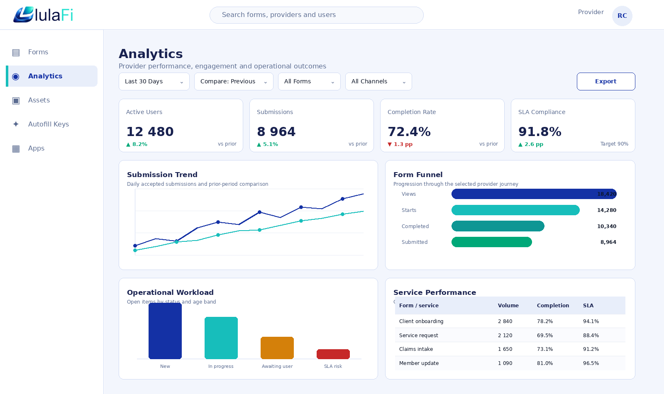
Figure 2 – Provider Analytics launched from the selected Analytics item on the Portal left navigation.
Callout | Design Behaviour
Scope | Provider label is locked and derived from the authenticated provider realm.
Time controls | The time range, comparison, forms and channel filters affect all visible panels.
KPI cards | Cards show value, comparison, target and drill availability.
Charts | Trend, funnel and workload panels have accessible data-table alternatives.
Service table | Selecting a row navigates to a form/service drill-down while retaining filter state.
Footer/status | Page exposes data refresh time, quality state and metric definitions.

10.2 Global lulaFi Admin Dashboard
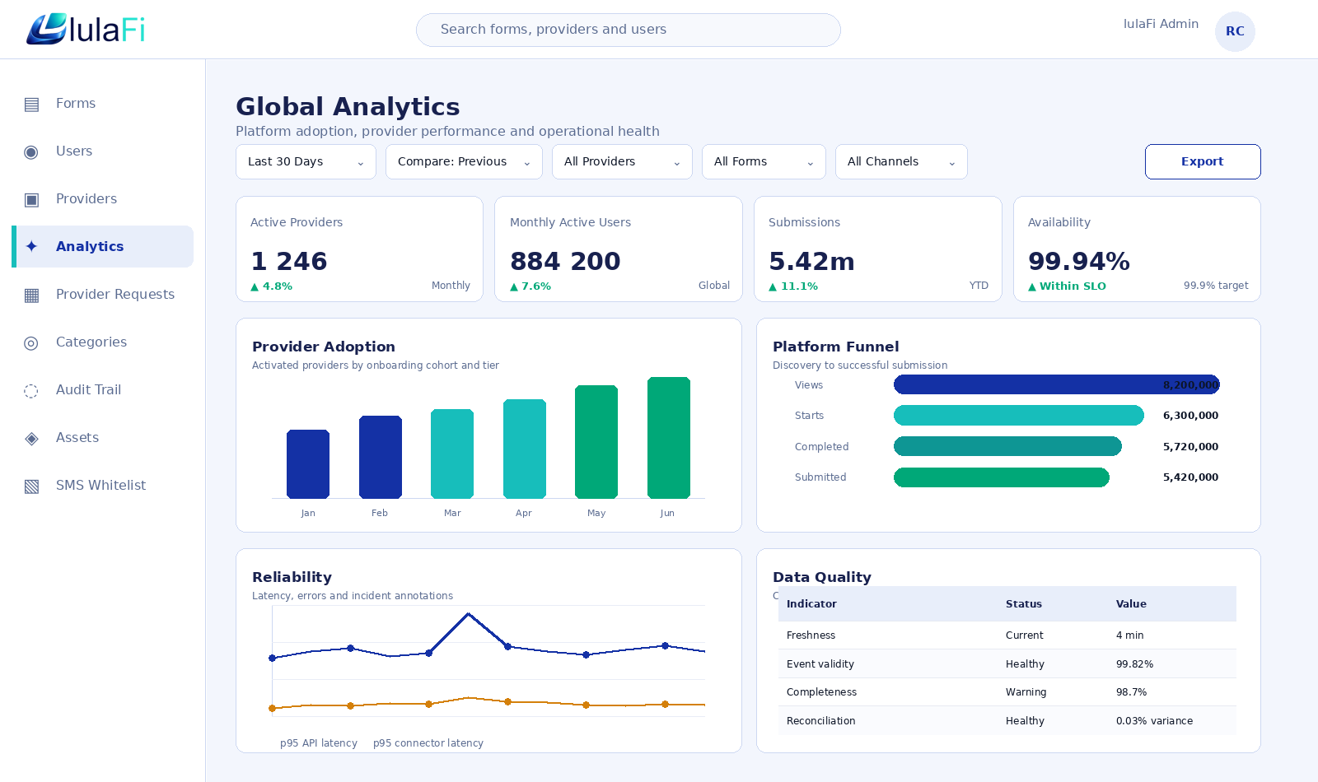
Figure 3 – Global Admin Analytics with aggregate adoption, reliability and data-quality panels.
Callout | Design Behaviour
Navigation | Admin Analytics appears with the current Admin left-nav items.
Scope | Default is All Providers; cohort and provider selection require global permissions.
Environment | Production, staging and test are visibly labelled and permission controlled.
Provider adoption | Cohort panel drills to an authorised provider list.
Reliability | Operational series may link to incidents/traces when the user also has observability access.
Privacy | Global small cohorts are suppressed and do not render as zero.

10.3 Form Funnel and Version Drill-Down
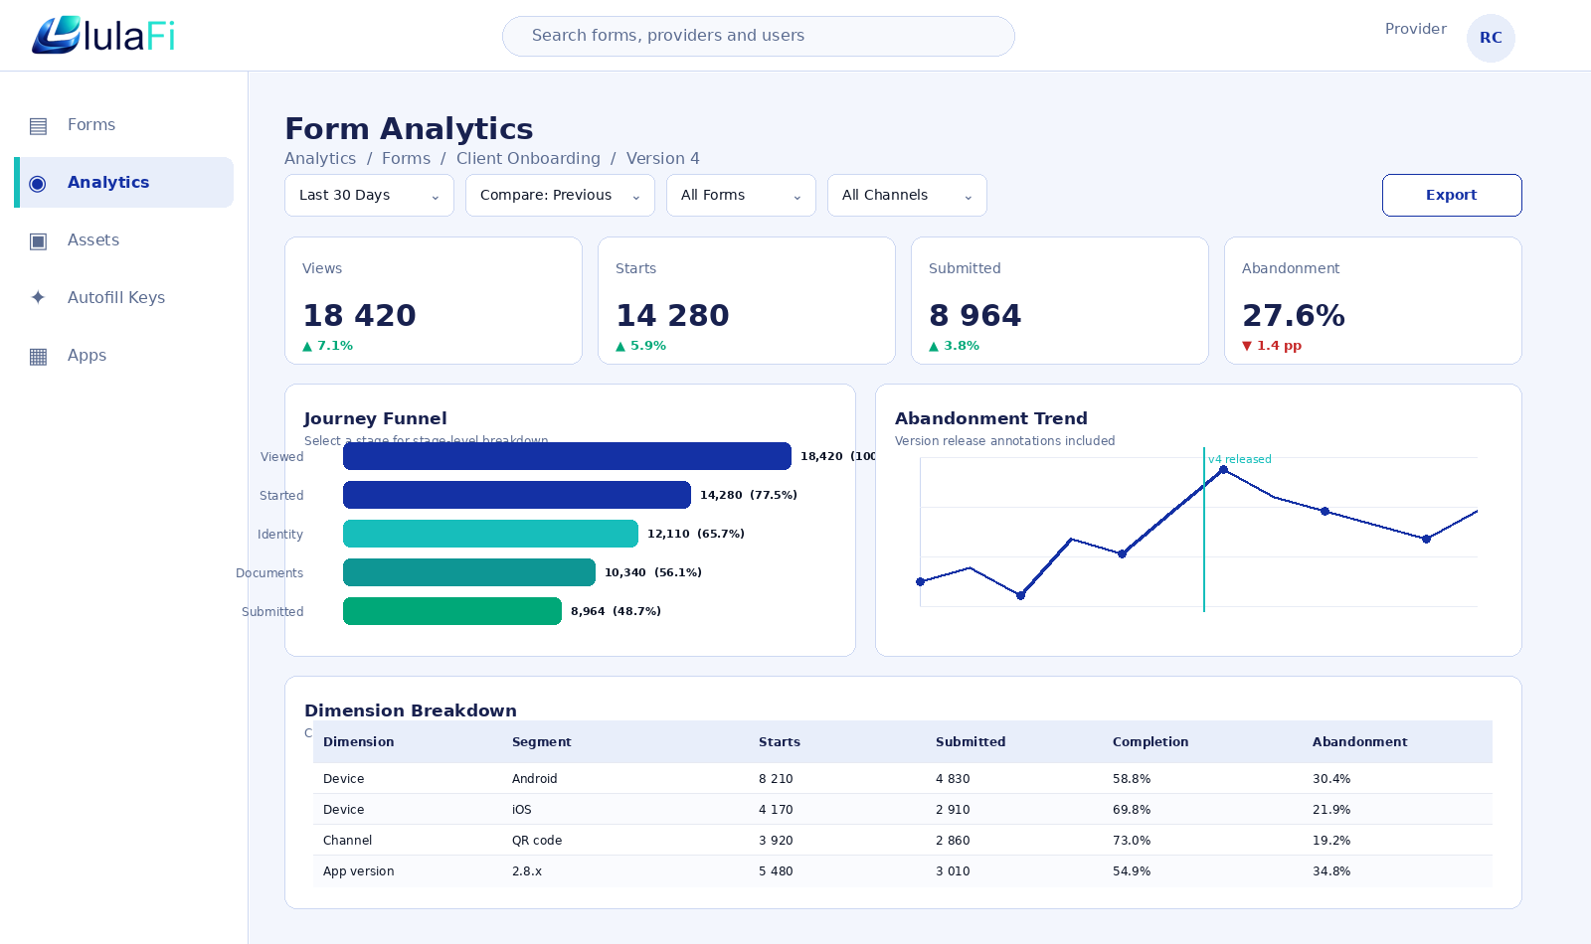
Figure 4 – Form Analytics drill-down showing journey funnel, release annotation and segmented breakdown.
Interaction | Result
Select funnel stage | Adds the stage to the drill path and loads stage-specific trend and dimensions.
Select version annotation | Compares before/after periods using the metric definition in effect for each period.
Select a dimension row | Applies the segment to the complete page and creates a removable filter chip.
Open metric info | Displays exact formula, numerator, denominator, exclusions, version and coverage.
Export | Exports the same authorised scope, filters and metric versions.

10.4 Workflow and SLA Drill-Down
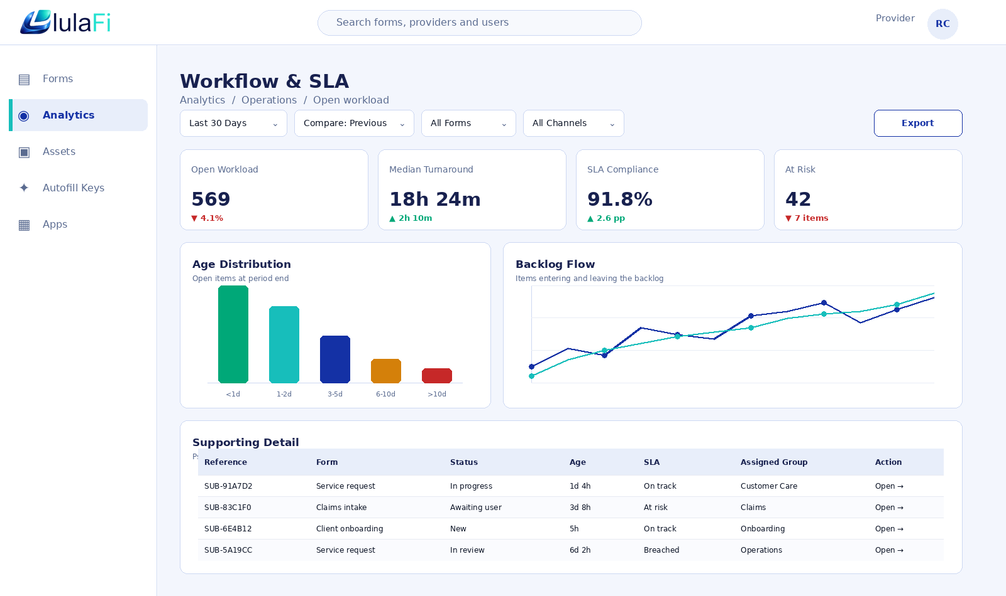
Figure 5 – Workflow/SLA dashboard with age distribution, backlog flow and authorised supporting metadata.
The supporting table uses a pseudonymous analytics reference. The Open action invokes the operational submission route, where the Forms/Workflow module performs its own authorisation. Analytics does not supply the form payload or attachment content.

10.5 Filter Drawer and Saved Views
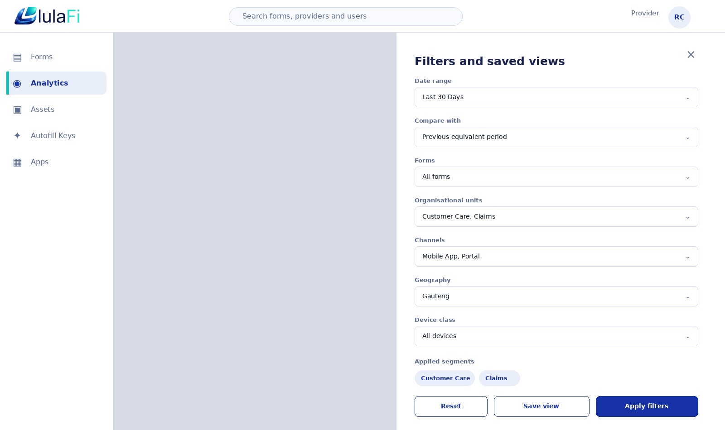
Figure 6 – Filter drawer with common dimensions, applied segments and saved-view action.
Control | Rule
Available filters | Returned by the API for the selected metric/module and user scope.
Multi-select | Values inside one dimension use OR; separate dimensions use AND unless the metric declares otherwise.
Applied chips | Always visible after applying filters and removable by keyboard.
Save view | Stores an allow-listed query descriptor, never raw API tokens or unrestricted identifiers.
Published view | Provider Admin or global Admin only; validation occurs again each time it is opened.

10.6 Reports, Exports and Scheduling
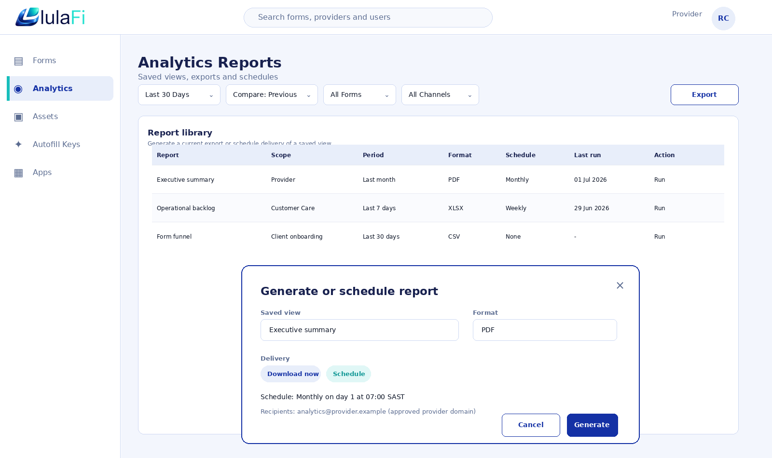
Figure 7 – Report library and controlled export/schedule dialog.
The dialog estimates output size and selects synchronous or asynchronous processing. Scheduled recipients are checked against provider/global policy. Report metadata includes scope, time zone, filters, metric versions, generated time and quality status.

10.7 Metric Catalogue Administration
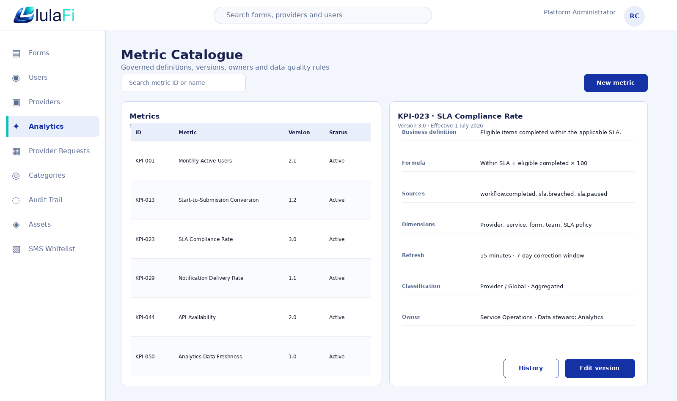
Figure 8 – Platform metric catalogue for controlled definition and version management.
Editing an active metric creates a draft version. The new version requires approval and an effective date. Historical snapshots retain the metric version used at calculation time. A definition that affects comparability generates a dashboard annotation.

11. Analytics Backend Service Design

11.1 Module Structure
src/
routes/analytics.routes.ts
controllers/analytics.controller.ts
middleware/analyticsScope.middleware.ts
services/analytics/
eventGateway.service.ts
analyticsQuery.service.ts
metricEngine.service.ts
aggregate.service.ts
drilldown.service.ts
export.service.ts
schedule.service.ts
alert.service.ts
dataQuality.service.ts
privacyPolicy.service.ts
repositories/analytics/
clickhouse.client.ts
clickhouseEvent.repository.ts
clickhouseMetric.repository.ts
mongoMetricDefinition.repository.ts
mongoSavedView.repository.ts
mongoJobSchedule.repository.ts
workers/
analyticsProcessor.worker.ts
analyticsOutbox.worker.ts
analyticsExport.worker.ts
analyticsSchedule.worker.ts
schemas/analytics-events/
models/analytics-control/

11.2 Service Responsibilities
Service | Responsibilities
AnalyticsScopeService | Resolve realm/global scope, org units, permission set, environment and maximum detail class.
EventGatewayService | Authenticate producer, validate schema/version, reject prohibited fields, derive realm, tokenise identifiers and enqueue accepted events.
AnalyticsQueryService | Resolve metric versions from MongoDB, select ClickHouse aggregate-state, time-series or bounded-detail query templates, apply suppression and return quality metadata.
MetricEngineService | Compile approved calculation templates into parameterised ClickHouse SQL and aggregate-state merges; never execute arbitrary user expressions or SQL.
AggregateService | Insert raw facts, maintain hourly/daily aggregate-state tables and rebuild affected partitions/buckets for late events within the correction window.
DrilldownService | Resolve allowed next dimensions and entity levels; construct row/field filters.
ExportService | Create immutable authorised job descriptor, estimate size, generate file and manage signed access.
ScheduleService | Evaluate time-zone-aware schedules and create export jobs.
AlertService | Evaluate thresholds and anomaly rules allowed in current release; rate-limit and deduplicate notifications.
DataQualityService | Reconcile ClickHouse totals and processing lag against source controls; calculate validity, freshness, completeness, uniqueness, consistency and coverage.
PrivacyPolicyService | Apply minimum cohorts, tokenisation, disallowed dimensions, redaction and retention policy.
AnalyticsAuditService | Write dashboard, sensitive drill, export, definition, schedule and correction audit entries.

11.3 Request Processing Pipeline
- Authenticate bearer token using the existing internal authentication service.
- Resolve current user and Authentik claims into an AnalyticsAccessContext.
- Validate route/query schema using the existing request-handler validation framework or Zod.
- Derive server-side scope and remove any unauthorised filter values.
- Resolve metric definition/version for the requested period.
- Choose snapshot, time-series or bounded detail query plan.
- Apply row, field, dimension, minimum-cohort and environment controls.
- Attach freshness, quality, coverage, metric version and applied-filter metadata.
- Audit sensitive access or export actions.
- Return a structured response with a correlation identifier.

11.4 Compatibility Controllers
During migration, the existing `GET /forms/analytics` endpoint delegates to AnalyticsQueryService for the legacy summary and per-form contract. The existing `GET /forms/:id/analytics` endpoint maps to the new form view/submission metrics. Deprecation headers and telemetry identify remaining clients. No new features are added to the legacy response shape.

12. Event Capture and Processing Design

12.1 Processing Flow
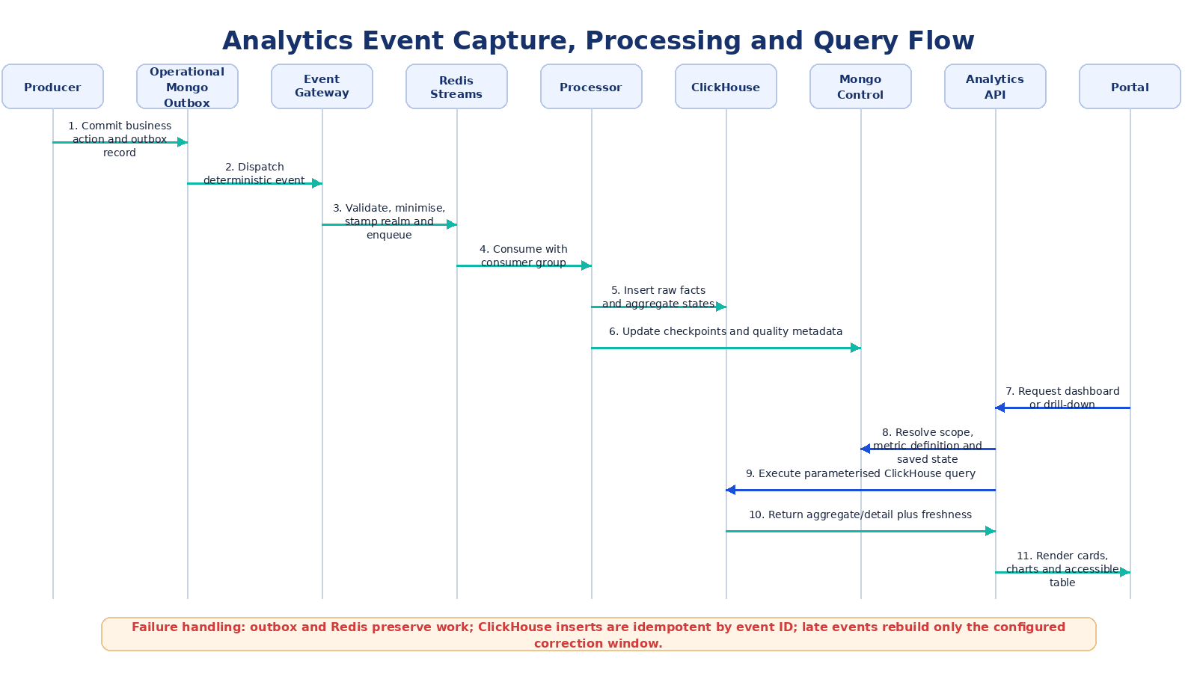
Figure 9 – Reliable analytics event capture, processing, query and drill-down flow.

12.2 Event Sources and Capture Method
Source | Capture Method | Reliability Rule
API business transaction | Write an AnalyticsOutbox record in the same MongoDB transaction/session where supported, or immediately after a successful committed action with deterministic event ID. | Dispatcher retries until acknowledged; processor idempotent.
Portal interaction | Batch endpoint for approved UI interaction events. | Client retries with same event IDs; non-critical events may be sampled by policy.
Mobile interaction | Encrypted local buffer and batch upload when online. | Preserve occurred time; accept late events within retention/correction limits.
Messaging/XMPP/Matrix | Adapter receives room/message lifecycle metadata. | Content fields not accepted; delivery callbacks deduplicated.
Notification provider | Signed callback/webhook or service event. | Callback validation and provider message ID deduplication.
Connector runtime | Service-authenticated event API or stream. | Realm and connector instance must match service credentials.
Advertising | Placement SDK events plus server-side campaign outcomes. | Invalid-traffic processing retains classification, not user profile.
Observability | Scheduled import or approved metrics adapter. | Operational metrics tagged by service/environment and kept separate from business content.

12.3 Canonical Event Envelope
Field | Type | Rule
eventId | UUID/string | Globally unique, immutable and used for idempotency.
eventName | string | Governed lower-case `domain.action` value.
eventVersion | integer | Registered schema version.
occurredAtUtc | ISO-8601 | Producer event time in UTC.
receivedAtUtc | ISO-8601 | Set by gateway.
providerRealmId | ObjectId/string or null | Required for provider events; server derived where possible.
actorIdToken | string or null | Pseudonymous token; direct personal identifier prohibited.
actorType | enum | end_user, provider_user, admin_user, service, connector.
sessionIdToken | string or null | Pseudonymous journey/session ID.
sourceComponent | enum | mobile, portal, api, chat, notification, connector, advertising, billing, platform.
environment | enum | test, staging, production.
correlationId | string or null | Links approved logs/traces and related events.
entityType / entityId | string | Stable approved entity reference.
result | enum | success, failure, cancelled, timeout, rejected or governed extension.
durationMs | number or null | Non-negative integer.
errorCode | string or null | Governed class, no error stack or sensitive text.
dimensions | object | Allow-listed low-risk attributes; no arbitrary nested payload.
schemaQualityStatus | enum | accepted, accepted_with_warning, rejected.

12.4 Event Validation and Redaction
- Unknown event names or versions are rejected unless an explicit forward-compatible policy exists.
- Free-text dimensions are rejected by default. Search analytics uses normalised and risk-filtered term classes rather than raw personal queries when possible.
- Attributes matching password, token, secret, OTP, message body, form answer, attachment content, email address or phone-number patterns are rejected and counted.
- Provider realm supplied by client events is compared with authenticated service/client context and replaced or rejected on mismatch.
- IP address may be used transiently for fraud/security controls or approved coarse geography derivation; it is not persisted in the analytical event by default.
- Event time outside configured future/past tolerance is quarantined or marked late according to policy.

12.5 Idempotency and Ordering
Concern | Design
Duplicate event | Deduplicate in the processor using event ID and an ingestion ledger/checkpoint; ClickHouse inserts use a deterministic event ID and duplicate-tolerant query semantics.
Out-of-order event | Metrics use occurredAtUtc and explicit journey/session state; processor can update a prior bucket within correction window.
Late event | If inside the correction window, recompute the affected ClickHouse aggregate bucket/partition and update calculated time; outside the window, retain or reject per class without silently altering published history.
Poison event | Moved to quarantine with schema/error code and source reference; no sensitive payload copied to logs.
Worker restart | Stream consumer group resumes unacknowledged messages; writes are idempotent.
Replay | Replay job uses source range and metric version; audit entry records reason and affected periods.

13. Analytics Data Architecture

13.1 Logical Data Stores
The target implementation uses a dual-store architecture. ClickHouse is the analytics data plane and holds append-oriented event facts, aggregate states, KPI snapshots, funnel states and bounded drill-down metadata in the `lulafi_analytics` database. MongoDB remains the operational database and analytics control plane, holding metric definitions, saved views, export and schedule records, alert rules, processing checkpoints and quality-run metadata. Redis Streams coordinates processing and Redis may cache authorised query responses. Controlled references use immutable IDs; no form answers or chat content are copied into either analytics store.
Store / Object | Purpose | Typical Retention
ClickHouse: analytics_events_raw | Approved immutable event facts used for calculation, diagnostics and bounded drill-down. | 90 days default using TTL; configurable by event class.
ClickHouse: analytics_event_rejections | Rejected event identity, source and non-sensitive error classification. | 30 days using TTL.
ClickHouse: analytics_metrics_hourly | Mergeable aggregate states by hour, realm, metric and approved dimensions. | 13 months default.
ClickHouse: analytics_metrics_daily | Daily aggregate states and longer-period query basis. | 7 years default or contract/policy period.
ClickHouse: analytics_metric_snapshots | Point-in-time KPI values, numerator, denominator, coverage, sample count and quality state. | 7 years default or reporting policy.
MongoDB: analytics_metric_definitions | Versioned catalogue, formula template, storage/query plan and approval lifecycle. | Permanent with version history.
MongoDB: analytics_saved_views | Personal, provider-published and global saved view definitions. | Until deleted/owner archived plus audit retention.
MongoDB: analytics_export_jobs | Authorised query descriptor, status, row count, object reference and expiry. | Metadata 12 months; file normally 24-72 hours.
MongoDB: analytics_report_schedules | Frequency, recipients, saved view, time zone and owner. | Until disabled/deleted plus audit.
MongoDB: analytics_alert_rules | Metric threshold, scope, evaluation window, cooldown and target. | Until disabled/deleted plus audit.
Operational MongoDB: analytics_outbox | Durable pending business events committed with operational changes. | Until dispatched plus a short audit window.
MongoDB: analytics_processing_state | Consumer checkpoints, replay/correction jobs, quality runs and reconciliation metadata. | Operational retention; quality history normally 25 months.

13.2 ClickHouse Raw Event Table
CREATE TABLE lulafi_analytics.analytics_events_raw
(
event_id String,
event_name LowCardinality(String),
event_version UInt16,
occurred_at_utc DateTime64(3, 'UTC'),
received_at_utc DateTime64(3, 'UTC'),
scope_type Enum8('provider' = 1, 'platform' = 2),
provider_realm_id String,
actor_id_token String,
actor_type LowCardinality(String),
session_id_token String,
source_component LowCardinality(String),
environment LowCardinality(String),
correlation_id String,
entity_type LowCardinality(String),
entity_id String,
entity_version UInt32,
result LowCardinality(String),
duration_ms UInt64,
error_code LowCardinality(String),
dimensions Map(LowCardinality(String), String),
processed_at_utc DateTime64(3, 'UTC')
)
ENGINE = ReplicatedMergeTree('/clickhouse/tables/{shard}/analytics_events_raw','{replica}')
PARTITION BY (environment, toYYYYMM(occurred_at_utc))
ORDER BY (environment, provider_realm_id, event_name, occurred_at_utc, entity_id, event_id)
TTL occurred_at_utc + INTERVAL 90 DAY DELETE
SETTINGS index_granularity = 8192;

13.3 MongoDB Metric Definition Document
{
"metricId": "KPI-013",
"version": "1.2",
"name": "Start-to-Submission Conversion",
"calculationType": "rate",
"numerator": {"eventName":"form.submitted","result":"success","distinctBy":"sessionIdToken"},
"denominator": {"eventName":"form.started","distinctBy":"sessionIdToken"},
"dimensions": ["providerRealmId","formId","formVersion","channel","deviceClass"],
"storagePlan": {"hourlyTable":"analytics_metrics_hourly","dailyTable":"analytics_metrics_daily"},
"queryTemplateId": "rate_distinct_sessions_v1",
"suppression": {"minimumDenominator":10},
"refresh": "PT15M",
"correctionWindow": "P7D",
"effectiveFrom": "2026-07-01T00:00:00Z",
"status": "active",
"accessClassification": ["provider","global"]
}

13.4 ClickHouse Aggregate and Snapshot Tables
Hourly and daily tables use `AggregatingMergeTree` (or another approved MergeTree variant) to retain mergeable states for counts, distinct counts, sums and quantiles. Materialised views transform accepted rows from `analytics_events_raw` into approved aggregate combinations. A KPI snapshot is identified by metric ID/version, environment, scope type, provider realm where applicable, bucket start/end in UTC, reporting time zone and dimension signature. Snapshot rows retain value or aggregate state, numerator, denominator, coverage, sample count, quality state, calculated time and lineage reference. Refreshable rebuild jobs are used where a metric requires joins, point-in-time state or correction beyond insert-time materialised-view logic.

13.5 ClickHouse Sorting, Partitioning and Supporting Indexes
Store / Table | Key / Index | Purpose
analytics_events_raw | PARTITION BY environment, toYYYYMM(occurred_at_utc) | Efficient monthly retention, replay and environment isolation.
analytics_events_raw | ORDER BY environment, provider_realm_id, event_name, occurred_at_utc, entity_id, event_id | Provider/global time-range pruning and common drill-down order.
analytics_events_raw | Bloom/token skip index on correlationId where justified | Diagnostic lookup without making correlation ID part of the primary ordering key.
analytics_metrics_hourly | ORDER BY environment, metric_id, metric_version, provider_realm_id, bucket_start_utc, dimension_signature | Fast provider and global hourly trends and state merges.
analytics_metrics_daily | ORDER BY environment, metric_id, metric_version, provider_realm_id, bucket_start_utc, dimension_signature | Long-period dashboards, comparisons and exports.
analytics_metric_snapshots | ORDER BY environment, scope_key, metric_id, metric_version, bucket_end_utc, dimension_signature | Deterministic KPI and point-in-time retrieval.
Materialised views | Approved source-event and dimension combinations only | Incremental aggregate updates without uncontrolled cardinality.
MongoDB control collections | Unique metric/version; owner/name; job status/createdAt; schedule nextRunAt | Transactional integrity and worker pickup for control-plane records.
Operational MongoDB analytics_outbox | status + nextAttemptAt; unique deterministic eventId | Reliable dispatcher and duplicate protection.
analytics_data_quality_runs | source + periodEndUtc | Quality dashboard and alerting.

13.6 Provider-Realm Migration Fields
Entity | New / Corrected Fields
User | `providerRealmId`, organisationUnitIds, analyticsPermissions/claims reference.
Form | `providerRealmId` as tenant owner; `createdByProviderUserId` retained separately.
FormSubmission | `providerRealmId`, form ID/version and user token; existing provider user reference retained only for migration/audit if needed.
Connector instance | `providerRealmId`, connectorAppId/version and instance ID.
Analytics event | Canonical providerRealmId, source actor token and optional providerUserIdToken; inserted into ClickHouse provider facts.
ClickHouse aggregate/snapshot | Scope key and ORDER BY dimensions are based on providerRealmId, never an individual provider owner account.

13.7 Retention and Deletion
- ClickHouse TTL rules delete raw event facts and rejection records by event class. The default is 90 days for accepted raw events and 30 days for rejected-event metadata.
- Hourly aggregate states are retained for approximately 13 months and daily/KPI aggregates for approximately 7 years unless contract, legal or privacy policy requires a different period. Older approved aggregates may be archived to S3-compatible storage.
- When personal-data deletion applies, token mappings are destroyed or affected ClickHouse rows are anonymised/reprocessed within the required service level. Non-identifying governed aggregates may remain where lawful.
- MongoDB export jobs, schedules, saved views, alert definitions and processing state follow their control-plane retention rules. Export files expire automatically in object storage and require a new authorised request after expiry.
- Production, staging and test use separate ClickHouse databases or clusters, MongoDB databases/credentials, Redis namespaces/instances and object-storage prefixes. The production UI never silently displays non-production data.

14. Metric Calculation and Governance Design

14.1 Supported Calculation Types
Type | Method | Examples
Count | Count accepted qualifying events or entities after deduplication. | Form views, submissions, notifications sent.
Distinct count | Cardinality of a governed pseudonymous key. | DAU, MAU, active providers, active conversations.
Rate / percentage | Numerator divided by denominator with both retained in snapshot. | Completion, delivery, SLA compliance, error rate.
Duration distribution | Difference between governed start/stop events; store sample count and quantiles. | Form completion, turnaround, first response, latency.
Point-in-time | State reconstruction at bucket end from lifecycle events or operational snapshot. | Open workload, active connector instances.
Flow / net change | Entered minus left during period. | Backlog inflow/outflow.
Ratio / utilisation | Consumed units divided by entitlement/capacity. | Subscription utilisation, saturation.
Availability / SLI | Good eligible requests/time divided by total eligible requests/time. | API availability and SLO attainment.
Reconciliation variance | Analytics control total minus governed source total. | Submission or billing reconciliation.

14.2 Metric Lifecycle
- Metric owner submits a definition using an approved calculation type and source event versions.
- Technical steward validates data availability, dimensions, suppression, correction window and performance.
- Privacy/security review confirms classification and permitted detail.
- Definition is saved as draft and tested against controlled event fixtures.
- Approver activates the version with an effective date.
- Processor calculates snapshots using the active definition for each event period.
- Dashboard displays definition version and annotations when comparability changes.
- Retirement prevents new calculation but preserves historical interpretation.

14.3 Time Allocation
- Events are stored in UTC. Reporting buckets are generated using the selected IANA time zone and saved with their UTC boundaries.
- Preset date ranges are calculated in the selected time zone. “Today” begins at local midnight, not UTC midnight.
- Daylight-saving transitions are handled through the IANA time-zone library. South African providers normally use `Africa/Johannesburg`.
- Comparison periods use equal logical duration where possible. If a percentage change has a zero denominator, the API returns `comparisonState: no_baseline` rather than infinity.
- Attribution windows, SLA pause rules and business calendars are part of the metric or policy definition.

14.4 Percentiles
ClickHouse aggregate functions are used for duration distributions. `quantileExact` may be used for controlled low-volume metrics; `quantileTDigest` or another approved mergeable quantile state is used for high-volume hourly/daily aggregation. The selected function, parameters and approximation status are fixed by metric version and returned in metric metadata.

14.5 Suppression and Coverage
Rule | Behaviour
Minimum cohort | Return `suppressed` with no hidden numeric value when count/denominator is below configured threshold.
Coverage-limited metric | Return measurable denominator and coverage percentage, for example notification opens or ad viewability.
Unavailable source | Return `unavailable` with affected source and last complete time.
Known zero | Return numeric zero only when the source is complete and the qualifying count is zero.
Null / not applicable | Return `not_applicable` where the metric is not meaningful for the selected scope.

14.6 Calculation Example
Metric: KPI-013 Start-to-Submission Conversion
Period: 2026-06-01 to 2026-06-30, Africa/Johannesburg
Scope: Provider Realm PRV-001, Form F-100, Version 4
Numerator = distinct sessionIdToken where form.submitted result=success = 8,964
Denominator = distinct sessionIdToken where form.started = 14,280
Value = 8,964 / 14,280 × 100 = 62.7731% → display 62.8%
Coverage = 100%
Metric version = 1.2
Quality = current, complete, reconciled

15. Analytics API Design

15.1 API Principles
- Versioned REST/JSON endpoints under `/api/v1/analytics`.
- Bearer authentication and server-derived AnalyticsAccessContext.
- No arbitrary query language or direct database field selection.
- Allow-listed metrics, dimensions, filters, sort fields and drill paths.
- Cursor pagination for detail tables; bounded date range and result cardinality.
- Metric value and metadata returned together.
- Consistent problem response with correlation ID; unauthorised resource existence is not revealed.
- Asynchronous job resources for large exports and recalculations.

15.2 Endpoint Catalogue
Method | Endpoint | Purpose
GET | /analytics/context | Return resolved scope, permissions, modules, time zones and valid common filters.
GET | /analytics/overview | Provider or global overview metric cards and panels.
GET | /analytics/metrics/:metricId | Single metric value and comparison.
GET | /analytics/metrics/:metricId/timeseries | Bucketed time series.
GET | /analytics/metrics/:metricId/breakdown | Grouped values for one approved dimension.
GET | /analytics/forms | Ranked form performance and funnel summaries.
GET | /analytics/forms/:formId | Form-specific metric set and drill metadata.
GET | /analytics/operations | Workflow, backlog and SLA metrics.
GET | /analytics/messaging | Conversation and message-delivery metrics.
GET | /analytics/notifications | Notification delivery, open and action metrics.
GET | /analytics/connectors | Connector performance and usage metrics.
GET | /analytics/advertising | Campaign and placement metrics.
GET | /analytics/platform | Global platform reliability metrics; Admin operations only.
GET | /analytics/data-quality | Freshness, validity, completeness and reconciliation.
GET | /analytics/drill | Authorised next-level rows for a signed drill descriptor.
GET | /analytics/metric-definitions | Read metric catalogue according to scope.
POST | /analytics/metric-definitions | Create draft metric version; metric admin only.
POST | /analytics/saved-views | Create personal or published saved view.
GET | /analytics/saved-views | List permitted saved views.
POST | /analytics/exports | Create export job.
GET | /analytics/exports/:jobId | Get job status and temporary download link.
POST | /analytics/report-schedules | Create scheduled report.
POST | /analytics/alert-rules | Create threshold alert.
POST | /analytics/events/batch | Client/service event batch ingestion.
POST | /analytics/internal/events | Internal service-authenticated event ingestion.

15.3 Common Query Parameters
Parameter | Example | Rule
start | 2026-06-01T00:00:00+02:00 | Inclusive logical period start.
end | 2026-07-01T00:00:00+02:00 | Exclusive logical period end.
timeZone | Africa/Johannesburg | IANA name; must be permitted.
granularity | day | hour/day/week/month subject to range.
compare | previous_period | none, previous_period, prior_year or approved custom baseline.
filters | encoded allow-listed descriptor | Validated against context; no direct Mongo operators.
dimension | formId | One approved breakdown dimension.
sort | -value | Allow-listed columns only.
cursor | opaque token | Signed/opaque server paging cursor.
limit | 50 | Server maximum applies.
environment | production | Visible and permission controlled.

15.4 Standard Metric Response
{
"metric": {"id":"KPI-013","version":"1.2","name":"Start-to-Submission Conversion","unit":"percent"},
"scope": {"type":"provider","providerRealmId":"prv_...","displayName":"Acme Services"},
"period": {"start":"2026-06-01T00:00:00+02:00","end":"2026-07-01T00:00:00+02:00","timeZone":"Africa/Johannesburg"},
"value": 62.8,
"numerator": 8964,
"denominator": 14280,
"comparison": {"state":"available","absoluteChange":2.1,"percentagePointChange":2.1},
"quality": {"status":"current","freshnessSeconds":240,"completeness":0.997,"reconciled":true},
"coverage": 1.0,
"appliedFilters": [{"dimension":"formId","values":["f_100"]}],
"drill": {"available":true,"nextDimensions":["formVersion","channel","deviceClass"]},
"generatedAtUtc":"2026-07-04T10:09:00Z",
"correlationId":"corr_..."
}

15.5 Error Response
{
"type": "https://lulafi/errors/analytics-query-too-broad",
"title": "Analytics query is too broad",
"status": 422,
"detail": "Reduce the date range or number of dimensions.",
"code": "ANL_QUERY_COST_LIMIT",
"correlationId": "corr_..."
}

15.6 Query Cost Controls
Control | Initial Rule
Interactive preset range | Up to 24 months for pre-aggregated monthly data; up to 90 days for detailed daily/hourly data.
Breakdown cardinality | Maximum 500 returned groups; top-N plus Other for supported metrics.
Detail page | Maximum 100 rows per request; cursor pagination.
Concurrent interactive queries | Per-user and per-realm limits.
Export size | Synchronous only below configured row/byte threshold; otherwise job.
Custom dimensions | Not supported in initial release; only catalogue dimensions.
Query timeout | Short bounded timeout with cancellation and correlation ID.

16. Identity, RBAC and Provider-Realm Security

16.1 Access Context
type AnalyticsAccessContext = {
userId: string;
userType: 'provider' | 'vendor';
providerRealmId?: string;
organisationUnitIds: string[];
geographyScopes: string[];
permissions: string[];
environmentScopes: Array<'production'|'staging'|'test'>;
detailClass: 'aggregate'|'pseudonymous'|'operational-link';
};

16.2 Permission Codes
Permission | Capability
analytics.provider.view | View provider dashboards and approved metric definitions.
analytics.provider.drilldown | Drill from aggregate to authorised lower-level provider metadata.
analytics.provider.export | Export authorised provider analytics.
analytics.provider.configure | Publish provider views, targets and schedules.
analytics.provider.commercial | View subscription, advertising and revenue-share metrics.
analytics.admin.view | View global aggregate analytics.
analytics.admin.provider_detail | Drill from global/cohort to named provider detail.
analytics.admin.sensitive_detail | View permitted pseudonymous supporting metadata.
analytics.operations.view | View platform SLI/SLO and diagnostic links.
analytics.data_quality.view | View pipeline and reconciliation detail.
analytics.metric.manage | Create, approve, activate and retire metric versions.
analytics.report.schedule | Create schedules in permitted scope.
analytics.alert.manage | Create and manage threshold alerts.
analytics.audit.view | View analytics audit and lineage evidence.

16.3 Scope Enforcement Sequence
- Verify token and current user using existing authentication middleware.
- Resolve provider realm from authoritative user/provider relationship or Authentik claim; do not accept provider client override.
- Resolve organisation, geography and service scopes.
- Check route permission.
- Intersect requested metric dimensions/filters with allowed scope.
- Apply providerRealmId to every provider query and aggregate key.
- Apply field-level restriction for sensitive metadata.
- Apply minimum cohort suppression.
- Audit sensitive drill-down and export.

16.4 Defence-in-Depth Controls
Layer | Control
Portal | Hide unauthorised navigation/actions, but do not rely on client-side checks.
Route middleware | Role and permission gate before controller.
Scope service | Creates immutable scope predicate and permitted dimension list.
Query service | Uses allow-listed parameterised ClickHouse SQL templates and separate MongoDB repositories; the mandatory scope predicate is constructed server-side and cannot be removed by callers.
Database | Separate least-privilege ClickHouse read/write identities and MongoDB control-plane credentials; production row policies may provide additional read-only defence in depth, but API scope remains authoritative.
Export worker | Re-resolves scope and permission at job execution; signed query descriptor.
Operational link | Destination API independently authorises the record.
Audit/monitoring | Alert on cross-realm attempts, unusual export volume and permission-denied patterns.

16.5 Current User-Type Mapping
Current Code Value | Target Business Label | Analytics Use
provider | Provider user | Requires provider realm and provider analytics permissions.
vendor | lulaFi Admin / support / platform admin | Capabilities differentiated by permission claims, not by vendor type alone.
end | End user | No Portal Analytics access; may be an event actor only.

17. Privacy and Data Protection Design

17.1 Prohibited Analytics Content
Prohibited Content | Enforcement
Form answer values and form payload | Event schema has no value field; redaction scanner rejects suspicious arbitrary payloads.
Chat/message content | Messaging adapter emits IDs, type, timestamps and delivery states only.
Attachment content or filenames containing personal information | Only attachment count/type class/size band when approved; no object content.
OTP values and notification bodies | Not accepted by schemas; callback adapter extracts delivery metadata only.
Passwords, API tokens, connector credentials and secrets | Schema deny-list, log redaction and secret-store separation.
Direct phone/email/name identifiers | Tokenised before persistence; no direct dimension.
Precise location trails | Only approved coarse geography or geofence classification with suppression.

17.2 Tokenisation
Actor and session identifiers are generated using keyed HMAC with a versioned secret. The token supports distinct-count and journey correlation without exposing the original identifier. Key versions rotate under secret-management control. Where deletion must remove linkability, the mapping/key strategy is designed so the relevant token can no longer be resolved or is replaced by a non-linkable aggregate.

17.3 Cohort Suppression
- Minimum user/event denominator is defined per metric and dimension, with a platform default.
- Suppressed values are omitted from APIs and exports, not merely hidden in the chart.
- Top-N grouping must ensure the “Other” group does not permit subtraction attacks.
- Repeated queries with overlapping filters are monitored; high-risk dimensions may be restricted to coarse groupings.

17.4 Export Protection
- CSV/XLSX cells beginning with formula characters are neutralised.
- Exports include only allow-listed fields and the same row/field restrictions as interactive views.
- Files are encrypted at rest, served through short-lived signed URLs and deleted at expiry.
- Recipients of scheduled reports are validated against provider/global recipient policy.
- Every request, generation and download is audited.

17.5 Privacy Impact Controls
Control | Evidence
Purpose and lawful basis | Metric catalogue access classification and privacy approval reference.
Data minimisation | Event schema registry and prohibited-field tests.
Retention | Class-based retention configuration and automated expiry job.
Data subject action | Token deletion/anonymisation workflow and completion audit.
Cross-provider protection | Realm test suite and query-scope invariant.
Special-category dimensions | Disabled unless explicitly approved and configured.

18. Query, Filter and Drill-Down Design

18.1 Filter Descriptor
{
"time": {"preset":"last_30_days","timeZone":"Africa/Johannesburg","granularity":"day"},
"compare": {"type":"previous_period"},
"filters": [
{"dimension":"formId","operator":"in","values":["f_100","f_104"]},
{"dimension":"organisationUnitId","operator":"in","values":["ou_claims"]}
]
}

The API validates the descriptor against the context endpoint. Database column names, SQL fragments, ClickHouse functions, MongoDB operators, regular expressions and arbitrary expressions are not accepted. Values are resolved to authorised IDs and normalised to a canonical ordering for cache keys and audit.

18.2 Drill Descriptor
A drill action is represented by an opaque signed descriptor created by the API. It contains the parent metric/version, scope hash, period, filters, selected category and permitted next level. This prevents clients from substituting a different realm or detail level.

18.3 Provider Drill Hierarchies
Domain | Hierarchy
Forms | Provider → Form/category → Form version → Journey stage → approved session metadata.
Workflow | Provider → Service/form → Status/queue/team → Age/SLA band → submission metadata → operational link.
Messaging | Provider → Conversation type/form/service → Response band/status → conversation metadata → authorised room link.
Notifications | Provider → Type/channel/campaign/template → Result/failure class → message metadata token.
Connectors | Provider → Connector app → Instance/version/endpoint class → Result/error code → correlation ID.
Advertising | Provider/campaign → Placement/creative/audience/geography → measurable/viewable/click/conversion aggregates.

18.4 Global Drill Hierarchies
Domain | Hierarchy
Adoption | Platform → Cohort/industry/tier/geography → provider list → provider overview.
Forms | Platform → category/form cohort → provider → form/version.
Reliability | Platform → service/environment → endpoint/dependency → time bucket → approved trace/log link.
Data Quality | Platform → source → event/schema version → rejection/reconciliation class → source correlation.
Advertising | Platform → advertiser/campaign → provider/placement → creative/segment aggregate.

18.5 Query Plan Selection
Request | Plan
KPI card | Single ClickHouse snapshot/aggregate query by metric, scope and period.
Trend | Hourly or daily aggregate-state merge across the selected and optional comparison ranges.
Breakdown | Approved dimension aggregate table or bounded raw aggregation for low-use combinations.
Top forms/providers | Precomputed ranking from daily aggregates with volume and coverage context.
Supporting table | Bounded ClickHouse event/detail query using a signed cursor and mandatory provider/global scope.
Large historical detail | Asynchronous export job against daily aggregates or bounded facts; otherwise rejected as too broad.
Current operational workload | Approved MongoDB operational read model or ClickHouse point-in-time snapshot, not full event replay per request.

19. Reporting, Export, Scheduling and Alerts

19.1 Export Job Lifecycle
Status | Meaning
queued | Authorised job created and awaiting worker.
running | Worker executing query and generating file.
completed | File stored; signed download available until expiry.
failed | Non-sensitive reason and correlation ID available.
expired | File removed and no download available.
cancelled | Owner/admin cancelled before completion.

19.2 Export Job Security
- Portal sends current metric/query descriptor and requested format.
- API revalidates scope, fields, estimated cost and export permission.
- API stores immutable job with scope hash, owner, metric versions and filters.
- Worker re-resolves owner status/permission and executes through AnalyticsQueryService.
- Worker escapes spreadsheet formulas and adds report metadata.
- File is stored with expiry, encryption and restricted object key.
- Portal receives short-lived signed URL; download is audited.

19.3 Format Design
Format | Design
CSV | UTF-8; machine-readable headers; ISO timestamps; one tabular dataset per file.
XLSX | Summary sheet, data sheet(s), definition/metadata sheet; table headers and filters; formula injection protection.
PDF | NDT/lulaFi report heading, scope, time range, filters, KPI cards, charts, accessible text summaries, page numbers and data-quality note.

19.4 Scheduled Reports
Field | Rule
Saved view | Required; view is revalidated at each execution.
Frequency | Daily, weekly or monthly in configured time zone.
Recipients | Approved users/addresses within permitted scope.
Format | CSV, XLSX or PDF subject to report design.
Failure handling | Retry policy, owner notification and automatic disable after repeated permanent failures.
Ownership change | Disable when owner is archived or loses permission until transferred by an administrator.

19.5 Alerts
Initial alerts are deterministic threshold, target, stale-data and SLO/error-budget rules. AI anomaly detection is not part of this release. Evaluation occurs after metric refresh. The alert key combines rule, scope, metric and period to prevent duplicates. Cooldown and recovery notifications are configurable.
Alert Type | Example
Threshold | SLA compliance below 90% for the last complete day.
Rate of change | Notification failure rate increases by more than 5 percentage points versus previous period.
Staleness | Analytics freshness exceeds 30 minutes.
Connector degradation | p95 latency exceeds SLO for three consecutive buckets.
SLO/error budget | Monthly error-budget consumption exceeds configured pace.
Reconciliation | Submission variance exceeds tolerance.

20. Performance, Caching and Scalability

20.1 Performance Targets
Operation | Target Design
Standard dashboard initial summary | p95 ≤ 3 seconds for preset period ≤ 90 days under normal load.
First drill-down page | p95 ≤ 4 seconds.
Filter update | No full Portal reload; primary panels update independently.
Event ingestion | Batch accepted rapidly with asynchronous processing; transactional flow not blocked.
Data freshness | Operational/provider summary target 5–15 minutes by domain; displayed explicitly.
Export | Job acceptance ≤ 2 seconds; generation time depends on row/format limits and is reported.

20.2 Caching Layers
Layer | Use | Invalidation
Portal RTK Query | Per-user browser cache for recent query responses. | Query-key changes, TTL or explicit refresh.
Redis query cache | Shared cache for identical authorised aggregate queries by scope hash. | ClickHouse aggregate refresh publishes an invalidation tag; short TTL remains a safety control.
ClickHouse aggregate tables/materialised views | Primary pre-aggregation and mergeable metric state, not merely a cache. | Updated by inserts, materialised views or controlled rebuild jobs.
MongoDB reference/control cache | Metric definitions, labels, allowed dimensions and saved-view metadata. | Version/change event.
Signed export URL | Temporary access reference only. | Expiry or job cancellation.

20.3 Capacity Controls
- Batch event ingestion with configurable maximum events and payload bytes.
- Redis consumer groups allow horizontal worker scaling.
- ClickHouse partitions and sorting keys include environment, reporting time, provider realm and approved metric/dimension keys.
- Materialise only approved dimension combinations; use aggregate states and projection/materialised-view design reviews to control cardinality and small-part growth.
- Use precomputed top-N/ranking tables for high-cardinality lists and retain volume/coverage context.
- Use replicated ClickHouse production tables, workload/query limits and separate service users; isolate export concurrency from interactive dashboard queries.
- Separate worker and API resource limits so exports cannot starve interactive dashboards.

20.4 ClickHouse Scaling Strategy
ClickHouse is the target analytical store from the first production analytics release. Development may use a single node; production shall use a managed service or replicated cluster sized from measured event rate, compressed storage, active parts, merge pressure, query concurrency and recovery objectives. Scale-out decisions review shard/replica count, partition width, ORDER BY effectiveness, materialised-view cost, retention and object-storage archive. Portal and API contracts remain unchanged when the ClickHouse topology changes.

21. Observability and Data Quality

21.1 Analytics Service Telemetry
Signal | Examples
Traffic | Ingest events/s, query requests/s, export jobs, schedule executions.
Latency | Gateway validation, stream lag, processing latency, metric refresh, query p50/p95/p99, export duration.
Errors | Schema rejection, auth mismatch, worker failure, query timeout, export failure, schedule delivery failure.
Saturation | Redis lag, worker concurrency, ClickHouse active parts/merges, query concurrency, disk/CPU/memory, MongoDB pools, queue depth and object-storage throughput.
Business quality | Freshness, completeness, duplicate rate, reconciliation variance, measurable coverage.

21.2 Data Quality Status Model
Status | Condition | UI Treatment
current | Freshness and quality within threshold. | Normal value plus last refresh.
delayed | Freshness exceeds warning threshold but data remains usable. | Amber badge and latest complete time.
stale | Freshness exceeds critical threshold. | Warning banner; comparisons may be disabled.
partial | One or more sources or periods incomplete. | Value shown only where safe with affected sources listed.
unverified | Reconciliation pending or failed within warning tolerance. | Verification badge; export metadata includes warning.
unavailable | No reliable result can be produced. | No numeric value; explanatory state.
suppressed | Result withheld by privacy threshold. | “Suppressed to protect privacy”; never zero.

21.3 Reconciliation Design
Source systems expose control totals for governed periods where available, such as accepted form submissions, notification sends, connector usage units and billing records. DataQualityService compares analytical totals to controls by source/realm/period, records variance and marks affected metrics. Material variances create alerts and may block a “verified” report status.

21.4 Correlation and Diagnostic Links
- Every query and event batch receives a correlation ID.
- Connector and platform events may include approved correlation IDs that link to Loki/Grafana/trace searches.
- Diagnostic links are generated only when the user has observability access and do not embed credentials.
- Error messages shown to users include correlation ID but no stack trace, query or sensitive filter values.

22. Error Handling and User Messages
Condition | HTTP / State | Portal Behaviour
No data | 200, state=no_data | Explain no data for selection; retain filters.
Suppressed | 200, state=suppressed | Show privacy explanation; omit numeric value.
Partial/delayed | 200 with quality metadata | Render available panels and visible warning.
Permission denied | 403 | Generic access message; no confirmation restricted data exists.
Invalid filter | 400 | Identify invalid control and restore last valid state.
Query too broad/costly | 422 | Ask user to reduce range/dimensions; preserve choices.
Rate limited | 429 | Show retry time and keep page state.
Metric version unavailable | 409/422 | Explain definition/time incompatibility.
Export queued | 202 | Show job in report library.
Export failed | Job failed | Show correlation ID and retry where permitted.
Service unavailable | 503 | Show stale cache only if labelled and policy permits.

22.1 Error Logging Rules
- Log code, component, correlation ID, scope hash and error class.
- Do not log bearer tokens, filter values containing personal information, event payload content or export data.
- Provider realm may be logged as an internal ID under controlled operational access.
- Repeated cross-realm or object-substitution attempts generate security alerts.

23. Deployment and Runtime Design
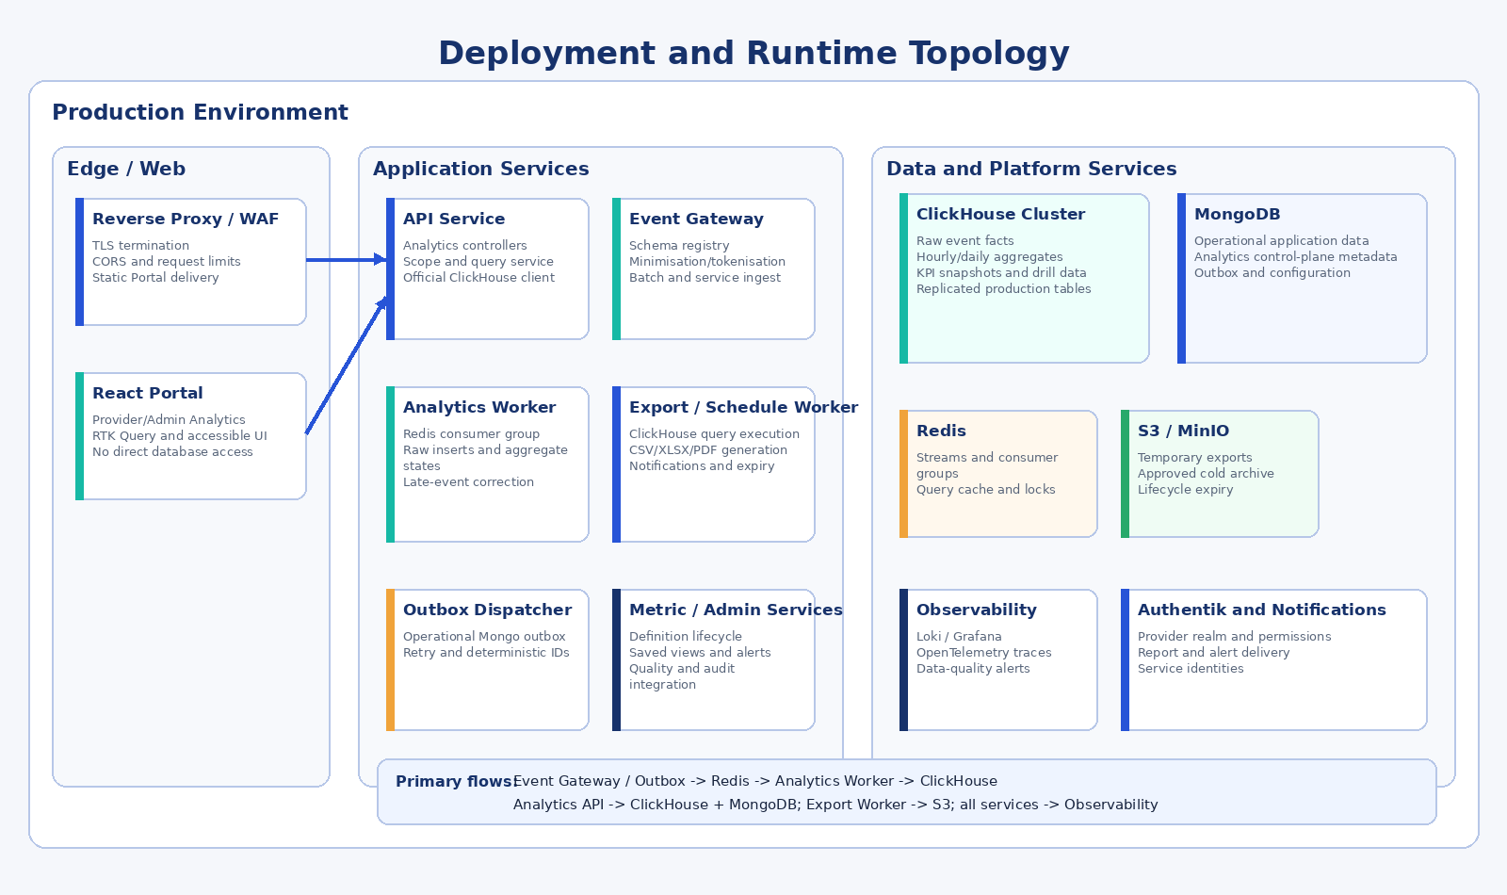
Figure 10 – Production deployment and runtime topology.

23.1 Deployable Units
Unit | Image / Process | Scale
Portal | Existing Vite build served by current web/reverse-proxy deployment. | Static horizontal delivery/CDN as configured.
API Service | Existing API image with analytics controllers, scope service and ClickHouse/Mongo repositories. | Horizontal replicas; stateless apart from external stores.
Event Gateway | May initially run in API service; separable by route/process profile. | Scale by ingest load.
Analytics Processor Worker | Same repository, dedicated start command and container. | Redis consumer-group replicas; batched ClickHouse inserts.
Outbox Dispatcher Worker | Dedicated command/container or combined with processor at low volume. | At least two replicas with distributed lease/consumer semantics.
Export/Schedule Worker | Dedicated command/container with document-generation dependencies. | Scale separately; strict CPU/memory and ClickHouse query concurrency.
ClickHouse | Dedicated `lulafi_analytics` data plane. | Single node for development; replicated/managed cluster for production; optional sharding at measured scale.
MongoDB | Operational database plus analytics control-plane collections. | Managed cluster/replica set according to environment.
Redis | Streams, consumer groups, cache and locks. | HA according to production requirement.
S3-Compatible Store | Temporary exports and optional approved cold archive. | Lifecycle expiry, versioning where required and encryption.

23.2 Docker Commands
# Illustrative package and deployment commands
npm run start # API service
npm run start:analytics-worker
npm run start:analytics-outbox
npm run start:analytics-export-worker
npm run analytics:clickhouse-migrate # Apply versioned ClickHouse DDL
# ClickHouse, MongoDB and Redis run as external/compose services with separate
# credentials, health checks, resource limits and least-privilege identities.

23.3 Health Checks
Process | Liveness | Readiness
API | Event loop/responding. | Operational/control MongoDB reachable, ClickHouse read query succeeds, Redis/configuration available for enabled route profile.
Processor | Worker loop heartbeat. | Redis stream reachable, ClickHouse insert/quorum policy healthy and metric catalogue available from MongoDB.
Outbox Dispatcher | Heartbeat. | Operational MongoDB readable/writable and Redis stream available.
Export Worker | Heartbeat. | Analytics query service, ClickHouse, object storage and temporary filesystem available.
Schedule Worker | Heartbeat. | MongoDB schedule store, lock service and notification integration available.

23.4 Backup and Recovery
- Back up MongoDB metric definitions, saved views, schedules, alert rules, export metadata, processing state, audit references and quality records according to the application backup policy.
- Back up ClickHouse schemas and governed long-retention aggregates/snapshots. Raw events may rely on TTL and replay/cold archive policy, but the recovery point must support the approved recalculation and audit window.
- Use ClickHouse `BACKUP`/`RESTORE` or the managed-service backup mechanism to approved S3-compatible storage. Outbox and Redis/processing checkpoints must be recoverable or reconstructible without double counting.
- Recovery tests restore ClickHouse tables and materialised views, MongoDB control-plane versions, provider-realm scope, lineage and export/schedule configuration; reconciliation confirms no silent duplication or omission.
- Temporary export files need not be backed up when ephemeral and reproducible. Cold archive objects, if used for raw events or aggregates, follow governed retention, encryption and restore tests.

23.5 Environment Separation
Production, staging and test use separate ClickHouse databases/clusters, MongoDB databases and credentials, Redis namespaces/instances, object-storage prefixes and event-producer credentials. The Admin UI displays the environment prominently. Production exports cannot include test data.

24. Configuration and Operational Administration

24.1 Configuration Groups
Group | Illustrative Settings
Ingestion | Batch size, payload limit, accepted clock skew, schema versions, rate limits.
Processing | Stream name/group, consumer concurrency, retry/backoff, correction windows.
Retention | ClickHouse raw-event TTL, rejection TTL, hourly/daily aggregate retention, MongoDB control metadata, export file and job retention periods.
Privacy | Default minimum cohort, prohibited dimensions, token key version, geography precision.
Queries | Maximum ranges, dimensions, cardinality, detail page size, timeout, ClickHouse max execution/rows/bytes and Redis cache TTL.
Exports | Synchronous threshold, maximum rows/bytes, file expiry, formats, recipient domains.
Schedules | Allowed frequencies, timezone, failure disable threshold.
Alerts | Evaluation frequency, cooldown, notification channels.
Quality | Freshness thresholds, reconciliation tolerances, expected-source rules.
UI | Enabled modules, default cards, published views, provider targets.

24.2 Secrets
- ClickHouse API/worker service credentials, TLS certificates and optional cluster/backup credentials
- MongoDB operational and analytics control-plane credentials
- Redis credentials/TLS material
- HMAC/tokenisation key versions
- Internal service-event signing keys
- S3 access identity and notification callback/webhook secrets
- No secret is stored in ClickHouse facts/aggregates, MongoDB saved views/jobs or export content

24.3 Administration Functions
Function | Authorised Role
Register/approve event schema | Platform technical administrator with change approval.
Create/activate metric version | Metric administrator and approver.
Run/review reconciliation | Data quality/operations administrator.
Replay period/source | Platform operations with audited reason.
Publish global saved view | Global analytics administrator.
Set provider default dashboard/targets | Provider administrator or authorised global administrator.
Cancel/export purge | Owner or authorised administrator.
Disable schedules/alerts | Owner or administrator in scope.

25. Migration and Compatibility Design

25.1 Migration Phases
Phase | Scope | Exit Condition
0 – Foundations | Create providerRealmId mapping, permission claims, analytics module skeleton, ClickHouse database/tables, MongoDB control collections, Redis stream and feature flags. | Realm mapping verified; ClickHouse DDL applied; security and connectivity tests pass.
1 – Current Form Analytics Compatibility | Transform current `AnalyticsArtifact` history into ClickHouse facts/aggregates; new gateway captures form.viewed and form.submitted; legacy endpoints delegate to the new service. | Old MongoDB totals and new ClickHouse dashboard totals reconcile within approved tolerance.
2 – Provider Dashboard | Release AnalyticsShell, time filters, KPI cards, form funnel, operations and saved views behind provider feature flag. | Provider acceptance and ClickHouse performance targets pass.
3 – Additional Domains | Instrument messaging, notifications, connectors and advertising; add domain tabs and aggregate tables. | Domain reconciliation, privacy and merge/retention tests pass.
4 – Global Admin | Add global, cohort, reliability and data-quality routes; controlled provider drill-down. | Admin security, cross-provider suppression and cluster load tests pass.
5 – Reports and Governance | Enable exports, schedules, alerts and metric catalogue administration. | Audit, expiry, formula-injection, recipient and export-isolation tests pass.
6 – Retire Legacy | Remove direct Portal use of legacy form analytics hooks and old artifact writes/routes after telemetry confirms no consumers. | Deprecation period complete; ClickHouse reconciliation and migration signed off.

25.2 Historical AnalyticsArtifact Transformation
Current Artifact | Target Event
type=form_viewed | eventName=form.viewed; provider user mapping converted to providerRealmId; form ID; occurredAt from createdAt; user agent reduced to approved device/browser class if retained.
type=form_response_submitted | eventName=form.submitted; result=success; providerRealmId and form ID; occurredAt from createdAt.
ipAddress | Not copied by default. Optional approved coarse geography is derived during one-time migration, then source value discarded.
provider ObjectId referencing User | Resolve User.provider or migration mapping to stable Provider realm; unresolved records quarantined.

25.3 Provider-Realm Backfill
- Create a provider-realm mapping from approved Provider and provider-user records.
- Identify forms and submissions currently owned by provider users.
- Backfill providerRealmId while retaining existing owner fields during transition.
- Add non-unique indexes, validate counts, then add required constraints where safe.
- Change application writes to populate providerRealmId.
- Change reads to scope by providerRealmId and compare results in shadow mode.
- Enable new analytics scope after reconciliation.

25.4 Feature Flags
Flag | Purpose
analytics_v2_capture | Enable canonical event/outbox capture while legacy artifact capture continues.
analytics_v2_provider_ui | Enable new provider analytics route implementation by provider cohort.
analytics_v2_admin_ui | Enable global Admin Analytics.
analytics_v2_exports | Enable controlled export jobs.
analytics_v2_legacy_adapter | Serve legacy endpoint from new query service.
analytics_v2_disable_legacy_write | Stop creating old AnalyticsArtifact records after reconciliation.

25.5 Rollback
Portal feature flags can return providers to the legacy Analytics page while canonical event capture and ClickHouse ingestion continue. API deployment rollback does not delete ClickHouse tables or MongoDB control records. Workers use backward-compatible event versions and versioned DDL. Metric versions are immutable; a defective version is retired and replaced, and affected ClickHouse buckets are rebuilt from retained facts or approved archive.

26. Test Design

26.1 Test Levels
Level | Coverage
Unit | Metric formula templates, time-zone boundaries, permission intersections, suppression, tokenisation, CSV escaping and query canonicalisation.
Component | React cards/charts/tables, keyboard navigation, filter drawer, dialogs and error states.
API integration | Auth, scope enforcement, query validation, pagination, exports, saved views, schedules and metric catalogue.
Data pipeline | Outbox dispatch, duplicate/late events, Redis worker retry, batched ClickHouse insert, materialised-view update, partition rebuild, replay and checkpoints.
Reconciliation | Controlled source totals against ClickHouse facts, aggregates, dashboard responses and exports.
Security | Cross-provider access, ID substitution, filter injection, export bypass, formula injection, signed URL expiry and service credential mismatch.
Performance | Dashboard p95, drill p95, concurrent ClickHouse queries, ingest throughput, insert batch size, active parts/merge pressure, stream lag and export isolation.
Accessibility | WCAG 2.2 AA keyboard, focus, semantics, chart alternatives, contrast and responsive design.
Resilience | Redis/ClickHouse/MongoDB/object-storage interruptions, partial source failure, worker restart and recovery without double counting.

26.2 Controlled Event Fixtures
The test suite contains deterministic event fixtures for each metric. Fixtures explicitly include duplicates, late events, daylight-boundary events, zero denominators, small cohorts, missing sources, version transitions and provider-realm overlaps. Expected numerator, denominator, quantiles and quality states are stored with the fixture.

26.3 Critical Security Scenarios
Scenario | Expected Result
Provider changes providerRealmId in request | Ignored or rejected; response remains current realm only.
Provider requests another provider form ID | Generic not-found/forbidden response; no existence disclosure; security audit.
Admin without provider-detail permission drills to provider | Aggregate/cohort remains available; named provider list/detail denied.
Export job owner loses permission before execution | Job fails/cancels; no file generated.
Saved view contains now-restricted dimension | Restricted filters removed/rejected with explanation.
Low-volume filter combination | Suppressed in dashboard, API and export.
Operational link opened without Forms permission | Operational module denies access independently.

26.4 Acceptance Test Mapping
Acceptance Area | Primary Evidence
Provider isolation | Automated two-provider end-to-end test, ClickHouse query inspection and MongoDB control-plane inspection.
Global access | Admin permission matrix and cohort/provider drill tests.
Time and comparison | Boundary and timezone fixture tests.
KPI correctness | Metric fixture reconciliation and catalogue version evidence.
Drill-down privacy | Prohibited-content and field-level access tests.
Exports | Scope match, metadata, formula protection, expiry and audit.
Event reliability | Duplicate, late, restart and replay tests.
Performance | Approved load-test report.
Accessibility | WCAG audit report.
Audit | Access/export/definition/change records and tamper-evidence review.

27. Requirements Traceability and Acceptance
SRS Requirement Area | Design Component | Verification Evidence
ANL-UI-001, ANL-PROV-001, ANL-ADM-001 | Sections 7–10: left-nav items, routes, AnalyticsShell and provider/Admin mockups. | Navigation role/permission E2E tests.
ANL-TIME-001–009 | Sections 7.4, 8.2, 14.3, 15.3 and screen filter bars. | Time-zone and preset test fixtures.
ANL-FLT-001–008 | Sections 10.5 and 18.1; context endpoint and allow-listed filter descriptor. | Filter permission and suppression tests.
ANL-DRL-001–009 | Sections 10.3–10.4 and 18; signed drill descriptor and operational re-authorisation. | Drill path, breadcrumb and security tests.
ANL-PROV / FRM / WKF / CHT / NTF / SRC / CON | Sections 9 and 12–15; domain events, metric snapshots and provider modules. | Domain fixtures and reconciliation tests.
ANL-ADM / OPS | Sections 9, 10.2, 14–16 and 21. | Global/cohort/operations permission and reliability tests.
ANL-KPI-001–009 and KPI-001–053 | Sections 13–15; metric catalogue, supported calculation types and versioned snapshots. | Metric catalogue inspection and formula test suite.
ANL-ADV-001–009 | Provider/Admin Advertising module, event taxonomy and metric engine. | Controlled ad measurement fixtures.
ANL-RPT-001–011 | Sections 10.6 and 19. | Export, schedule, recipient and alert tests.
ANL-API-001–010 | Section 15 and event gateway design. | API contract, rate-limit, idempotency and audit tests.
ANL-DAT-001–012 | Sections 12–14 and 21. | Schema, late-event, retention, lineage and environment tests.
ANL-SEC / ANL-PRV | Sections 16–17. | Security/privacy test report.
ANL-NFR-001–025 | Sections 8.6, 20–23 and 26. | Performance, resilience, accessibility, deployment and observability evidence.

27.1 Design Acceptance Criteria
- Provider and Admin Analytics launch from the Portal left navigation and use the current Portal layout/theme.
- Provider scope is derived server-side from a stable provider realm and is enforced in every query/export.
- Global Admin access is permission controlled and small cohorts are suppressed.
- Common time, comparison and filter state is consistent across cards, charts, tables, drill-downs and exports.
- Metric results include definition version, numerator/denominator where applicable, freshness and quality.
- Canonical events are validated, idempotent and inserted into ClickHouse without blocking transactional functions; MongoDB control-plane state remains consistent.
- Dashboard performance meets SRS targets under the approved load profile.
- Exports are asynchronous when required, expire and are fully audited.
- Screen implementation passes accessibility assessment and chart data is available in table form.
- ClickHouse facts, aggregate states, TTL, backup/restore and production topology pass the approved load, resilience and recovery tests.
- Migration reconciles legacy form analytics before legacy writes/routes are retired.

28. Implementation Plan

28.1 Work Packages
WP | Work Package | Principal Outputs
WP-01 | Realm and Permission Foundation | providerRealmId schema/backfill, Authentik claims, permission guards and security tests.
WP-02 | Analytics Data and Control Core | ClickHouse DDL/migrations, event/aggregate repositories, MongoDB metric catalogue/control collections, query service, context endpoint and audit extensions.
WP-03 | Event Pipeline | Outbox, gateway, schema registry, Redis Streams, batched ClickHouse processor, rejection handling and checkpoints.
WP-04 | Portal Shell | Admin/provider routes, left-nav permissions, filter bar, status strip, reusable cards/charts/tables.
WP-05 | Provider Forms and Operations | Form journey instrumentation, snapshots, provider dashboard, funnel and workflow/SLA views.
WP-06 | Messaging, Notifications and Connectors | Adapters, metrics and provider tabs.
WP-07 | Global Admin and Reliability | Global/cohort dashboards, provider drill, platform and data-quality views.
WP-08 | Advertising and Commercial | Campaign, viewability, conversion, usage and authorised revenue-share metrics.
WP-09 | Reports and Alerts | Saved views, export worker, schedules, alert rules and object storage.
WP-10 | Migration and Hardening | Historical ClickHouse load, reconciliation, partition/retention tuning, backup/restore, load/security/a11y tests, runbooks and legacy retirement.

28.2 Recommended Delivery Order
- Provider-realm and permission foundation.
- ClickHouse data plane, MongoDB control plane, event and metric core with current form-view/submission compatibility.
- Portal AnalyticsShell and provider overview/form funnel.
- Workflow/SLA and report/export foundation.
- Messaging, notification and connector analytics.
- Global Admin, platform reliability and data quality.
- Advertising/commercial analytics and advanced schedules/alerts.
- ClickHouse performance/retention hardening, backup and recovery, accessibility, migration completion and legacy retirement.

28.3 Definition of Done per Module
- Approved events and metric definitions registered.
- Unit, integration, security, privacy and accessibility tests passing.
- Source totals reconcile within approved tolerance.
- Data freshness and quality visible.
- Provider/global scope tested with overlapping identifiers.
- Operational dashboards and alerts available.
- Runbook, configuration and rollback documented.
- SRS traceability and acceptance evidence updated.

29. Risks, Assumptions and Open Decisions

29.1 Design Risks
Risk | Impact | Mitigation
Provider-user ownership is embedded in current schemas | Cross-user provider aggregation and isolation may be incorrect. | Make providerRealmId migration a prerequisite; shadow-query and reconcile.
Incomplete event instrumentation | Metrics appear incomplete or misleading. | Coverage metadata, phased release and source control totals.
High dimension cardinality | Snapshot explosion and slow queries. | Approved dimension combinations, top-N, query cost limits and periodic capacity review.
Offline/late mobile events | Recent metrics may change after first display. | Correction windows, freshness labels and stable event IDs.
Export used to exfiltrate data | Privacy/security exposure. | Permission recheck, row/field controls, expiry, audit and unusual-export alerts.
Metric definitions change silently | Loss of comparability and trust. | Immutable versions, effective dates and visible annotations.
Redis stream outage | Processing delay. | Durable outbox, retries, health alerts and replay.
Provider source outcomes unavailable | Workflow metrics incomplete. | Provider outcome events, coverage disclosure and reconciliation agreements.
ClickHouse partition, ORDER BY or materialised-view design is poorly tuned | Excessive scans, active parts, merge pressure or slow dashboards. | Use representative load tests, query logs, active-part thresholds, approved dimension combinations and controlled DDL/version review.
Insufficient ClickHouse operational capability | Recovery, upgrades or production incidents may take longer. | Select managed ClickHouse or establish trained ownership, runbooks, backup/restore drills, monitoring and supported release policy.

29.2 Assumptions
- Authentik or the identity layer can issue provider-realm and permission claims.
- Provider Take-On establishes one stable realm per provider organisation.
- Source services can emit governed events and stable entity/correlation identifiers.
- A supported ClickHouse service is available for each environment, with production replication or managed high availability, TLS, monitoring and backup/restore.
- MongoDB remains available for operational data and analytics control-plane collections; Redis is available with persistence/availability suitable for stream coordination.
- Object storage and notification services are available for reports.
- Metric owners approve definitions and targets before production activation.

29.3 Open Decisions Requiring Governance
Decision | Required Owner / Outcome
Canonical provider realm mapping where one current provider user has created forms for multiple organisational entities. | Product/architecture and data migration owner.
Default raw-event retention by domain and applicable legal/contractual retention. | Privacy, legal and product owner.
Minimum cohort threshold by metric and dimension. | Privacy and analytics governance.
Which provider roles may see pseudonymous supporting metadata. | Provider access governance.
Initial metric refresh targets per domain. | Product and platform operations.
Approved advertising viewability and invalid-traffic rules. | Advertising product/legal/measurement owner.
Whether provider-published report recipients must be platform users only or may include approved external addresses. | Security/privacy/product owner.
ClickHouse deployment model: managed service, self-hosted replicated cluster or approved hybrid; initial shard/replica and recovery objectives. | Architecture, platform operations, security and commercial owner.
ClickHouse raw/hourly/daily retention and whether older facts/aggregates are archived to S3-compatible storage. | Privacy, legal, product, finance and platform operations.

30. Glossary and References

30.1 Glossary
Term | Definition
AnalyticsAccessContext | Server-resolved user, realm, permission, organisation, geography, environment and detail scope.
Correction window | Period during which late events may recalculate a published metric bucket.
Dimension signature | Canonical representation of a snapshot’s grouped dimension values.
Event gateway | Service that authenticates, validates, minimises and accepts analytics events.
Metric snapshot | Pre-calculated governed metric value for a scope, period and dimension set.
Outbox | Durable operational record indicating an event must be dispatched after a business transaction.
Provider realm | Stable provider tenancy/security boundary, independent of an individual provider user account.
Scope hash | Server-generated representation of the authorised analytical scope used for cache/job integrity.
Suppression | Withholding a result to protect privacy or because volume is below an approved threshold.
Analytics control plane | MongoDB-held definitions and mutable operational metadata governing analytics behaviour, jobs, schedules, alerts and processing state.
Analytics data plane | ClickHouse-held event facts, aggregate states, KPI snapshots and authorised drill-down data used to answer analytical queries.
Aggregate state | Mergeable intermediate representation used by ClickHouse aggregate functions for counts, distinct counts, sums or quantiles across buckets.
Materialised view | ClickHouse insert-time transformation that writes approved aggregate data to a target table; controlled rebuilds remain necessary for late corrections or source changes.

30.2 References
Ref | Reference
R1 | lulaFi Analytics System Requirements Specification, LULAFI-SRS-ANL-001, Version 1.0, 4 July 2026.
R2 | lulaFi Requirements Product Requirements Document, PRD v0.2, 18 May 2026.
R3 | Supplied lulafi-portal-dev source package, inspected 4 July 2026.
R4 | Supplied lulafi-api-dev source package, inspected 4 July 2026.
R5 | Supplied lulafi-mobile-dev source package, inspected 4 July 2026.
R6 | ISO/IEC 25010:2023 product quality model.
R7 | ISO/IEC 25012 data quality model.
R8 | ISO/IEC 27001 information security management requirements.
R9 | WCAG 2.2 Level AA.
R10 | OpenTelemetry semantic conventions and SRE SLI/SLO practices referenced by the SRS.
R11 | ClickHouse Documentation: MergeTree family, primary/sorting keys, partitions and data modelling.
R12 | ClickHouse Documentation: Materialized Views and incremental aggregation.
R13 | ClickHouse Documentation: TTL rules for data retention and movement.
R14 | ClickHouse Documentation: Official JavaScript/TypeScript client (`@clickhouse/client`).
R15 | ClickHouse Documentation: BACKUP and RESTORE operations and managed-service backup guidance.

Appendix A – Portal Route and Component Map
Existing File / Element | Target Change
src/layouts/MainLayout.tsx | Retain provider Analytics item; add admin Analytics item; add requiredPermission filtering and selected nested-route logic.
src/routes/index.ts | Add adminAnalytics and nested analytics route builders.
src/main.tsx | Register provider/admin AnalyticsShell nested routes under existing ProtectedComponent role gates and new permission guard.
src/pages/provider/Analytics/index.tsx | Replace basic page with compatibility re-export or redirect to new ProviderOverviewPage.
src/services/api/form.ts | Retain legacy analytics hooks temporarily; migrate consumers to analytics.ts.
src/services/api/index.ts | Add Analytics tags for context, metrics, views, exports, schedules and definitions.
src/types/index.ts | Move analytics contracts into analytics.types.ts and export public types.
src/components/ProtectedComponent | Extend or compose with PermissionGuard; role remains broad first gate.
src/styles/index.ts | No new theme required; use current primary blue, teal accent and neutral surfaces.

Appendix A.1 Recommended Navigation Configuration
type NavigationItem = {
id: string;
label: string;
path?: string;
icon: ReactNode;
allowedRoles: TUserType[];
requiredPermission?: AnalyticsPermission;
subItems?: NavigationItem[];
};
const canRender = allowedRoles.includes(user.type) &&
(!requiredPermission || permissions.includes(requiredPermission));

Appendix B – API Payload Examples

B.1 Batch Event Ingestion Request
POST /api/v1/analytics/events/batch
{
"events": [
{
"eventId":"evt_01J...",
"eventName":"form.started",
"eventVersion":1,
"occurredAtUtc":"2026-07-04T10:01:00Z",
"sessionIdToken":"client_session_token",
"entity":{"type":"form","id":"f_100","version":4},
"sourceComponent":"mobile",
"dimensions":{"channel":"mobile","deviceClass":"phone"}
}
]
}
202 Accepted
{"accepted":1,"rejected":0,"batchId":"batch_...","correlationId":"corr_..."}

B.2 Overview Request
GET /api/v1/analytics/overview
?start=2026-06-01T00:00:00%2B02:00
&end=2026-07-01T00:00:00%2B02:00
&timeZone=Africa%2FJohannesburg
&compare=previous_period
Provider realm is not supplied by a provider client; it is resolved from identity.

B.3 Export Job
POST /api/v1/analytics/exports
{
"savedViewId":"view_...",
"format":"xlsx",
"includeDefinitions":true
}
202 Accepted
{"jobId":"exp_...","status":"queued","estimatedClass":"medium","correlationId":"corr_..."}

Appendix C – Analytics Data Store Dictionary
Store / Object | Key Fields | Security / Quality Notes
ClickHouse analytics_events_raw | eventId, eventName/version, occurredAt, providerRealmId, actor/session tokens, source, entity, result, dimensions | No content payload; realm mandatory for provider facts; deterministic event ID; raw TTL.
ClickHouse analytics_metrics_hourly | metric/version, environment, providerRealmId, bucketStart, dimensions, aggregate states, sampleCount | Approved dimension combinations only; mergeable states; correction-window rebuild.
ClickHouse analytics_metrics_daily | metric/version, environment, providerRealmId, bucketStart, dimensionSignature, aggregate states | Long-range dashboards and exports; daily retention/archival policy.
ClickHouse analytics_metric_snapshots | scopeKey, metric/version, bucket, timeZone, dimensions, value/states, numerator, denominator, coverage, quality, lineage | Scope key mandatory; query includes server-derived realm/global predicate.
MongoDB analytics_metric_definitions | metricId/version, formula template, storage/query plan, sources, dimensions, suppression, effective dates, status | Immutable active versions; approval and change audit.
MongoDB analytics_saved_views | owner, scope, route, panels, filter descriptor, visibility | Filters revalidated on open; no arbitrary SQL/columns.
MongoDB analytics_export_jobs | owner, scopeHash, query descriptor, format, status, storage reference, expiry, row count | Permission recheck at execution/download; signed URL expiry.
MongoDB schedules / alert rules | owner, savedView/metric, recurrence or threshold, timeZone, recipients, cooldown, status | Owner and recipient validation; no arbitrary code.
MongoDB processing / quality state | consumer checkpoints, replay ranges, correction jobs, source/period controls, variance, status | Feeds quality badges, recovery and audited reprocessing.
Operational MongoDB analytics_outbox | deterministic eventId, transaction/entity reference, status, attempts, nextAttemptAt | Committed with business action where supported; deleted/archived after acknowledgement.

Appendix D – Indicative Permission Matrix
Capability | Provider Viewer | Provider Analyst | Provider Admin | Provider Executive | Support | Global Analyst | Platform Admin
View provider overview | Yes | Yes | Yes | Yes | Assigned | Global aggregate | Yes
Provider drill-down | No/assigned | Yes | Yes | Assigned | Assigned | With provider-detail | Yes
Pseudonymous detail | No | Assigned | Yes | Assigned | Assigned | With sensitive-detail | Yes
Export provider analytics | No/optional | Yes | Yes | Optional | Assigned | With export | Yes
Publish provider views | No | No | Yes | No | No | No | Override only
Schedule provider reports | No | Optional | Yes | No | Assigned | No | Override only
View cross-provider cohorts | No | No | No | No | Assigned aggregate | Yes | Yes
View provider rankings | No | No | No | No | No | Restricted | Yes
View platform SLOs | No | No | Summary optional | No | Yes | Optional | Yes
View data quality | Status only | Status only | Status only | Status only | Assigned | Summary | Yes
Manage metric catalogue | No | No | No | No | No | No | Yes
Access logs/traces | No | No | No | No | Assigned | No | Operations permission

Appendix E – Implementation Backlog
ID | Type | Item | Description | Priority
ANL-001 | Epic | Provider realm migration | Create stable providerRealmId and backfill forms/submissions/events. | Critical
ANL-002 | Feature | Analytics permission claims | Add Authentik claims and PermissionGuard. | Critical
ANL-003 | Feature | Analytics context endpoint | Return resolved scope, modules, dimensions and time zones. | High
ANL-004 | Feature | Canonical event gateway | Validate, minimise and accept event batches. | Critical
ANL-005 | Feature | Outbox and dispatcher | Durable business-event delivery. | Critical
ANL-006 | Feature | ClickHouse analytics processor | Consume Redis events, batch-insert raw facts, update aggregate states/materialised views and persist checkpoints idempotently. | Critical
ANL-007 | Feature | Metric catalogue | Versioned definitions and approval lifecycle. | High
ANL-008 | Feature | Provider AnalyticsShell | Left-nav launch, routes, filters and status strip. | Critical
ANL-009 | Feature | Provider overview dashboard | KPI cards, trends, funnel and workload. | High
ANL-010 | Feature | Form analytics drill-down | Version, journey stage and dimension breakdown. | High
ANL-011 | Feature | Workflow/SLA analytics | Backlog, turnaround, risk and detail metadata. | High
ANL-012 | Feature | Messaging analytics | Conversation and delivery metadata. | Medium
ANL-013 | Feature | Notification analytics | Delivery/open/action and failure classes. | Medium
ANL-014 | Feature | Connector analytics | Success, error, latency and usage. | Medium
ANL-015 | Feature | Global Admin dashboard | Global/cohort/provider drill and left-nav item. | High
ANL-016 | Feature | Platform reliability | SLIs, SLOs, incidents and diagnostics. | High
ANL-017 | Feature | Data quality dashboard | Freshness, completeness and reconciliation. | High
ANL-018 | Feature | Saved views | Personal and published views. | Medium
ANL-019 | Feature | Export worker | CSV/XLSX/PDF, storage, expiry and audit. | High
ANL-020 | Feature | Schedules and alerts | Recurring reports and threshold alerts. | Medium
ANL-021 | Task | Legacy adapter and migration | Serve old contracts from new query service and transform history. | High
ANL-022 | Task | Security/a11y/performance hardening | Complete acceptance evidence. | Critical
ANL-023 | Feature | ClickHouse data plane foundation | Provision environments; implement versioned DDL, partitions, ORDER BY keys, materialised views, TTL, users/roles and repositories. | Critical
ANL-024 | Task | ClickHouse backup, recovery and capacity runbook | Configure backup/restore, retention/archive, active-parts/merge alerts, query limits and recovery tests. | High

End of Document
This document is controlled. Printed or exported copies are uncontrolled unless explicitly marked otherwise.

