Shared Parking
Screen Captures
Dark Mode — Sarah (Owner Role)
07 April 2026

Table of Contents
01. Login Page
02. My Requests
03. New Request
04. Requests View
05. Pending Requests
06. Approvals
07. Parking Status
08. Lot Calendar
09. My Lots
10. Notification Windows

01. Login Page
Sign-in screen with demo account quick-fill tags for fast switching between roles.
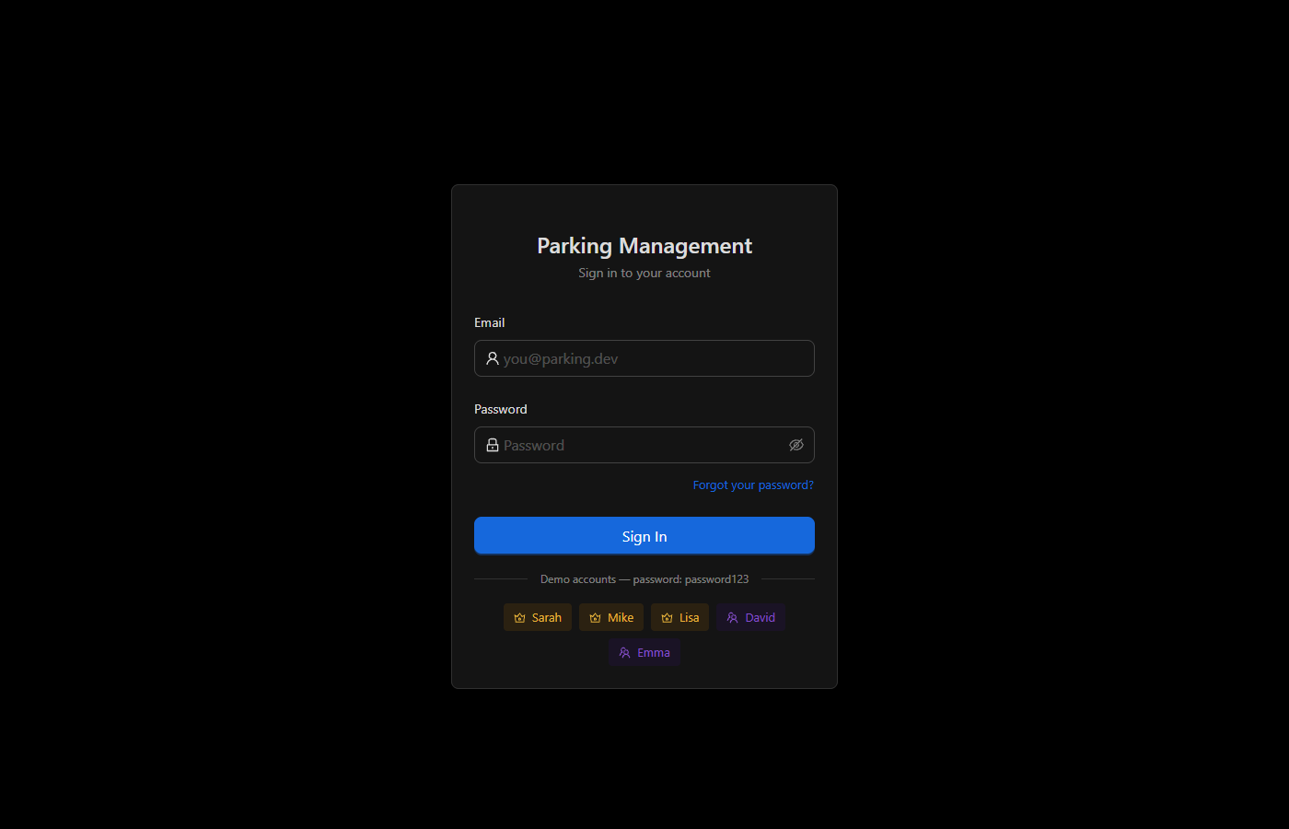

02. My Requests
Displays the current user's active parking requests with status tags, time slots, and cancel actions.
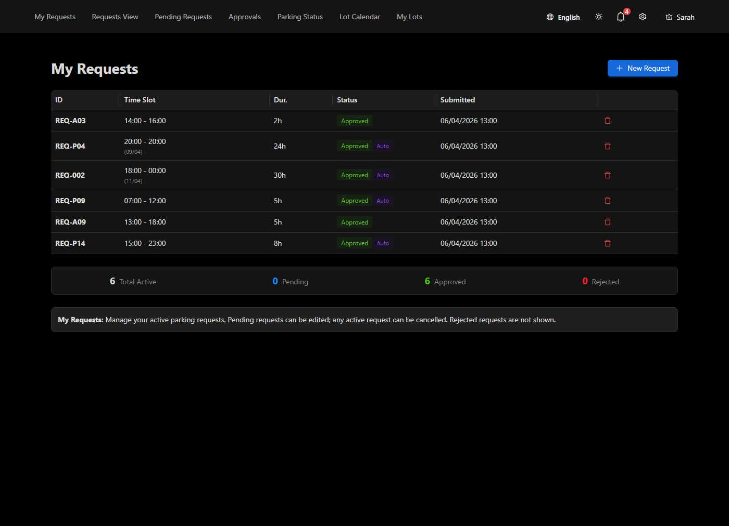

03. New Request
Form to submit a new parking request with date, time, and duration fields.
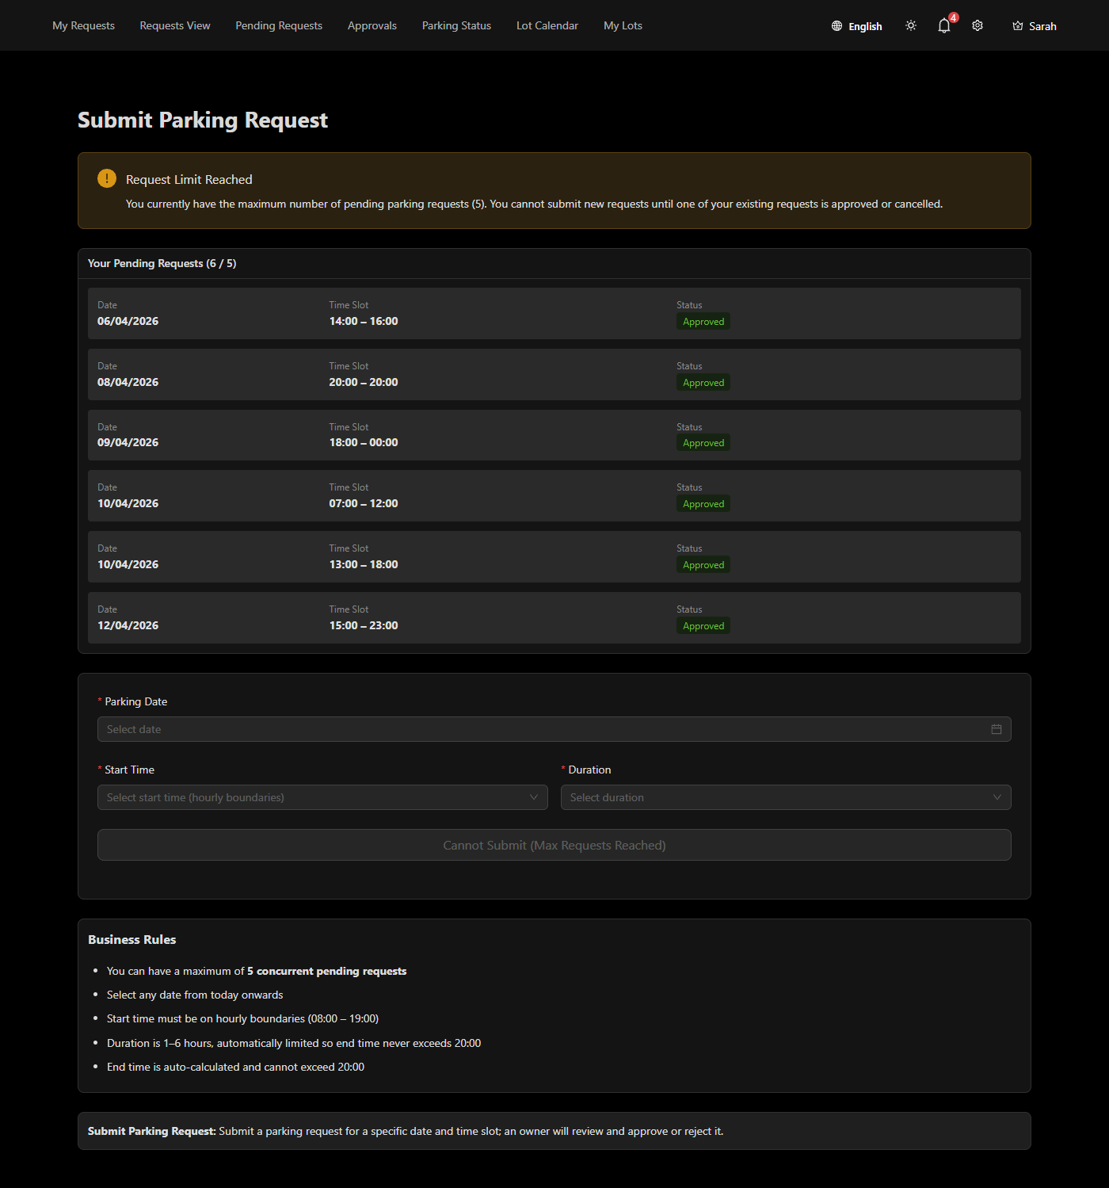

04. Requests View
Calendar view showing all requests across the system in day, week, or month layout.
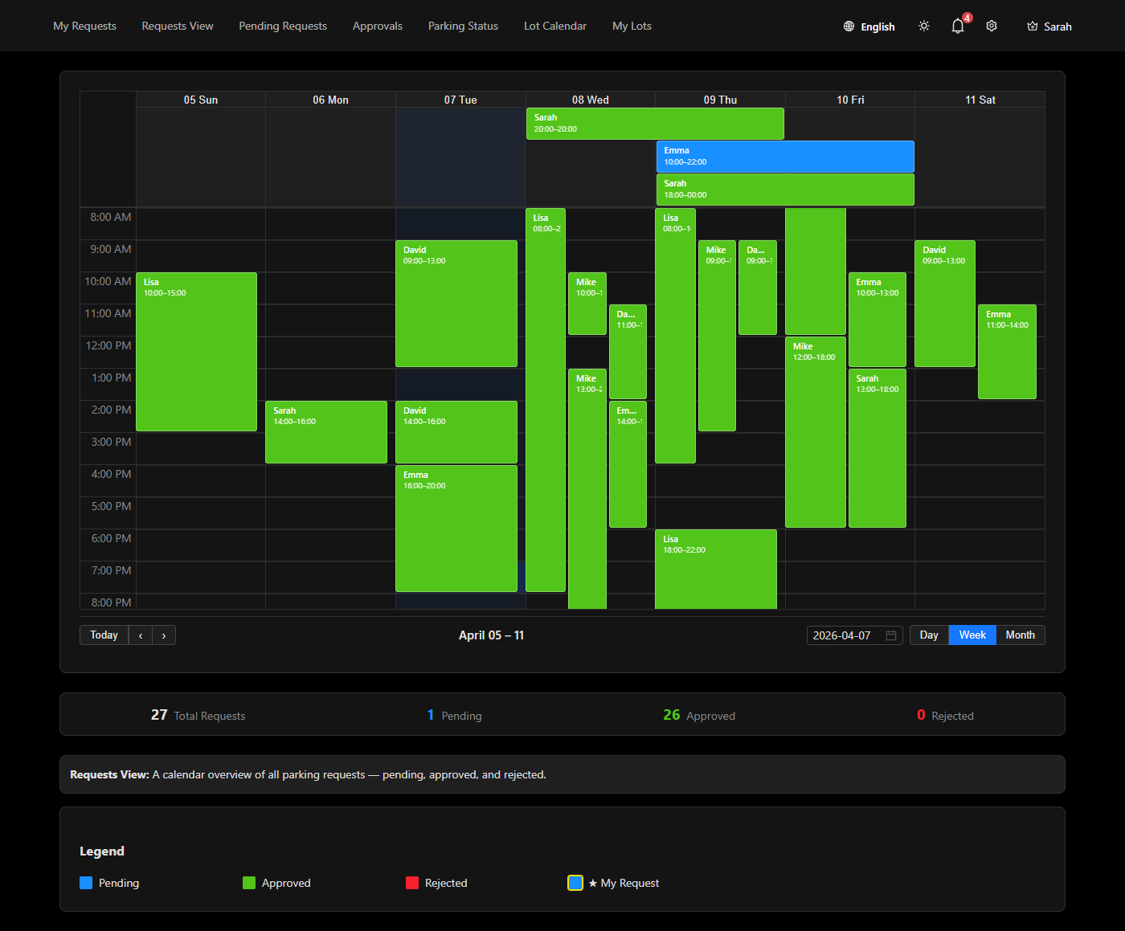

05. Pending Requests
List of pending requests awaiting owner or manager approval, with filter controls.
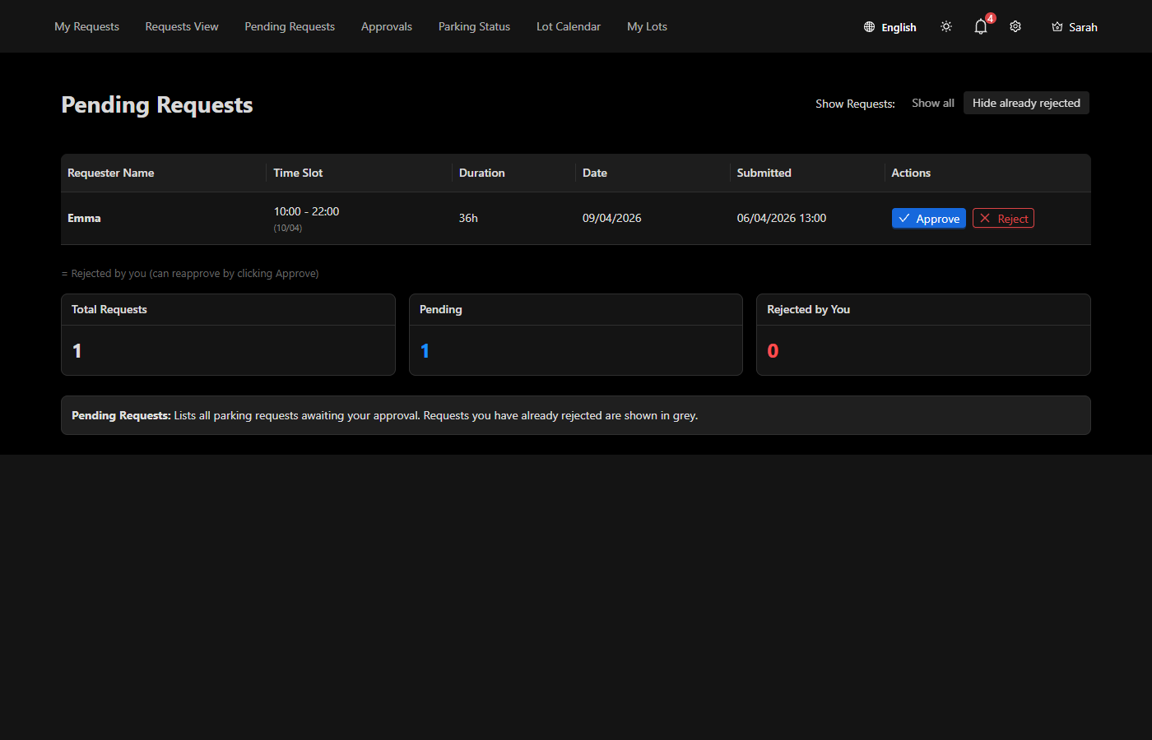

06. Approvals
Approval history showing approved and rejected requests with lot assignment details.
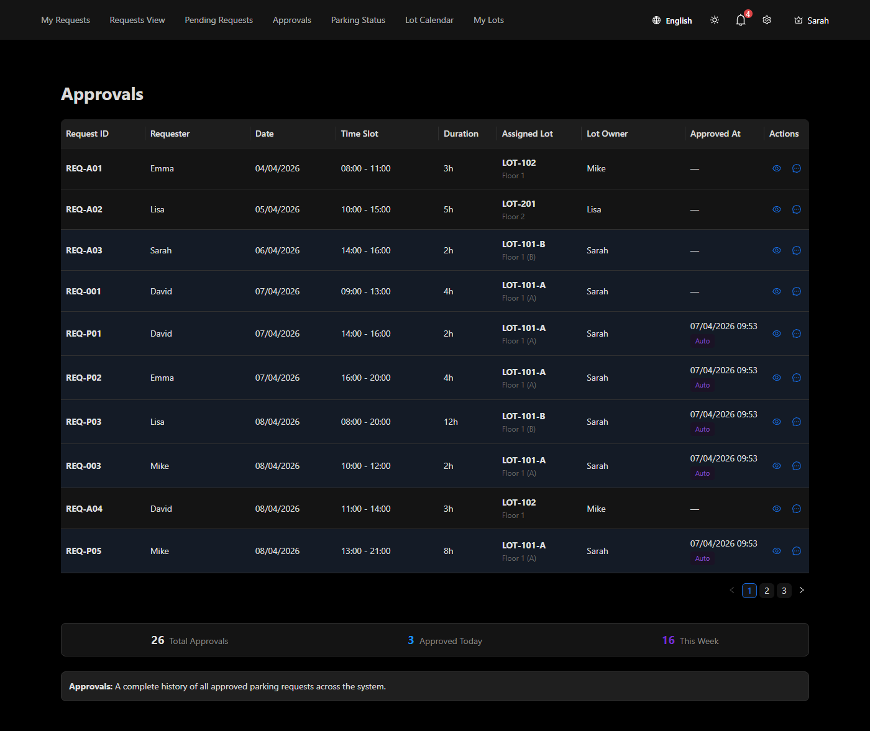

07. Parking Status
Real-time lot occupancy board with datetime picker to view status at any point in time.
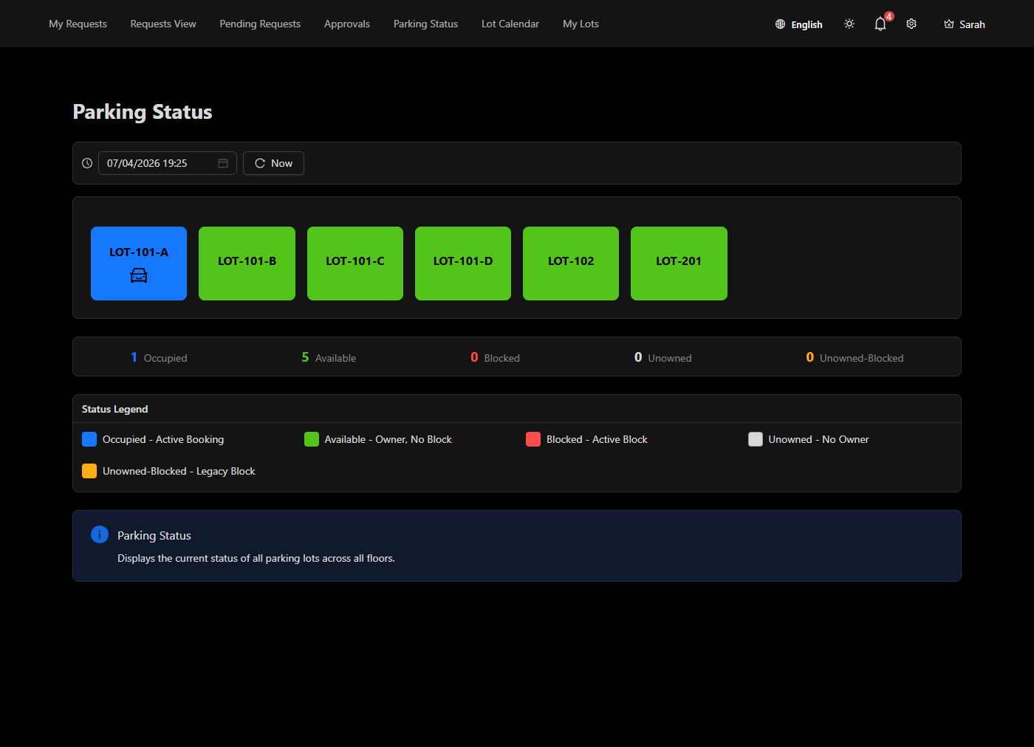

08. Lot Calendar
Owner's calendar view of lot bookings, pending requests, blocked periods, and available slots.
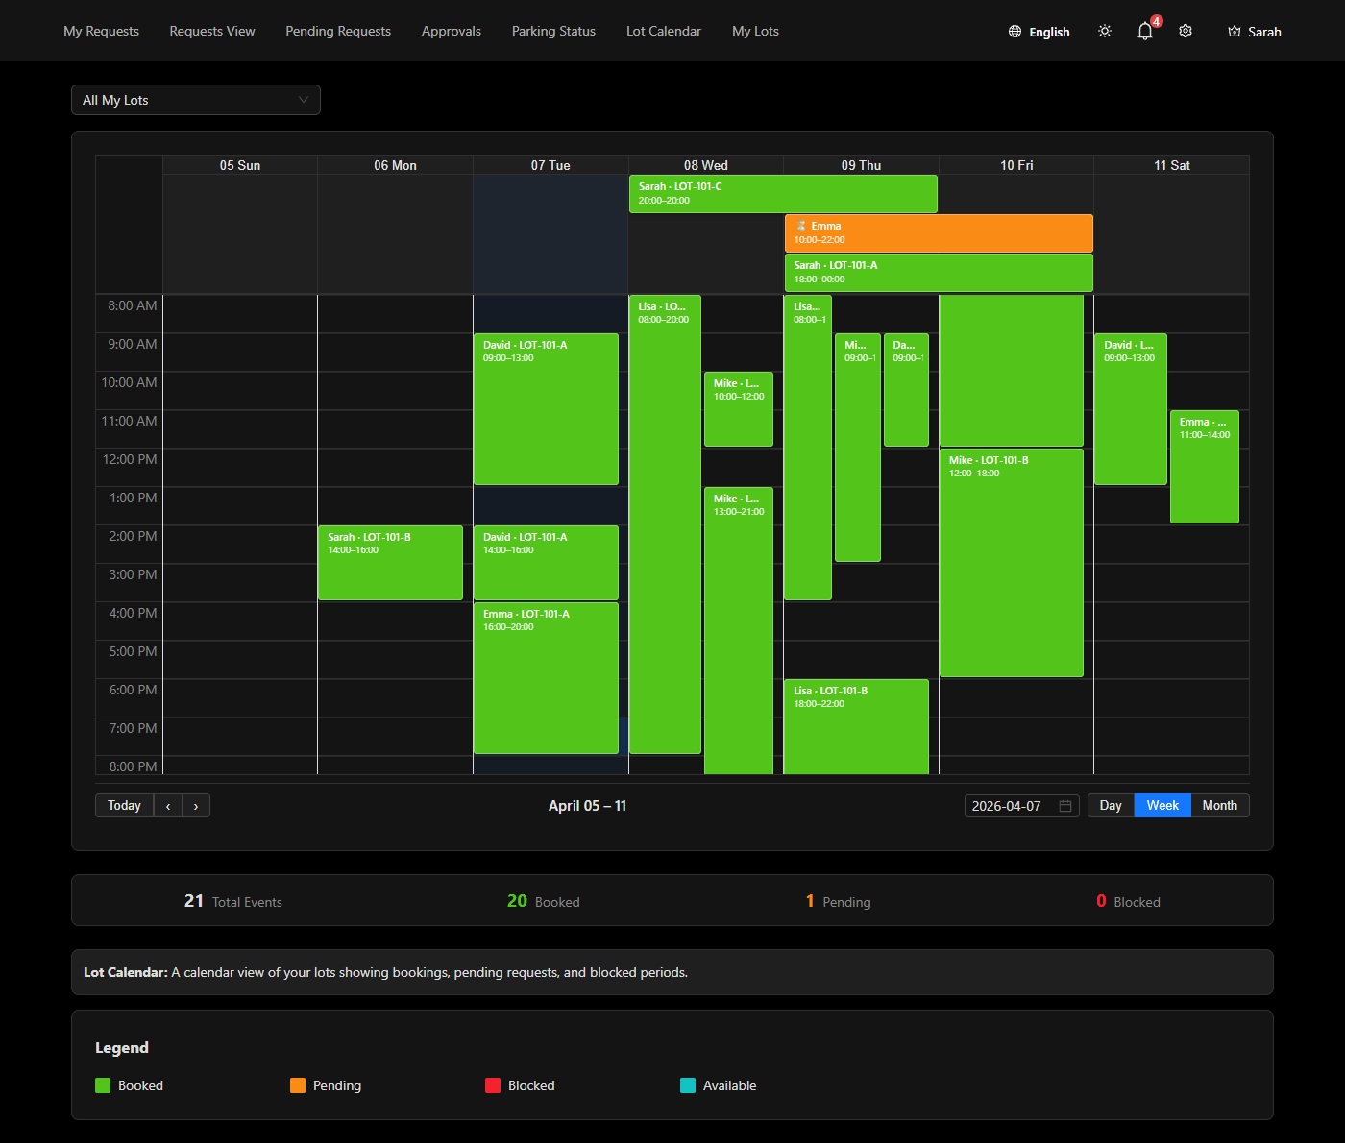

09. My Lots
Owner's lot management screen for viewing and configuring owned parking lots.
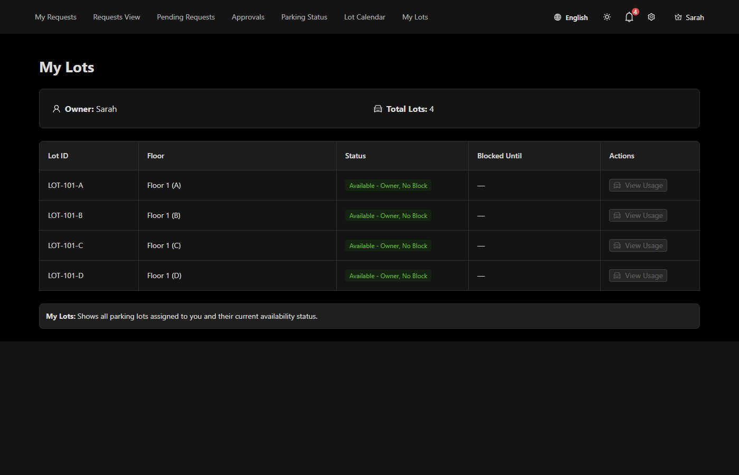

10. Notification Windows
Notification preference configuration for managing alert time windows.


