Parking Management System
Application Screen Review
Dark Mode — March 2026

1. Login
The login screen greets unauthenticated users. Quick-fill tags let reviewers sign in as User, Owner or Manager instantly using the demo accounts (password: password123).
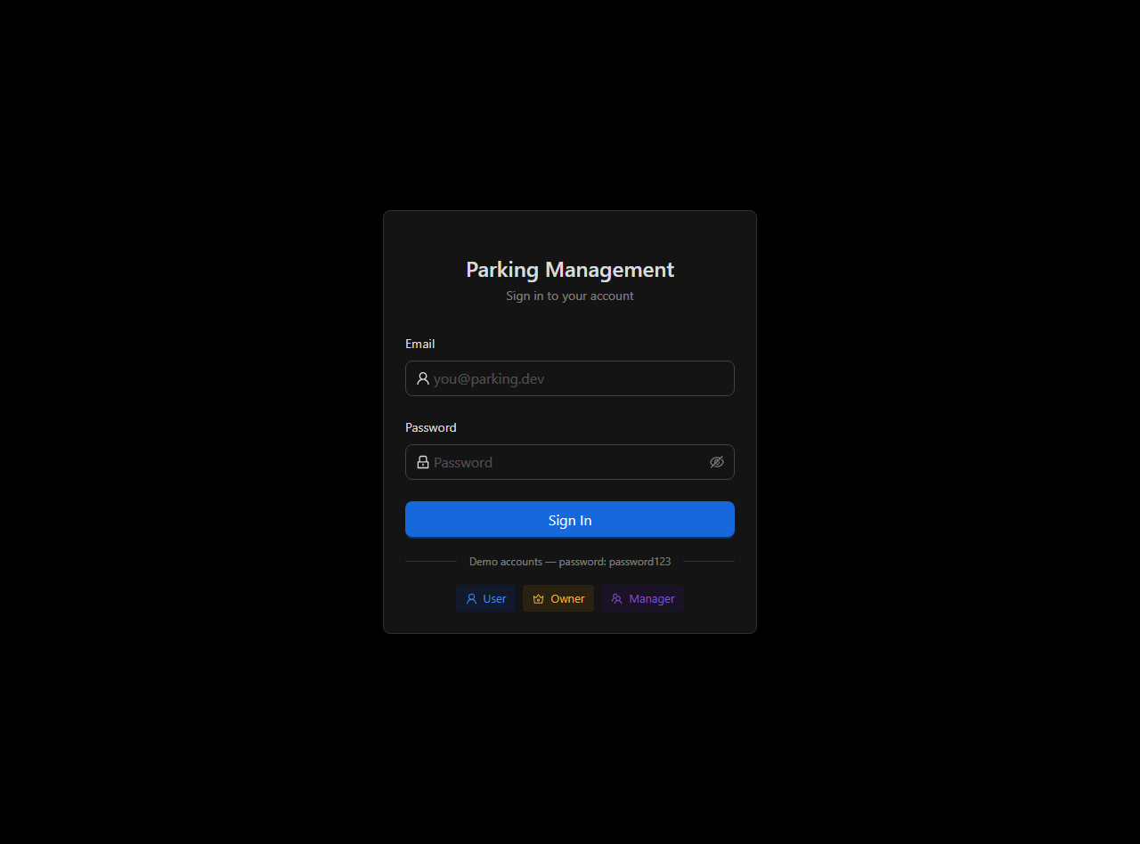

2. My Requests
Role: User
Lists the current user's active parking requests (pending + approved). On mobile the table switches to a card layout. Pending requests can be edited; any request can be cancelled. Stats cards at the bottom summarise totals.
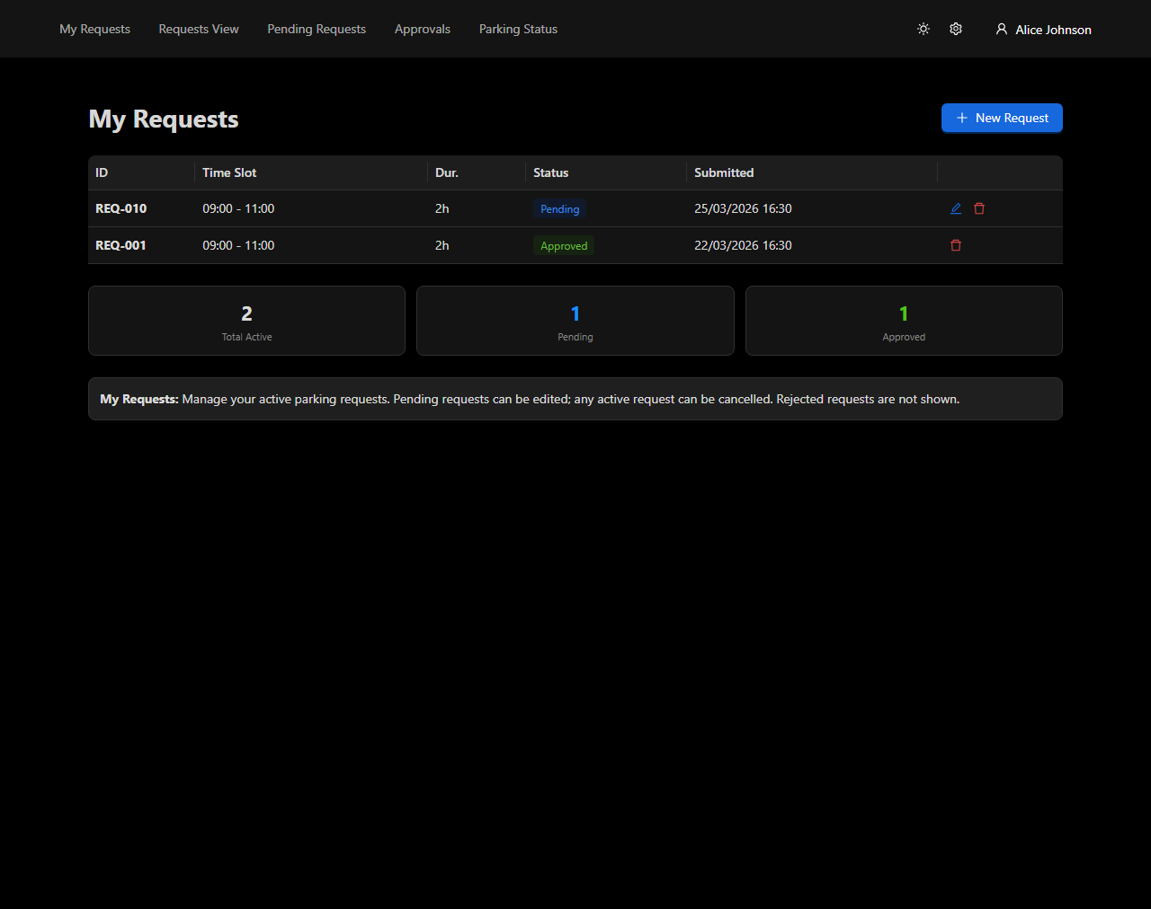

3. New Request
Role: User
Form for submitting a new parking request. Shows the user's active requests (max 3) with real-time status badges. Duration options are dynamically filtered so the end time never exceeds 20:00. Business rules are summarised in an info card at the bottom.
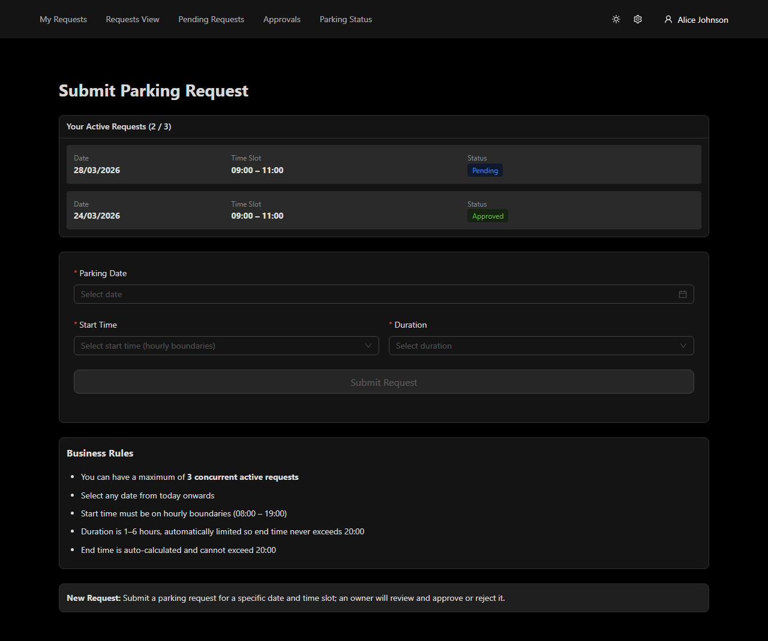

4. Requests View (Calendar)
Role: User
A react-big-calendar showing all requests across the system. The current user's own events are starred. Default view is Day on mobile, Week on desktop. Stats cards below show total, pending, approved and rejected counts.
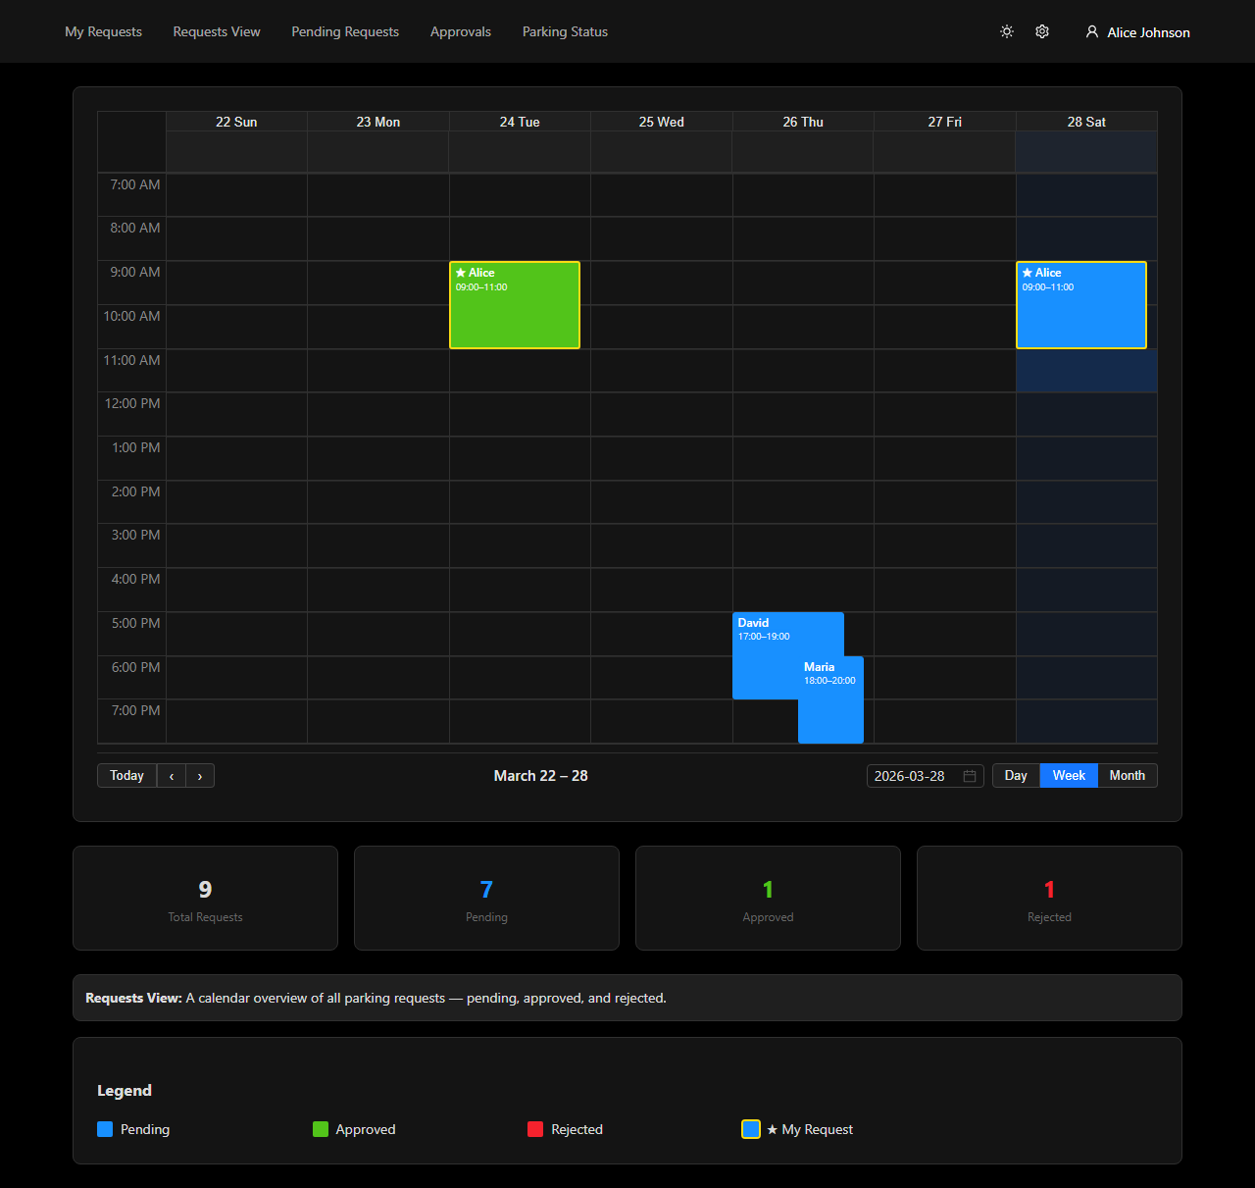

5. Request Detail
Role: User
Detailed view of a single request showing full metadata and — for approved requests — assigned lot, floor, owner and approval timestamp. A live message thread below allows the requester and the lot owner to communicate. Messages are persisted server-side with 7-day audit retention.
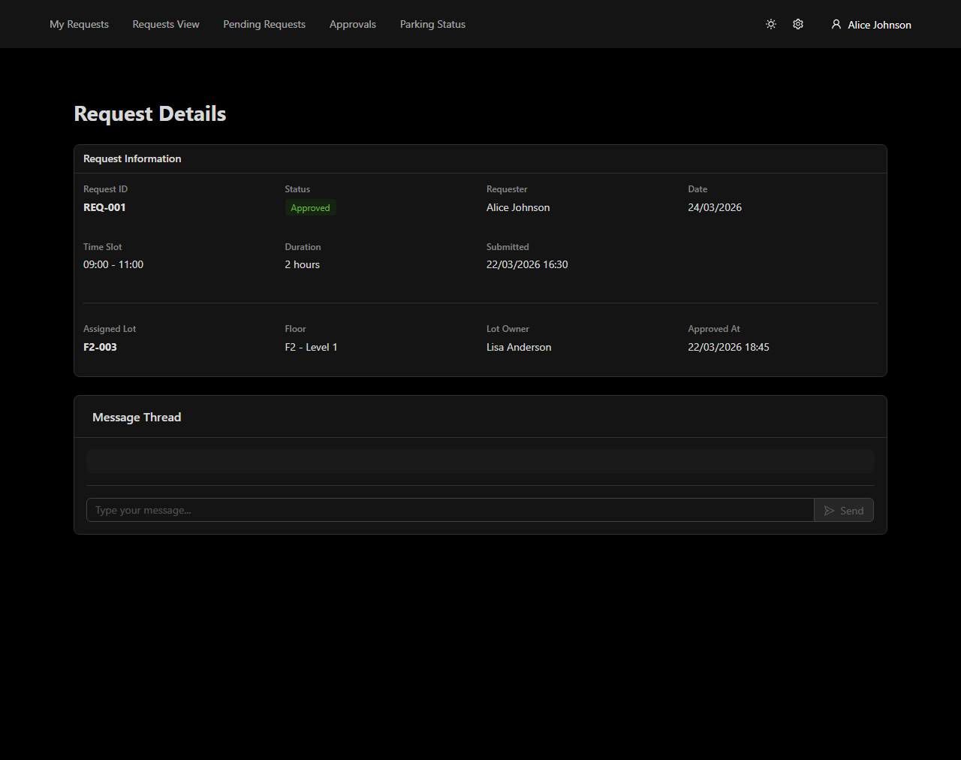

6. Pending Requests
Role: Owner
Lists all requests awaiting approval. Owners see Approve / Reject action buttons; the owner's own requests are tagged "(You)". A toggle hides previously rejected requests. Time-conflict detection prevents approving overlapping slots on the same lot.
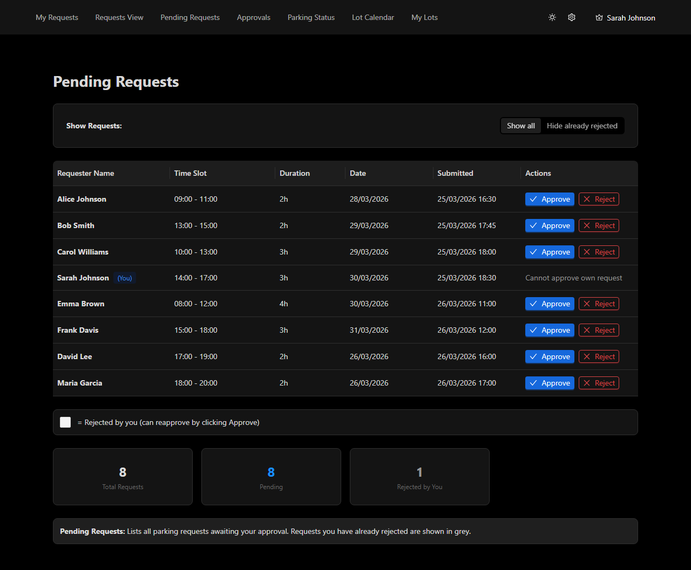

7. Approvals
Role: Owner / Manager
Full history of all approved requests across the system. Rows where the current owner is the lot owner are highlighted. Actions column links to the Request Detail page or opens a message preview.
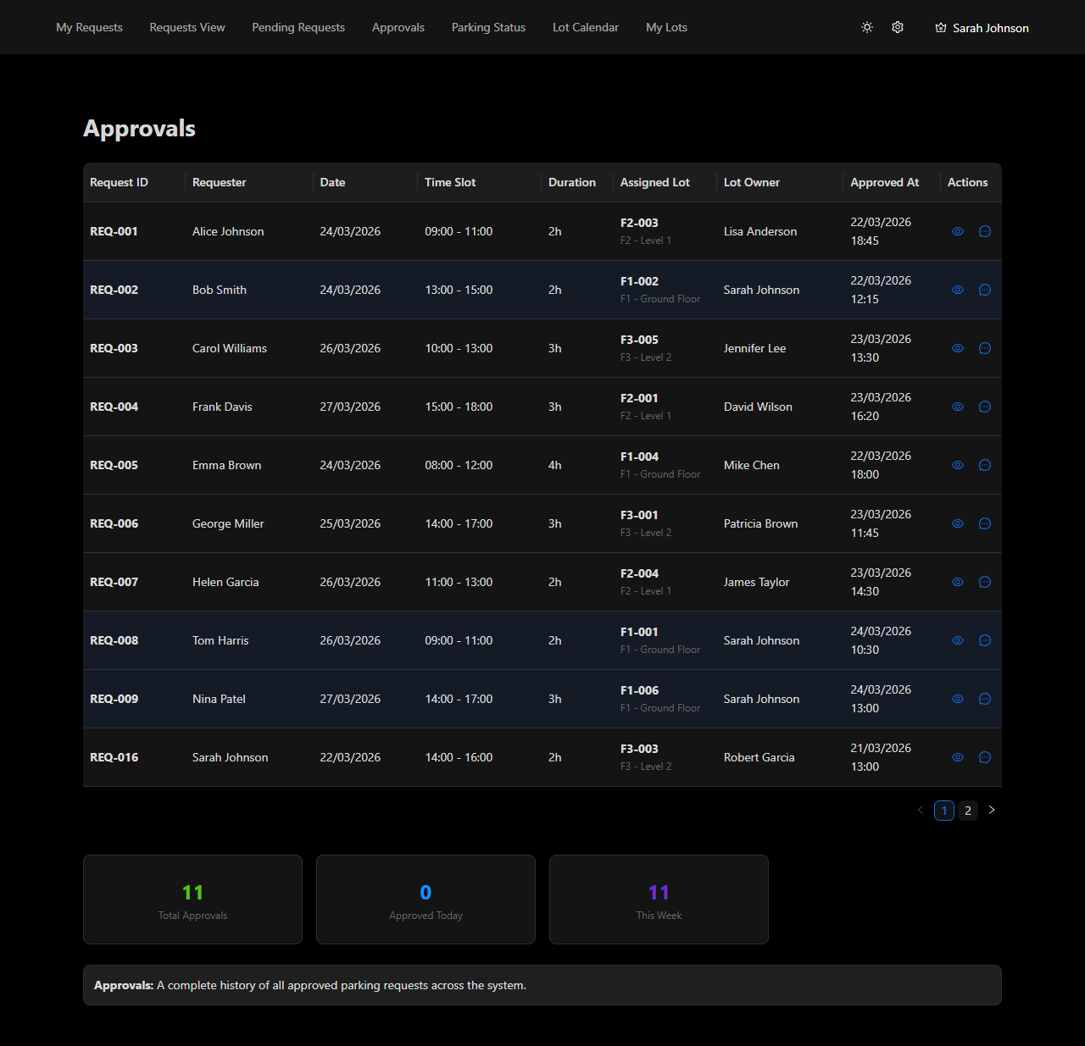

8. Parking Status
Role: All
Floor-by-floor accordion view of all lots with colour-coded status tags (available / blocked / unowned / unowned-blocked). A status legend and summary stats cards help at-a-glance monitoring.
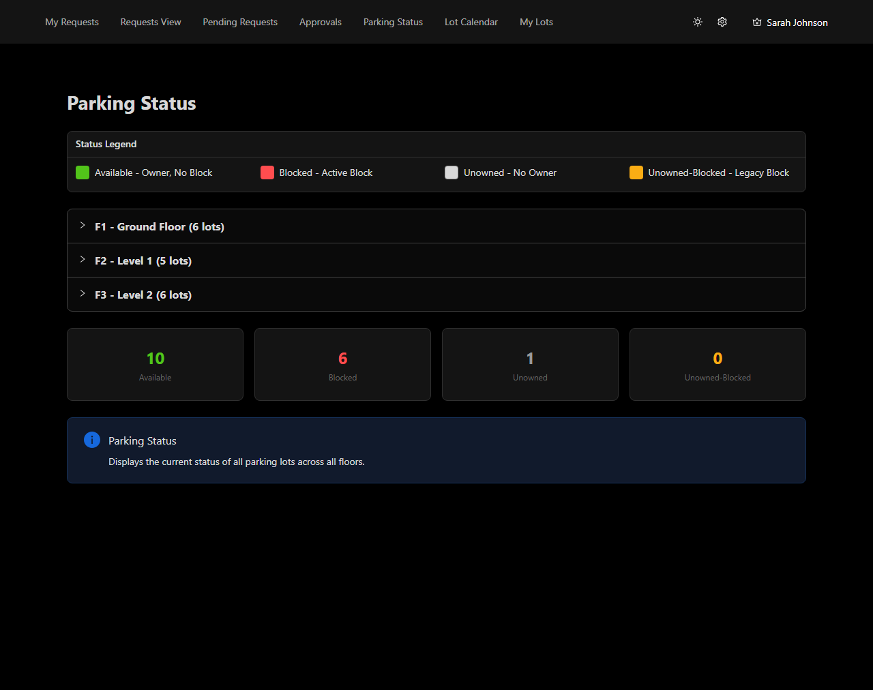

9. Lot Calendar
Role: Owner
Calendar view scoped to the owner's lots. Booked slots appear in red, pending requests in orange, blocked periods in dark red. The lot selector allows filtering to a single lot. Clicking an event opens an approval / rejection modal.
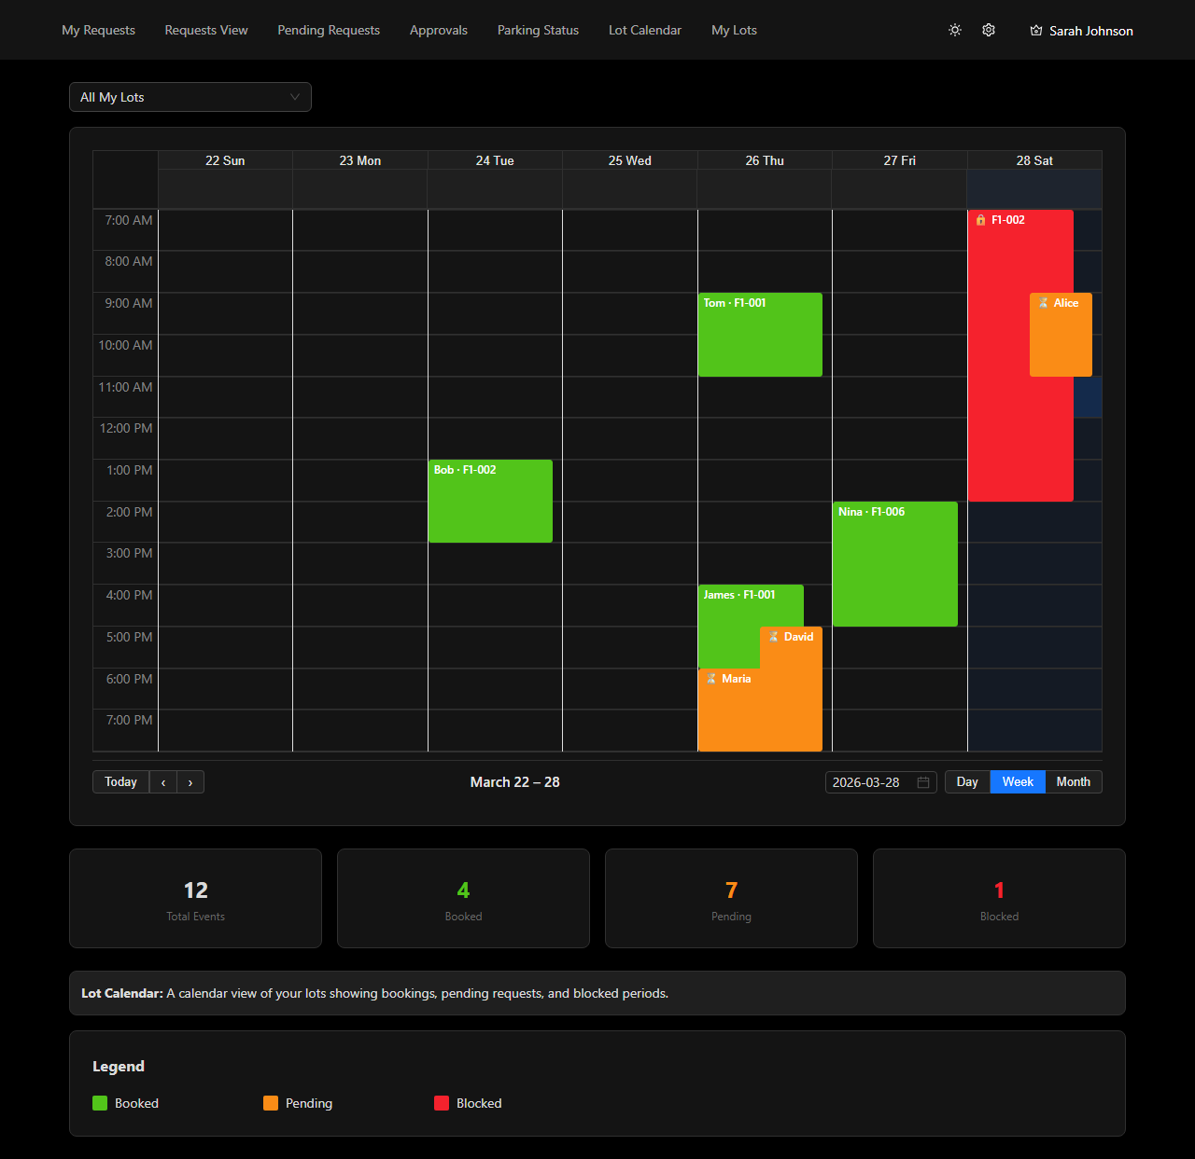

10. My Lots
Role: Owner
Table of all lots assigned to the logged-in owner with their current status and blocked-until date. Standard pagination (10 per page, hidden when not needed).
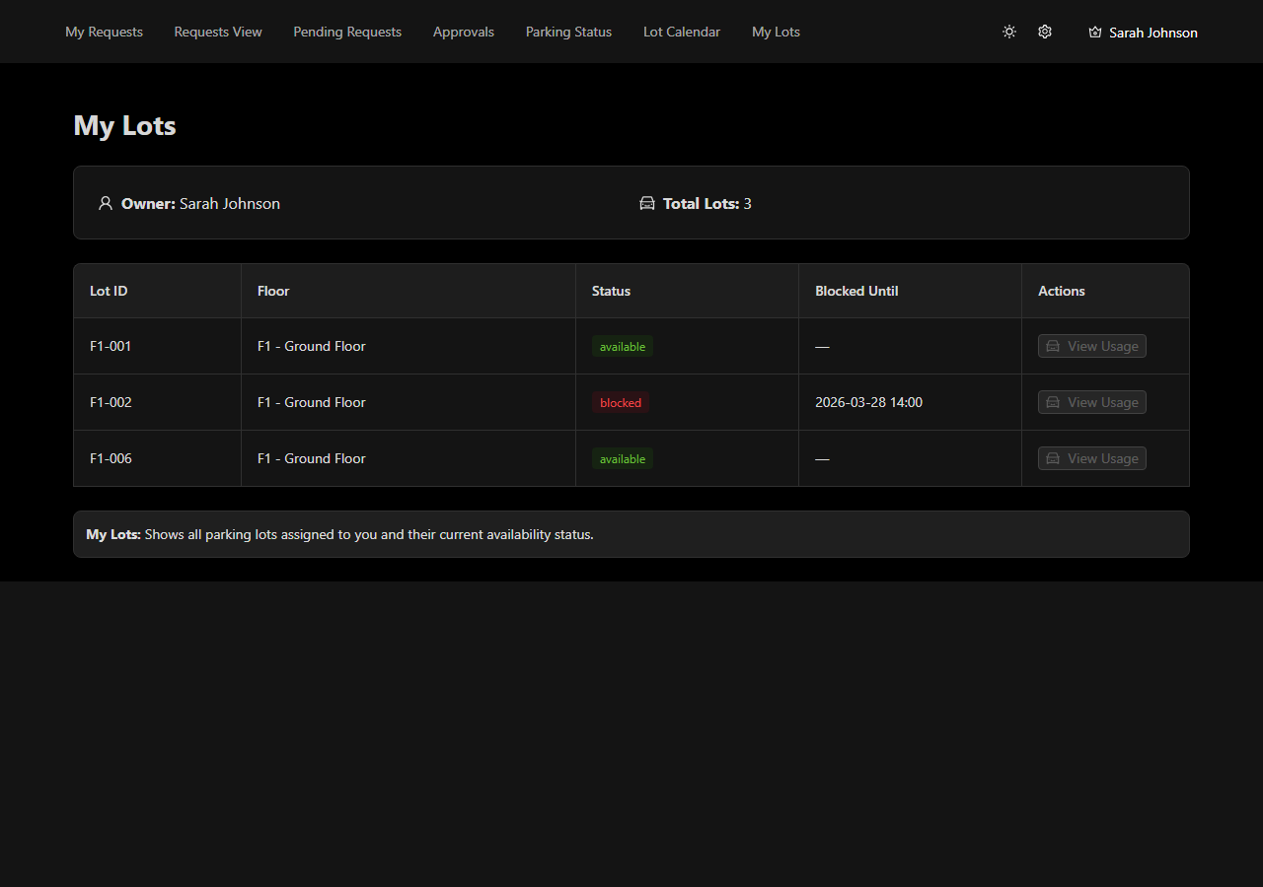

11. Admin Panel
Role: Manager
Sidebar-navigated panel with five sections: User Management, Lot Management, Import / Export, System Configuration, Reports and Broadcast Messages. Each section has an info banner at the bottom.


