¿Que es un "Hacktivista"?
por Perter Ludlow

fuente: http://opinionator.blogs.nytimes.com/2013/01/13/what-is-a-hacktivist/

La prematura muerte del joven activista de Internet Aaron Swartz, aparentemente por suicidio, a llevado a una reacción en torrente en el mundo digital. El principal debate que se ha recalentado, uno que ya se había desarrollado con la mayor y más audaz filtraciones de los últimos años, es si las actividades de Swartz como "hactivista" estaban siendo injustamente definidas como dañinas o criminales. En particular, los críticos (como también la familia de Swartz en la declaración formal) se han centrado en la acusación del gobierno federal de que Swartz descargo millones de documentos de la base de datos académica JSTOR, una acusación que en sí misma JSTOR había negado continuar.

“Lexical Warfare” is a phrase that I like to use for battles over how a term is to be understood. Our political discourse is full of such battles; it is pretty routine to find discussions of who gets to be called “Republican” (as opposed to RINO – Republican in Name Only), what “freedom” should mean, what legitimately gets to be called “rape” —and the list goes on.

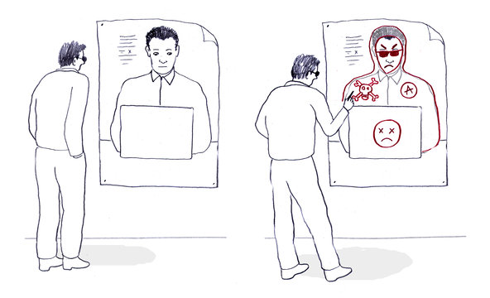Leif Parsons

Lexical warfare is important because it can be a device to marginalize individuals within their self-identified political affiliation (for example, branding RINO’s defines them as something other than true Republicans), or it can beguile us into ignoring true threats to freedom (focusing on threats from government while being blind to threats from corporations, religion and custom), and in cases in which the word in question is “rape,” the definition can have far reaching consequences for the rights of women and social policy.
Lexical warfare is not exclusively concerned with changing the definitions of words and terms — it can also work to attach either a negative or positive affect to a term. Ronald Reagan and other conservatives successfully loaded the word “liberal” with negative connotations, while enhancing the positive aura of terms like “patriot” (few today would reject the label “patriotic,” but rather argue for why they are entitled to it).

Over the past few years we’ve watched a lexical warfare battle slowly unfold in the treatment of the term “hacktivism.” There has been an effort to redefine what the word means and what kinds of activities it describes; at the same time there has been an effort to tarnish the hacktivist label so that anyone who chooses to label themselves as such does so at their peril.
In the simplest and broadest sense, a hacktivist is someone who uses technology hacking to effect social change. The conflict now is between those who want to change the meaning of the word to denote immoral, sinister activities and those who want to defend the broader, more inclusive understanding of hacktivist. Let’s start with those who are trying to change the meaning so that it denotes sinister activities.
Over the past year several newspapers and blogs have cited Verizon’s 2012 Data Breach Investigations Report, which claimed that 58 percent of all data leaked in 2011 was owing to the actions of “ideologically motivated hacktivists.” An example of the concern was an article in Infosecurity Magazine:
The year 2011 is renowned for being the year that hacktivists out-stole cybercriminals to take top honors according to the Verizon data breach report. Of the 174 million stolen records it tracked in 2011, 100 million were taken by hacktivist groups.
Suddenly, things are looking black and white again. Regardless of political motivation or intent, if there are victims of the attacks they perpetrate, then hacktivism has crossed the line. Not OK.
Meanwhile an article in ThreatPost proclaimed “Anonymous: Hacktivists Steal Most Data in 2011.”
The first thing to note is that both of these media sources are written by and for members of the information security business — it is in their interest to manufacture a threat, for the simple reason that threats mean business for these groups. But is it fair to say that the threat is being “manufactured”? What of the Verizon report that they cite?
The problem is that the headlines and articles, designed to tar hacktivists and make us fear them, did not reflect what the Verizon report actually said. According to page 19 of the report only 3 percent of the data breaches in the survey were by hacktivists — the bulk of them were by routine cybercriminals, disgruntled employees and nation states (83 percent were by organized criminals).
The “most data” claim, while accurate, gives a skewed picture. According to Chris Novak, the Managing Principal of Investigative Response on Verizon’s RISK Team, interviewed in ThreatPost, 2 percent of the 90 actions analyzed in the report accounted for 58 percent of the data released. The interview with Novak suggests that this data loss came from precisely two hacktivist actions — both by spin-offs of the well-known hacktivist group Anonymous — and that these large data dumps stemmed from the actions against the security firm HB Gary Federal, which had publicly announced their efforts to expose Anonymous, and a computer security firm called Stratfor). That means that in 2011 if you were worried about an intrusion into your system it was 33 times more likely that the perpetrator would be a criminal, nation state or disgruntled employee than a hacktivist. If you weren’t picking fights with Anonymous the chances would have dropped to zero — at least according to the cases analyzed in the report.
In effect, these infosecurity media outlets cited two actions by Anonymous spin-offs, implicated that actions like this were a principle project of hacktivism, and thereby implicated a larger, imminent threat of hacktivism. Meanwhile, the meaning of hacktivist was being narrowed from people who use technology in support of social causes to meaning individuals principally concerned with infiltrating and releasing the data of almost anyone.
Now let’s turn to an attempt to maintain the broader understanding of hacktivism. Several months ago I attended a birthday party in Germany for Daniel Domscheit-Berg, who was turning 34. As it happened, Domscheit-Berg had also been the spokesperson for Wikileaks and, after Julian Assange, the group’s most visible person. He had left the organization in 2010, and now he had a new venture, OpenLeaks. The party was also meant to be a coming out party for OpenLeaks.
The party was to be held in the new headquarters and training center for OpenLeaks — a large house in a small town about an hour outside of Berlin. I was half-expecting to find a bunker full of hackers probing Web sites with SQL injections and sifting through State Department cables, but what I found was something else altogether.

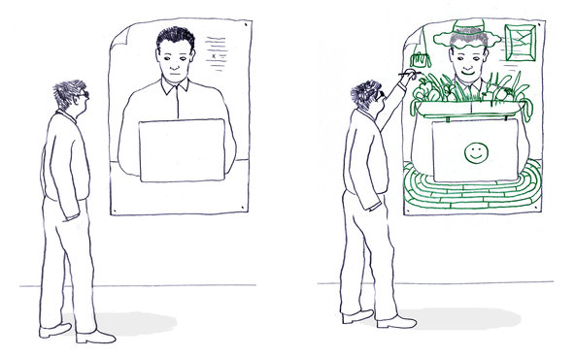Leif Parsons

When I arrived at the house the first thing I noticed was a large vegetable garden outside. The second thing I noticed was that a tree out front had been fitted out with a colorful knit wool sweater. This was the effort of Daniel’s wife Anke — “knit hacking,” she called it. And around the small town I saw evidence of her guerilla knit hacking. The steel poles of nearby street signs had also been fitted with woolen sweaters. Most impressively, though, a World War II tank, sitting outside a nearby former Nazi concentration camp for women had also been knit-hacked; the entire barrel of the tank’s gun had been fit with a tight colorful wool sweater and adorned with some woolen flowers for good measure. I interpreted these knit-hackings as counteractions to the attempts to define hacktivist as something sinister; they serve as ostensive definitions of what hacktivism is and what hacktivists do.

Of course the birthday party had elements of hackerdom understood more narrowly. There were some members of the Chaos Computer Club (a legendary hacker group), and there was a healthy supply of Club Mate — the energy drink of choice of European hackers, but the main message being delivered was something else: a do-it-yourself aesthetic — planting your own garden, knitting your own sweaters, foraging for mushrooms and counting on a local friend to bag you some venison. What part of this lifestyle was the hacktivism part? Daniel and his friends would like to say that all of it is.
The intention here was clear: an attempt to defend the traditional, less sinister understanding of hacktivism and perhaps broaden it a bit, adding some positive affect to boot; more specifically, that hacking is fundamentally about refusing to be intimidated or cowed into submission by any technology, about understanding the technology and acquiring the power to repurpose it to our individual needs, and for the good of the many. Moreover, they were saying that a true hacktivist doesn’t favor new technology over old — what is critical is that the technologies be in our hands rather than out of our control. This ideal, theoretically, should extend to beyond computer use, to technologies for food production, shelter and clothing, and of course, to all the means we use to communicate with one another. It would also, of course, extend to access to knowledge more generally — a value that was inherent in Aaron Swartz’s hacking of the JSTOR data base.
Our responsibility in this particular episode of lexical warfare is to be critical and aware of the public uses of language, and to be alert to what is at stake — whether the claims made by the infosecurity industry or the government, or the gestures by the hacktivists, are genuine, misleading or correct. We are not passive observers in this dispute. The meaning of words is determined by those of us who use language, and it has consequences. Whether or not Aaron Swartz suffered because of the manipulation of the public discourse surrounding hacking, his case is a reminder that it is important that we be attuned to attempts to change the meanings of words in consequential ways. It is important because we are the ones who will decide who will win.

Peter Ludlow is professor of philosophy at Northwestern University. His most recent book is “The Philosophy of Generative Linguistics.”

