1. What is JPython & CPython

CPython

The default implementation of the Python programming language is Cpython. As the name suggests Cpython is written in C language. Cpython compiles the python source code into intermediate bytecode, which is executed by the Cpython virtual machine. CPython is distributed with a large standard library written in a mixture of C and Python. CPython provides the highest level of compatibility with Python packages and C extension modules. All versions of the Python language are implemented in C because CPython is the reference implementation.

Jpython

Jython is an implementation of the Python programming language that can run on the Java platform. Jython programs use Java classes instead of Python modules .Jython compiles into Java byte code, which can then be run by Java virtual machine. Jython enables the use of Java class library functions from the Python program. Jython is slow as compared to Cpython and lacks compatibility with CPython libraries.

1. Basic difference between Python2 & python3

Python 3 default storing of strings is Unicode whereas Python 2 stores need to define Unicode string value with "u."

Python 3 value of variables never changes whereas in Python 2 value of the global variable will be changed while using it inside for-loop.

1. Difference between ASCII & unicode

ASCII originally used seven bits to encode each character. This was later increased to eight with Extended ASCII to address the apparent inadequacy of the original. In contrast, Unicode uses a variable bit encoding program where you can choose between 32,16,8 bit encoding.

1. What should be the output? ( 3 + 4 \*\* 6 - 9 \* 10 / 2 )

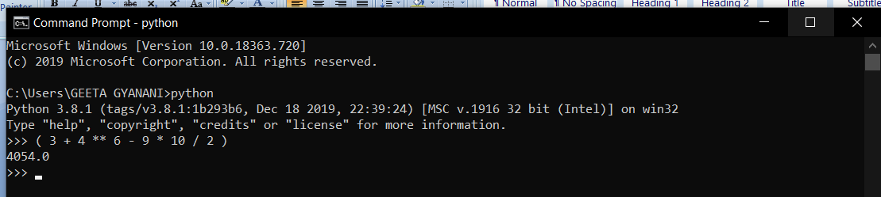

1. Let say I have, some string "hello this side regex"

● Find out the count of the total vowels ○ vowels - ['a','e','i','o','u']

a="hello this side regex"

k=0

for i in a:

if i in {'a','e','i','o','u'}:

k=k+1

print(k)

1. Find out the area of triangle - 1/2 \* b \* h (formula of area) - You have to take value from user about the base, & the height

b=int(input("enter the value of base "))

h=int(input("enter the value of height "))

area=1/2 \* b \* h

print(area)

1. Print the calendar on the terminal. If you give the year. - Allow the user to input the year. - Then should that calendar of that year

import calendar

y=int(input("enter the year"))

print(calendar.calendar(y))

1. Find the Armstrong Number between the two numbers which are input by user ○ Armstrong number : 153 -> 1\*1\*1 + 5\*5\*5 + 3\*3\*3

num1=input("enter first number")

num2=input("enter second number")

j=0

k=0

for i in num1:

i=int(i)\*int(i)\*int(i)

j=j+int(i)

if(j==int(num1)):

print("number one is armstrong")

for m in num2:

m=int(m)\*int(m)\*int(m)

k=k+int(m)

if(k==int(num2)):

print("number two is armstrong")

1. Let’s say you have a string “hello this world @2020!!! ” ○ Remove the punctuation like [“@!#$%&\*()”] from the string ■ Final output should be without the punctuation ● “hello this world 2020”

import string

a="hello this world @2020!!!"

for i in a:

if i not in string.punctuation:

print(i,end=(""))

1. ● You have a list with words - [“Apple”, “banana”, “cat”, “REGEX”,”apple”] ○ Sort words in Alphabetical order ■ If you get output, like [Apple, apple, banana] ● How has it happened?

a=['Apple', 'banana', 'cat', 'REGEX','apple']

a.sort()

print(a)

we get output, like [Apple, apple, banana] because sort function uses the Unicode value and Unicode value for ‘A’ and ‘a’ is different.